|  |
| --- |
| Andrew Burton |
| Comp 4 Project – Badges |
|  |

|  |
| --- |
|  |

Contents

Investigation 6

Introduction 6

Investigation methods 6

Questionnaires 8

Interview 12

Observation 14

Existing system documents 14

IOPS Chart for the existing system 25

Existing system flowchart 26

Document specification sheets 27

Analysis 42

Scope and Objectives 42

Tasks to be computerised 43

Proposed solutions 44

Constraints 45

New system design 47

Storage specification sheets 48

IOPS Chart for the new system 54

New system flowchart 61

Top down design for the new system 68

Interface designs 68

Database normalisation 72

Entity relationship diagrams 73

Storage media 73

Pseudo code 74

SQL statements 76

Validation 81

Security 81

Classes 82

Alpha testing Plan 83

Beta testing plan 88

Testing 90

Alpha testing 91

Systems Maintenance 104

Summary of packages used 104

Top down design 104

Classes 108

Attendance 110

BadgeDescribe 110

BadgeParts 110

Log 110

Meeting 110

Scout 111

StagedBadge 111

Forms 112

Delete meeting 112

Delete record 113

Edit record 114

Enter Attendance 116

Enter Badge Parts 118

Enter Badges 120

Enter Details 122

Enter Log 124

Enter Programme 126

Change staged badges 128

Get SQL 130

Loading SQL 131

Main form 132

View badges between date range 137

View individual record 139

View least achived badges 141

View Missed Meetings 143

Database 145

tblAttendance 145

tblBadgeDescribe 146

tblBadgePart 146

tblLog 147

tblMeeting 148

tblScout 148

SQL commands 150

Algorithms 153

Quicksort 153

View achieved badges 154

View least achieved badges 156

Calculate missed sessions 159

Display Attendance 160

Save Attendance 162

Badges User Manual 165

Introduction 167

System requirements: 167

Navigation 167

Installation instructions 173

Uninstallation instructions 176

Opening badges and connecting to the SQL server 177

Disconnecting from the SQL server 179

Closing forms 179

Adding badges 179

Stage badges 180

Non – staged badges 181

Adding Badge parts 181

Editing badges 182

Staged badges 182

Non – staged badges 182

Editing parts 182

Adding a meeting 183

Editing a meeting 185

Entering dates 186

Deleting meetings 186

Enter record 188

Editing a record 189

Delete record 190

View individual record 191

Enter register 192

Printing forms 193

Enter achieved badges 194

View achieved badges 195

View least achieved badges 196

View missed sessions 198

Error messages and troubleshooting 199

Quick Guides 201

Enter attendance 201

Create new record 203

View Achieved badges 204

Add a meeting 206

Appraisal 207

Comparison with original objectives 207

User Feedback 212

Analysis of user feedback 212

Future Improvements 213

Appendix A – Testing Screenshots 214

Appendix B – Developmental Testing 258

Appendix C – Program Code 314

Classes 314

Attendance 314

BadgeDescribe 314

BadgeParts 315

Log 316

Meeting 317

Scout 318

StagedBadge 319

Forms 320

Delete meeting 320

Delete record 321

Edit record 322

Enter Attendance 326

Enter Badge Parts 329

Enter Badges 332

Enter Details 334

Enter Log 337

Enter Programme 340

Change staged badges 343

Get SQL 347

Loading SQL 347

Main form 347

SQL commands 352

View badges between date range 364

View individual record 369

View least achived badges 373

View Missed Meetings 378

Investigation

# Forms

This details the forms in alphabetical order. The code for the forms can be seen in Appendix C

## Delete meeting

This form allows the end user to select a meeting and delete it from the database. The interface can be seen below:

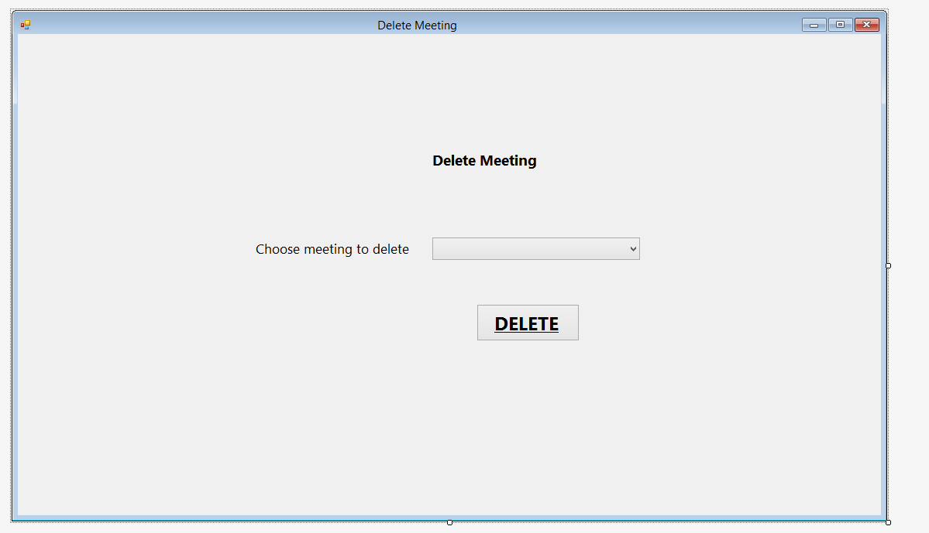

btnDelete

SelDelete

LblChooseMeetingDelete

LblDeleteMeeting

**Buttons for Delete meeting:**

SelDelete – populated from loadlist

btnDelete – runs sub to detete meeting from database

**Subs**

DeleteMeeting_Load – loads the meeting list when the form opens

btnDelete_Click – Asks for confirmation and then deletes meeting

LoadList – Gets the dates from meetings

DeleteValues – Deletes the meeting from the database, reloads lists and reloads the list of meetings

**Variables**

MeetingDate – Date – Local variable within DeleteValues used to hold the meetingdate the user selected

## Delete record

This form allows the user to delete a Scout’s record

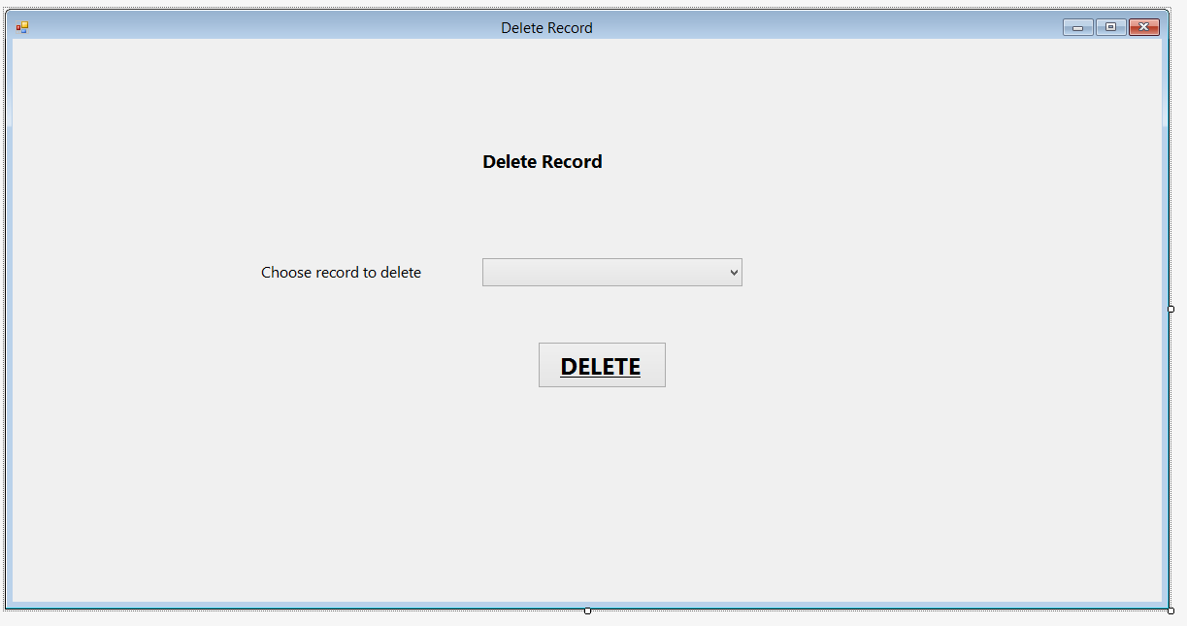

lblChooseRecordDelete

btnDelete

SelDelete

lblDeleteRecord

**Buttons for Delete record:**

SelDelete – populated from loadlist

btnDelete – runs sub to delete record from database

**Subs for Delete record:**

DeleteRecord_Load – populates SelDelete with scout names when form opens

btnDelete_Click – Displays confirmation and deletes record from database

LoadList – adds names to drop down list

DeleteValues – deletes record from database and then reloads databases and list

**Variables used in delete record**

NameInput(2) – 1D string array with 2 elements – Local variable declared within delete values – used to hold split name

FirstName – String - Local variable declared within DeleteValues - used to hold selected Scout’s first name

LastName – String – Local variable declared within DeleteValues – used to hold selected Scout’s last name

ScoutID – integer – local variable declared within DeleteValues – used to hold scoutID for selected Scout

## Edit record

lblSELName

lblDetails

lblJoinDate

SelName

dtJoin

btnChange

txtFirstName

lblDOB

lblLastName

lblValid

lblFirstName

**Buttons / textboxes for edit record:**

lblPatrolValidate

dtDOB

btnSave

lblPatrol

txtPatrol

lblValidateLastName

txtLast

SelName – allows user to select name to edit

btnChange – invokes get values – populates text boxes with scouts details

txtFirstName – Allows user to edit first name – invokes txtFirstName_TextChanged when changed

txtLast – Allows user to edit last name – Invokes txtLast_TextChanged when text changed

dtDob – Allows user to edit DOB

dtJoin – Allows user to edit join date

txtPatrol – Allows user to edit patrol – invokes txtPatrol_TextChanged when text changed

btnSave – Saves changes – invokes btnSave_Click

lblValid – displays whether txtFirstName is valid

lblValidateLastName – displays whether txtLastName is valid

lblPatrolValidate – displays whether PatrolValidate is valid

**Subs for edit record:**

EditRecord_Load – sets date boxes to today’s date and loads list when form loads

LoadList – loads list with scout names

btnChange_Click – Runs GetValues when btnChange clicked

GetValues – Populates textboxes and date boxes with chosen scouts data

btnSave_Click – Updates database if inputs valid

txtFirstName_TextChanged – checks that first name is valid when changed (invokes FirstValidate)

FirstValidate – checks that firstname is valid

txtLast_TextChanged – Checks that lastname is valid when changed (invokes LastValidate)

LastValidate – checks that lastname is valid

txtPatrol_TextChanged – checks that patrol is valid (invokes PatrolValidate)

PatrolValidate – checks that patrol is valid

**Variables for edit record**

ScoutID – Private integer – Used throughout the form to hold the Scout ID

Validate – Private Regex – used to validate text boxes using regex

## Enter Attendance

btnView

lblEndDate

btnPrint

dtEnd

dtStart

lblStartDate

btnSave

grdAttendance

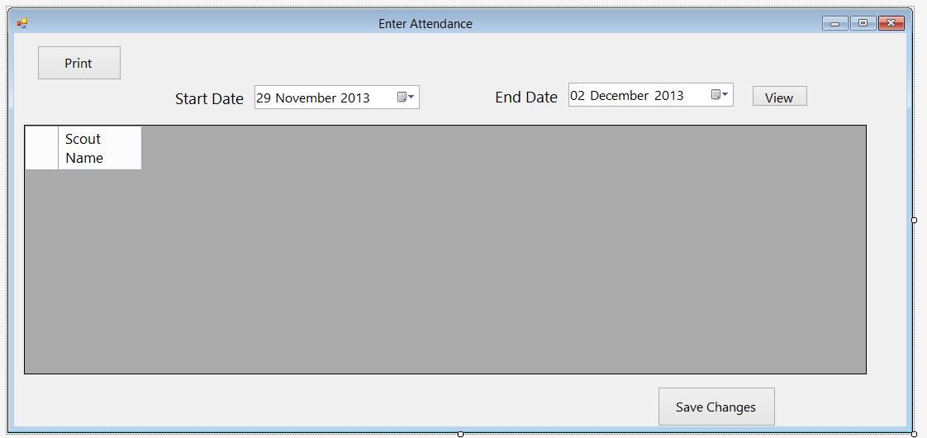This form allows the user to entrer the register. Overall, this form functions the same as it was in the design stage, although the print and view range buttons have been added so the user is not presented with all of the attendance in the database, and the sort by dropdown has been removed

**Buttons / textboxes used for enter attendance**

btnPrint – calls btnPrint_Click – Prints form

dtStart – Allows user to enter start date

dtEnd – allows user to enter end date

btnView – allows user to view attendance – calls LoadAttendance, LoadViewMeeting and DisplayAttend

grdAttendance –displays and allows user to enter attendance

btnSave – runs btnSave_Click – Saves the grid to the database

**Subs used for enter attendance**

EnterAttendance_Load – sets date boxes to todays date and loads databases

DisplayAttend – Displays attendance in grdAttendance

GetName – Returns name from scout ID

GetID – returns scout ID from name

btnView_Click – loads database and calls display attend when clicked

btnSave_Click – saves changes to attendance grid to database

GetMeetingDetails – gets badgeID and part from meeting date

SaveBadge – saves badge details in log

btnPrint_Click – prints view when btnPrint clicked

**Variables for enter attendance**

BadgeID – Private integer – contains badge id

PartID – Private integer – con tains badge part ID

Name – Local string within displayattend – contains scout name

Position – Local integer within DisplayAttend – contains position of column

ObjDate – Local Date within DisplayAttend – contains date from list

ClmDate – Local Date within DisplayAttend – contains date from column

Splitname – Local string array (2 elements) within getID – contains name when split into first and last

ExistingAttend – local Boolean within btnSave_click – contains weather entered attendance was modified or newly entered

AttendCount – local integer within btnSave_click – contains number of values in attend

Position – local integer within SaveBadge – contains number of values in logs

Print – local printdialogue in btnPrint_Click – used to print view

## Enter Badge Parts

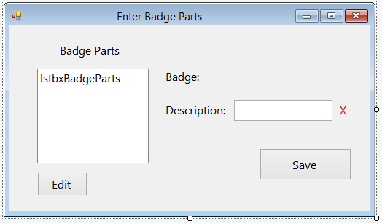

lblBadge

lblBadgeParts

btnSave

lblPartValidate

lblBadgeName (assigned text in code)

txtDescription

lblDescription

btnEdit

lstbxBadgeParts

This form allows the user to enter the parts of the badge. Originally, this was intended to just be a “number of parts” box on the enter parts form, however it was not practical to do that due to the need to assign parts to meetings. As a result this form was created, which is given the name of the badge and displays the existing parts, allowing the user to enter new or edit existing parts. It is called from the enter badge screen, and appears as a pop up window.

**Buttons / textboxes used for enter badge parts**

lstbxBadgeParts – allows user to select existing badge parts – populated by loadlist

lblBadgeName – contains the name of the badge and the stage – populated by lblBadge_load when form loads

txtDescription – allows user to enter part description – runs txtDescription_TextChanged when changed

lblPartValidate – displays whether description is valid or not

btnEdit - runs btnEdit_Click when clicked – allows user to edit selected part

btnSave – runs btnSave_Click when clicked – saves badge part to database

**Subs used for enter badge parts**

lblBadge_Load – Sets lblBadge to badge name (and stage if applicable) when form opens

SetValues – Sets local variables before form opens

LoadList – Adds badgeparts to list

btnEdit_Click – sets txtDescription to selected part description so user can edit it

btnSave_Click – saves badge part to database and reloads list

txtDescription_TextChanged – Validates txtDescription when changed, calls part validate – changes lblPartValidate

PartValidate – Validates txtDescription – changes lblPartValidate

**Variables used for EnterBadgeParts**

BadgeID – private integer – contains ID for badge

BadgeName – private string – contains name of badge

PartID – private integer – contains ID for part

ExistingPart – Private Boolean – set to true if user presses edit for existing part

Position – private integer – contains position of item in list

Stage – private integer - contains stage if staged badge

Validate – Private Regex – contains regex for validation

PartDescribe – local string within btnEdit_Click – contains entered part description

BadgePostion – local integer within btnSave_Click – contains position to put part in badgelist

Valid – local Boolean in partvalidate – contains whether text is valid

## Enter Badges

lblChangeBadgeDetails

Button1

selBadge

lblChooseBadge

txtBadgeName

lblBadgeNameValidate

btnParts

lblBadgeName

btnSave

This form allows the user to enter or edit a badge. It is similar to the design, however the parts section has been moved to a different form (see above).

**Buttons used for enter badges**

selBadge – allows user to select badge

Button 1 – runs Button1_Click – allows user to edit name and parts for selected badge

txtBadgeName – allow user to enter badge name

lblBadgeNameValidate – displays whether badgename is valid

btnSave – runs btnSave_Click

btnParts – runs btnParts_Click

**Subs used for enter badges**

Button1_Click - allows user to edit selected badge

btnChange_Load – runs loadlist when form opens

SaveChanges – saves changes to badge

SaveNew – saves new badge if no badge edited

btnSave_Click – saves new / existing badge when btnSave clicked

LoadList – puts names of badges into list

btnParts_Click – Shows enter badge parts form

txtBadgeName_TextChanged – validates txtBadgeName when changed – calls BadgeValidate

BadgeValidate – validates badgename – changes lblBadgeNameValidate

**Variables used for enter badges**

ID – private integer – contains badgeID

ExistingBadge – private Boolean – contains weather edit badge has been pressed

Position – private integer – contains position in list

Validate – private regex – validates inputs

Saved – private Boolean – contains weather changes have been saved

ChosenBadge – local string in Button1_Click – contains badge chosen from list

Match – local Boolean in Button1_Click – contains if found

ExistingDescribe – local integer in SaveNew – contains id to assign to badge

PositionInList – local integer in SaveNew – contains position of value in list

Valid – local Boolean in badgevalidate – contains whether badge name is valid

## Enter Details

This form allows the user to enter details for a new Scout. Overall it is similar to the design, however the edit and delete Scout sections have been moved to different forms to make it easier to use.

dtJoin

lblDetails

lblLastName

txtPatrol

lblJoinDate

txtFirstName

lblValidateLastName

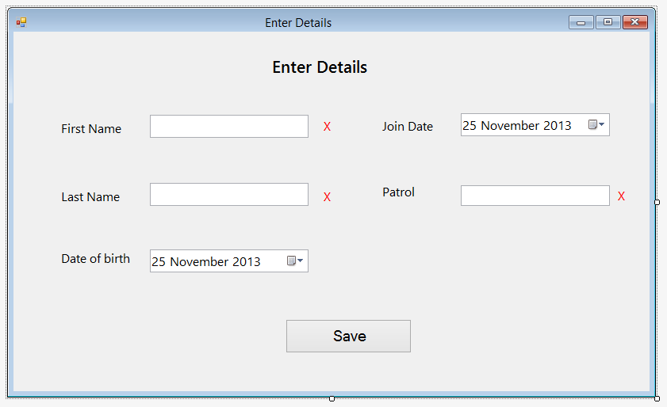

lblPatrol

lblPatrolValidate

dtDOB

btnSave

txtLast

lblDOB

lblValid

lblFirstName

**Enter details textboxes / buttons**

txtFirstName – allows user to enter Scout’s first name – runs txtFirstName_TextChanged when changed

lblValid – displays whether txtFirstName is valid

dtJoin – Allows user to enter join date

txtLast – Allows user to enter Scout’s last name – runs txtLast_TextChanged when changed

lblValidateLastName – displays whether txtLast is valid

txtPatrol – allows user to enter patrol – runs txtPatrol_TextChanged when changed

lblPatrolValidate – displays whether patrol is valid

dtDOB – allows user to enter Scout’s DOB

btnSave – Allows user to save details in database – runs btnSave_Click_1 when clicked

**Subs used for enter details**

EnterDetails_Load – sets date to todays dates when form loads

btnSave_Click_1 – saves details in database when btnSave clicked

txtFirstName_TextChanged – Validates txtFirstname when changed – runs FirstValidate

FirstValidate – Validates txtFirstname

txtLast_TextChanged – validates txtLast when changed – runs lastValidate

LastValidate – validates txtlast

txtPatrol_TextChanged – validates txtpatrol when changed – runs patrolValidate

PatrolValidate – validates patrol

**Variables used for enter details**

Validate – private regex – used to validate inputs

Valid – local variable in FirstValidate, LastValidate and PatrolValidate (they use the same regex method) – used to validate inputs

## Enter Log

SelName

lblName

lblBadgeName

SelBadgeName

lblEnterLog

lblPartName

selBadgePart

btnSave

This form allows the user to enter other badges, such as if a Scout chooses to do a part of a badge at home. Overall it is the same as the design, however it now works with all types of badges, instead of just stage badges.

**Buttons used in Enter log**

SelName – Allows user to select Scout name

SelBadgeName – allows user to select badge name – runs selBadgeName_SelectedIndexChanged

SelBadgePart – allows user to select badge part

btnSave – saves input to database – runs btnSave_Click when clicked

**Subs used in enter log**

Enter_Log_Load – runs listload when form opens

ListLoad – puts badges and names in lists

btnSave_Click - saves log when button pressed - runs Savebadge

GetID – gets Scout ID from Scout name

SaveBadge – Saves entry to database

selBadgeName_SelectedIndexChanged – reloads partlist when badge selected badge changed

GetPartNo – gets part ID

GetPartName – gets part name from part id

FindBadgeID – gets badgeid from badgedescription

**Variables used for enter log**

ID – private integer – contains scout ID

Badge ID – private integer – contains badge id

partID – private integer – contains part id

SelectedName – local variable in GetID – contains selectedName

SplitName – 1D local integer array in getID – contains name split into first and last name

Position – local integer in savebadge – contains number of items in logs

Name – local string in FindBadgeID – contains badge name

Found – local boolean in FindBadgeID – contains whether found in lstbadges

## Enter Programme

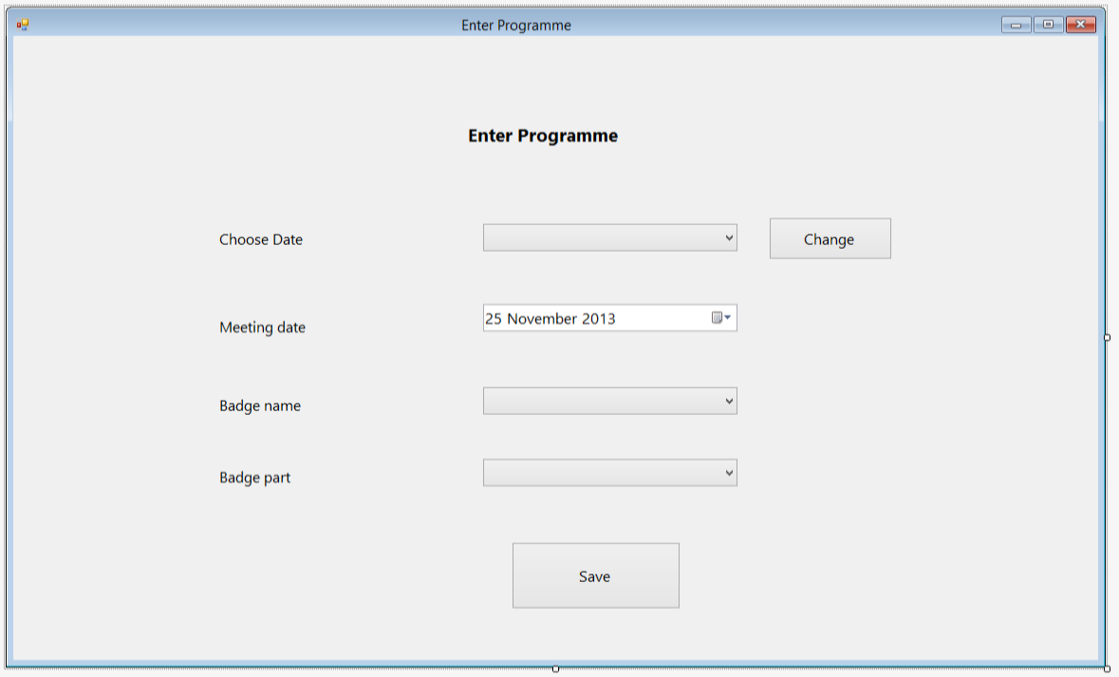

dtMeeting

lblMeetingDate

chgDate

lblEnterProgramme

lblDateChoose

selDate

This form allows the user to enter a new meeting date and badge, or edit an existing one. It also allows the user to edit an existing meeting date. Overall this is the same as the design, although the user can edit meetings as well as add new ones

lblBadgePart

btnSave

selBadgePart

selBadgeDescribe

lblBadgeName

**Buttons / textboxes used for enter programme**

selDate – allows user to select existing meeting date

chgDate – allows user to change details of existing meeting date – runs chgDate_Click

dtMeeting – allows user to enter / edit the date of the meeting

selBadgeDescribe – allows user to enter / edit the badge – runs selBadgeDescribe_SelectedIndexChanged

selBadgePart – allows user to enter / edit the padge part

btnSave – allows the user to save new meeting / changes

**Subs used for enter programme**

chgDate_Click – populates boxes with selected meeting details when pressed

GetBadgeName – gets badge name from badge id

GetPartNo – gets part id from part description

LoadList – loads badges and meeting dates into lists

Enter_Programme_Load – sets meeting date to today and runs loadlist when form loads

btnSave_Click – saves changes / new badge when btnSave clicked

SaveChanges – updates database with changes to meeting

SaveNew – saved new meeting to database

FindBadgeID – finds badgeID from badge description

selBadgeDescribe_SelectedIndexChanged – loads parts for badge when selected badge changed

**Variables used for enter programme**

ChosenDate – private date – contains chosen meeting date to edit

badgeID – private integer – contains ID for chosen badge

StagedBadge – private boolean – contains whether chosen badge is staged or not

Part id – private integer – contains ID for chosen part

Position – private integer - contains position of meeting in list

Match – private boolean – contains whether meeting is new or existing

GotName – local boolean for GetBadgeName – contains wheteher name was in badgelist so stagedbadgelist doenst need to be searched

ExistingMeetingNo – local integer for SaveNew – contains number of meetings in list

Name – local string for findbadgeID – contains name of selected badge

Found - local boolean for findbadgeID – contains whether ID was found in lstbadges

**Enter programme code:**

## Change staged badges

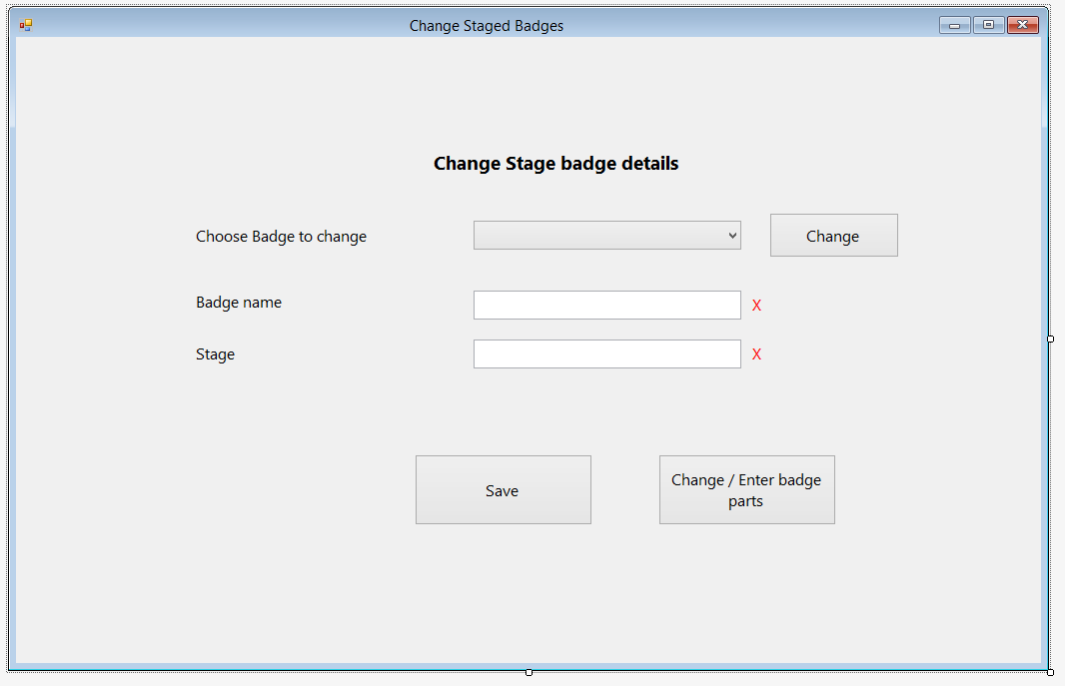

lblChangeBadgeDetails

lblChooseBadge

txtBadgeName

lblBadgeName

btnSave

btnEnterParts

lblStageValidate

lblBadgeNameValidate

Button1

selBadge

txtChangeStageBadge

This form allows the user to enter badges which are staged. Originally, this was designed to be part of the a simple textbox form for the user to enter a badge name and stage each time a staged badge was achieved, however I decided to implement stage badges in a similar way to badges in order to make the programme more functional, however a manual “enter badges” screen still exists.

**Buttons / textboxes used for change staged badges:**

selBadge – contains existing badges – allows user to select one to edit

Button1 – allows user to edit selected badge – runs Button1_Click

txtBadgeName – allows user to enter badge name – runs txtBadgeName_TextChanged when changed

lblBadgeNameValidate – displays if badgename is valid

txtChangeStageBadge – allows user to enter stage – runs txtChangeStageBadge_TextChanged when changes

lblStageValidate – displays if stage is valid

btnSave – allows user to save badge / changes to database – runs btnSave_Click when clicked

btnEnterParts – shows enter parts form – runs btnEnterParts_Click when clicked

**Subs used for change staged badges:**

Button1_Click – populates boxes with selected badges data

btnChange_Load – Runs loadlist when form opens

SaveChanges – saves changes to database

SaveNew – saves new badge to database

btnSave_Click – saves badge when save button pressed

LoadList – adds staged badges to list

btnEnterParts_Click – shows enterbadgeparts form

txtBadgeName_TextChanged – validates badge name when changed – runs BadgeValidate

BadgeValidate – validates badge name

txtChangeStageBadge_TextChanged – validates stagebadge when changed – runs StageValidate

StageValidate – validates stagebadge

**Variables used for change stage badges**

ID – Private Integer – contains badge ID

ExistingBadge – private Boolean – contains whether badges is a new or edited one

NoParts – Private Integer – contains number of parts

Stage ID – Private Integer – contains stage of badge

Position ID – Private Integer – contains position of stgbadge in list

Validate – private regex – used to validate inputs

Saved – private Boolean – contains whether changes have been saved

ChosenBadge – Local string in Button1_Click – contains chosen badge name

Match – local Boolean in Button1_Click – contains whether chosen badge is found

ExistingDescribe – local integer in SaveNew – contains BadgeID

NostageBagde – contains number of items in stgbadge

Valid – local Boolean for BadgeValidate and StageValidate – contains whether input is valid

## Get SQL

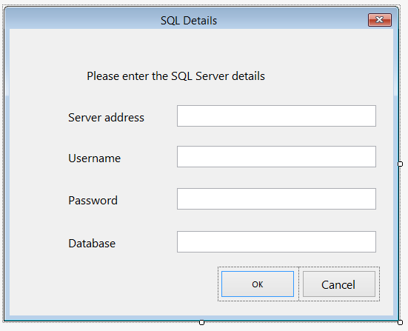

OK_Button

lblInfo

lblServerAddress

txtAddress

txtUsername

lblUserName

txtPassword

lblPassword

txtDatabase

lblDatabase

Cancel_Button

This form allows the user to enter the details of the SQL server they wish to connect to. Originally, this was not included in the design, however I have decided to create this in order to make the program more flexible, since it will now work with any MySQL server. This form is called when the user presses connect to SQL server in the menu bar, and if the OK button is pressed the program will connect to the server with the details given.

**SQL Details buttons / textboxes**

txtAddress – Allows user to enter server address

txtUserName – allows user to enter SQL username

txtPassword – allow user to enter password

txtDatabase – allows user to enter database name

OK_Button – connects to SQL server with those details

Cancel_Button – cancels connection

**SQL details subs:**

OK_button_click – returns ok result

Cancel_button_click – returns cancel result

## Loading SQL

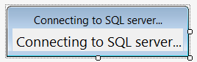

lblConnect

**Code for Loading SQL**

This form is shown by the main form whilst connecting to the SQL server, and is hidden once the connection is complete

## Main form

BadgesToolStripMenuItem

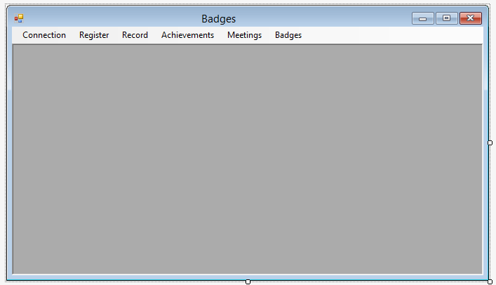

RecordToolStripMenuItem

ConnectionToolStripMenuItem

RegisterToolStripMenuItem

AchivementsToolStripMenuItem

MeetingsToolStripMenuItem

MenuStrip1

Connection menu item

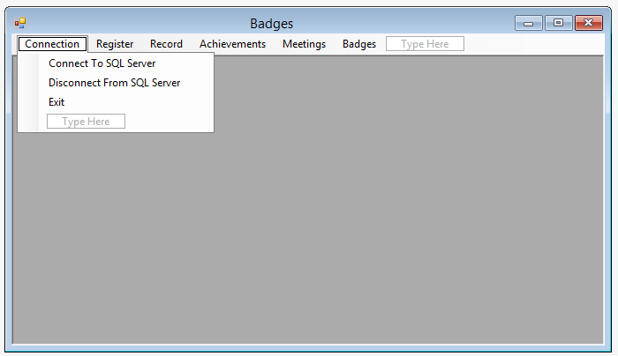

ConnectToSQLServerToolStripMenuItem

ExitToolStripMenuItem

DisconnectFromSQLServerToolStripMenuItem

Register menu item

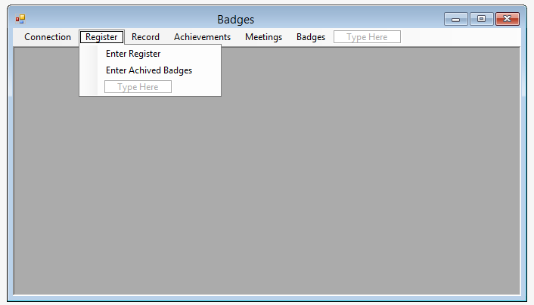

EnterRegisterToolStripMenuItem

EnterLogToolStripMenuItem

Record menu item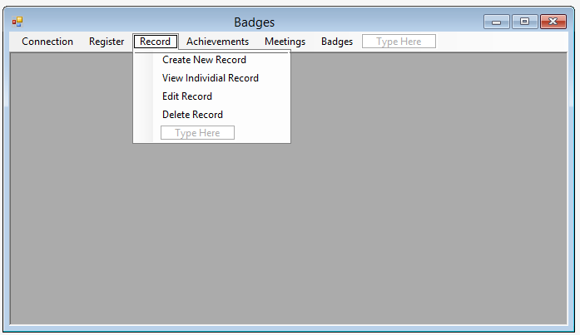

ViewIndividialRecordToolStripMenuItem

EditRecordToolStripMenuItem

DeleteRecordToolStripMenuItem

CreateNewRecordToolStripMenuItem

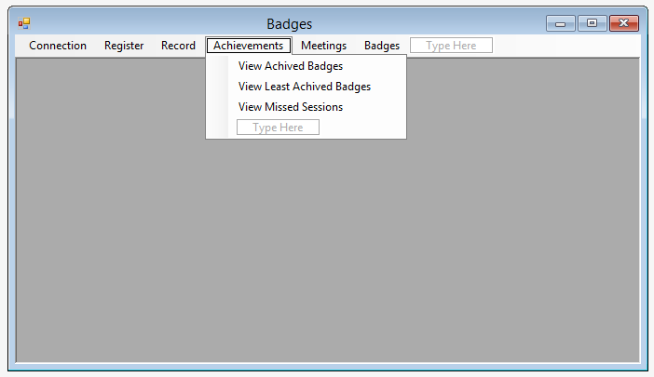Achievements menu item

BetweenDateRangeToolStripMenuItem

ViewLeastAchivedBadgesToolStripMenuItem

ViewMissedSessionsToolStripMenuItem

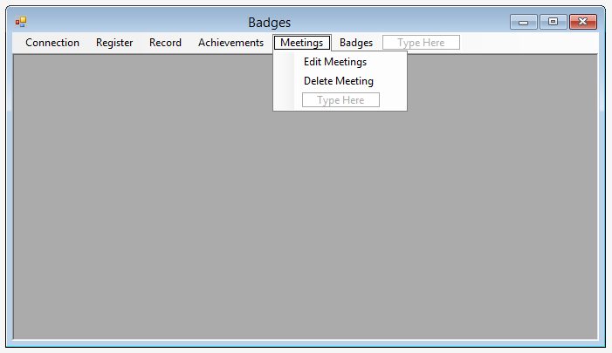Meetings menu item

EnterNewProgrammeToolStripMenuItem

DeleteMeetingToolStripMenuItem

Badges menu item

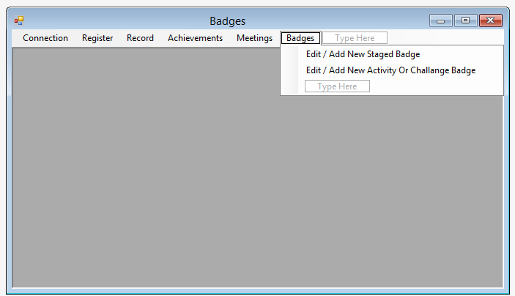

ChangeActivityChallengeBadgesToolStripMenuItem

ChangeSagedBadgesToolStripMenuItem

This form is the main form in which other forms are shown. Originally, this was designed to have buttons to control the individual forms, such as undo and print, however I found that this was impractical. The layout of this form can be seen in the flowchart at the start of systems maintenance.

**Subs / Buttons for main form (buttons show first)**

ConnectToSQLServerToolStripMenuItem – runs ConnectToSQLServerToolStripMenuItem_Click – connects to SQL server

DisconnectFromSQLServerToolStripMenuItem – runs DisconnectFromSQLServerToolStripMenuItem_Click – disconnects from SQL server

ExitToolStripMenuItem– runs ExitToolStripMenuItem_Click – closes program

EnterRegisterToolStripMenuItem – runs EnterRegisterToolStripMenuItem_Click – shows enter register form

EnterLogToolStripMenuItem – runs EnterLogToolStripMenuItem_Click – shows enter log form

CreateNewRecordToolStripMenuItem – runs CreateNewRecordToolStripMenuItem_Click – shows create new record

ViewIndividialRecordToolStripMenuItem – runs ViewIndividialRecordToolStripMenuItem_Click – shows view individual record

EditRecordToolStripMenuItem – runs EditRecordToolStripMenuItem_Click – shows editrecord

DeleteRecordToolStripMenuItem – runs DeleteRecordToolStripMenuItem_Click – shows delete record

BetweenDateRangeToolStripMenuItem – runs BetweenDateRangeToolStripMenuItem_Click – shows ViewBadgesBetweenDateRange

EnterNewProgrammeToolStripMenuItem – runs EnterNewProgrammeToolStripMenuItem_Click – shows enternewprogramme

ViewLeastAchivedBadgesToolStripMenuItem – runs ViewLeastAchivedBadgesToolStripMenuItem_Click – shows viewleastachivedbadges

ViewMissedSessionsToolStripMenuItem – runs ViewMissedSessionsToolStripMenuItem_Click – shows viewmissedsessions

DeleteMeetingToolStripMenuItem – runs DeleteMeetingToolStripMenuItem_Click – shows delete meeting

ChangeSagedBadgesToolStripMenuItem – runs ChangeSagedBadgesToolStripMenuItem_Click – shows enterstagedbadges

ChangeActivityChallengeBadgesToolStripMenuItem – runs ChangeActivityChallengeBadgesToolStripMenuItem_Click – shows enterbadges

**SQL commands**

The main form also contains the SQL commands (see SQL commands section for more on this). Overall the DDL is similar to the design, however the individual SQL commands have changed significantly.

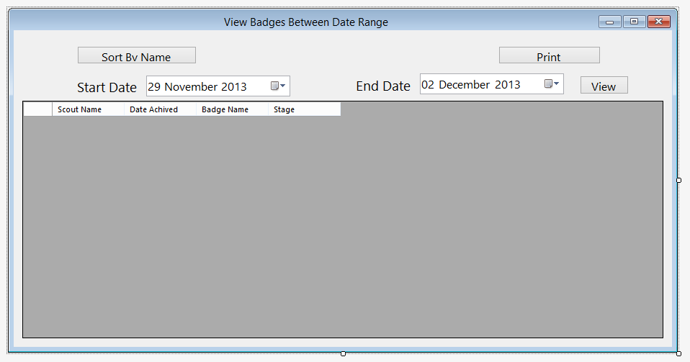

btnQuickSort

## View badges between date range

btnView

btnPrint

dtEnd

lblEndDate

dtStart

lblStartDate

ViewGrid

This form allows the user to view achived badges between date range. It is similar to the design, however the sort by dropdown has been replaced by a button, and it shows a line for each achived badge, and not for each person. The print button has also been moved to the form from the toolbar

**Buttons used for view achived badges**

btnPrint – runs btnPrint_Click – prints form

dtStart – allows user to enter start date to view

dtEnd – allows user to enter last date to view

btnView – runs btnView_Click – views record

btnQuickSort – runs btnQuickSort_Click – sorts by name

**Subs used for view achieved badges**

btnView_Click – views achived badges when btnView pressed

LoadStagedBadges – Gets achived staged badges between date range

ViewBadgesBetweenDateRange_Load – sets date to today and loads view on form load

LoadBadges – Gets achived badges between date range

QuickSortNumbers – Quicksort for numbers (used for sorting parts)

Quicksort – Quicksort for string – used for sorting names

btnPrint_Click – prints form when btnPrint pressed

btnQuickSort_Click – sorts viewgrid by scout name

**Variables used for view achived badges**

Position – local integer in LoadStagedBadges and LoadBadges – contains position of badge id in list

Firstname - local string in LoadStagedBadges and LoadBadges – contains scouts first name

Lastname - local string in LoadStagedBadges and LoadBadges – contains scouts last name

BadgeName - local string in LoadStagedBadges and LoadBadges – contains name of badge

HighDate – local date in LoadStagedBadges and LoadBadges – contains highest date achived

Valid - local Boolean in LoadStagedBadges and LoadBadges – contains whether parts are valid

Stg – local boolean in LoadStagedBadges – contains stage

Parts – local list of integer in LoadStagedBadges and LoadBadges – contains parts for sorting

Achived Parts – local list of integer in LoadStagedBadges and LoadBadges – contains parts for sorting

A – local integer in quicksorts – value for quicksort

B – local integer in quicksorts – value for quicksort

Mid – local integer in quicksortnumbers, string in quicksort – midpoint for quicksort

Tempvalue – local integer in quicksortnumbers, string in quicksort – value for quicksort

Tempgroup – local list of scout in btnQuickSort_click – temp group for name quicksort

GotValue – local Boolean in btnQuickSort_click – contains whether value found

Currentposition – local integer in btnQuickSort_click – contains position in list

## View individual record

lblEndDate

btnView

btnPrint

SelName

dtEnd

dtStart

lblName

This form allows the user to view an indivudual record. It has changed from the desugn tue to the fact that it is in a gridview instead of textboxes, and it is not possible to edit the view in this mode, however it still performs the same function as intended.

lblStartDate

ViewGrid

**Buttons used in view individual record**

SelName – allows user to select scout name

btnPrint – runs btnPrint_Click – prints form

dtStart – allows user to enter start date to view

dtEnd – allows user to enter last date to view

btnView – runs btnView_Click – views record

**Subs used for view individual record**

btnView_Click – views recors when btnView pressed

LoadStagedBadges – Gets achived staged badges between date range

ViewIndividualRecord_Load – sets date to today and loads view on fomr load

LoadBadges – Gets achived badges between date range

QuickSortNumbers – Quicksort for numbers (used for sorting parts)

GetID – returns scout ID

btnPrint_Click – prints form when btnPrint pressed

**Variables used for view individual record**

ScoutID – Private integer – contains scout Id

Position – local integer in LoadStagedBadges and LoadBadges – contains position of badge id in list

Firstname - local string in LoadStagedBadges and LoadBadges – contains scouts first name

Lastname - local string in LoadStagedBadges and LoadBadges – contains scouts last name

BadgeName - local string in LoadStagedBadges and LoadBadges – contains name of badge

HighDate – local date in LoadStagedBadges and LoadBadges – contains highest date achived

Valid - local Boolean in LoadStagedBadges and LoadBadges – contains whether parts are valid

Stg – local boolean in LoadStagedBadges – contains stage

Pos – Local integer in loadStagedBadges and LoadBadges – contains position of scout

Parts – local list of integer in LoadStagedBadges and LoadBadges – contains parts for sorting

Achived Parts – local list of integer in LoadStagedBadges and LoadBadges – contains parts for sorting

SelectedName – local string in get id – contains selected name

Splitname – 1D array – contains name split into first and last name

A – local integer in quicksort – value for quicksort

B – local integer in quicksort – value for quicksrt

Mid – local integer in quicksort – midpoint for quicksort

Tempvalue – local integer in quicksort – value for quicksort

**View individual record code:**

## View least achived badges

btnView

dtEnd

lblEndDate

dtStart

lblStartDate

btnPrint

ViewGrid

This form allows the user to see which badges have been achived the least in order to assist with programme planning. It is very similar to the design, however the current Scout’s dropdown has been replaced with a date range to filter out old results if needed, and the sort view drop down has been removed. A column for the stage of the badge has also been added

**Buttons used for view least achived badges**

btnPrint – runs btnPrint_Click – prints form

dtStart – allows user to enter start date to view

dtEnd – allows user to enter last date to view

btnView – runs btnView_Click – views badges

**Subs for view least achived badges**

ViewBadgesBetweenDateRange_Load -– sets date to today and loads view on form load

LoadBadges – Gets least achived badges between date range

LoadStagedBadges – Gets least achived staged badges between date range

btnView_Click – views least achived badges when btnView pressed

QuickSortNumbers – Quicksort for numbers (used for sorting parts)

Quicksort – Quicksort for string – used for sorting names

btnPrint_Click – prints form when btnPrint pressed

**Variables for view least achived badges**

HighDate – local date in LoadStagedBadges and LoadBadges – contains highest date achived

Valid - local Boolean in LoadStagedBadges and LoadBadges – contains whether parts are valid

Position – local integer in LoadStagedBadges and LoadBadges – contains position of badge id in list

Parts – local list of integer in LoadStagedBadges and LoadBadges – contains parts for sorting

Achived Parts – local list of integer in LoadStagedBadges and LoadBadges – contains parts for sorting

A – local integer in quicksorts – value for quicksort

B – local integer in quicksorts – value for quicksort

Mid – local integer in quicksortnumbers, string in quicksort – midpoint for quicksort

Tempvalue – local integer in quicksortnumbers, string in quicksort – value for quicksort

Tempgroup – local list of scout in btnQuickSort_click – temp group for name quicksort

HighDate – Local date in loadbadges and loadstgbadges– contains highest achived date

Noachived – Local integer in loadbadges and loadstgbadges – contains number of times achived

## View Missed Meetings

lblEndDate

dtStart

lblStartDate

btnPrint

btnView

dtEnd

ViewGrid

This form allows the user to see which meetings have been missed and by which Scouts. It is the same as the design, although a stage and part column have been added, along with a view and print button.

**Buttons used for view missed meetings**

btnPrint – runs btnPrint_Click – prints form

dtStart – allows user to enter start date to view

dtEnd – allows user to enter last date to view

btnView – runs btnView_Click – views missed meetings

**Subs used for view missed meetings**

ViewMissedMeetings_Load - sets date to today and loads view on form load

CalculateMissedSessions – calculates missed sessions between date range

GetBadgeName – gets badgename from badge id

GetStage – Gets stage from badgeID

GetPart – Gets part description from partID

btnView_Click – shows missed meeting when btn_View clicked

btnPrint_Click – prints form when btnPrint pressed

**Variables used for view missed meetings**

MissedNames – local string in calculate missed sessions – contains names that have missed meeting

MeetAttend – local Boolean in CalculateMisssedSessions – contains attencance for a meeting

# Database

The program uses a MySQL database to store the data. This is made up of the following tables:

tblAttendance

tblBadgeDescribe

tblBadgePart

tblLog

tblMeeting

tblScout

## tblAttendance

This table contains details of which Scouts have attended which meetings

MeetingDate – Date

ScoutID – int(11)

Attendance – tinyint(1)

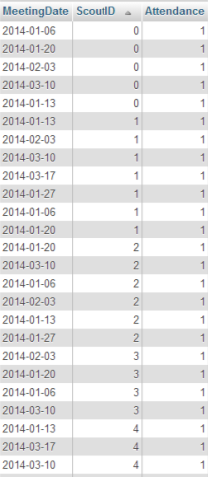A screenshot of some data in this table in phpMyAdmin can be seen below

## tblBadgeDescribe

This table contains the badgeID, along with the description and stage if applicable

BadgeID – int(11)

BadgeDescription – varchar (100)

Stage – int(11)

A screenshot of some data in this table in phpMyAdmin can be seen below

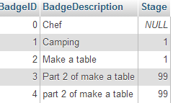

## tblBadgePart

This table contains details of the badgeparts

PartID – int(11)

BadgeID – int(11)

PartDescription – varchar(11)

A screenshot of some data in this table in phpMyAdmin can be seen below

## tblLog

This table contains details of achived badge parts

ScoutID – int(11)

Date – date

PartID – int(11)

BadgeID – int(11)

A screenshot of some data in this table in phpMyAdmin can be seen below

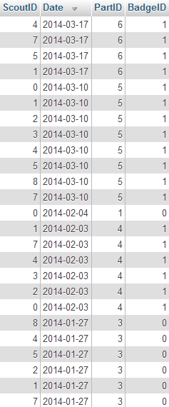

## tblMeeting

This table contains details of the meeting and badges for meeting

MeetingDate – date

BadgePartID – int(11)

BadgeID – int(11)

A screenshot of some data in this table in phpMyAdmin can be seen below

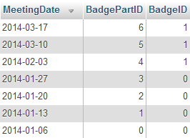

## tblScout

This contains details of each Scout

ScoutID – int(11)

Firstname – varchar(255)

LastName – varchar(255)

DOB – Date

JoinDate – date

Patrol – varchar(255)

A screenshot of some data in this table in phpMyAdmin can be seen below

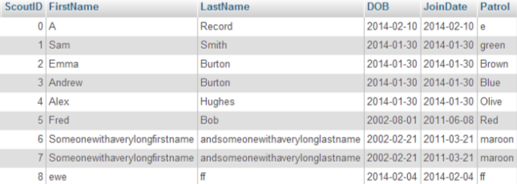

# SQL commands

The following SQL commands (in MainForm) can be seen below along with the corresponding sub

Table creation:

These commands in SQLConnect create the tables and assign the coloums if they don’t exist.

Create Table If Not Exists tblAttendance(MeetingDate Date , ScoutID int, Attendance Boolean); - Creates tblAttendance if it doesn’t exist with a meetingdate, scoutID and attendance coloum

Create Table If Not Exists tblMeeting (MeetingDate Date PRIMARY KEY NOT NULL, BadgePartID integer, BadgeID Integer); - Creates tblMeeting if it doesn’t exist with a MeetingDate, BadgePartID and BadgeID coloum

Create Table If Not Exists tblScout (ScoutID integer PRIMARY KEY NOT NULL, FirstName varchar(255), LastName varchar(255), DOB Date, JoinDate Date, Patrol varchar(255)); - creates tblScout if it doesn’t exist with ScoutID, FirstName, LastName, DOB and patrol coloum

Create Table If Not Exists tblBadgePart (PartID integer PRIMARY KEY NOT NULL, BadgeID integer, PartDescription varchar(100)); - Creates tblBagdePart if it doesn’t exist with PartID, BadgeID and PartDescription coloums

Create Table If Not Exists tblLog (ScoutID integer, Date Date NOT NULL, PartID integer, BadgeID integer); - Creates tblLog if it doesn’t exist with ScoutID, Date, PartID and BadgeID coloums

Create Table If Not Exists tblBadgeDescribe(BadgeID integer PRIMARY KEY NOT NULL, BadgeDescription varchar(100), Stage integer) – Creates tblBadgeDescribe if it doesn’t exist with badgeID, BadgeDescription and Stage coloums

Select / Insert / Delete / Update statements

select * from tblScout – LoadValues - Selects scout info

SELECT tblLog.ScoutID, tblLog.Date, tblLog.PartID, tblLog.BadgeID FROM tblLog INNER JOIN tblScout WHERE tblScout.ScoutID = tblLog.ScoutID – LoadLog – Selects achived badges info

select tblBadgePart.BadgeID, tblBadgePart.PartID, tblBadgePart.PartDescription, tblBadgeDescribe.BadgeDescription from tblBadgePart INNER JOIN tblBadgeDescribe where tblBadgePart.BadgeID = tblBadgeDescribe.BadgeID – LoadBadges – Selects badge part info

select tblBadgeDescribe.BadgeID, tblBadgeDescribe.BadgeDescription, tblBadgeDescribe.Stage from tblBadgeDescribe Where tblBadgeDescribe.Stage IS NOT NULL – LoadStageBadges – Selects stage badges

SELECT tblMeeting.MeetingDate, tblMeeting.BadgePartID, tblMeeting.BadgeID from tblMeeting inner join tblBadgeDescribe where tblMeeting.BadgeID = tblBadgeDescribe.BadgeID – LoadMeeting – Selects meeting info

SELECT * FROM tblAttendance INNER JOIN tblScout WHEREtblScout.ScoutID = tblAttendance.ScoutID AND tblAttendance.MeetingDate BETWEEN '" & VBDateToSQL(FirstDate) & "' AND '" & VBDateToSQL(LastDate) & "' – LoadAttendance – selects attendance between date range

SELECT * FROM tblMeeting WHERE tblMeeting.MeetingDate BETWEEN '" & VBDateToSQL(FirstDate) & "' AND '" & VBDateToSQL(LastDate) & "' ORDER BY MeetingDate; - LoadViewMeeting – Selects meetings between date range

Select * from tblLog where scoutID = " & ScoutID & " and tblLog.badgeID = " & BadgeID & " And tblLog.Date Between '" & VBDateToSQL(startdate) & "' and '" & VBDateToSQL(EndDate) & "'; - LoadView – Selects individual item from tblLog

Select * from tblBadgeDescribe Where tblBadgeDescribe.Stage IS NULL; - LoadBadgeDescribe – Selects badge details

INSERT INTO `tblScout`(`ScoutID`, `FirstName`, `LastName`, `DOB`, `JoinDate`, `Patrol`) VALUES (" & ID & ", '" & FirstName & "', '" & LastName & "', '" & SQLDOB & "', '" & SQLJoinDate & "', '" & Patrol & "') – InsertData - inserts details into tblScout

INSERT INTO `tblAttendance`(`MeetingDate`, `ScoutID`, `Attendance`) VALUES ('" & USDateToSQL(MeetingDate) & "', '" & ScoutID & "', " & Attendance & "); - AddAttendance – inserts Attendance into database

INSERT INTO `tblBadgePart`(`BadgeID`, `PartID`, `PartDescription`) VALUES (" & BadgeID & ", '" & PartID & "', '" & PartDescription & "'); - AddBadgePart – Adds badgePart to database

Insert into `tblBadgeDescribe` (`BadgeID`, `BadgeDescription`) VALUES ( " & BadgeID & ", '" & BadgeDescription & "'); - AddBadge – Adds badge to database

Update `tblBadgeDescribe` Set BadgeDescription='" & BadgeDescribe & "' Where BadgeID=" & BadgeID & "; - UpdateBadgeDescribe – updates badge info

Update `tblBadgePart` Set PartDescription='" & PartDescribe & "' Where PartID=" & PartID & "; - UpdateBadgePart – Updates part info

insert into `tblBadgeDescribe`(`BadgeID`,`BadgeDescription`, `Stage`) Values (" & BadgeID & ", '" & BadgeDescription & "', " & Stage & "); - AddStageBadge – adds Stage badge to database

UPDATE `tblBadgeDescribe` SET `BadgeDescription`='" & BadgeDescribe & "',`Stage`='" & Stage & "' WHERE `BadgeID`='" & BadgeID & "'; - UpdateStageBadgeDescribe – updates stage badge info

INSERT INTO `tblMeeting`(`MeetingDate`, `BadgePartID`, `BadgeID`) VALUES ('" & VBDateToSQL(MeetingDate) & "', " & Parts & ", " & ID & "); - SaveNewProgramme – Adds new meeting to database

Update `tblMeeting` Set MeetingDate='" & VBDateToSQL(MeetingDate) & "', BadgeID='" & ID & "', BadgePartID='" & Part & "' Where MeetingDate='" & VBDateToSQL(ExistingDate) & "'; - UpdateProgramme – updates meeting details

INSERT INTO `tblLog`(`BadgeID`, `PartID`, `Date`, `ScoutID`) VALUES (" & BadgeID & ", '" & PartID & "', '" & DateSave & "', " & ScoutID & "); - SaveLog – inserts Achived badge info into log

DELETE FROM `tblScout` WHERE tblScout.ScoutID = " & ScoutID & "; DELETE From `tblLog` WHERE tblLog.ScoutID = " & ScoutID & "; DELETE FROM `tblAttendance` WHERE tblAttendance.ScoutID = " & ScoutID & "; - DelRecord – Deletes scout record

"DELETE From `tblLog` WHERE ScoutID = " & ScoutID & " AND Date='" & USDateToSQL(MeetDate) & "' AND BadgeID=" & BadgeID & " AND PartID =" & PartID & "; DELETE From `tblAttendance` WHERE ScoutID=" & ScoutID & " AND MeetingDate ='" & USDateToSQL(MeetDate) & "'; - DeleteAttendance – Deletes attendance from database

DELETE FROM `tblMeeting` WHERE tblMeeting.MeetingDate = '" & VBDateToSQL(MeetingDate) & "'; - DelMeeting – Deletes meeting details

UPDATE `tblScout` SET `FirstName`='" & FirstName & "',`LastName`='" & LastName & "',`DOB`='" & VBDateToSQL(DOB) & "',`JoinDate`='" & VBDateToSQL(JoinDate) & "',`Patrol`='" & Patrol & "' WHERE scoutid = " & ScoutID & "; - UpdateRecord – Updates scout details

UPDATE `tblAttendance` SET `Attendance`=" & Attendance & " WHERE scoutid = " & ScoutID & " and MeetingDate='" & USDateToSQL(MeetingDate) & "'; - UpdateAttend – Updates attendance for scout

SELECT MAX(BadgeID) AS BadgeID FROM tblBadgeDescribe – GetMaxID – gets highest badge ID

# Algorithms

Quicksort – used in ViewLeastAchivedBadges, ViewBadgesBetweenDateRange, ViewIndividualRecord

This sorts the numbers or strings in an array into order of size

## Quicksort

Psudeocode for quicksort

Procedure Quicksort (List, First, Last)

If First > large

Then

PivotValue <- List [First]

LeftPointer <- First + 1

RightPointer <- Last

While LeftPointer <= RightPointer

While List[LeftPointer] < PivotValue AND LeftPointer <= RightPointer

LeftPointer <- LeftPointer + 1

EndWhile

While List [RightPointer] > PivotValue AND LeftPointer <=RightPointer

RightPointer <- RightPointer -1

EndWhile

If Left < Right

Then Swap (List[LeftPointer], List[RightPointer])

EndIf

End While

Pivot <- RightPointer

Swap (List[First], List[Pivot])

EndIf

QuickSort (List, First, Pivot -1)

QuickSort (List, Pivot +1, Last)

End If

End Procedure

VB.NET implementation

Public Sub QuickSortNumbers(ByVal ThingsToSort() As Integer, Low As Integer, Max As Integer)

'Quicksort'

Dim A As Integer

Dim B As Integer

Dim Mid As Integer

Dim TempValue As Integer

A = Low

B = Max

Mid = ThingsToSort(Int((A + B) / 2))

Do While A <= B

Do While ThingsToSort(A) < Mid

A = A + 1

Loop

Do While Mid < ThingsToSort(B)

B = B - 1

Loop

If A <= B Then

TempValue = ThingsToSort(A)

ThingsToSort(A) = ThingsToSort(B)

ThingsToSort(B) = TempValue

A = A + 1

B = B - 1

End If

Loop

If Low < B Then Call QuickSortNumbers(ThingsToSort, Low, B)

If Max > A Then Call QuickSortNumbers(ThingsToSort, A, Max)

End Sub

## View achieved badges

This algorithm determines which badges have been achived from badge parts. This is used in ViewBadgesBetweenDateRange. There is a version of this for badges and staged badges, with the only difference being a line to get the stage and a line to add the stage to the viewgrid. ViewIndividualRecord also uses the same algorithm, although the For each obje in group is replaced with a static position.

Psuedocode

Sub LoadBadges()

For Each obj In LstBadges

For Each obje In Group

Position As Integer <- 0

FirstName As String

LastName As String

BadgeName As String

HighDate As Date

Valid As Boolean = True

LoadView(obje.GetID, obj.GetBadgeID)

If ViewList.Count > 0 Then

Parts As New List(Of Integer)

For Each objec In BadgeList

If objec.GetBadgeID <- obj.GetBadgeID Then

Parts.Add(New Integer)

Parts(Position) <- objec.GetPartID

Position <- Position + 1

End If

Next

Dim AchivedParts As New List(Of Integer)

For Each item In ViewList

AchivedParts.Add(New Integer)

AchivedParts(AchivedParts.Count - 1) <- item.GetPartID

Next

QuickSortNumbers(Parts.ToArray, 0, Parts.Count - 1)

QuickSortNumbers(AchivedParts.ToArray, 0, AchivedParts.Count - 1)

If Parts.Count <- AchivedParts.Count Then

For counter <- 0 To Parts.Count - 1

If Parts(counter) = AchivedParts(counter) Then

Valid <- True

Else

Valid <- False

End If

Next

Else

Valid <- False

End If

If Valid Then

For Each vwlst In ViewList

If vwlst.GetDateAchived > HighDate Then HighDate <- vwlst.GetDateAchived

Next

FirstName <- obje.GetFirstName

LastName <- obje.GetLastName

BadgeName <- obj.GetBadgeDescription

ViewGrid.Rows.Add(FirstName & " " & LastName, HighDate, BadgeName)

End If

End If

Next

Next

End Sub

VB.NET Implementation

Private Sub LoadBadges()

'returns what badges have been achived by which scout within a date range

'For each item in list of badges'

For Each obj In LstBadges

'for each scout

For Each obje In Group

Dim Position As Integer = 0

Dim FirstName As String

Dim LastName As String

Dim BadgeName As String

Dim HighDate As Date

Dim Valid As Boolean = True

'SQL load'

LoadView(obje.GetID, obj.GetBadgeID)

If ViewList.Count > 0 Then

Dim Parts As New List(Of Integer)

'For number of items in viewlist, stick badgeparts into array

For Each objec In BadgeList

If objec.GetBadgeID = obj.GetBadgeID Then

Parts.Add(New Integer)

Parts(Position) = objec.GetPartID

Position = Position + 1

End If

Next

Dim AchivedParts As New List(Of Integer)

For Each item In ViewList

AchivedParts.Add(New Integer)

AchivedParts(AchivedParts.Count - 1) = item.GetPartID

Next

QuickSortNumbers(Parts.ToArray, 0, Parts.Count - 1)

QuickSortNumbers(AchivedParts.ToArray, 0, AchivedParts.Count - 1)

If Parts.Count = AchivedParts.Count Then

For counter = 0 To Parts.Count - 1

If Parts(counter) = AchivedParts(counter) Then

Valid = True

Else

Valid = False

End If

Next

Else

Valid = False

End If

'If valid then if number of items in partsachived = number of parts, valid = true and stick in list'

If Valid Then

For Each vwlst In ViewList

If vwlst.GetDateAchived > HighDate Then HighDate = vwlst.GetDateAchived

Next

FirstName = obje.GetFirstName

LastName = obje.GetLastName

BadgeName = obj.GetBadgeDescription

ViewGrid.Rows.Add(FirstName & " " & LastName, HighDate, BadgeName)

End If

End If

Next

Next

End Sub

## View least achieved badges

This algorithm performs a similar function to the one above, however it returns the number of times a badge has been achieved and the last date it was achieved, rather than who achieved a badge.

Psuedocode

Sub LoadBadges

For Each obj In LstBadges

Dim HighDate As Date

Dim NoAchived As Integer

For Each obje In Group

Position As Integer <- 0

Valid As Boolean = True

LoadView(obje.GetID, obj.GetBadgeID)

If ViewList.Count > 0 Then

Parts As New List(Of Integer)

For Each objec In BadgeList

If objec.GetBadgeID <- obj.GetBadgeID Then

Parts.Add(New Integer)

Parts(Position) <- objec.GetPartID

Position <- Position + 1

End If

Next

AchivedParts As New List(Of Integer)

For Each item In ViewList

AchivedParts.Add(New Integer)

AchivedParts(AchivedParts.Count - 1) <- item.GetPartID

Next

QuickSortNumbers(Parts.ToArray, 0, Parts.Count - 1)

QuickSortNumbers(AchivedParts.ToArray, 0, AchivedParts.Count - 1)

If Parts.Count <- AchivedParts.Count Then

For counter <- 0 To Parts.Count - 1

If Parts(counter) <- AchivedParts(counter) Then

Valid <- True

Else

Valid = False

End If

Next

Else

Valid <- False

End If

If Valid Then

For Each vwlst In ViewList

If vwlst.GetDateAchived > HighDate Then HighDate <- vwlst.GetDateAchived

Next

NoAchived <- NoAchived + 1

End If

End If

Next

If NoAchived > 0 Then

ViewGrid.Rows.Add(obj.GetBadgeDescription, "", HighDate, NoAchived)

Else

ViewGrid.Rows.Add(obj.GetBadgeDescription, "", "", NoAchived)

End If

Next

End Sub

VB.NET implementation

Private Sub LoadBadges()

'For each item in list of badges'

For Each obj In LstBadges

Dim HighDate As Date

Dim NoAchived As Integer

'for each scout

'for each scout

For Each obje In Group

Dim Position As Integer = 0

Dim Valid As Boolean = True

'varible

'SQL load'

LoadView(obje.GetID, obj.GetBadgeID)

If ViewList.Count > 0 Then

Dim Parts As New List(Of Integer)

'For number of items in viewlist, stick badgeparts into array

For Each objec In BadgeList

If objec.GetBadgeID = obj.GetBadgeID Then

Parts.Add(New Integer)

Parts(Position) = objec.GetPartID

Position = Position + 1

End If

Next

Dim AchivedParts As New List(Of Integer)

For Each item In ViewList

AchivedParts.Add(New Integer)

AchivedParts(AchivedParts.Count - 1) = item.GetPartID

Next

QuickSortNumbers(Parts.ToArray, 0, Parts.Count - 1)

QuickSortNumbers(AchivedParts.ToArray, 0, AchivedParts.Count - 1)

If Parts.Count = AchivedParts.Count Then

For counter = 0 To Parts.Count - 1

If Parts(counter) = AchivedParts(counter) Then

Valid = True

Else

Valid = False

End If

Next

Else

Valid = False

End If

'If valid then if number of items in partsachived = number of parts, valid = true and stick in list'

If Valid Then

For Each vwlst In ViewList

If vwlst.GetDateAchived > HighDate Then HighDate = vwlst.GetDateAchived

Next

NoAchived = NoAchived + 1

End If

End If

Next

If NoAchived > 0 Then

'Display badge with date'

ViewGrid.Rows.Add(obj.GetBadgeDescription, "", HighDate, NoAchived)

Else

'ohthewise date = ""'

ViewGrid.Rows.Add(obj.GetBadgeDescription, "", "", NoAchived)

End If

Next

End Sub

## Calculate missed sessions

This algorithm in view missed sessions determines from attendance which Scouts were absent for meetings, and then outputs the meeting date, badge name and a list of names for absent Scouts.

Psuedocode

Sub CalculateMissedSessions

For Each Meet In ViewMeeting

MissedNames As String <- ""

For Each obje In Group

MeetAttend As Boolean <- False

For Each obj In Attend

If obj.GetMeetingDate <- Meet.GetMetingDate Then

If obj.GetScoutID <- obje.GetID Then

MeetAttend <- True

End If

End If

Next

If MeetAttend <- False Then

MissedNames <- MissedNames & obje.GetFirstName & " " & obje.GetLastName & ", "

End If

Next

If MissedNames.Count > 0 Then

ViewGrid.Rows.Add()

ViewGrid.Rows(ViewGrid.Rows.Count - 1).SetValues(Meet.GetMetingDate, GetBadgeName(Meet.GetPlannedBadgeID), GetStage(Meet.GetPlannedBadgeID), GetPart(Meet.GetPlannedBadgePart), MissedNames)

End If

Next

End Sub

VB.NET implementation

Private Sub CalculateMissedSessions()

'For each meeting'

For Each Meet In ViewMeeting

Dim MissedNames As String = ""

'For each scout'

For Each obje In Group

Dim MeetAttend As Boolean = False

'And each attend

For Each obj In Attend

'if meetingDate = meetingDate meeting table'

If obj.GetMeetingDate = Meet.GetMetingDate Then

'If scoutID = getscoutID'

If obj.GetScoutID = obje.GetID Then

'Set meetattend to true'

MeetAttend = True

End If

End If

Next

'If not attended

If MeetAttend = False Then

MissedNames = MissedNames & obje.GetFirstName & " " & obje.GetLastName & ", "

End If

Next

'if there are missed names Adds meeting info (meetingdate, badgename, stage, part description, missed names to grid)

If MissedNames.Count > 0 Then

ViewGrid.Rows.Add()

ViewGrid.Rows(ViewGrid.Rows.Count - 1).SetValues(Meet.GetMetingDate, GetBadgeName(Meet.GetPlannedBadgeID), GetStage(Meet.GetPlannedBadgeID), GetPart(Meet.GetPlannedBadgePart), MissedNames)

End If

Next

End Sub

## Display Attendance

This algorithm displays the attendance in a grid for each Scout and each meeting. The number of columns and rows are changed depending on the date range.

Pseudocode

Sub DisplayAttend()

Name As String

GrdAttendance.Clear

GrdAttendance.AddNewColoum

grdAttendance.Columns(0).HeaderText <- "Scout Name"

grdAttendance.Columns(0).ReadOnly <- True

grdAttendance.Columns(0).Width <- 140

For Each obj In Group

grdAttendance.Rows.Add(obj.GetFirstName & " " & obj.GetLastName)

Next

Position As Integer

For Each obj In ViewMeeting

Position = grdAttendance.Columns.Count

grdAttendance.Columns.Add(New DataGridViewCheckBoxColumn)

grdAttendance.Columns(Position).HeaderText <- obj.GetMetingDate

grdAttendance.Columns(Position).SortMode <- DataGridViewColumnSortMode.Automatic

Next

For Each obj In Attend

For count <- 1 To grdAttendance.Columns.Count - 1

Dim ObjDate As Date <- obj.GetMeetingDate

Dim ClmDate As Date <- CDate(grdAttendance.Columns(count).HeaderText)

If ClmDate <- ObjDate Then

Name <- GetName(obj.GetScoutID)

For counter <- 0 To grdAttendance.Rows.Count - 1

If grdAttendance(0, counter).Value <- Name Then

For ColCount <- 1 To grdAttendance.Columns.Count - 1

If CDate(grdAttendance.Columns(ColCount).HeaderText).Date <- ObjDate Then

grdAttendance(ColCount, counter).Value <- obj.GetAttendance

End If

Next

End If

Next

End If

Next

Next

VB.NET implementation

Private Sub DisplayAttend()

Dim Name As String

'ClearsGrid'

grdAttendance.Columns.Clear()

'Adds Name column'

grdAttendance.Columns.Add(New DataGridViewTextBoxColumn)

'Sets header to scout name'

grdAttendance.Columns(0).HeaderText = "Scout Name"

'Makes it readonly'

grdAttendance.Columns(0).ReadOnly = True

'And set the with to 60

grdAttendance.Columns(0).Width = 140

'Adds rows for each scout'

For Each obj In Group

grdAttendance.Rows.Add(obj.GetFirstName & " " & obj.GetLastName)

Next

Dim Position As Integer

'Adds coloum for each meeting'

For Each obj In ViewMeeting

Position = grdAttendance.Columns.Count

grdAttendance.Columns.Add(New DataGridViewCheckBoxColumn)

'And sets the heading to the meetingdate'

grdAttendance.Columns(Position).HeaderText = obj.GetMetingDate

grdAttendance.Columns(Position).SortMode = DataGridViewColumnSortMode.Automatic

Next

For Each obj In Attend

For count = 1 To grdAttendance.Columns.Count - 1

Dim ObjDate As Date = obj.GetMeetingDate

Dim ClmDate As Date = CDate(grdAttendance.Columns(count).HeaderText)

If ClmDate = ObjDate Then

'And obj.GetAttendance = True

Name = GetName(obj.GetScoutID)

For counter = 0 To grdAttendance.Rows.Count - 1

If grdAttendance(0, counter).Value = Name Then

For ColCount = 1 To grdAttendance.Columns.Count - 1

If CDate(grdAttendance.Columns(ColCount).HeaderText).Date = ObjDate Then

grdAttendance(ColCount, counter).Value = obj.GetAttendance

End If

Next

End If

Next

End If

Next

Next

## Save Attendance

This algorithm works out who attended which meeting from the input and then updates the Log and attendance database.

Psuedocode

Sub Save()

For ColCount <- 1 To grdAttendance.Columns.Count - 1

For RowCount <- 0 To grdAttendance.Rows.Count - 1

ExistingAttend As Boolean = False

For Each obj In Attend

If scoutid <- getID and meetingDate <- meetingDate from coloum heading then

ExistingAttend = True

If grdAttendance(ColCount, RowCount).Value <- False Then

GetMeetingDetails(grdAttendance.Columns(ColCount).HeaderText)

DeleteAttendance(obj.GetScoutID, obj.GetMeetingDate, BadgeID, BadgePart)

End If

End If

Next

If ExistingAttend <- False Then

If grdAttendance(ColCount, RowCount).Value <- True Then

Dim AttendCount As Integer = Attend.Count

Attend.Add(New Attendance)

With Attend(AttendCount)

.SetScoutID(GetID(grdAttendance(0, RowCount).Value))

.SetMeetingDate(CDate(grdAttendance.Columns(ColCount).HeaderText))

.SetAttendance(grdAttendance(ColCount, RowCount).Value)

AddAttendance(.GetScoutID, .GetMeetingDate, .GetAttendance)

GetMeetingDetails(grdAttendance.Columns(ColCount).HeaderText)

SaveBadge(.GetScoutID, grdAttendance.Columns(ColCount).HeaderText)

End With

End If

End If

Next

Next

MsgBox("Saved")

End Sub

VB.NET Implementation

Private Sub btnSave_Click(sender As Object, e As EventArgs) Handles btnSave.Click

'For each coloum (except the name one)'

For ColCount = 1 To grdAttendance.Columns.Count - 1

'And for each row'

For RowCount = 0 To grdAttendance.Rows.Count - 1

Dim ExistingAttend As Boolean = False

'And each attendance'

For Each obj In Attend

'If scoutid = getID and meetingDate = meetingDate from coloum heading'

If obj.GetScoutID = GetID(grdAttendance(0, RowCount).Value) And obj.GetMeetingDate = CDate(grdAttendance.Columns(ColCount).HeaderText) Then

ExistingAttend = True

If grdAttendance(ColCount, RowCount).Value = False Then

'If attendance false then get meeting details'

GetMeetingDetails(grdAttendance.Columns(ColCount).HeaderText)

'And delete log'

DeleteAttendance(obj.GetScoutID, obj.GetMeetingDate, BadgeID, BadgePart)

End If

End If

Next

'If existing attend = false then add new attendance'

If ExistingAttend = False Then

'If Attendance is true

If grdAttendance(ColCount, RowCount).Value = True Then

'Assigns the number of values in attend to attendcount

Dim AttendCount As Integer = Attend.Count

'Adds new attendance'

Attend.Add(New Attendance)

'Sets values

With Attend(AttendCount)

'Sets scout ID (gets ID based on name'

.SetScoutID(GetID(grdAttendance(0, RowCount).Value))

'Sets Meeting Date (gets date from coloum heading)

.SetMeetingDate(CDate(grdAttendance.Columns(ColCount).HeaderText))

'Sets Attendance

.SetAttendance(grdAttendance(ColCount, RowCount).Value)

'Update database'

AddAttendance(.GetScoutID, .GetMeetingDate, .GetAttendance)

'Get meeting details'

GetMeetingDetails(grdAttendance.Columns(ColCount).HeaderText)

'Save Badge'

SaveBadge(.GetScoutID, grdAttendance.Columns(ColCount).HeaderText)

End With

End If

End If

Next

Next

'Then Display confirmation'

MsgBox("Saved")

End Sub

Badges User Manual

Contents

Introduction 167

System requirements: 167

Navigation 167

Installation instructions 173

Uninstallation instructions 176

Opening badges and connecting to the SQL server 177

Disconnecting from the SQL server 179

Closing forms 179

Adding badges 179

Stage badges 180

Non – staged badges 181

Adding Badge parts 181

Editing badges 182

Staged badges 182

Non – staged badges 182

Editing parts 182

Adding a meeting 183

Editing a meeting 185

Entering dates 186

Deleting meetings 186

Enter record 188

Editing a record 189

Delete record 190

View individual record 191

Enter register 192

Printing forms 193

Enter achieved badges 194

View achieved badges 195

View least achieved badges 196

View missed sessions 198

Error messages and troubleshooting 199

Quick Guides 201

Enter attendance 201

Create new record 203

View Achieved badges 204

Add a meeting 206

Introduction

This system allows you to register and view badges which have been achieved by the Scouts. You can also view which Scouts were away during meetings, and view the badges which have been achieved the least in order to assist with programme planning.

System requirements:

The minimum requirements for this program are:

OS: Windows Vista SP2 or newer

Processor: 1GHz or faster

RAM: 512 MB minimum

Disk space: 5 MB (and between 1 – 2 GB for .NET framework 4.5 if it is not installed)

Screen Resolution: 1024 x 786 or higher

Internet Connection

MySQL server

Navigation

The program has a navigation bar along the top, which provides easy access to all of the functions of the program



Connection menu

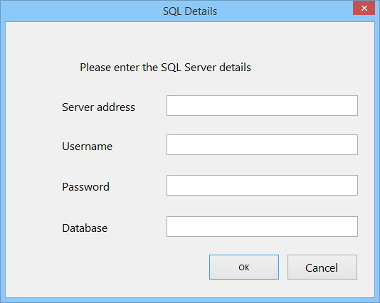The layout of the connection menu, along with the corresponding forms can be seen below

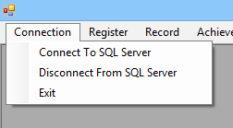

Closes program

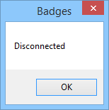

Register menu

The register menu and the corresponding forms can be seen below

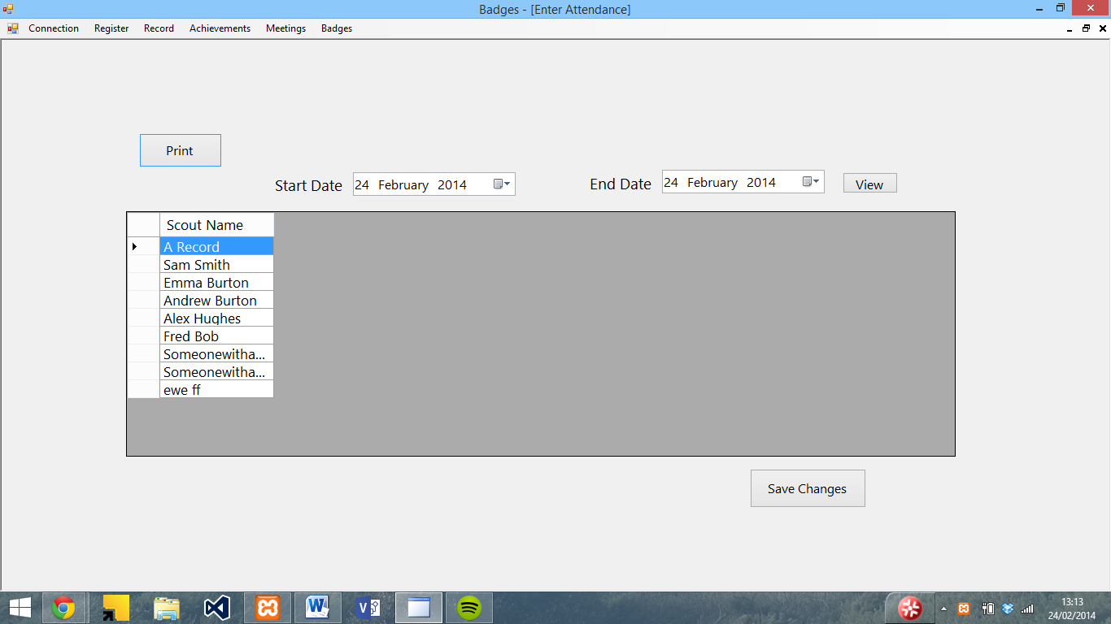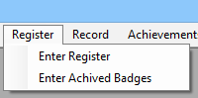

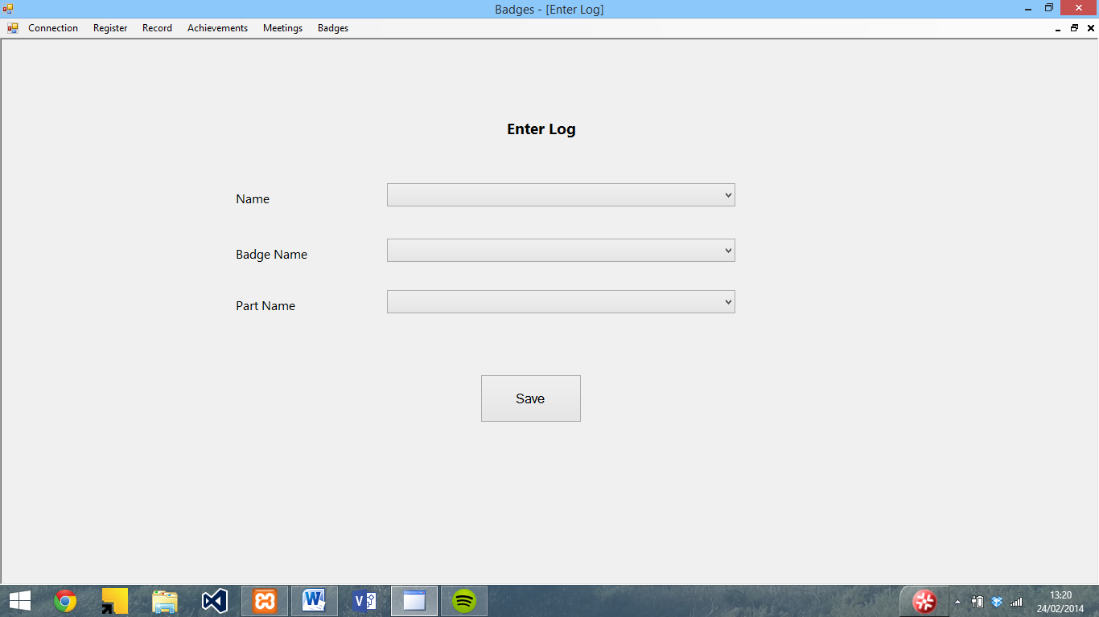

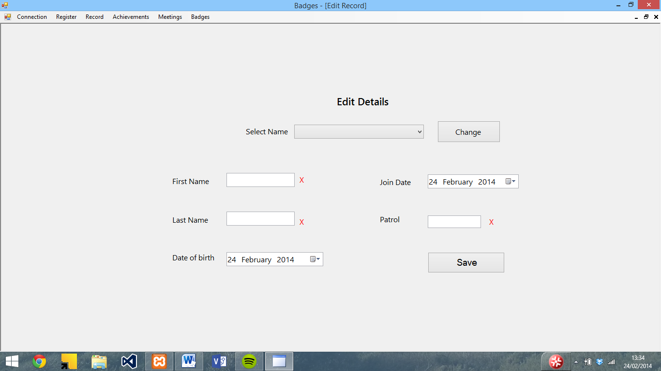Record menu

The record menu and corresponding forms can be seen below

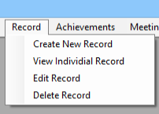

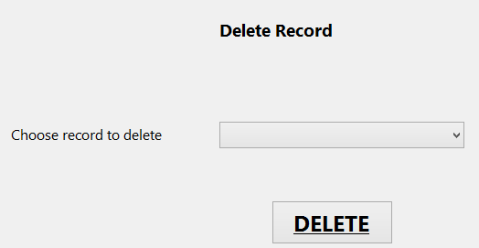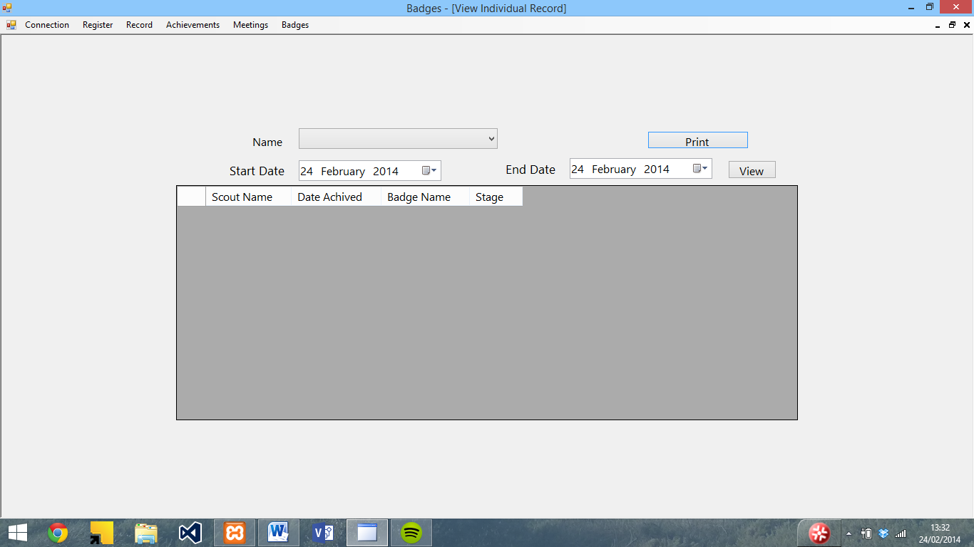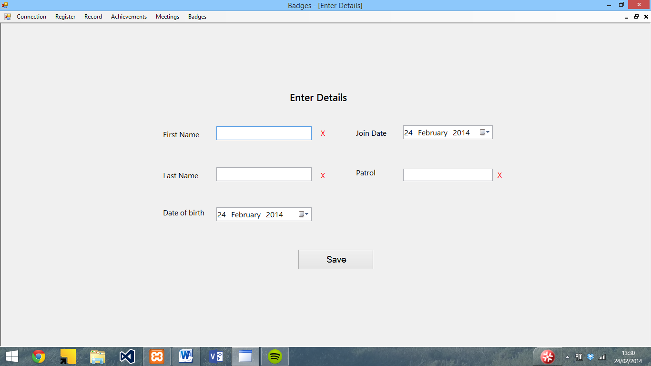

Achievements

The achievements menu and corresponding forms can be seen below

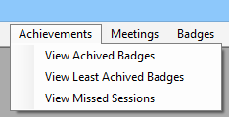

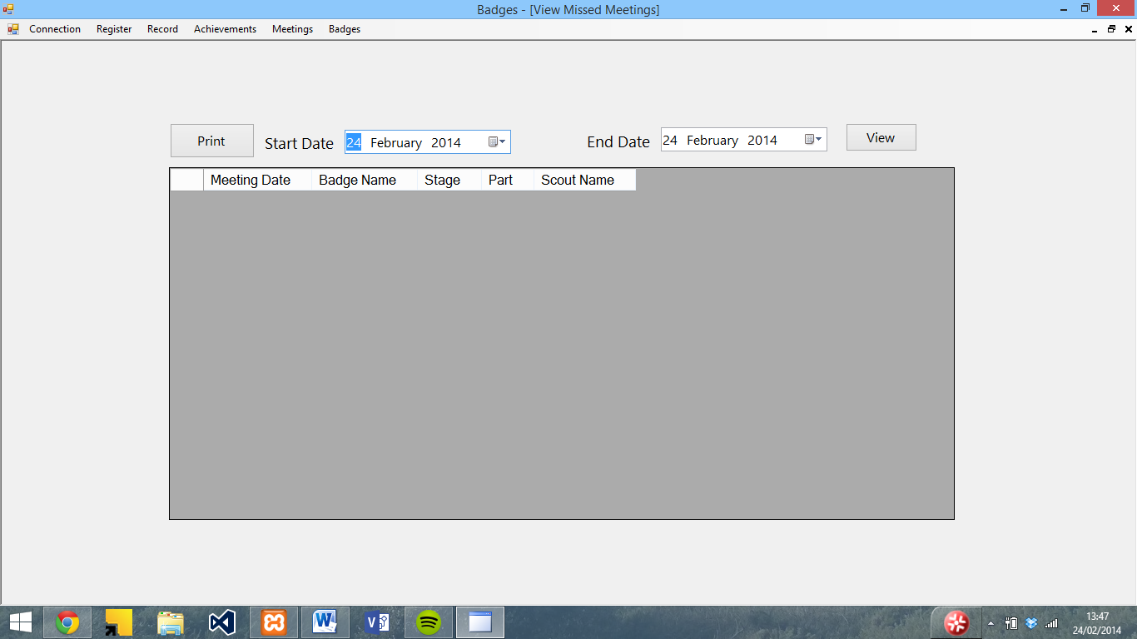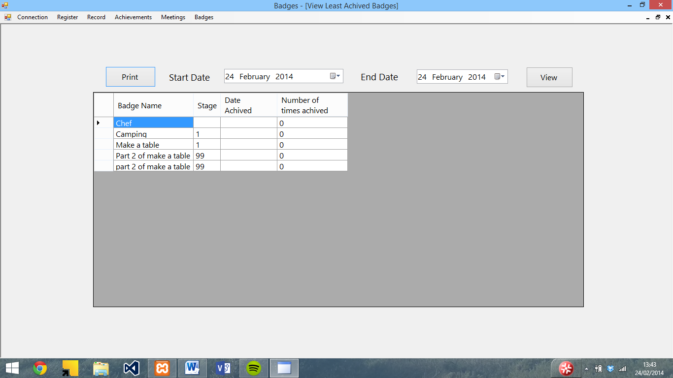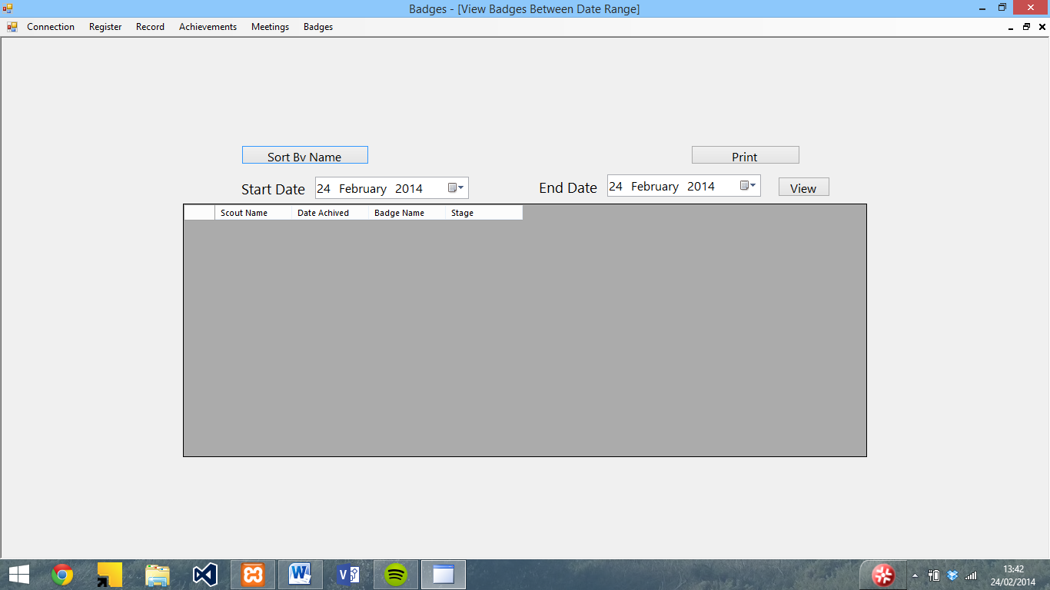

Meetings

The meetings menu and corresponding forms can be seen below

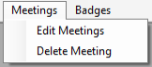

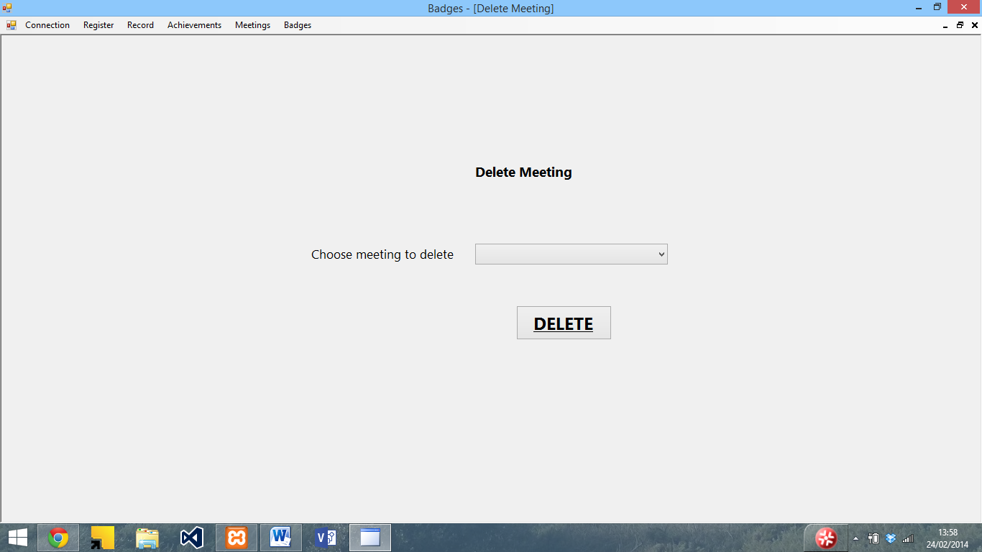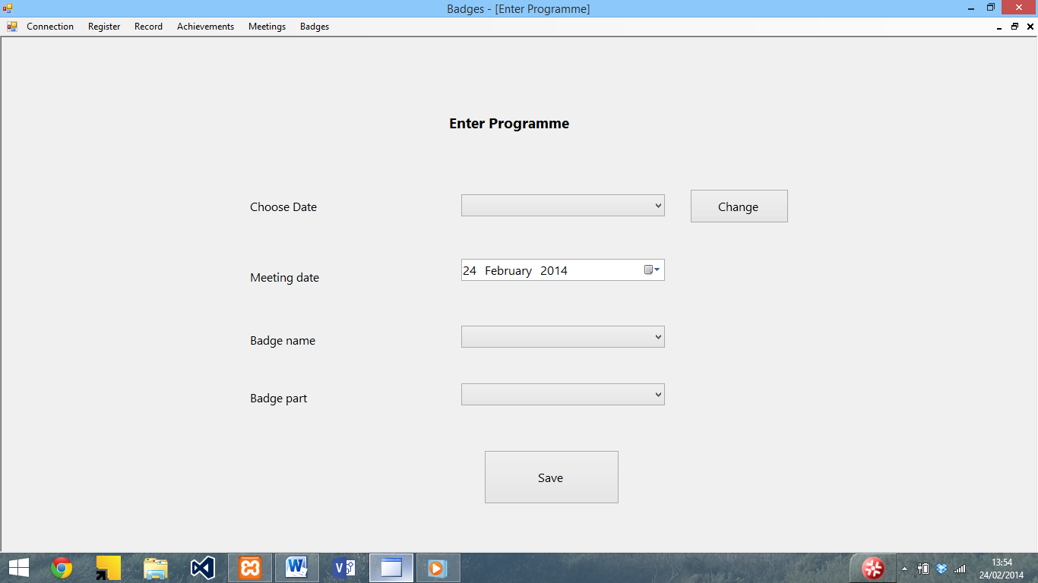

Badges

The badges menu and corresponding forms can be seen below

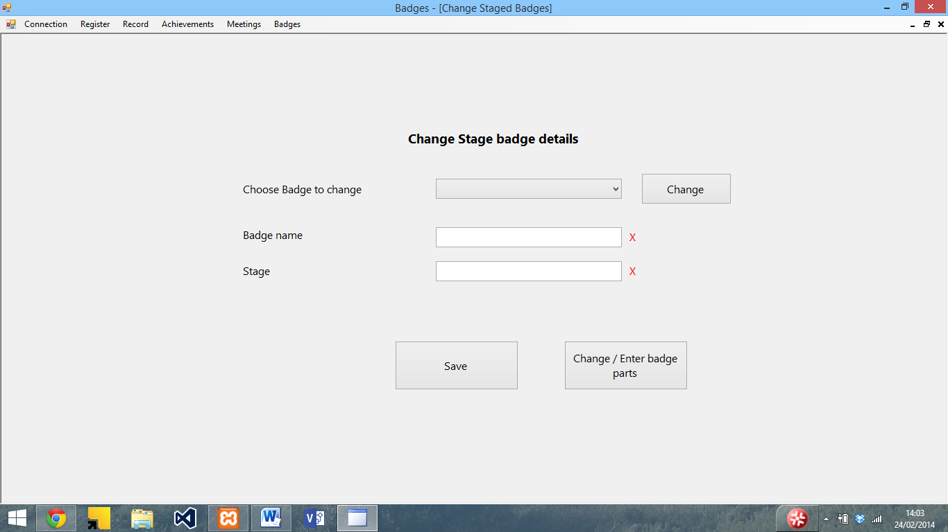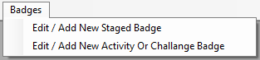

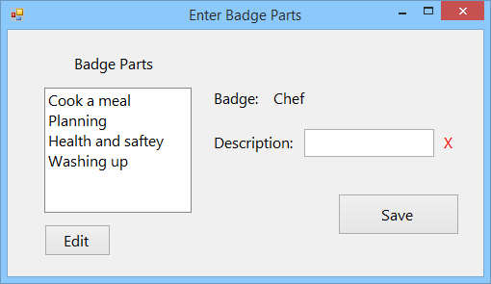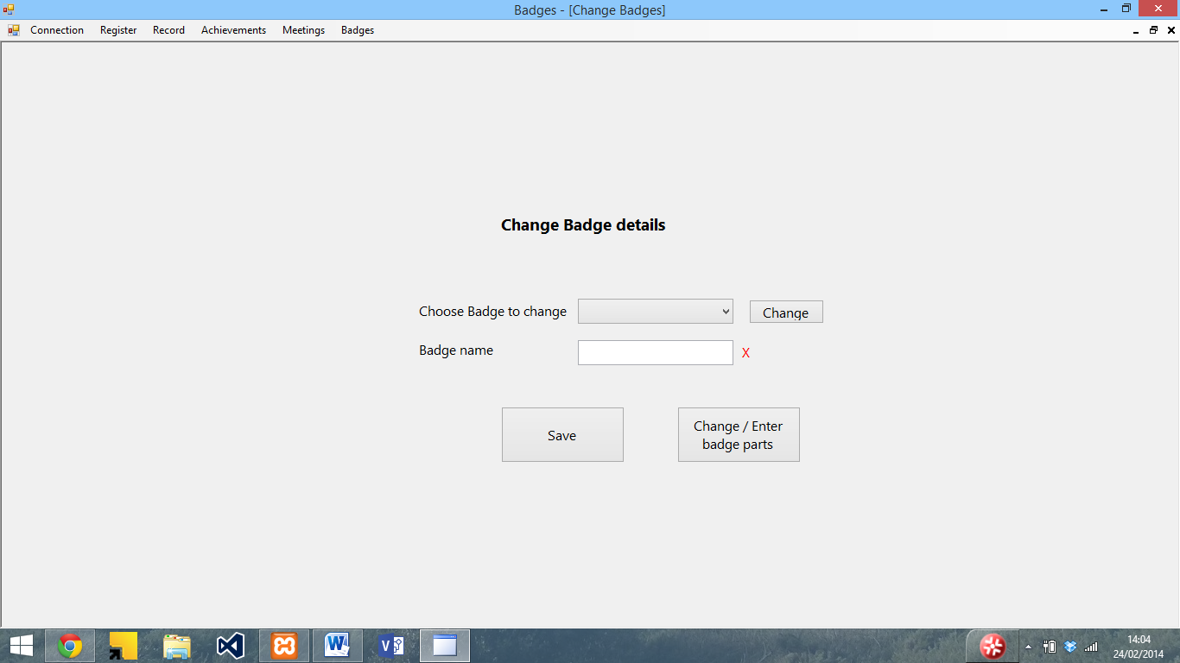

Installation instructions

Step 1: Disable your antivirus software temporarily. Although instructions for this vary, generally by right hand clicking on the logo in the bottom right hand corner, and then pressing shield control and then disable will disable it. (Whilst this software is not a virus, it tends to trigger antivirus software during installation as it is not a common program)

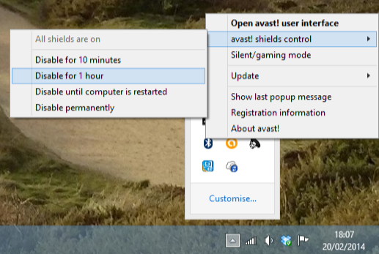

Step 2: Insert the installation CD into your computer and open the file browser (either labelled as Computer or This PC (depending on the version of windows you are running) and double click on the CD drive labelled badges. This will automatically run setup.

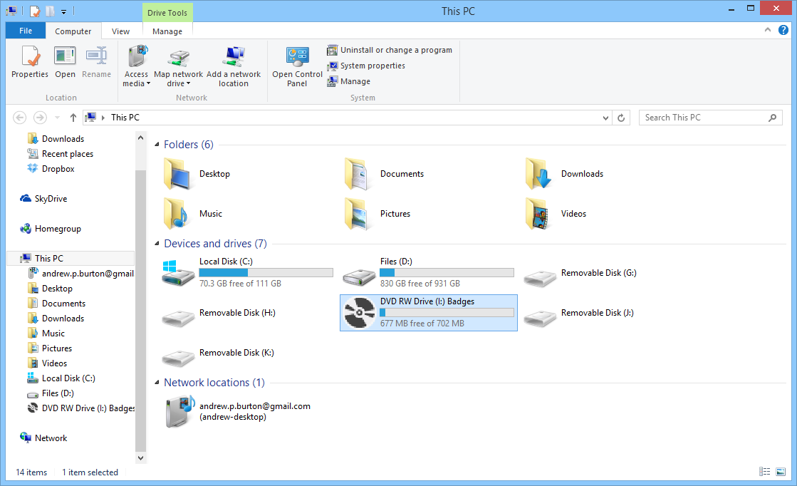

Step 3: (If you don’t see this, skip to step 4) When setup opens, you will be asked to accept the licence agreement for .NET framework. Read though this and if you accept press accept.

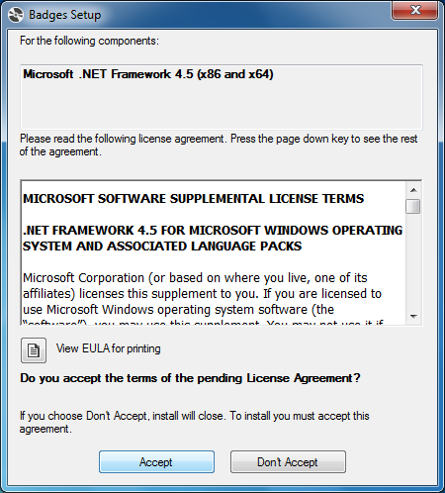

You will then be presented with a screen similar to the one below whilst the installer downloads and installs .NET framework. If you see a prompt asking if it can make changes to your computer, press Accept.

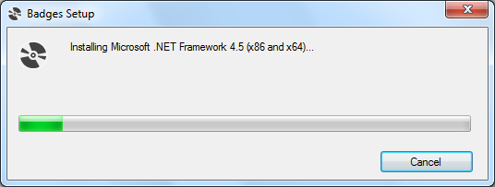

Step 4: Press install at the screen asking if you wish to run the application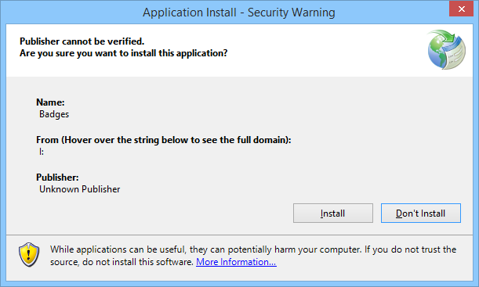

Step 5: The program will then install and then open. 

Step 6: Re–enable your antivirus by right hand clicking on it, and choosing enable (instructions vary depending on package used)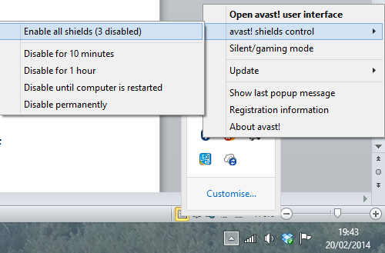

Uninstallation instructions

Step 1: Open the uninstall a program screen (steps to open this vary between versions of Windows) and double click badges from the list.

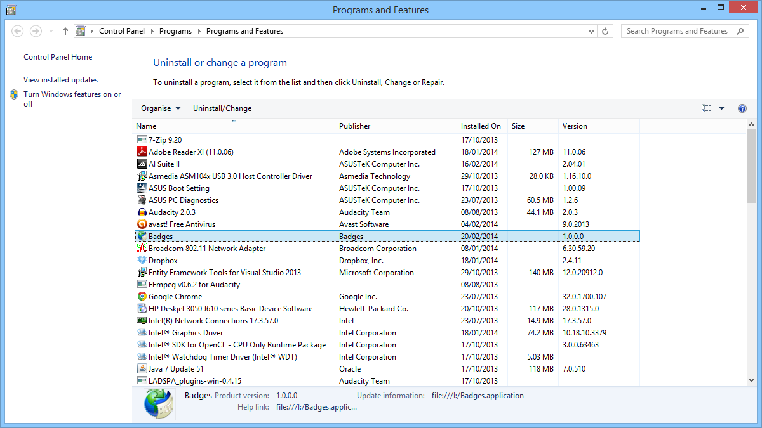

Step 2: On the screen which opens, select uninstall and press OK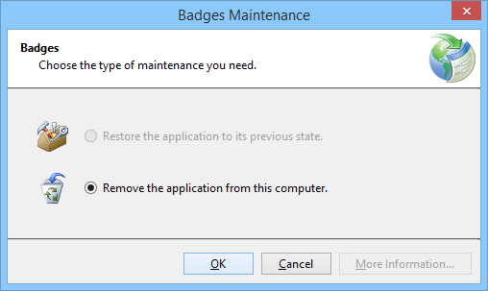

This will then completely uninstall Badges.

Opening badges and connecting to the SQL server

To open Badges, either double click on the shortcut on the desktop which will be created during install or open it from the badges folder in the programs menu

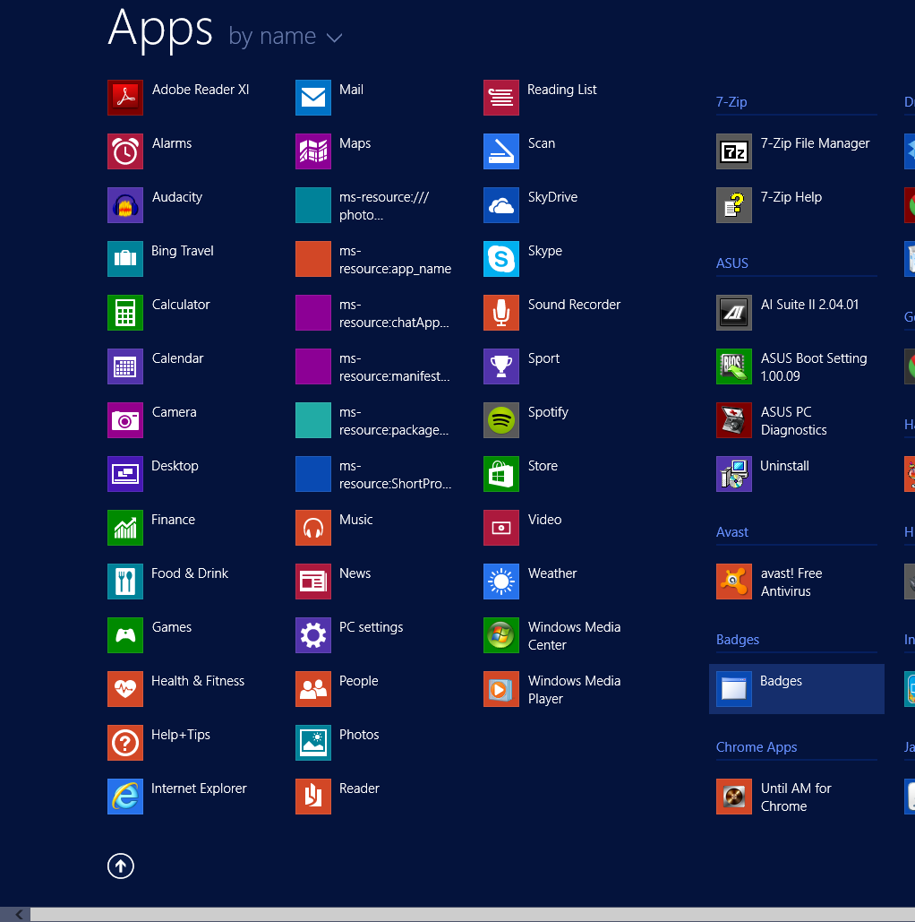

This will then open the main screen of the program.

This is the main screen for the program. Along the top is a file menu consisting of a Connection, Register, Record, Meetings and Badges.

Click on the Connection menu, and then press Connect to SQL server to connect to the server. You will then be presented with the following screen, in which you need to enter the details of the database server. Once these details have been entered, press OK

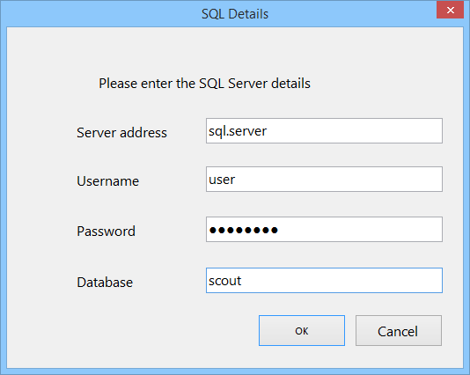

The program will then connect to the SQL server and display a confirmation once it has successfully connected.

Note: it is possible to have multiple databases for each user (the program will automatically create a database if the input one does not exist) and to have multiple users for each database

Disconnecting from the SQL server

To disconnect from the SQL server, choose disconnect from SQL server from the connection menu. This will display the following confirmation.



The program will also automatically disconnect when the Exit button from the connection menu is pressed or when the program closes.

Closing forms

This program uses forms within the main form. To close a form after use without closing the main program, use the little x in the top right hand corner

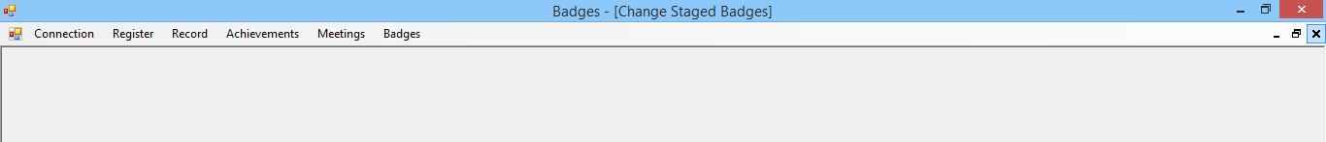

Adding badges

To add a badge to the system, from the badges menu choose either Edit / Add new Staged Badge or Edit / Add new Activity or challenge badge depending on the badge type.

Stage badges

If you press staged badge, you will be presented with the following screen.

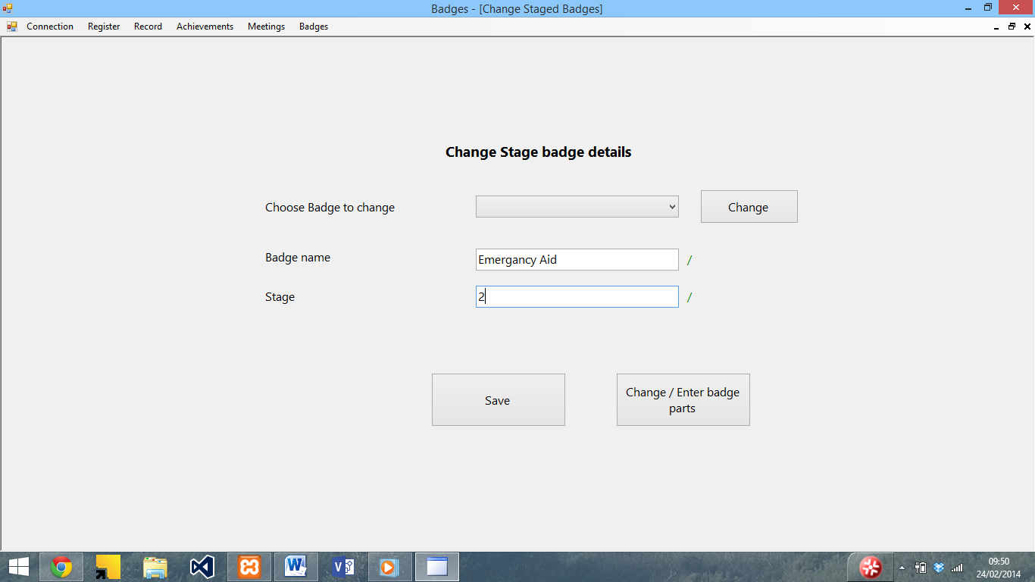

To add a new badge, enter the badge name into the badge name box and the stage into the stage box. The / or x to the right of the box will let you know if the input is valid (Characters which are not a-z or 0-9 are not allowed for the name and only numbers are allowed for the stage).

Once you have input the details of the badge, press the save button to save the badge, and a confirmation will be displayed.

Non – staged badges

Similarly to the staged badge screen, upon pressing the Edit / Add new Activity or challenge badge button the following screen will be displayed.

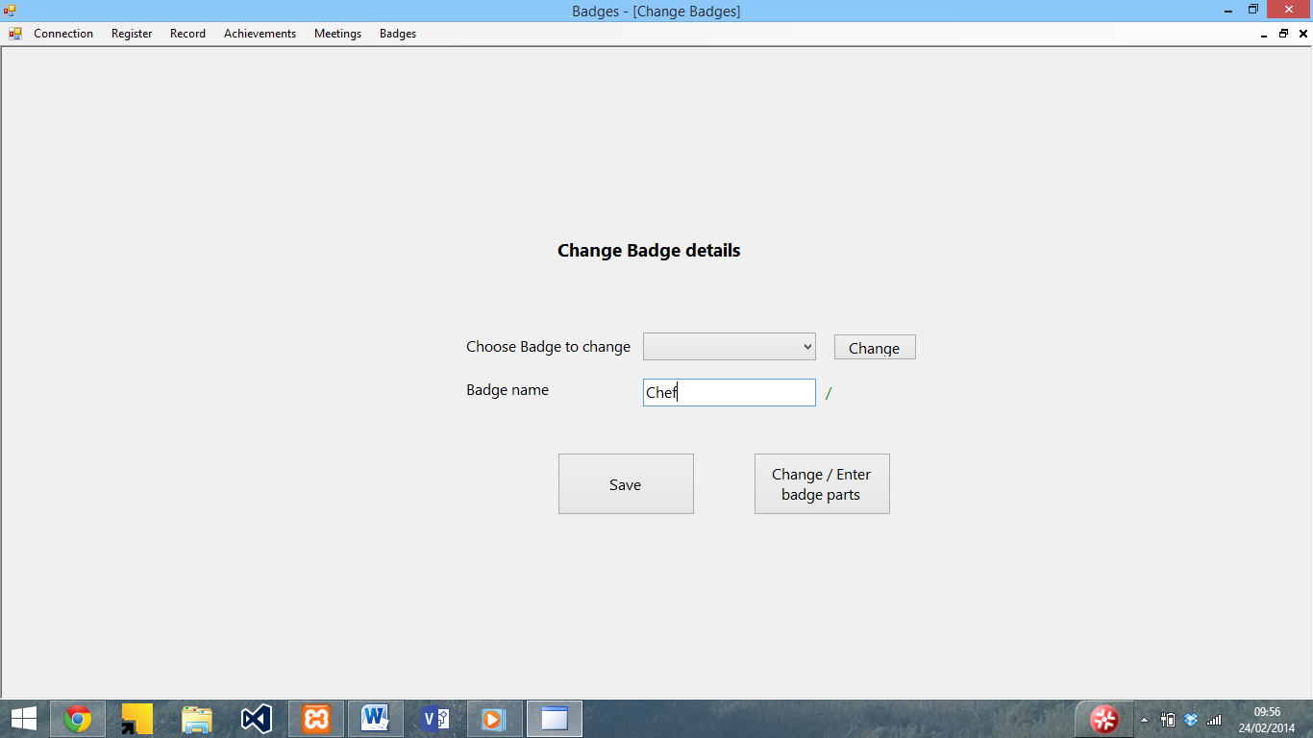

To add a new badge, simply enter the name of the badge into the box and press save. The / or x to the right of the box will let you know if the input is valid (Characters which are not a-z or 0-9 are not allowed). If the input is valid, the badge will save and a confirmation will be displayed when the save button.

Adding Badge parts

To add the criteria for each badge, once the badge has been saved press the Change / Enter Badge parts. The following screen will then be displayed.

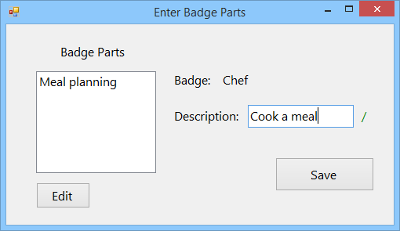

To add a new part, enter a description into the description box, and then press save. The part will then be displayed in the list to the left. The / or x to the right of the box will let you know if the input is valid (Characters which are not a-z or 0-9 are not allowed).

Editing badges

To edit the details of a badge, from the badges menu choose either Edit / Add new Staged Badge or Edit / Add new Activity or challenge badge depending on the badge type.

Staged badges

You will be presented with this screen. From the dropdown list, select the badge you wish to edit and then press edit.

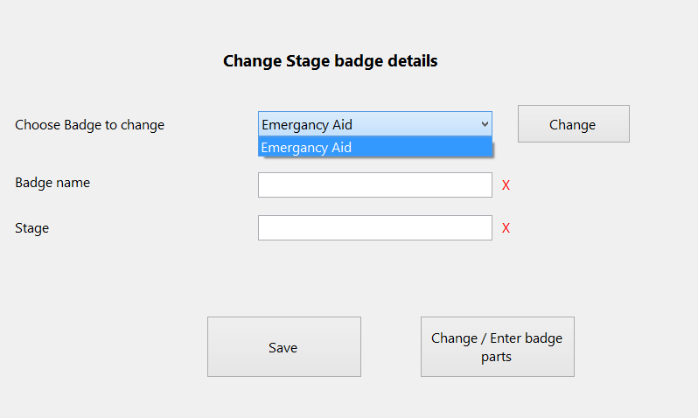

The textboxes will then be filled with the badge details for editing. The badge is saved in the same way as adding a badge.

Non – staged badges

Other badges are edited by using the Edit / Add new Activity or challenge badge button from the badges menu. The editing process is the same as for a staged badge.

Editing parts

To edit the parts for a badge, follow the instructions to edit the badge to select it. Once the boxes contain the details of the badge, save it and select the parts button. The following screen will then be displayed.

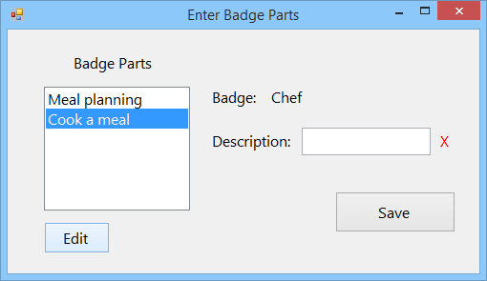

To edit a part, select the part you wish to edit and then press edit. The description box will then be filled with the name of the badge for you to edit. To save the part, press the save button.

Adding a meeting

To add a meeting, select Edit Meeting from the meeting menu. The following form will then be displayed.

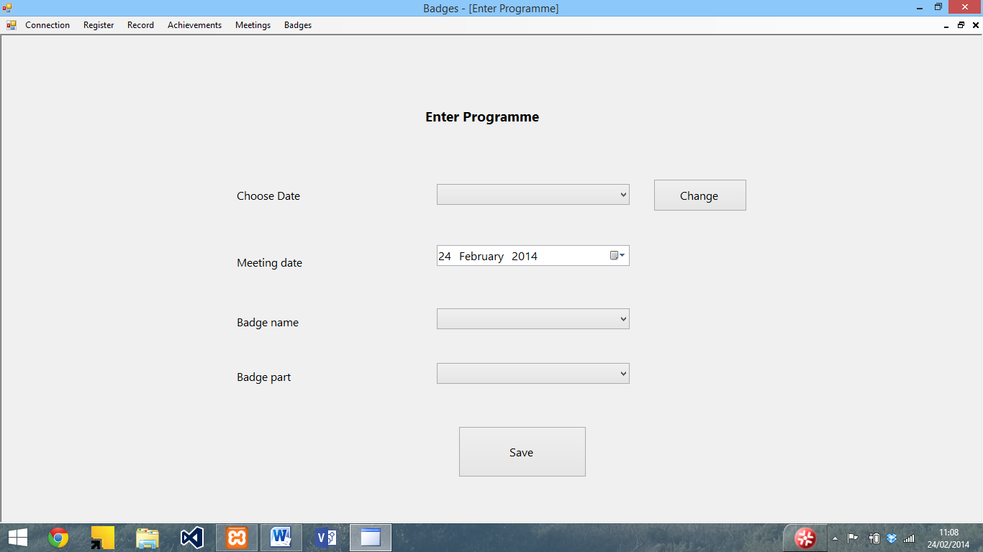

Enter the meeting date (see below) and select the badge name and part from the dropdown list (you will not be able to select a part without selecting a badge)

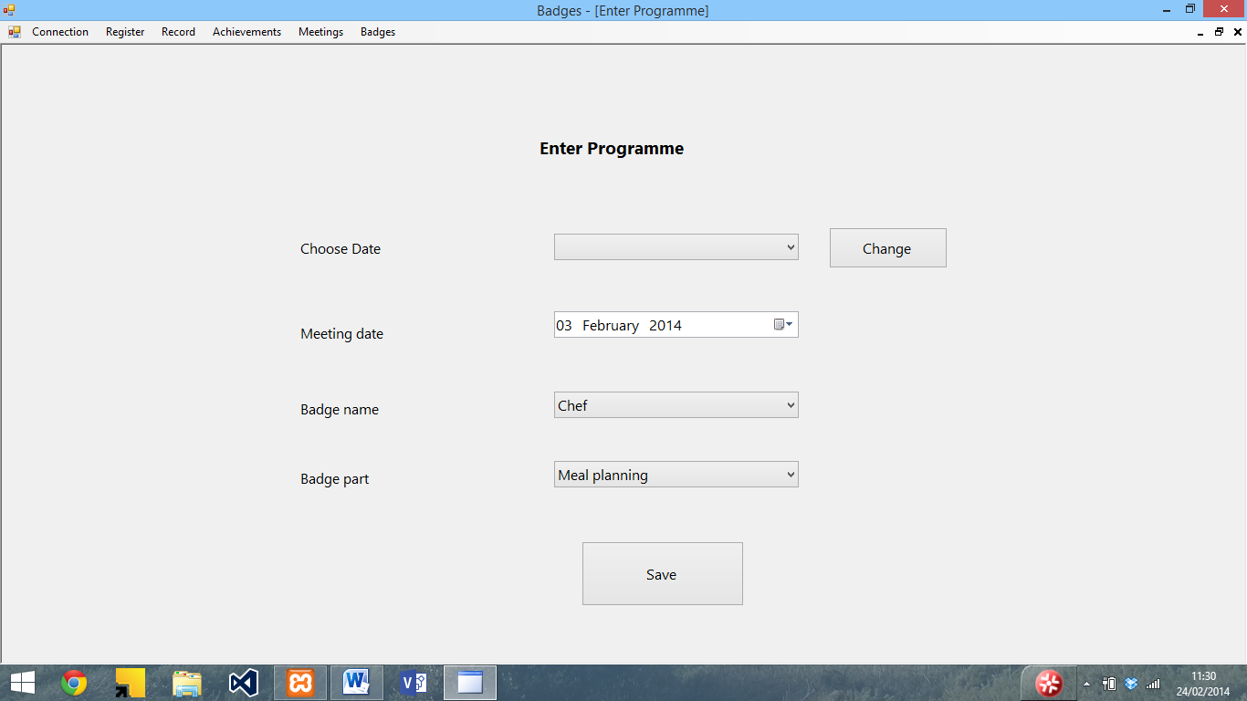

Once you have entered the badge name and part press save. A confirmation will then be displayed.

Editing a meeting

To edit a meeting, choose edit meeting from the meeting menu. In the screen that appears, choose a meeting date to edit.

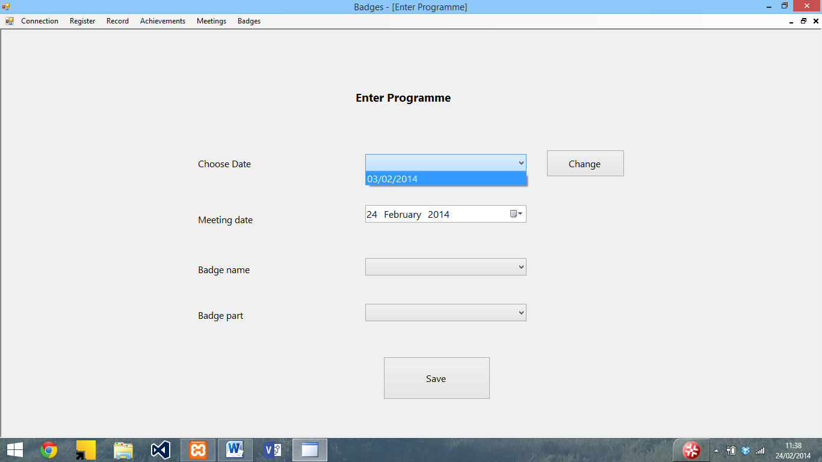

To change the date, press the change button. The boxes will then be filled with the details of the meeting, which can be edited in the same way as adding a meeting.

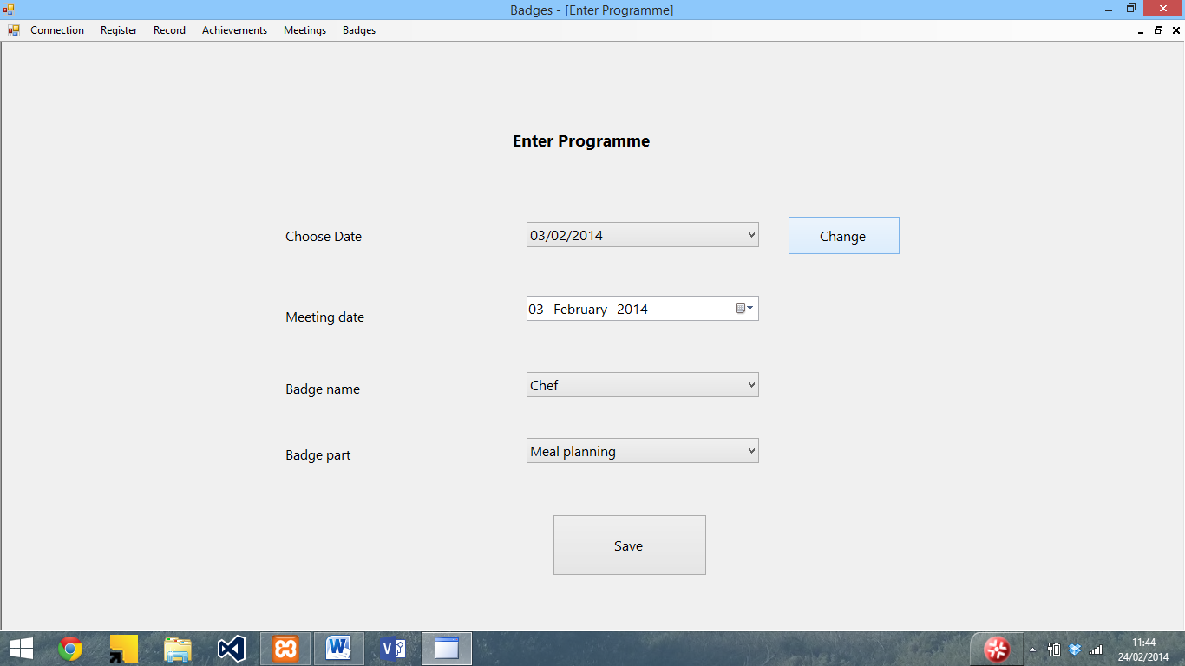

Entering dates

To enter a date, click on the calendar item next to the date box and use the arrows to navigate the month. To select the date, click on it.

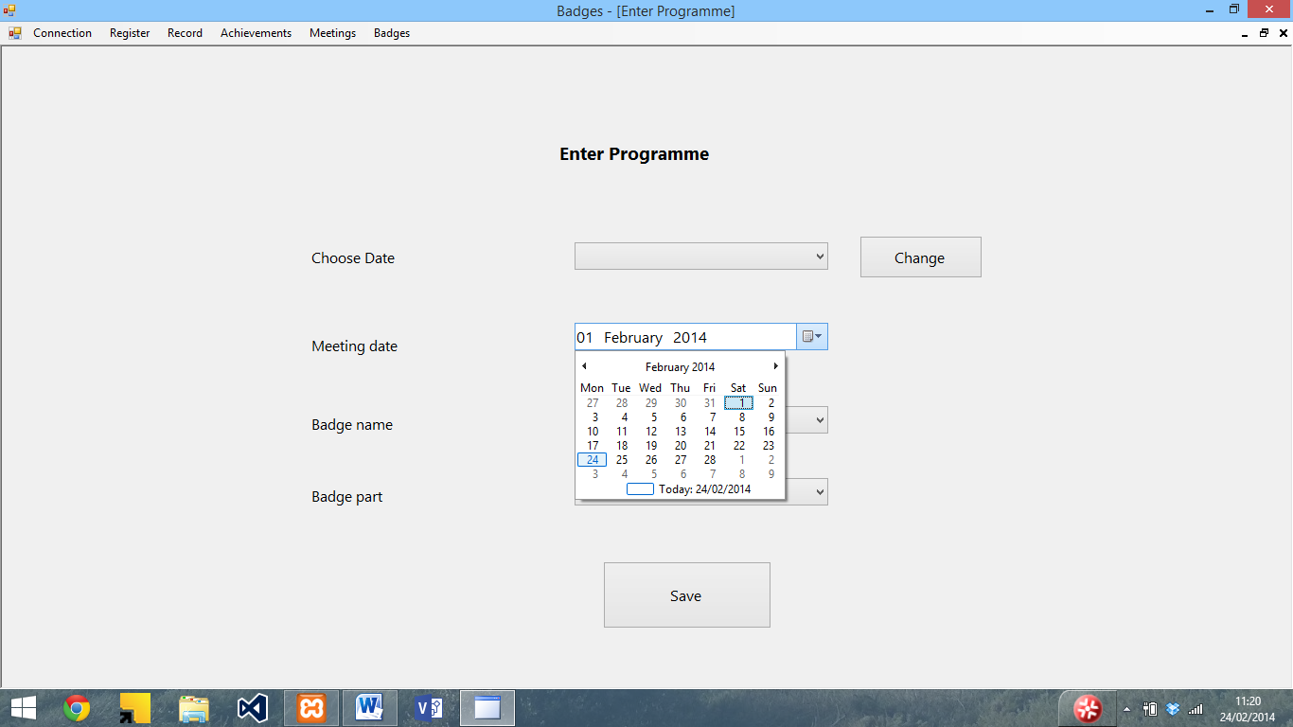

Deleting meetings

To delete a meeting, select delete meeting from the meeting menu. The following screen will then be displayed.

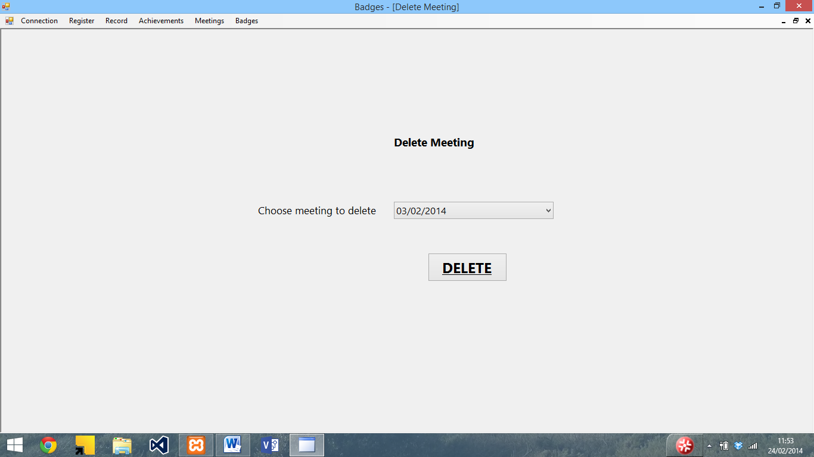

To delete a meeting, select the date from the list and press delete. The following confirmation will then be displayed

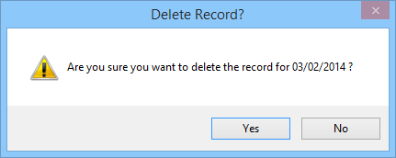

If you wish to delete the meeting, press yes. The following prompt will then be displayed.

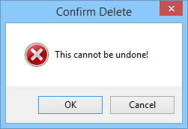

To delete the meeting, press OK. Once this is pressed the delete cannot be undone. To cancel the delete, press cancel. Upon pressing OK, the record will be deleted and a confirmation of the delete will then be displayed.

Enter record

To create a new record, select Create New Record from the record menu. The following form will be displayed.

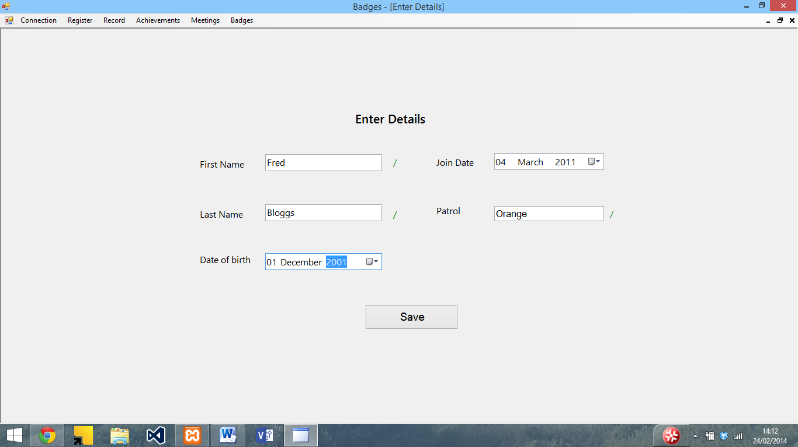

Enter the details into the system (see the entering dates section for entering dates). The / or X show whether the input is valid or not for the name and patrol boxes (only a-z and capitals are allowed). Once the details have been input, press the save button to save the details, and a confirmation will be displayed.

Editing a record

To edit a record, select the edit record button from the menu. The following screen will then be shown

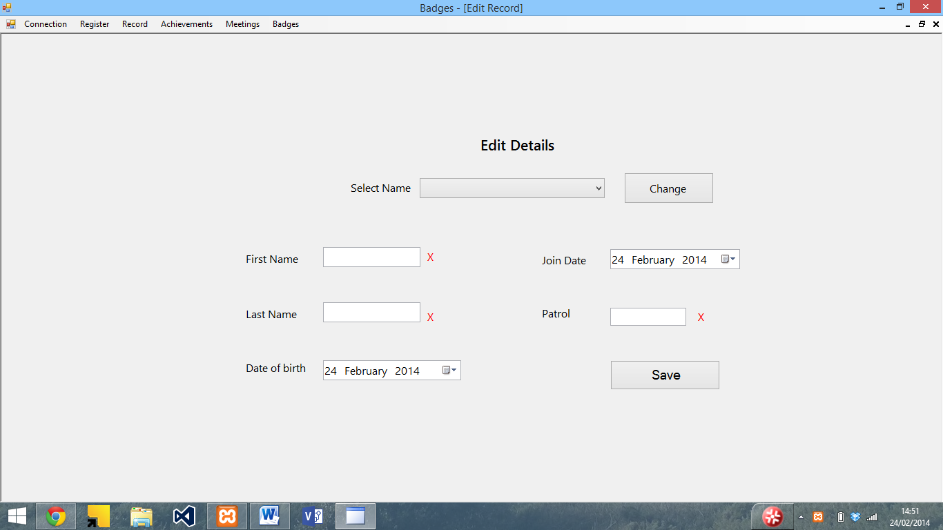

To edit a record, select the name from the drop down list, and press change. The boxes will then be filled with the details of that person

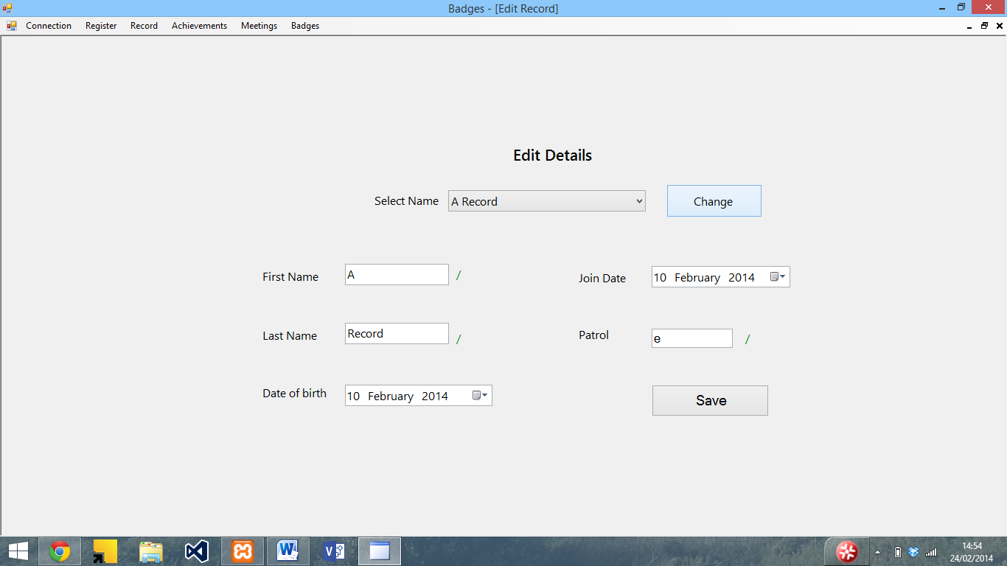

The record can then be edited in the same way as adding a new record.

Delete record

To delete a record, select the delete record button from the record menu. The following screen will then be displayed

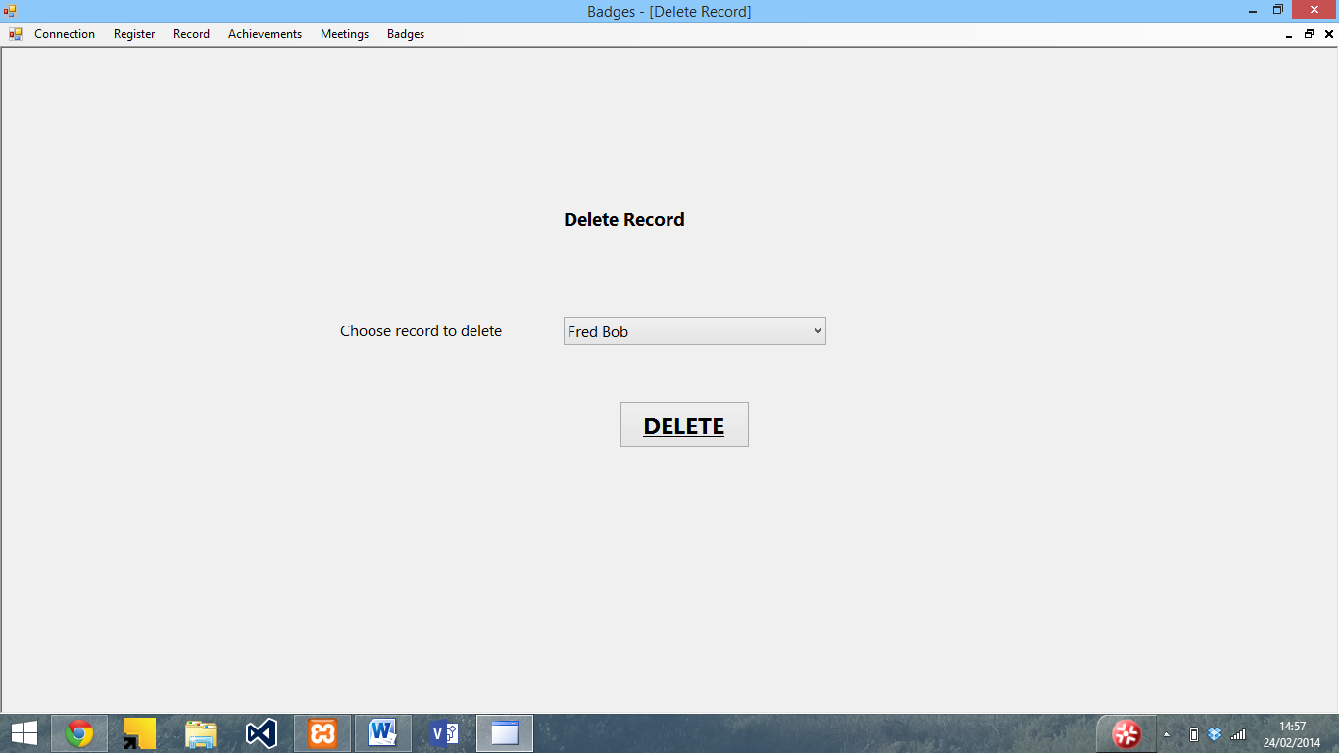

To delete a record, select the person from the dropdown list and press the delete button. The following message will then be displayed.

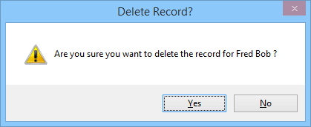

To delete the record, press the yes button. A message to warn you that it cannot be undone will then be displayed.

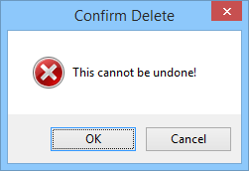

If the Ok button is pressed, then the record will be deleted and a confirmation will be displayed.

View individual record

To view an individual record, select the view individual record button from the record menu. The following screen will then be displayed.

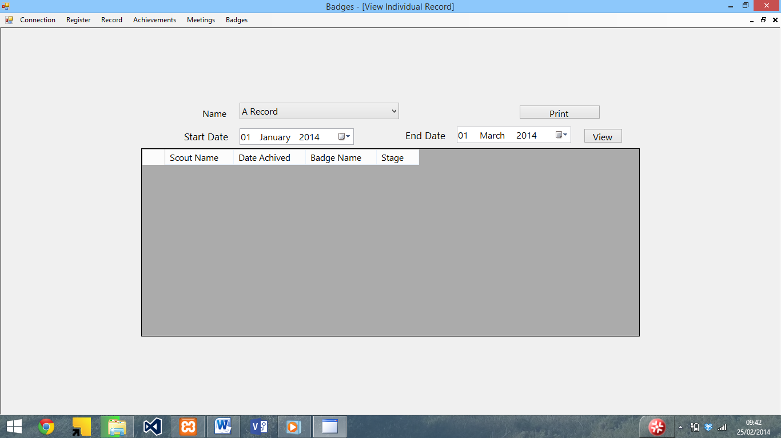

To view a record, select a name from the drop down list and a date range, and press the view button.

The badges achieved by that person will then be displayed

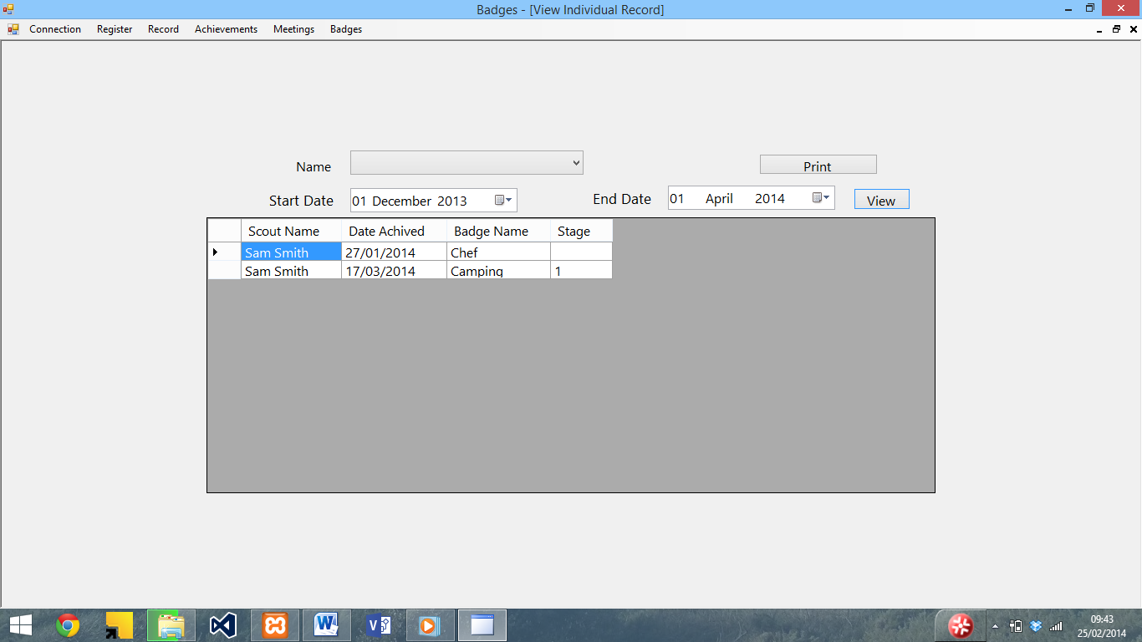

To print the view, press the print button (see printing forms for more on this)

Enter register

To enter the register, select the Enter Register button from the register menu. The following screen will be displayed

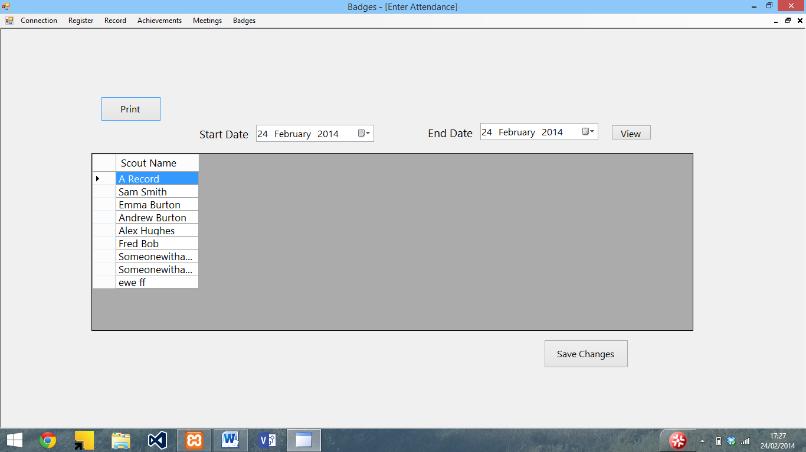To enter the register, select the date range using the start date and end date boxes and press view. The meetings between that date range and the attendance will be displayed

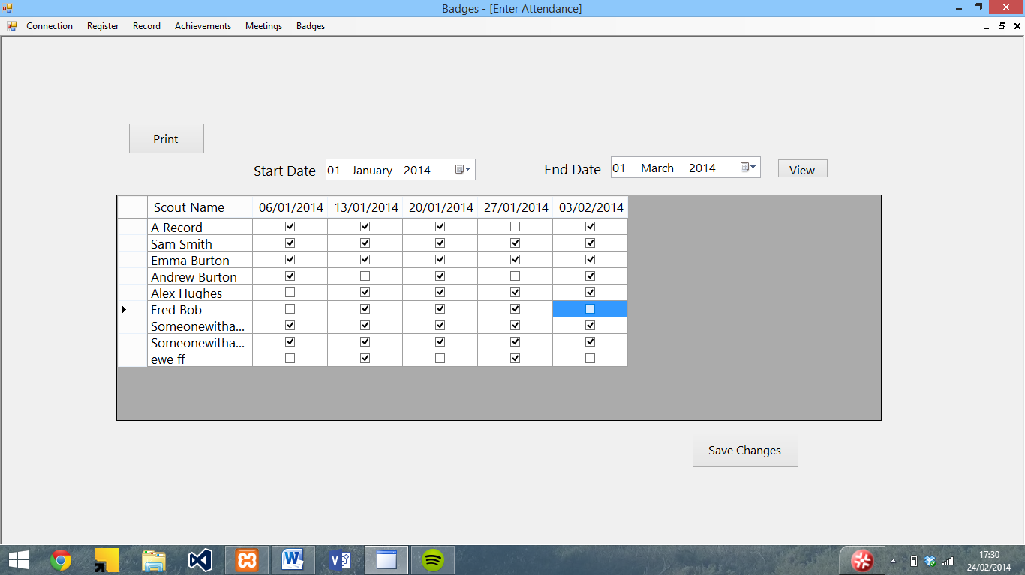

To edit the attendance, tick or untick the boxes (ticked means there) and press save to update the database. A confirmation message will then be displayed.

Printing forms

The enter attendance, View individual record, View missed meetings, View achieved badges and View least achieved badges all allow you to print what is being displayed. To do this, press the print button on the form. A dialogue box will then appear allowing you to set the printer and number of copies.

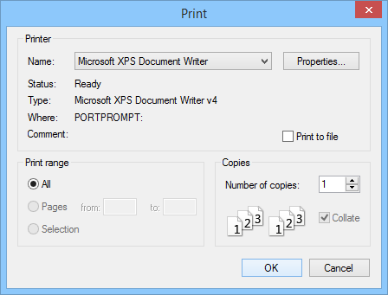

Once the OK button is pressed, a preview of the printout will appear. To print it, press the print button in the top left hand corner.

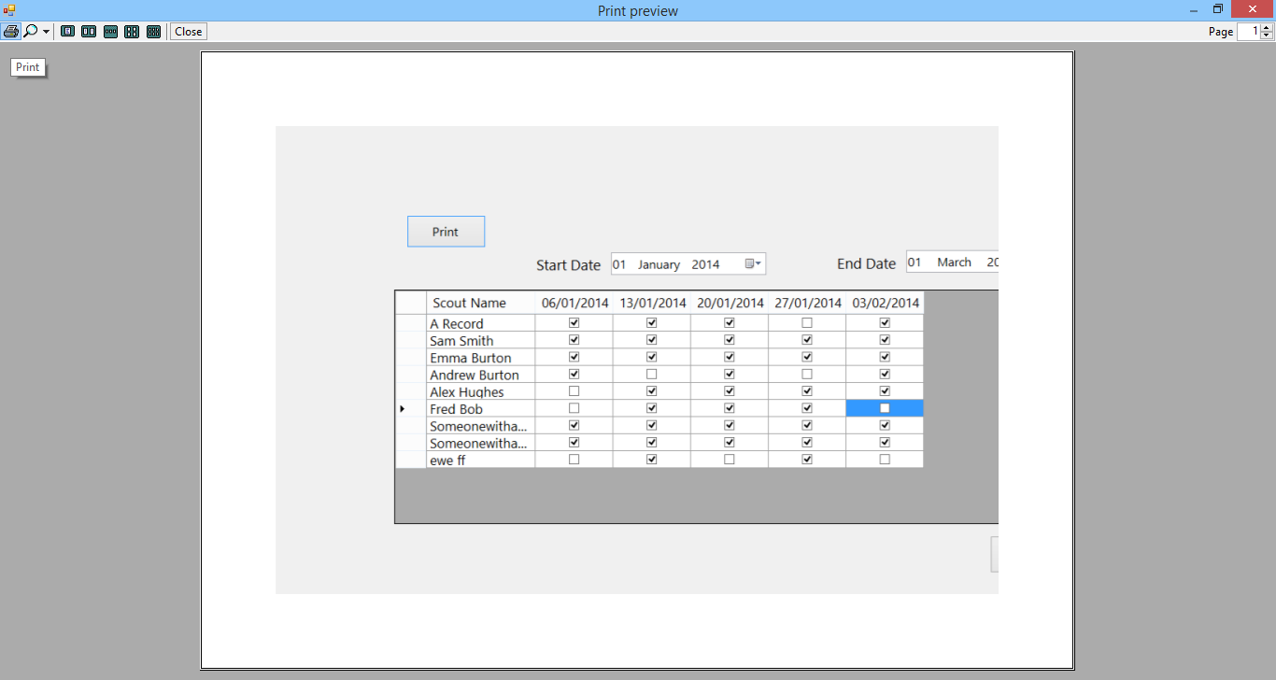

The selected printer will then print the view

Enter achieved badges

To enter achieved badges manually, select enter achieved badges from the register menu. The following screen will then be displayed.

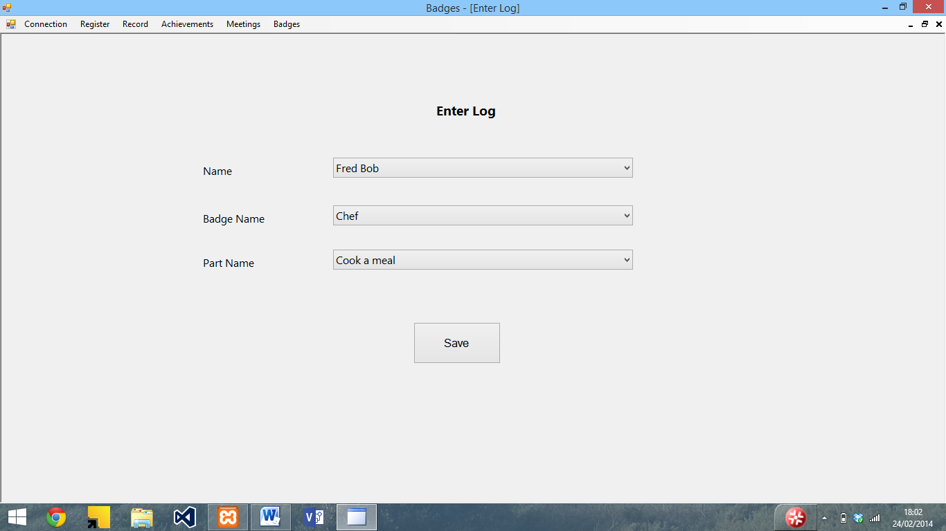

To enter the details, select the Scout name, badge name and part name from the lists (the badge needs to be selected before selecting the part). Once the details have been selected, press save. A confirmation will then be displayed.

View achieved badges

To view the achieved badges, select view achieved badges from the Achievements menu. The following screen will then be displayed

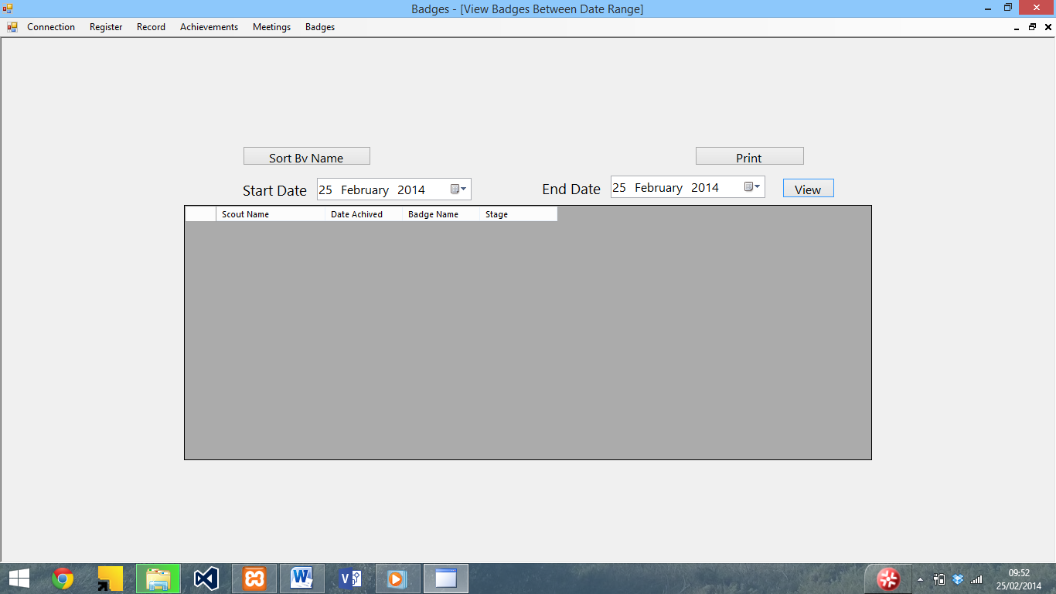

To view the achieved badges, select the date range and press view. The achieved badges will then be displayed

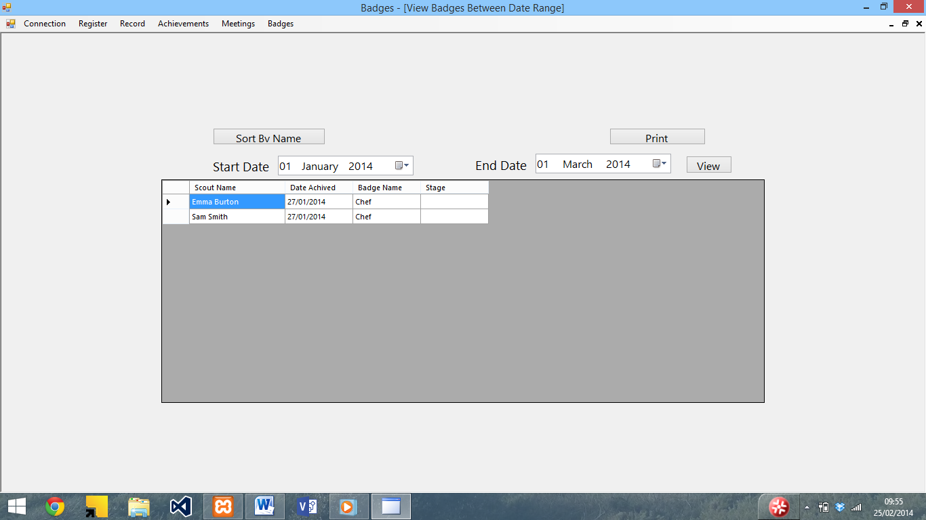

To sort the view, use the sort by name button at the top. It is also possible to print the view using the print button (see printing forms for instructions).

View least achieved badges

To view the least achieved badges, select View Least achieved badges from the Achievements menu. The following screen will be displayed.

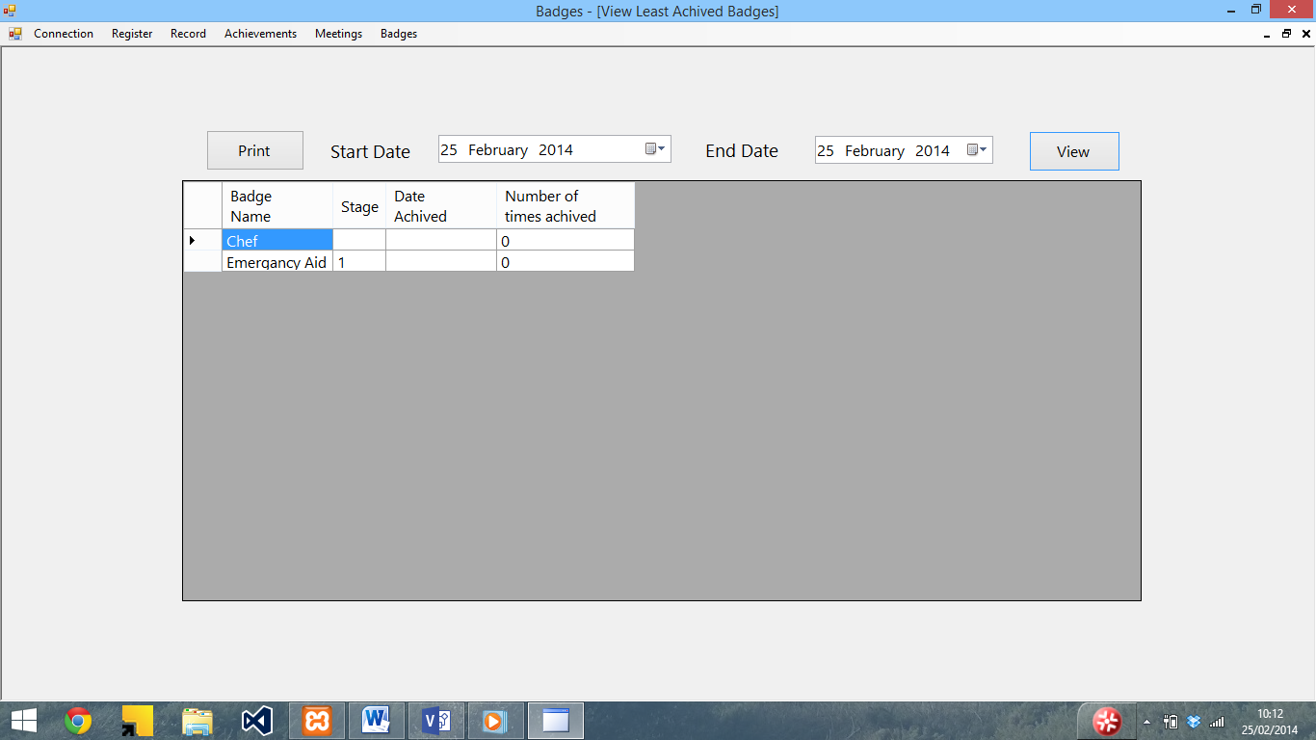

To view the number of times achieved and date last achieved, enter a date range using the boxes at the top, and press the view button. The date achieved and number of times columns will then be filled

It is also possible to print the view using the print button. See printing forms for more on this.

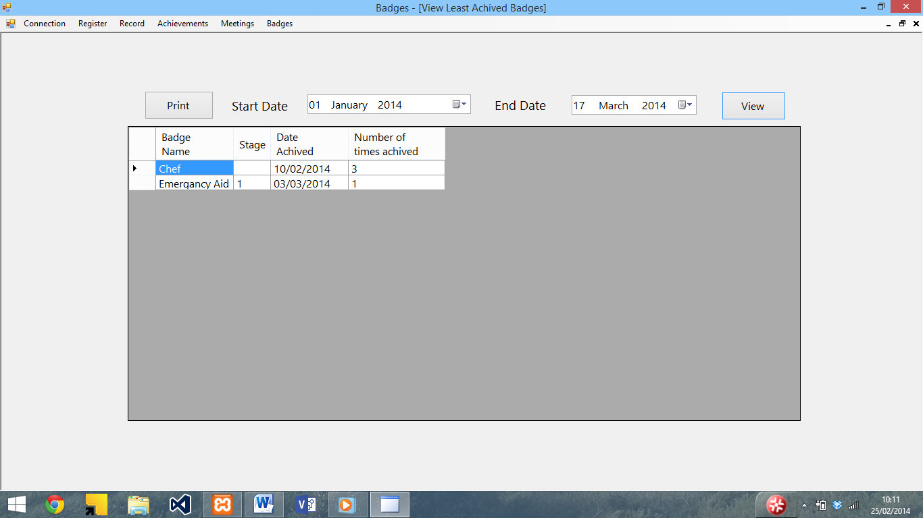

View missed sessions

To view missed sessions, select view missed sessions from the achievements menu. The following screen will then be displayed.

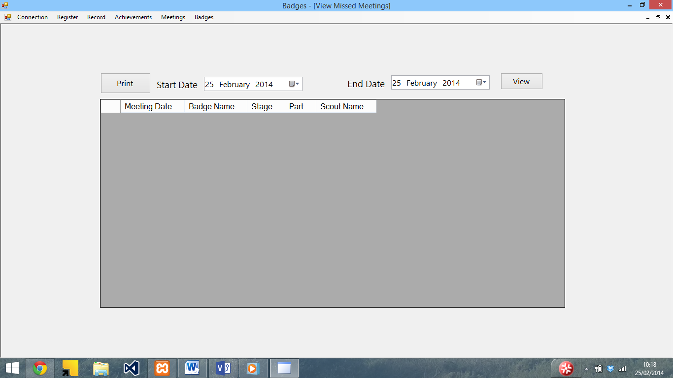

To view missed meetings, enter a date range using the date range boxes and press view. The meetings, along with absent Scouts’ names will be displayed.

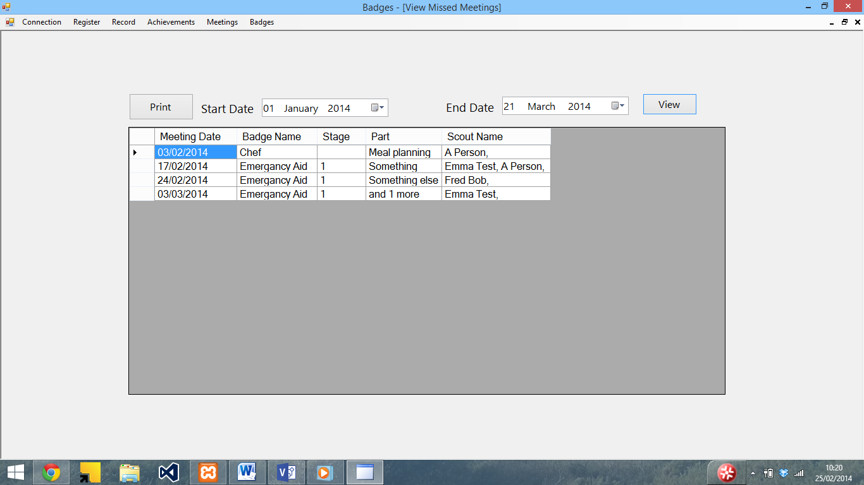

To print the view, press the print button (see printing forms for more on this).

Error messages and troubleshooting

This section contains the error messages within the program and details of how to resolve them.

|  |  |
| --- | --- |
| Error | Description |
|  | (Connect to SQL server) The SQL server details are incorrect. Check that the details (Address, Username, Password, and Database) are correct and try again. |
|  | (Connect to SQL server) You are already connected to the SQL server and don’t need to connect again. |
|  | (Enter achieved badges) You need to select a name, badge and part before saving. Ensure that you have selected a name, badge and part and try saving again |
|  | (Enter details / Edit details (similar error message for Enter and edit details)) You need to enter a valid first name / last name / patrol. Ensure that the details have been input and are valid (see section in user guide for valid inputs) |
|  | (View individual record) You need to select a name to view a record. Select a record and press view to solve this |
|  | (Delete record) You need to select a name before you delete it. Select a name from the list and press delete to solve this. |
|  | (Enter Programme) – You need to select a badge and part before saving a meeting. Ensure that a badge, part and date are selected and try saving again. |
|  | (Delete meeting) – You need to select a date before it can be deleted. Select a date and try deleting it again. |
|  | (Enter / Add new Staged badge and Enter / Add new Activity or Challenge badge) – The badge name needs to be valid before saving – Ensure that the name / stage have been entered and are valid (see section in user guide for valid inputs) |
|  | (Enter / Add new Staged badge and Enter / Add new Activity or Challenge badge) – The badge needs to be saved before the parts are edited. Save the badge and then press edit parts to edit the parts |
|  | (Enter badge parts) – The badge description needs to be valid before saving. Ensure that the description have been entered and are valid (see section in user guide for valid inputs) |
|  | (Entire program) – You need to connect to the SQL server before using this section. Use the connect to SQL button in the Connection menu to do this, and you will the be able to open the form. |

# Comparison with original objectives

Below I have compared the final system with the original objectives that I set out in the analysis.

1. To be easily useable

Met – All of the system is clearly labelled and a complete user guide is available as well.

* 1. The end user must be able to navigate to all of the functions within 4 mouse clicks.

With the exception of enter parts (which require more clicks to select the badge) this has been met.

* 1. Inputs need to provide instruction and validation to ensure the system doesn’t crash

This has been met – all of the inputs have labels descriptions and the system has a complete user manual. There is also validation for all of the inputs to ensure that they will not crash the system.

* 1. There must be adequate documentation in order to ensure that this happens. This must be ready at the same time as the program.

This has been met – The system has a full user manual which is ready at the same time as the system

1. To be able to store the attendance data

This has been met – the user is able to enter the attendance data into the system which then stores it for later viewing

* 1. The end user must be able to enter the attendance data into the system with no more than 2 clicks per record

This has been met – the attendance requires one click of a tick box to enter for each record

* 1. This data must then be stored for future use as soon as the user presses save

This has been met – the attendance data is stored in the database as soon as the user presses save

1. To be able to store details of the achieved badges

This has been met - The user can manually enter achieved badges as well as entering attendance for meetings which automatically updates the achieved badges record.

* 1. The end user must be able to enter in the achieved badges

This has been met – the user can manually enter achieved badges as well as the register

* 1. This will then need to be stored with the persons record as soon as the end user presses save

This has been met – the Log table is updated with the achieved badge part

1. To be able to see which badges have been achieved based on attendance

This has been met – the user can use the view achieved badges function to see the achieved badges based on attendance and manually entered achievements

* 1. The end user must be able to enter the attendance register each meeting

This has been met – the user can enter the attendance for each meeting

* 1. The system must be able to determine the attendance for each session, along with the parts of badges within 15 seconds of the end user loading the section

This has been partially met – the attendance for each session is displayed within 1 second of the section loading (tested on a dual core laptop) although the badge part for each meeting is not displayed next to the meeting date in the enter attendance screen.

* 1. The system must then be able to produce an achieved badges list which the user can then print

This has been met – the system is able to produce a list of achieved badges which can be then printed

1. To be able to print achieved badges lists

This has been met – the system is able to produce lists of achieved badges which can then be printed

* 1. The system must be able to produce an achieved badge list for the end user

This has been met – the system can produce a list of achieved badges from the achieved badge parts

* 1. The end user must then be able to print this list for reference if they want to

This has been met – the user and print the list of achieved badges

1. To be able to view and print record cards

This has been partially met – the user can view achieved badges for an individual person

* 1. The end user must be able to view a list of all the badges each person has achieved similar to the record card used in the existing system

This has been partially met – the user can view the all the badges each person has achieved, although it does not list all of their details and the badges they have not achieved.

* 1. The end user must then be able to print it

This has been met – the user is able to print the list of achieved badges for each person

1. To see which sessions have been missed in order to work out which stages to run

This has been met – the user is able to view which sessions have been missed and by whom.

7.1 The system must be able to work out which scouts missed meetings between a date ranges. The system must be able to calculate this within 15 seconds

This has been met – the user can enter a date range to view and the missed sessions will be displayed. The system can typically do this in less than one second (dual core laptop)

7.2 The system must then be able to determine which badges were being done on those dates and produce a list of people who missed the sessions sorted by date

This has been met – the system displays details of the badges which were being done at the meetings as well as the people who were not there.

1. To see which parts of a badge have not been achieved in order to assist in programme planning

This has not been met – the program is not able to produce a list of parts.

* 1. The system must be able to produce a list of the badges sorted by number of achieved times based on the badges database

Partially met – the system is unable to produce a list of parts, although it is able to produce a list of achieved badges

1. To be able to modify the badges to enable new badges to be entered / requirements to be updated

This has been met – the badges can be added to or edited at any time

9.1 The end user must be able to modify the badge details as well as being able to add and remove badges. This must be able to be done within the main programme

Partially met – the user is able to add and edit badges within the main program, although it is not possible to delete them within the program.

1. To be able to be easily adapted for use with Scouts and Beavers

This has been met – the user simply needs to create another database by entering Beavers or Scouts in the database box when connecting to the SQL server

10.1 The end user must be able to modify the badges and the records in order to use it with the other sections of Scouts. This must be able to be done within the program

This has been met – the user simply needs to create a new database (which can be done within the program) and enter the details for another section.

1. To be able to access the main functions of the program quickly

This has been met – the main functions are easily accessible from the menu bar.

* 1. The end user must be able to use the program without needing any external help

This has been met – there is a complete user guide which provides instructions on how to use the system

Overall, the system does meet the original objectives, with the exception of viewing the parts of the badge which have been achieved, which I ran out of time to implement, Badge parts next to the meeting dates in the enter attendance screen (which I could not find a way of having the part as well as meeting date without having big column headings), deleting meetings (although it is possible to edit them), which I ran out of time to implement, and Viewing the record cards, which I was unable to do due to the fact that I could not find a way do display it in the format of the record card, although I was able to create a view individual record form.

# User Feedback

I gave my program, along with the user guide to Terry Newman, the Assistant Group Scout Leader and a Cub Scout Leader, who gave me the following feedback on my program:

|  |  |
| --- | --- |
| Gmail | **Andrew Burton <andrew.p.burton@gmail.com>** |

|  |
| --- |
| **Your Database is setup** |

|  |  |
| --- | --- |
| **Terry Newman**<tmn.m6aqw@sky.com> | 16 March 2014 12:06 |
| To: Andrew Burton <andrew.p.burton@gmail.com> | |
| |  | | --- | | Hi Andrew  I've had a look at the database. Very good effort,  a couple of points to start with worth noting it could be a bit more intuitive for example it's not obvious in which order you put the data in, it's worth bearing in mind that not every user is going to be computer savvy.  The screen layout is very good, nice and clear the only thing I did notice is after putting data in and saving, the fields are not cleared a bit disconcerting, I did like the year fields, I didn't realise till after some time of scrolling day by day that clicking the year you could scroll back a year at a time and then pick the date from there nice touch.  The manual is very good, very clear my only comment would be the order that the instructions are in.  All in all a useful database I'll give you more feedback later when I've loaded more into it and used it more.  Regards Terry |  Analysis of user feedback The user said that the system could be a bit more intuitive. To do this I could have added more help prompts within the system, and made the system clearer to use.  They liked the layout of the program although found that the fields are not cleared after saving data. This could have been easily done, and if I was to make any changes to the program I would do this.  They also commented on the year fields. Again, I could have added the prompts to these to make it clearer how to use them.  The user liked the user manual, but felt that the instructions are in a slightly bad order, which I could have improved (such as by putting the quick guides first, or sorting the forms by order of use).  Overall they said it was a useful system. | |

# Future Improvements

There are a few ways in which the system could be improved. To start with, I would modify the view individual record to show a full record, add a function to see the badge parts achieved, add the badge parts to the attendance screen, and add a function to delete the meeting dates.

The system could also be made to work offline, using SQLite, Microsoft Access or a similar database system so an internet connection would not be required to use the program, however I did not have the time or skills to implement this whilst I was creating the program.

The system could also be modified to allow the user to edit the details of the SQL server, such as adding user accounts and changing permissions within the program, rather than having to use a SQL management program, however I did not have the time or skills to implement this whilst I was creating the program.

I could have also included some more help prompts and made parts of the system clearer to use, in order to make it easier to use. I could have also made sure that all the fields are cleared after saving data, rather than just some.

I could have also added a section to allow the user to edit the database, including setting levels of access and repairing the database within the program rather than having to use a specific database management package.

Appendix A – Testing Screenshots

This section contains screenshots of tests used in the testing section. The numbers above the screenshots relate to the numbers in the testing table in brackets.

1)

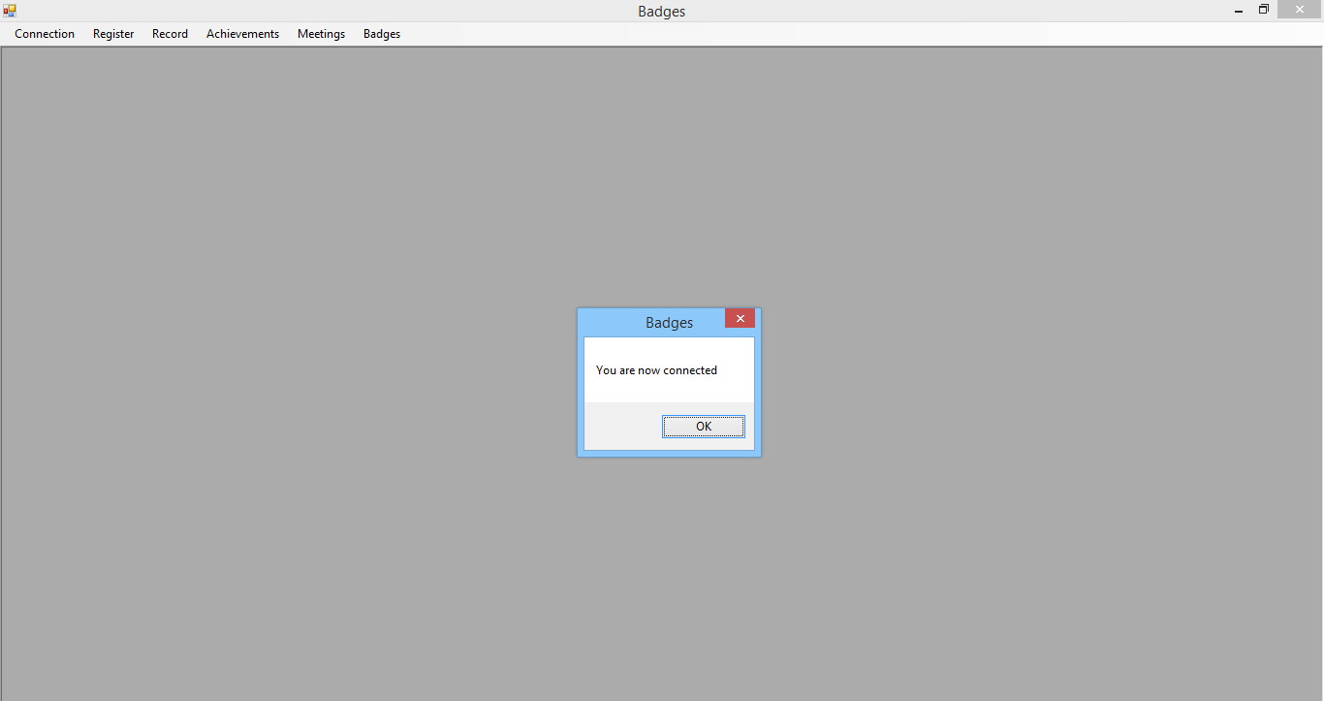

2)

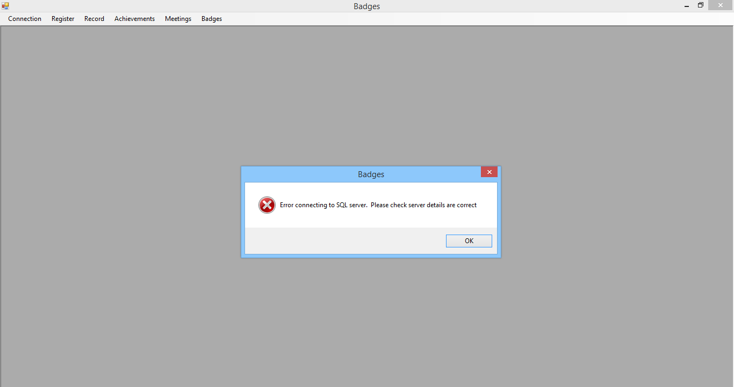

3) 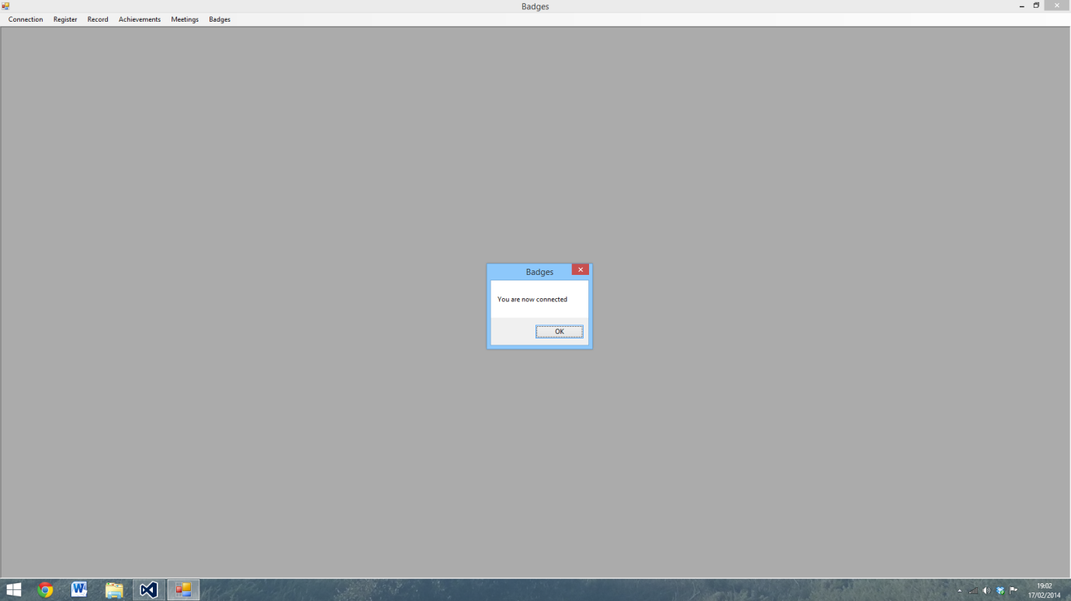

4)

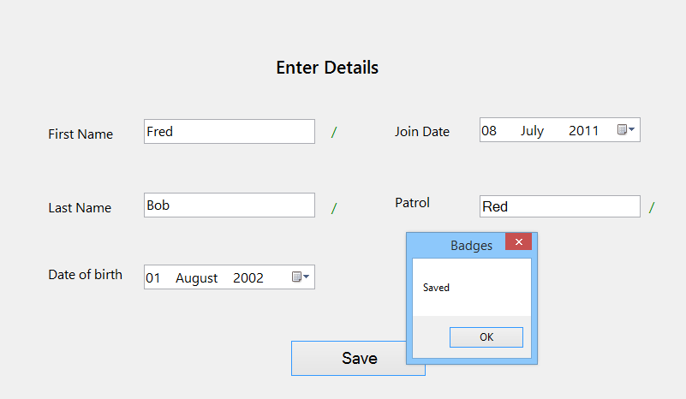

5)

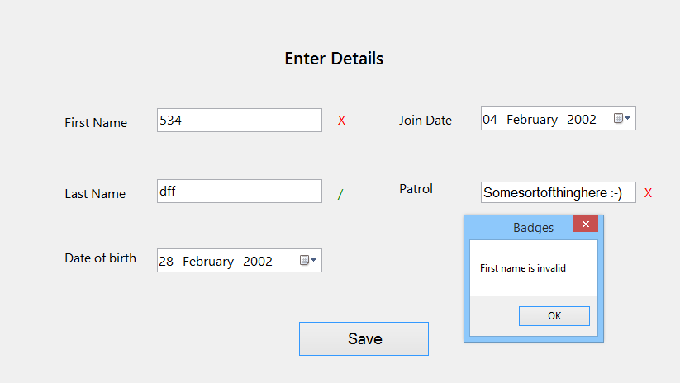

6)

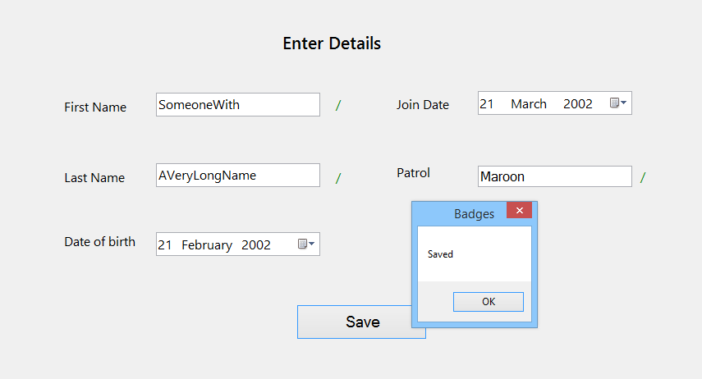

7)

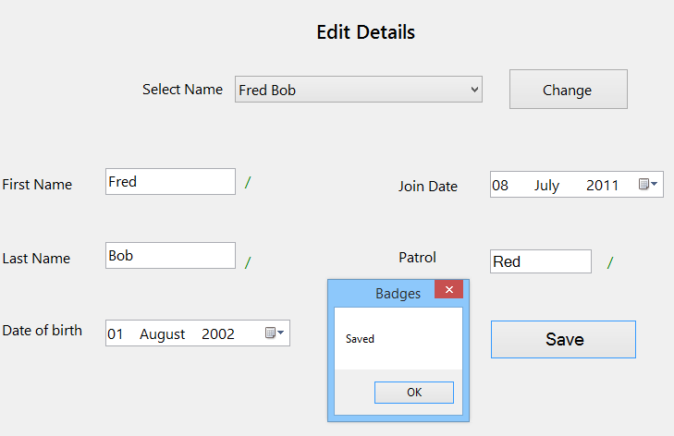

8)

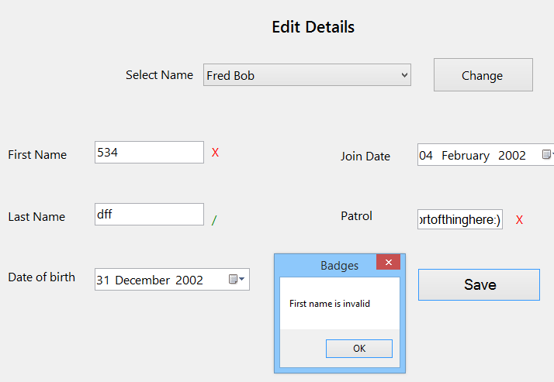

9)

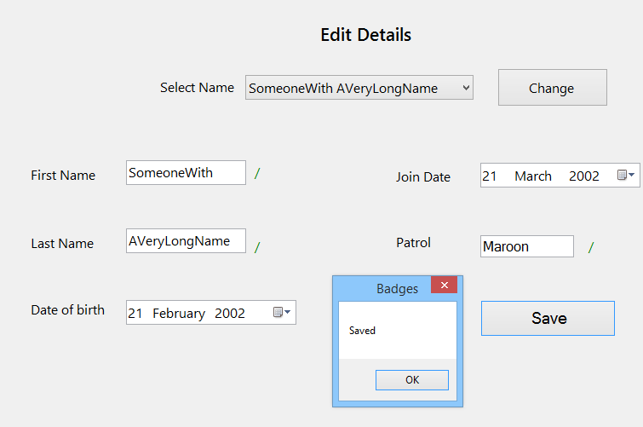

10)

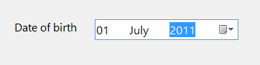

11)

Defaults to

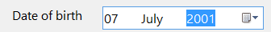

12)

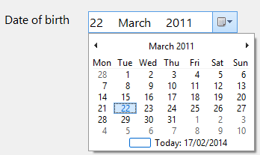

13)

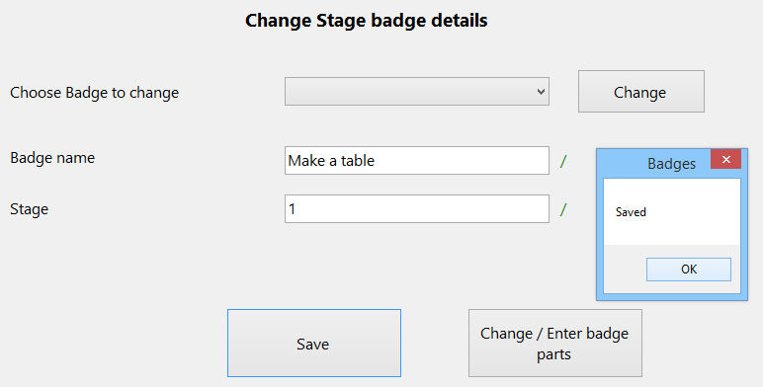

14)

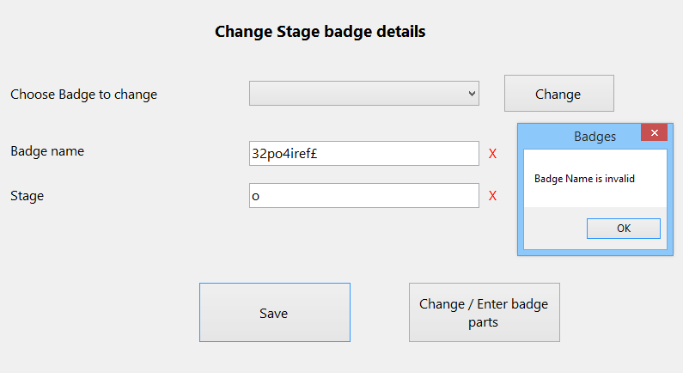

15)

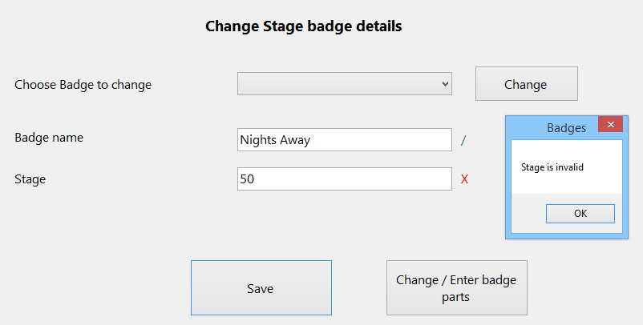

16)

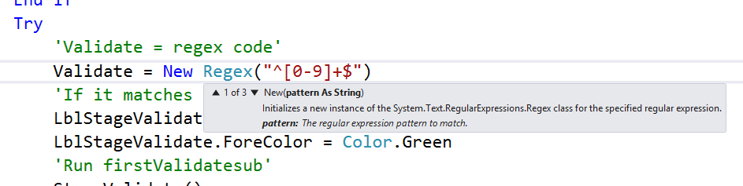

17)

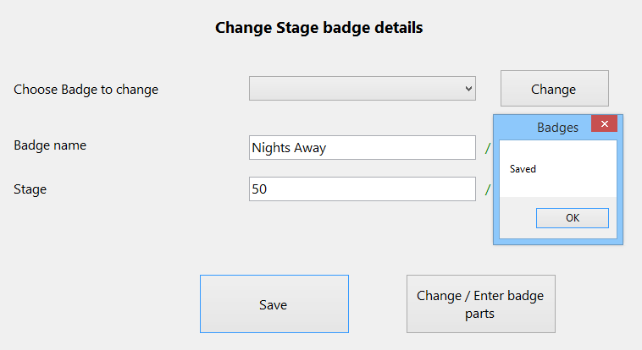

18)

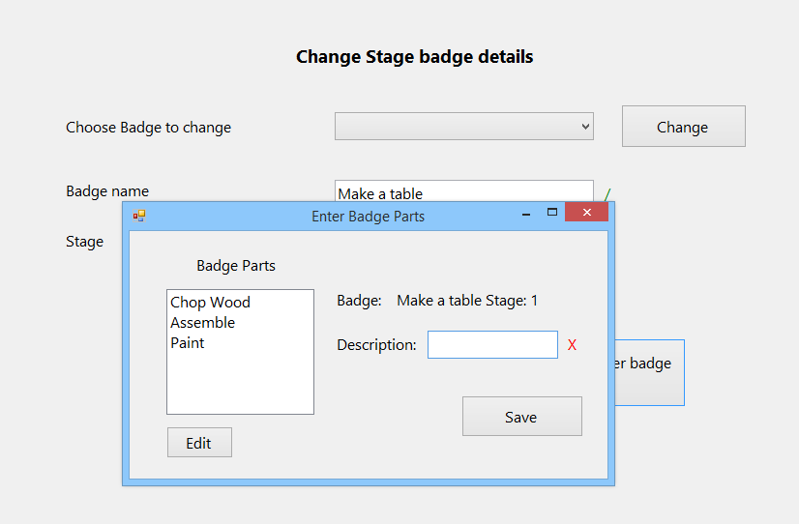

19)

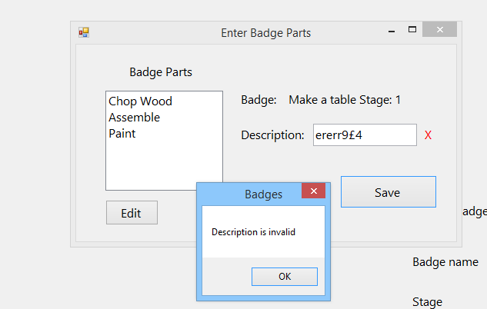

20)

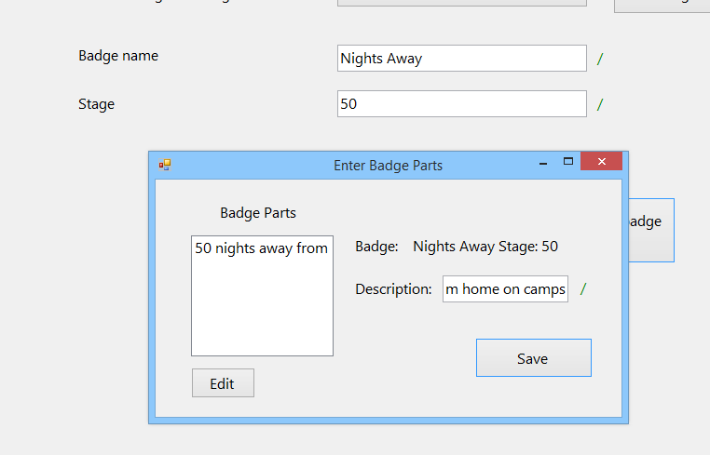

21)

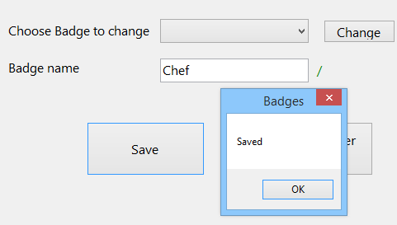

22)

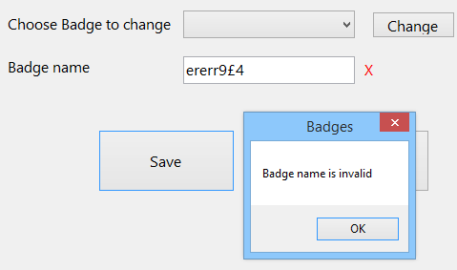

23)

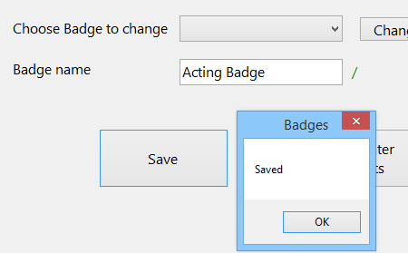

24)

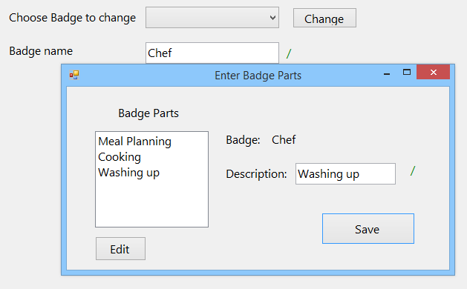

25)

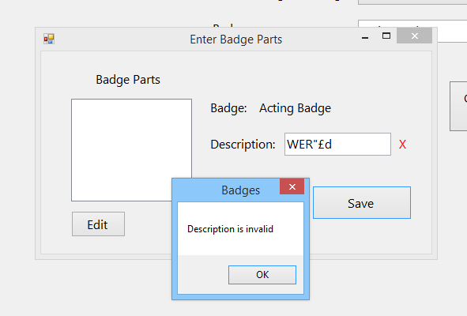

26)

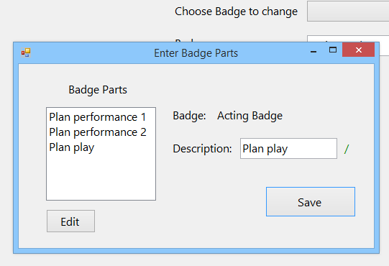

27)

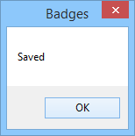

28)

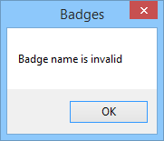

29)

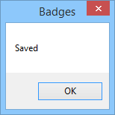

30)

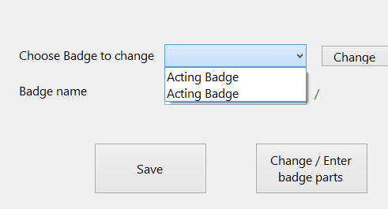

31)

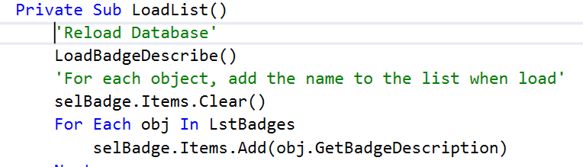

32)

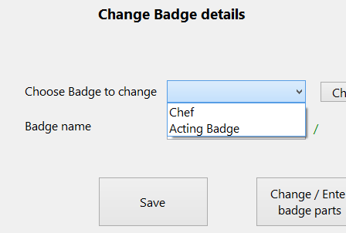

33)

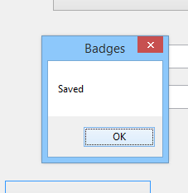

34)

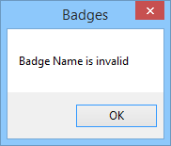

35)



36)

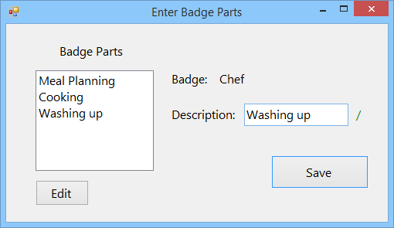

37)

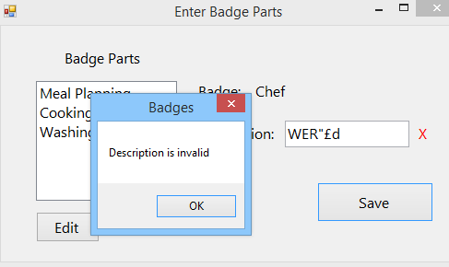

38)

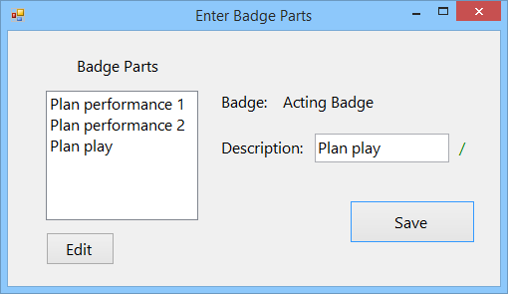

39)

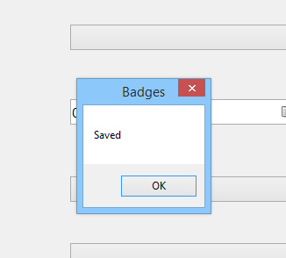

40)



41)



43)

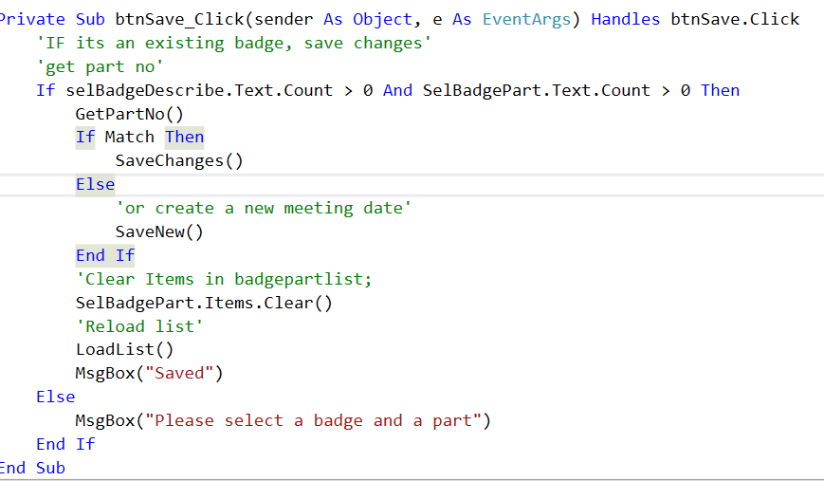

44)

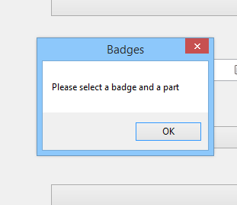

45)



46)

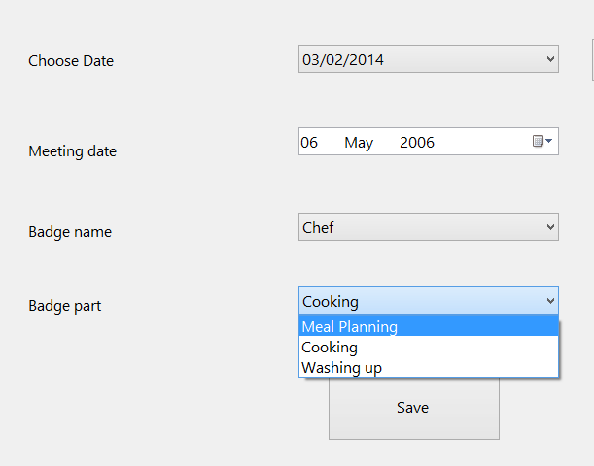

47)



48)

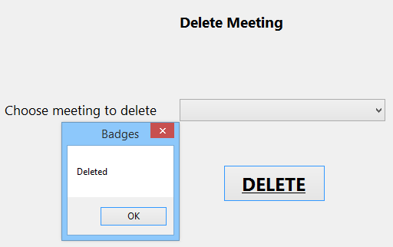

49)

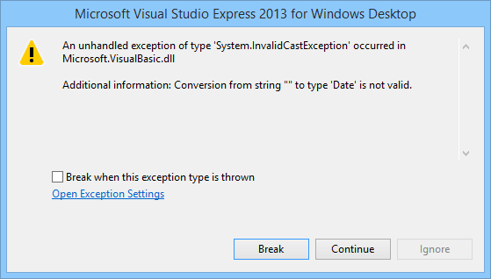

50)

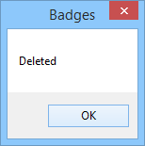

51)

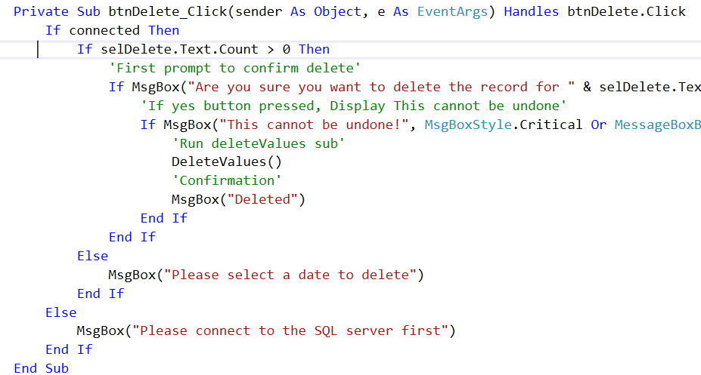

52)

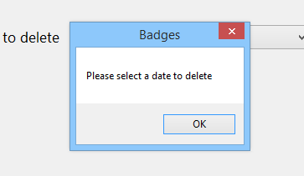

53)

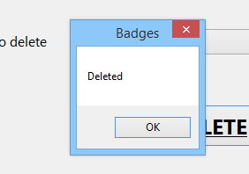

54)

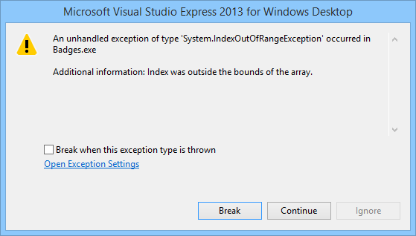

55)

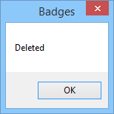

56)

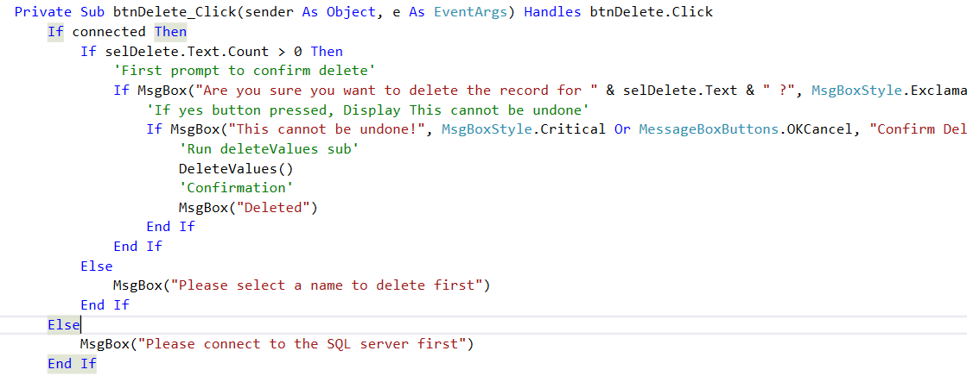

57)

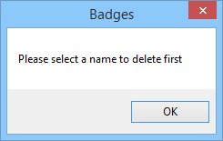

58)

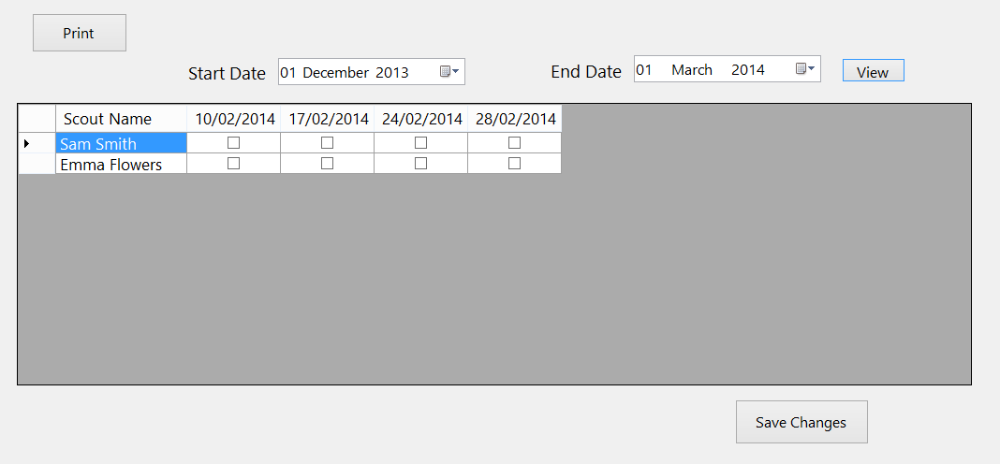

59)



60)

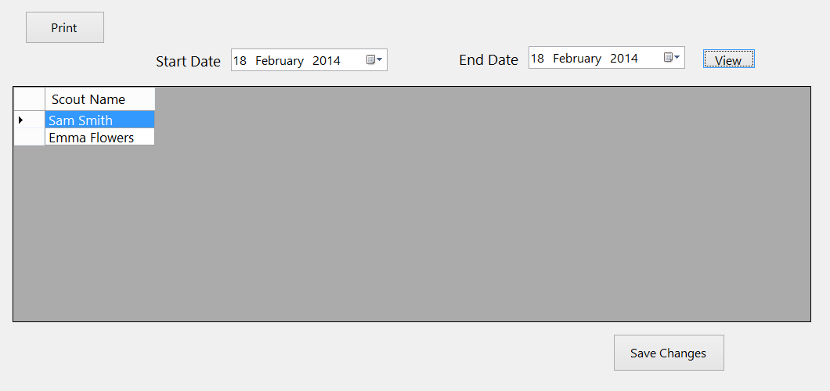

61)

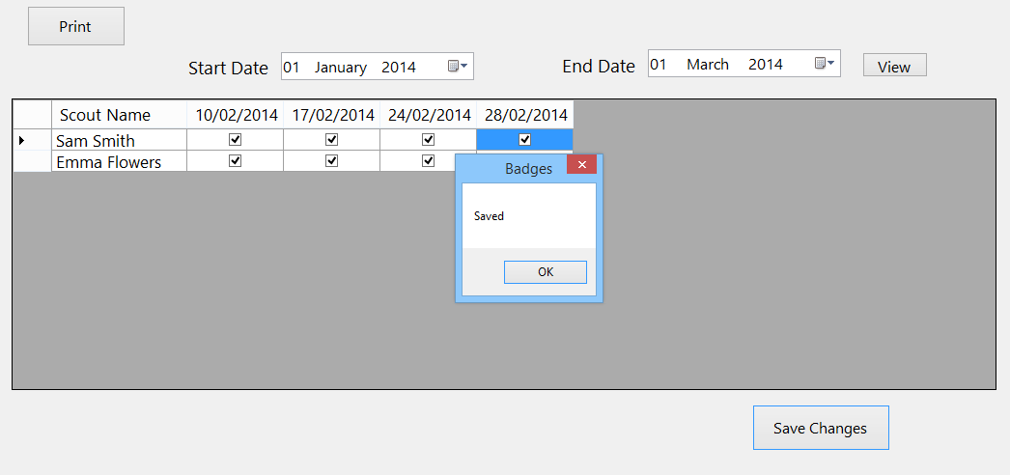

62)

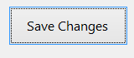

63)

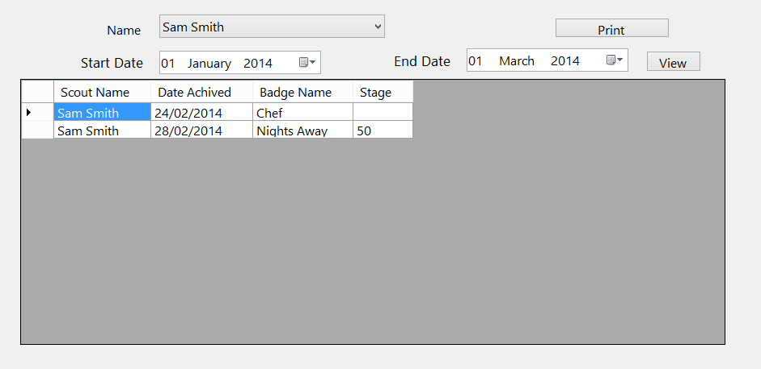

64)



65)

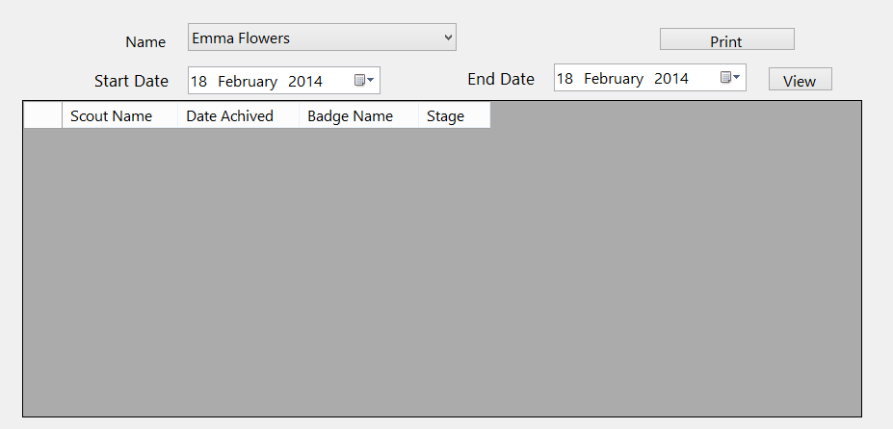

66)

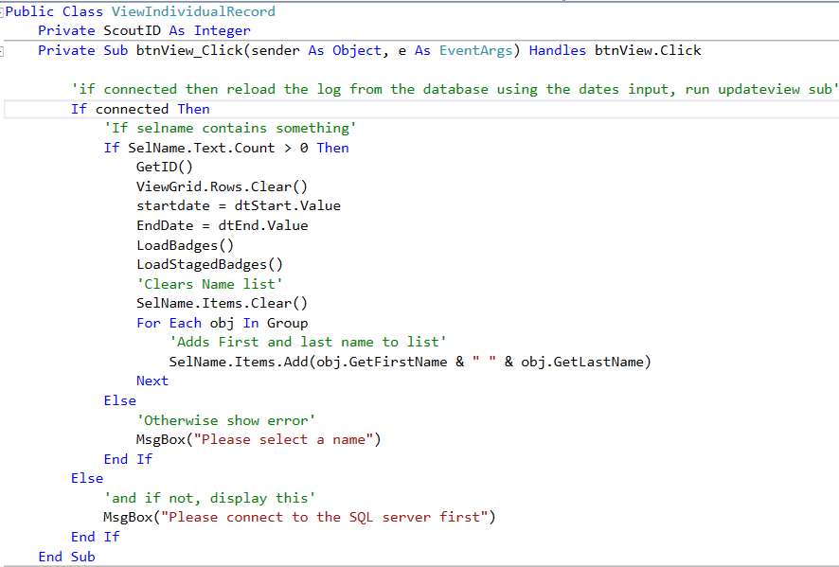

67)

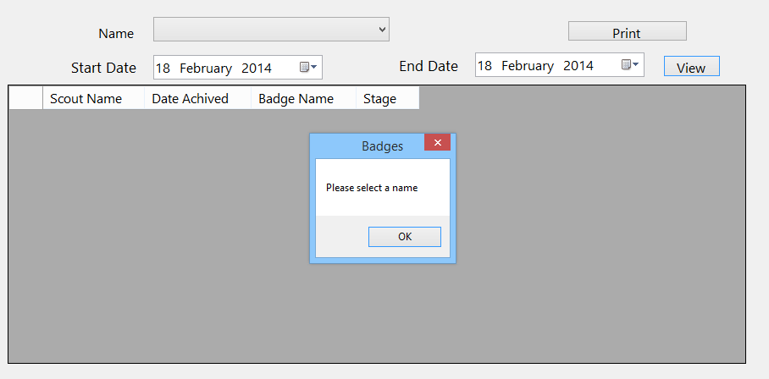

68)

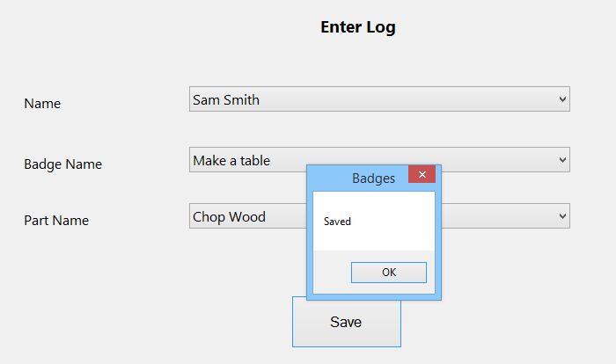

69)



70)

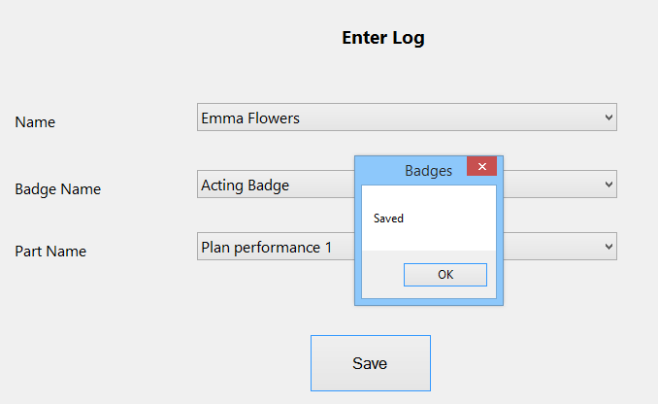

71)

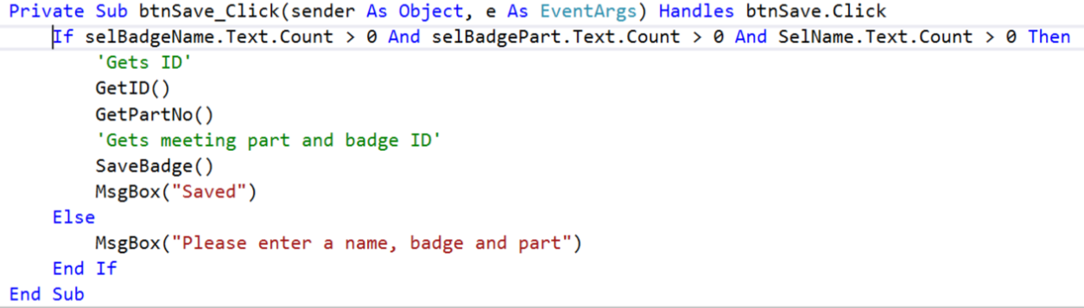

72)

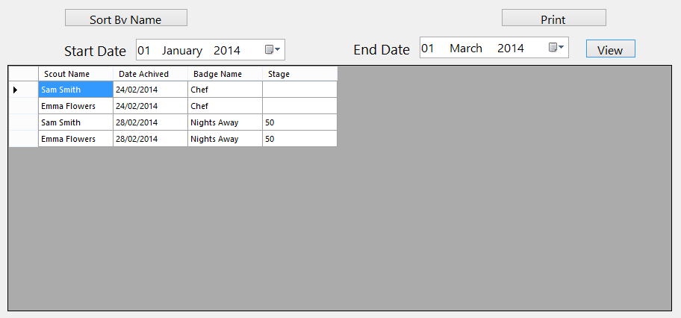

73)



74)

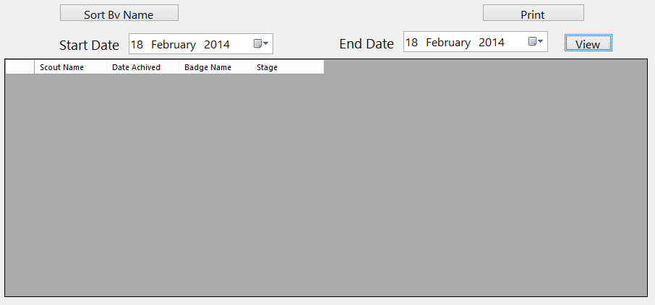

75)

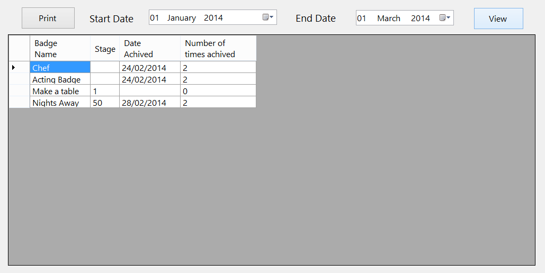

76)



77)

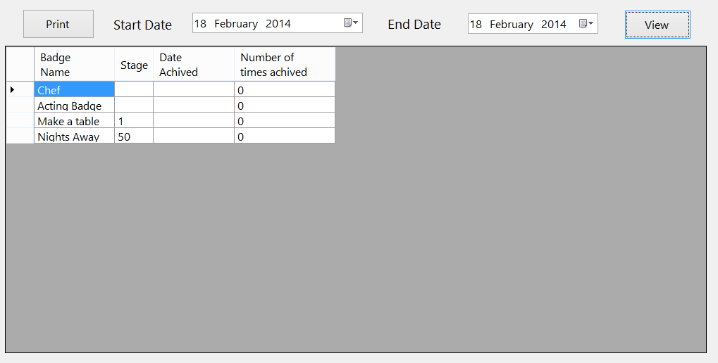

78)

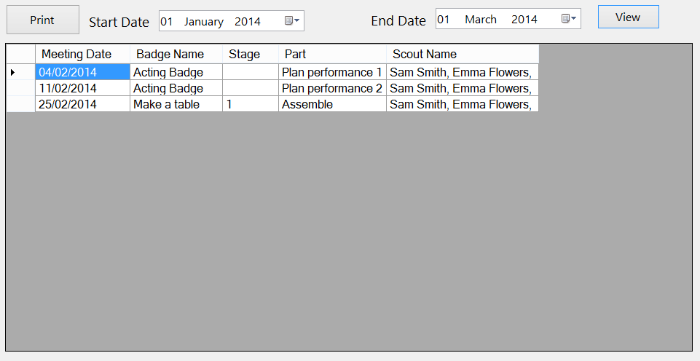

79)

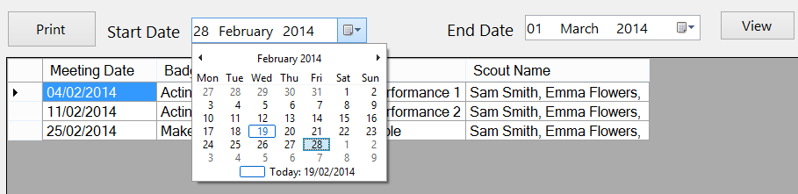

80)

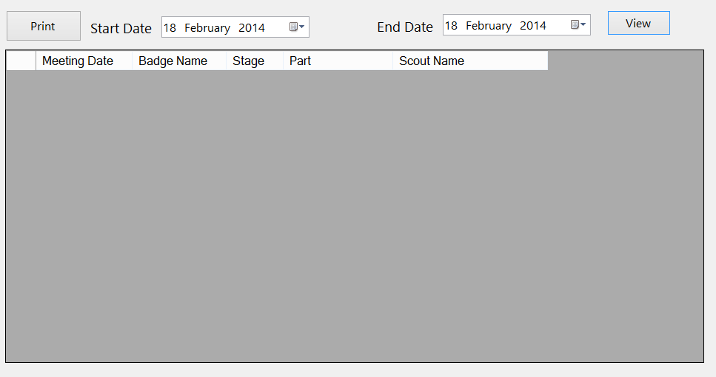

81)

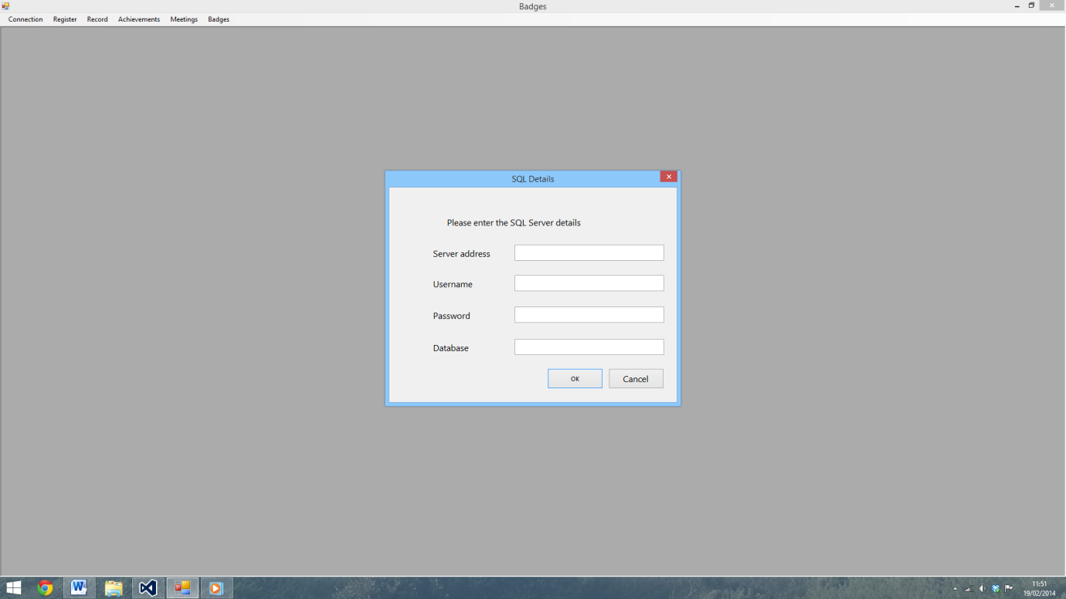

82)

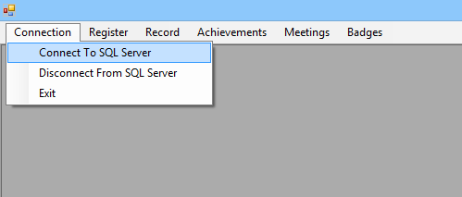

83)



84)



85)

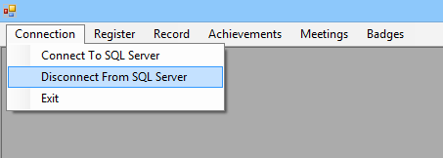

86)



87)



88)



89)



90)

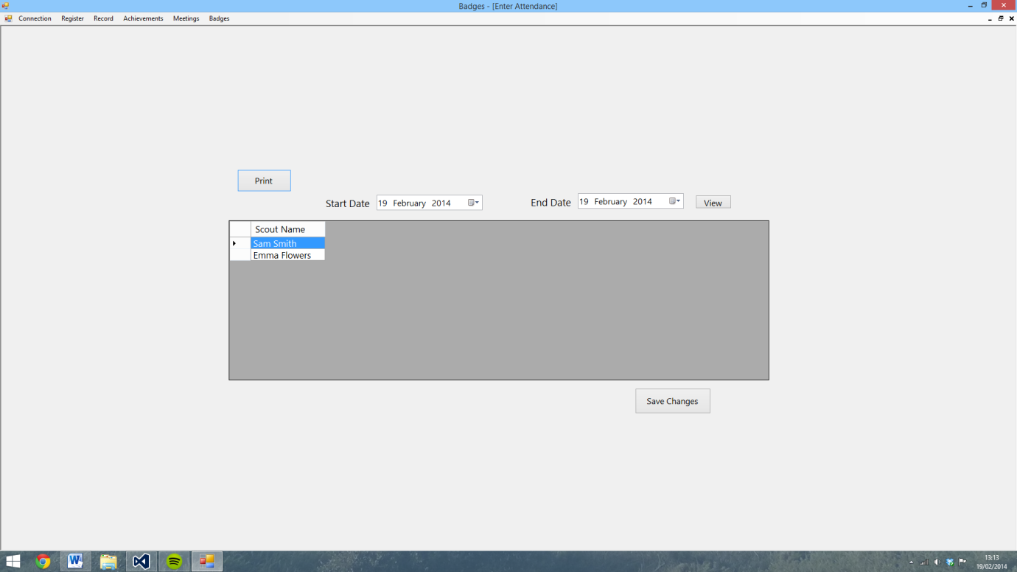

91)

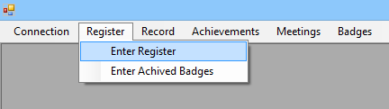

92)

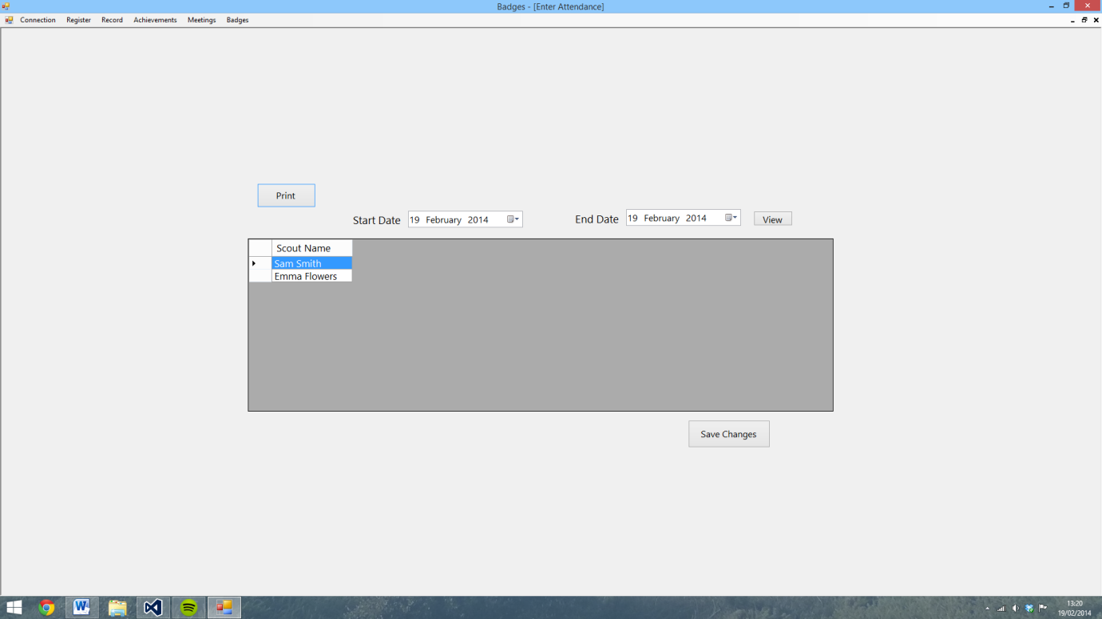

93)

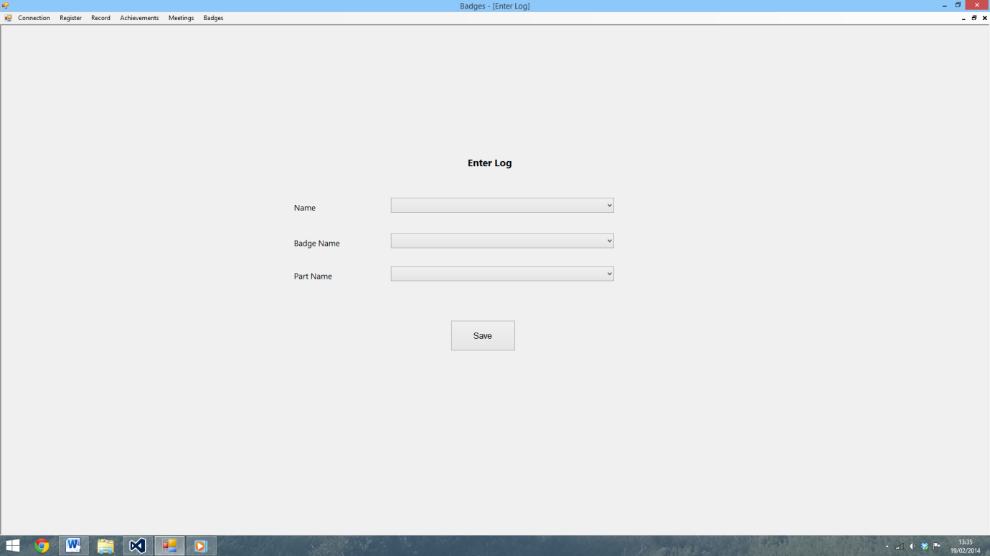

94)

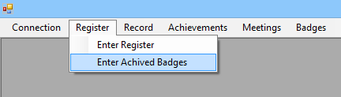

95)

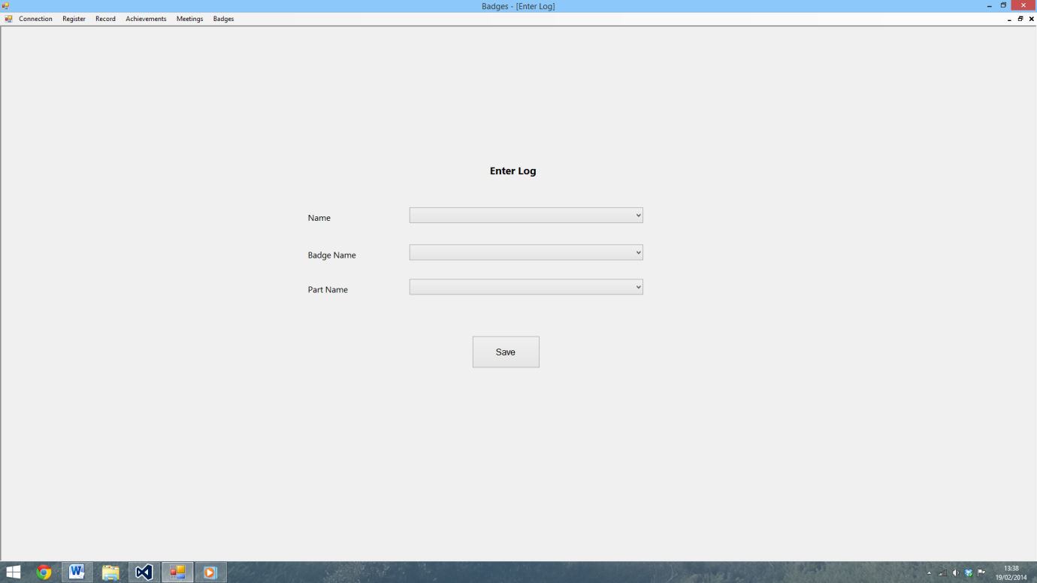

96)

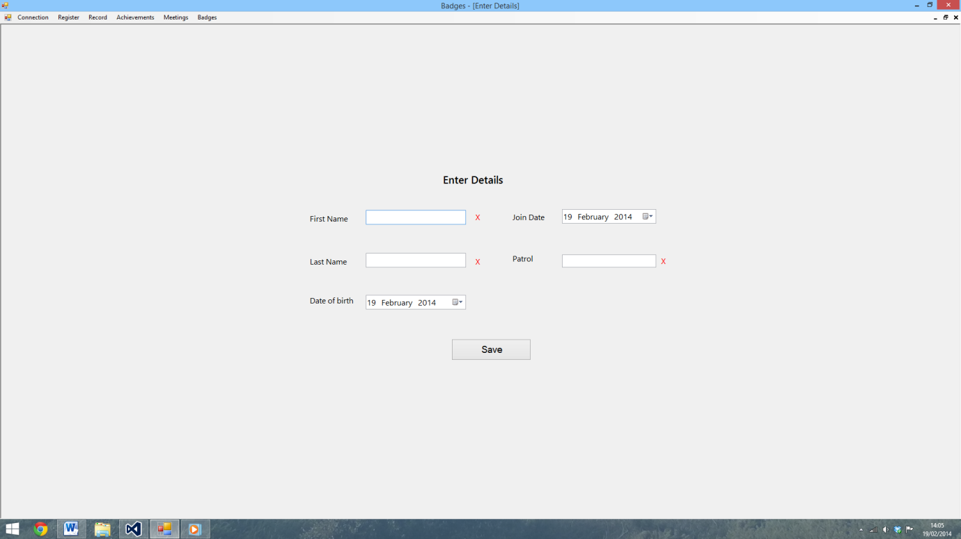

97)

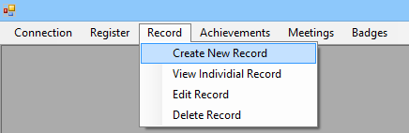

98)

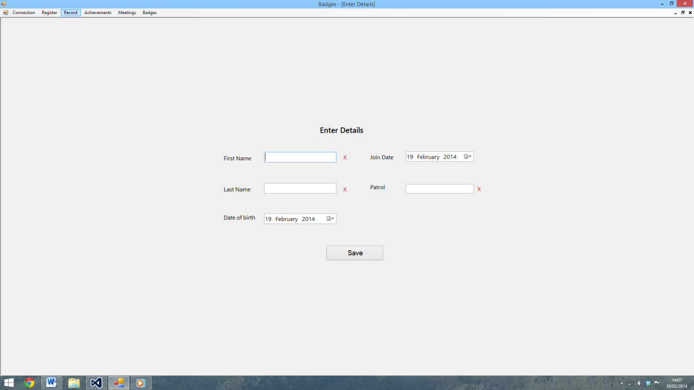

99)

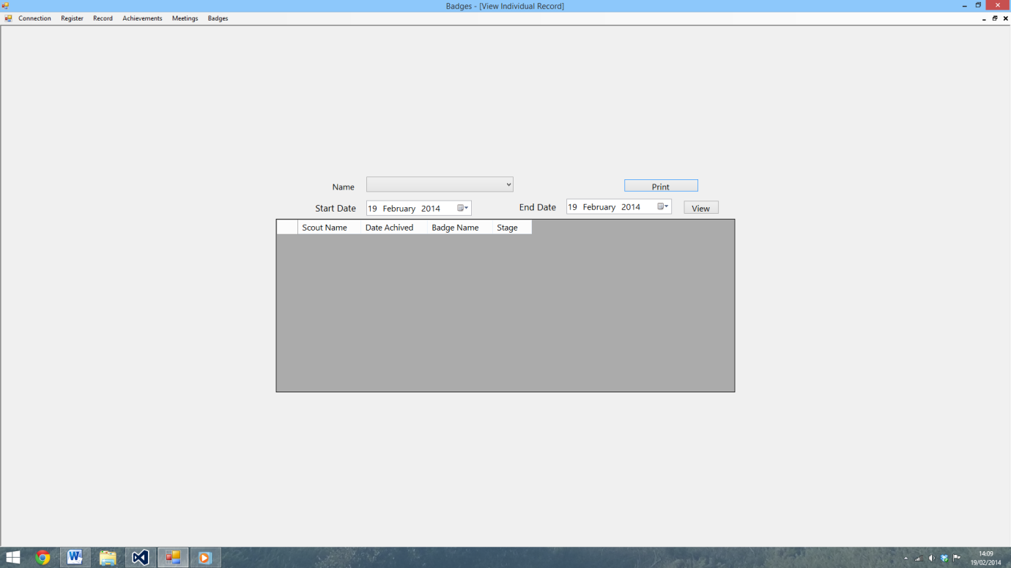

100)

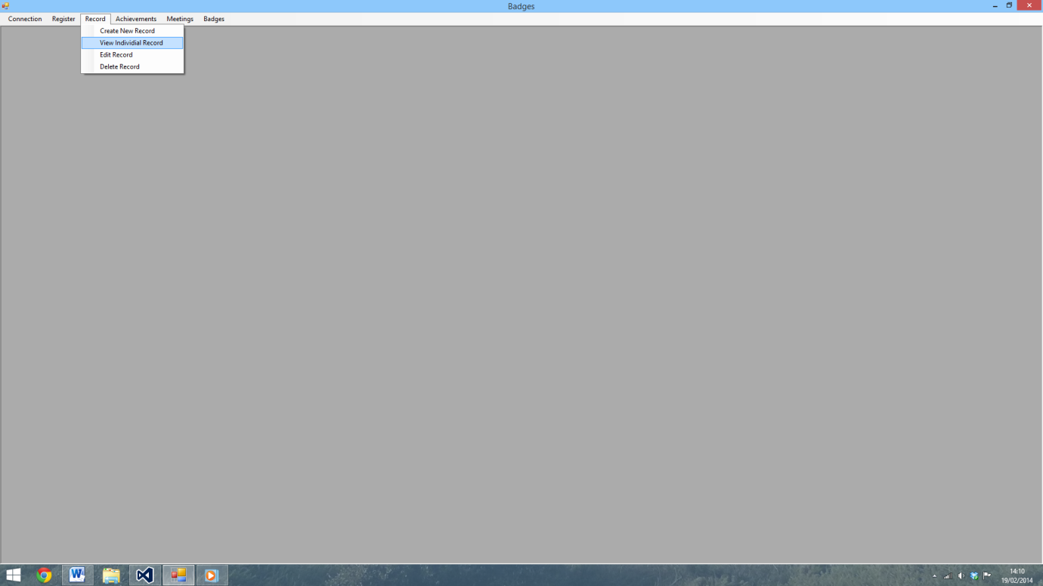

101)

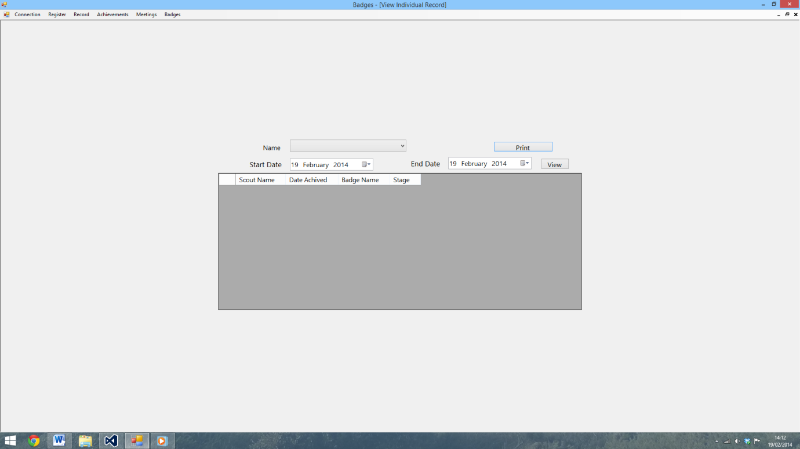

102)

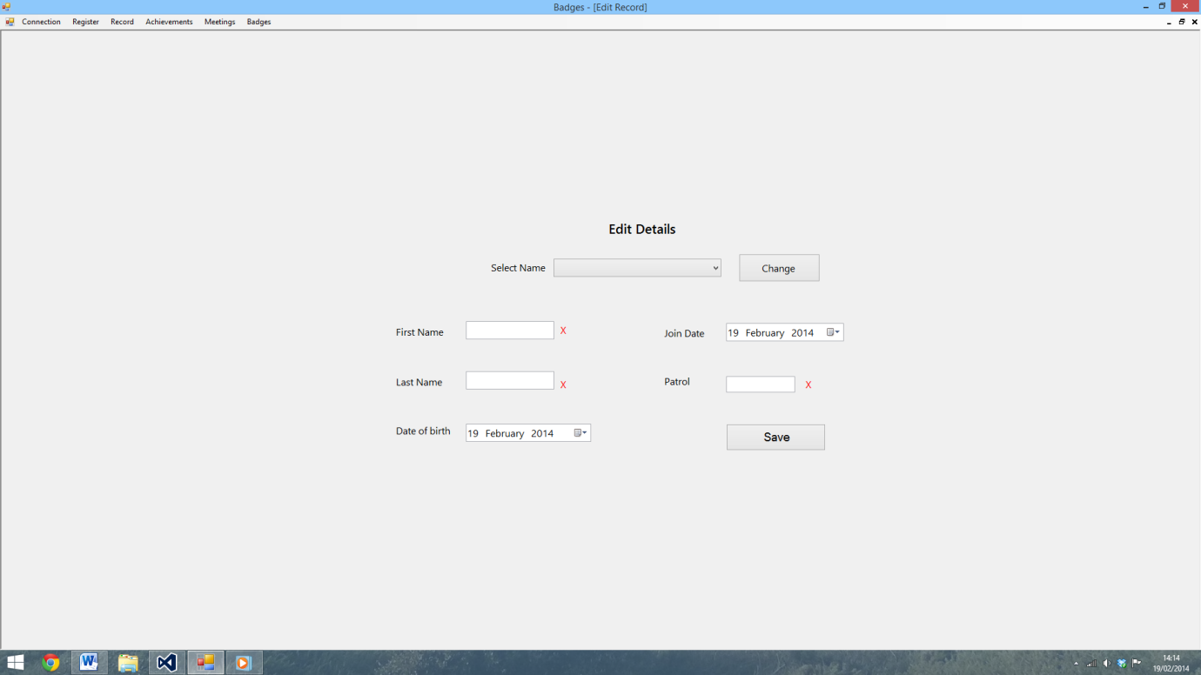

103)

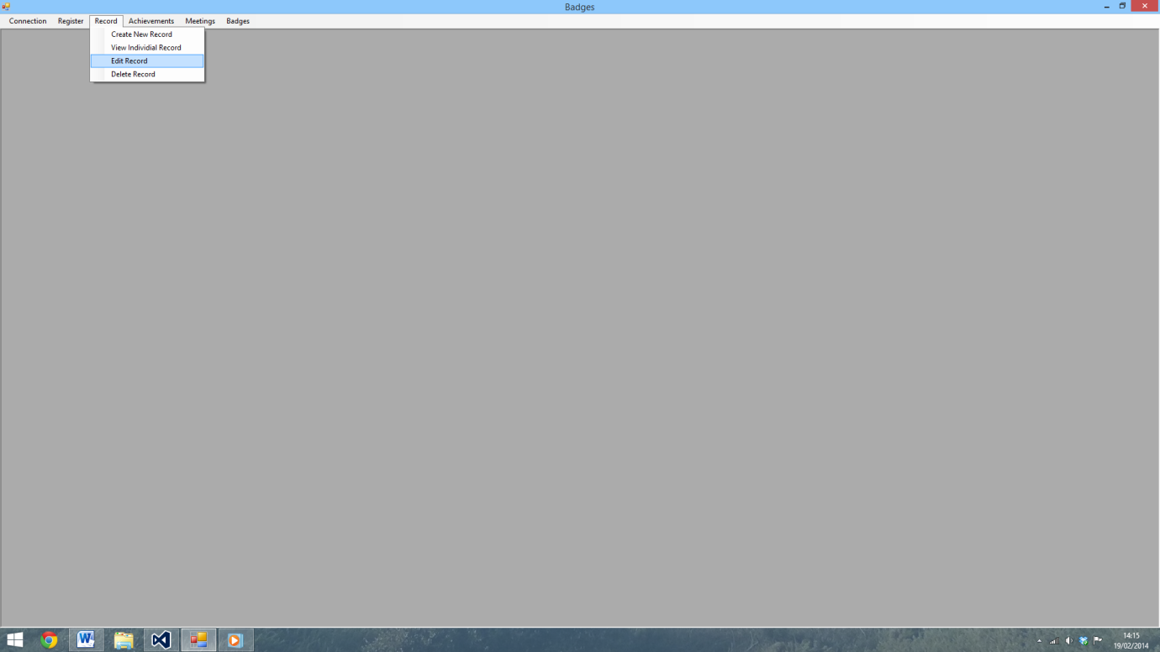

104)

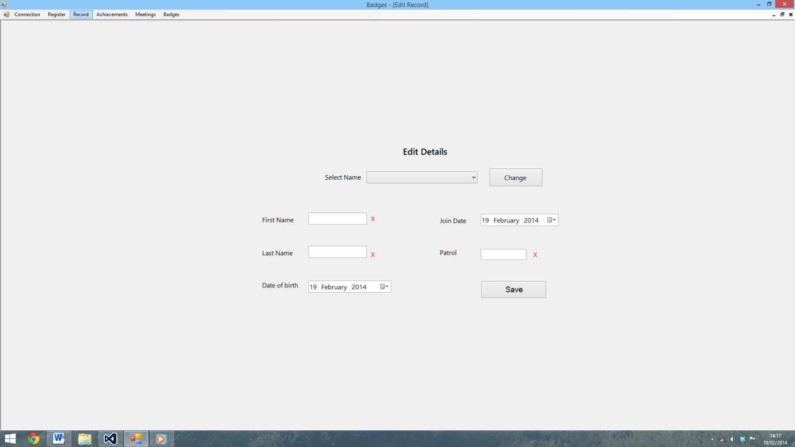

105)

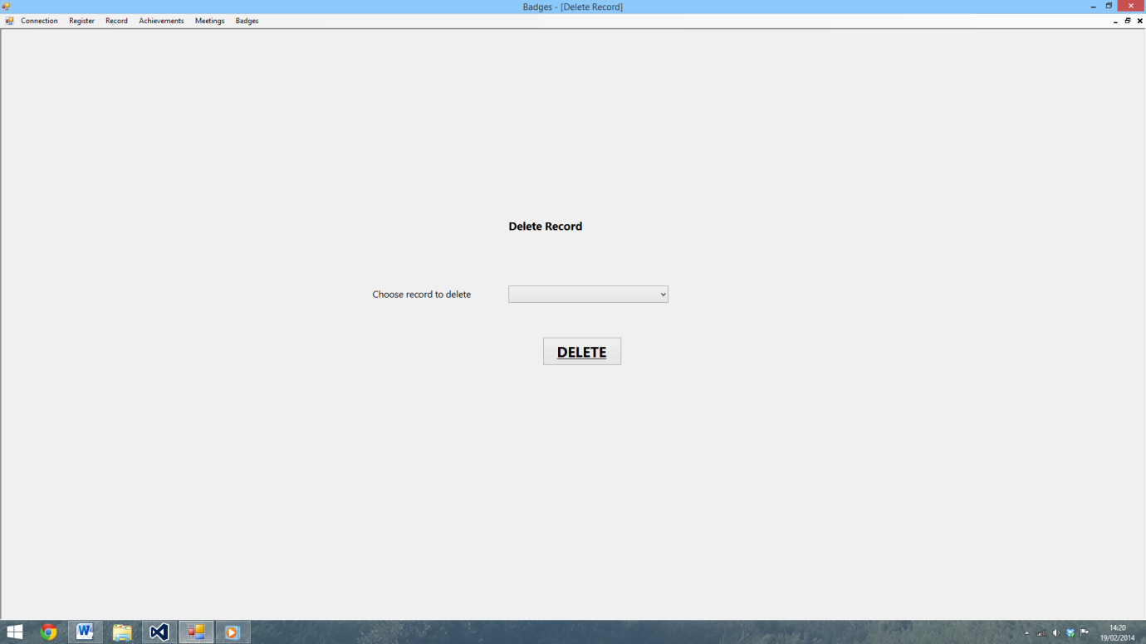

106)

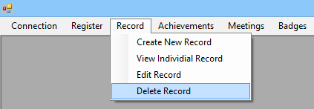

107)

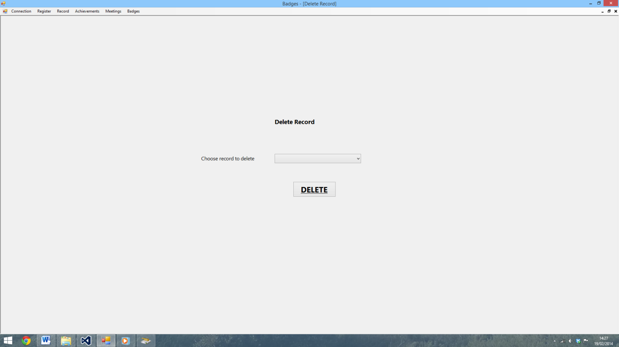

108)

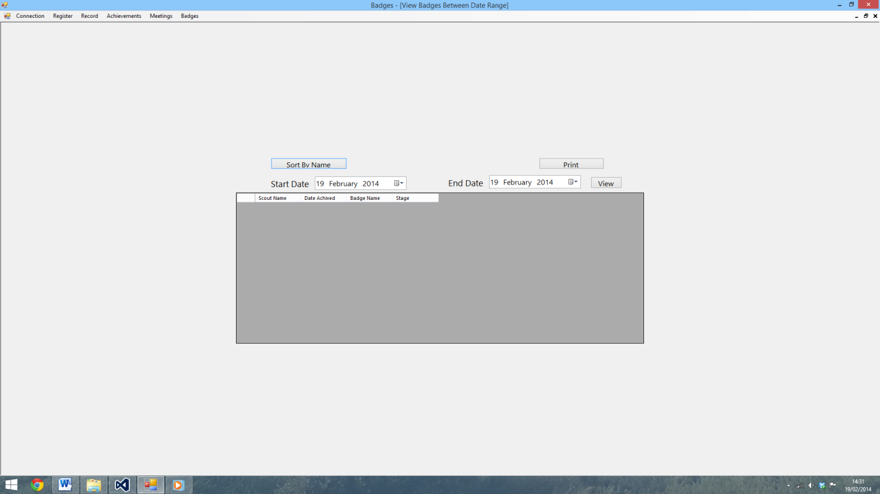

109)

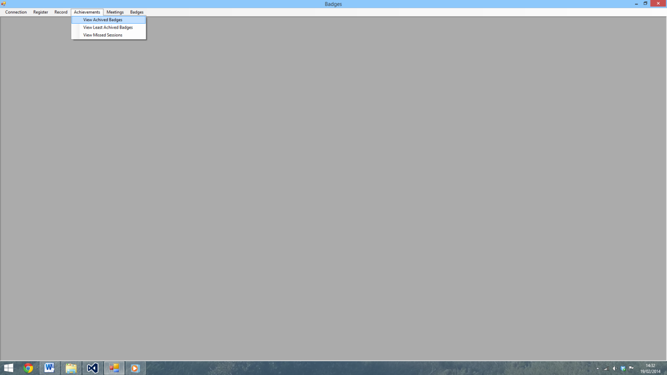

110)

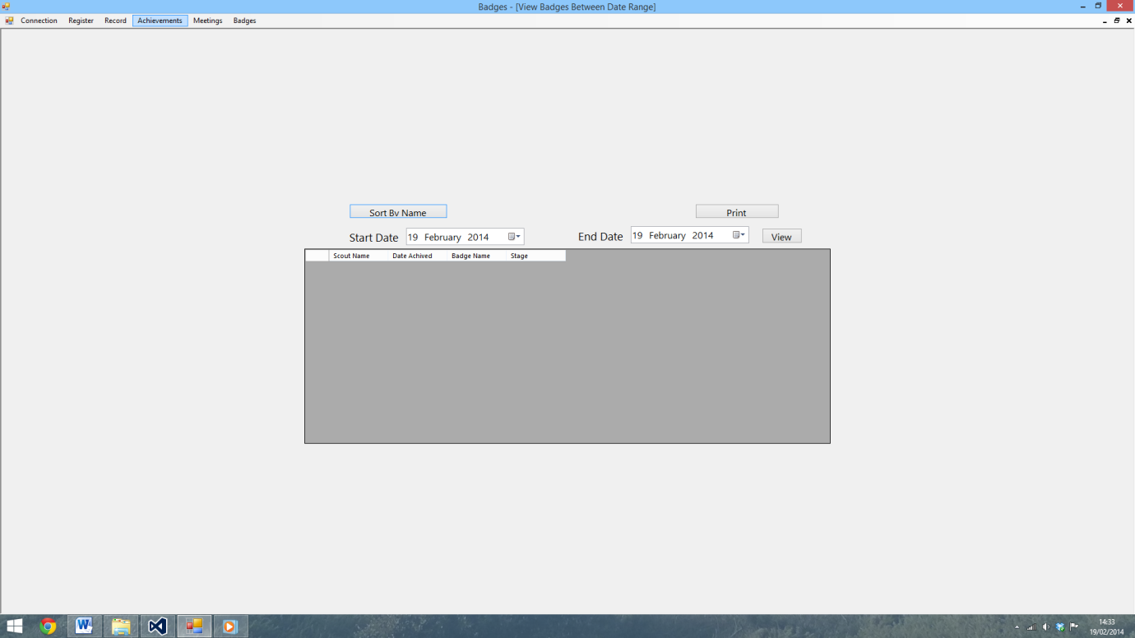

111)

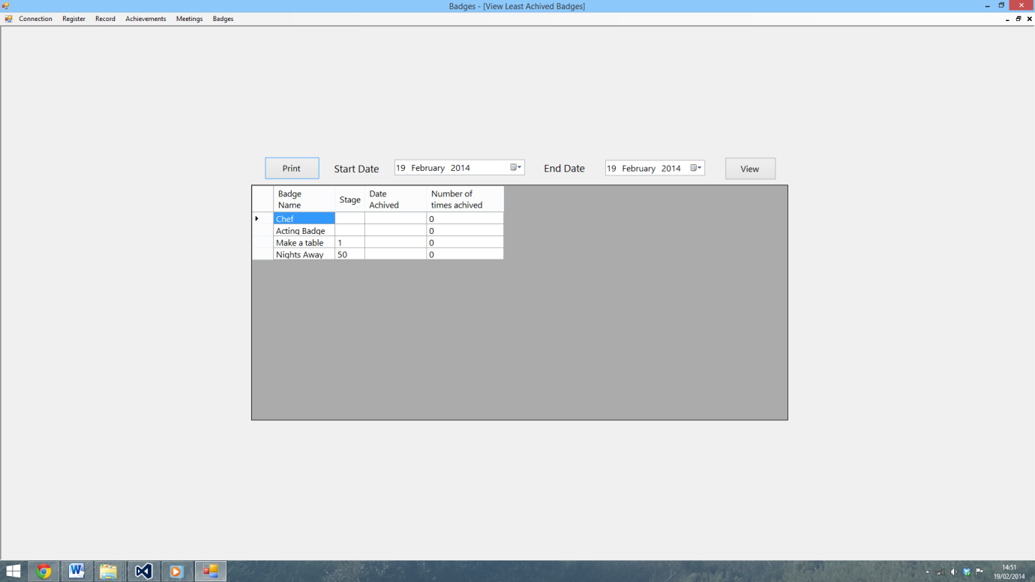

112)

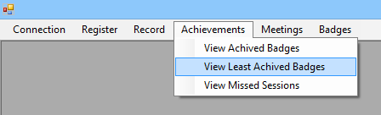

113)

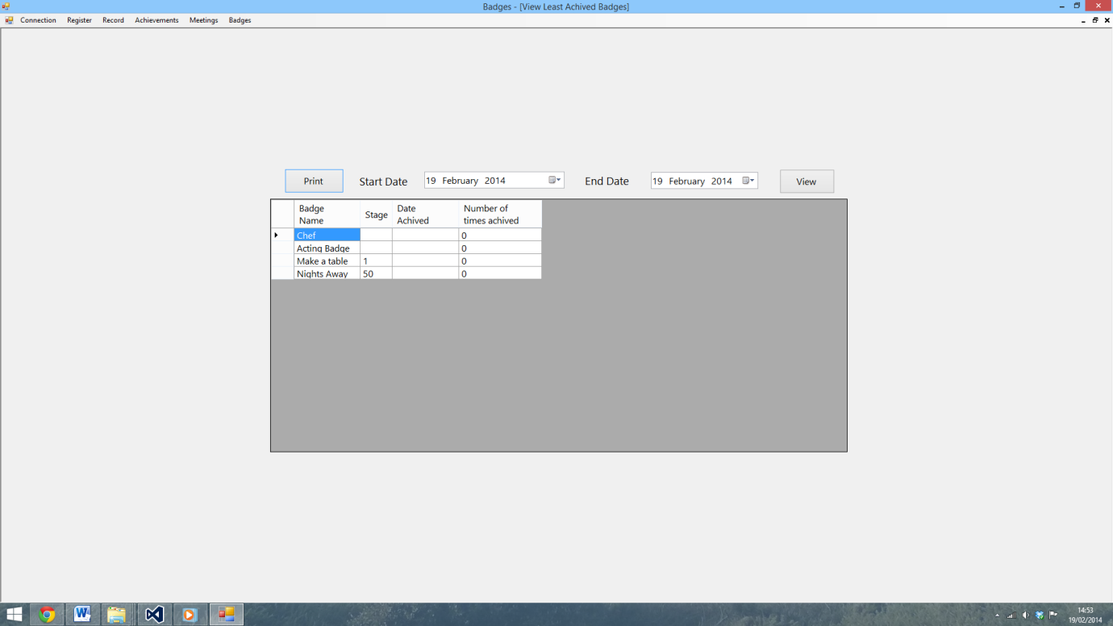

114)

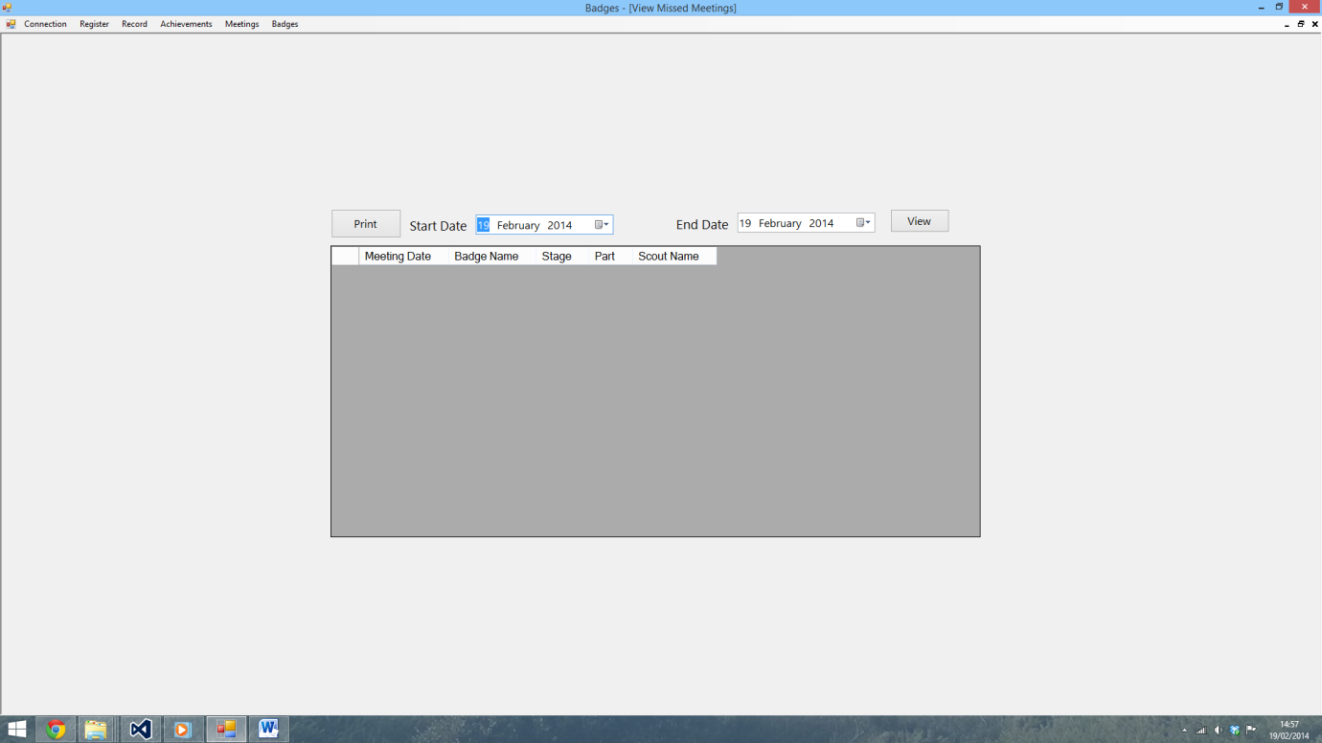

115)

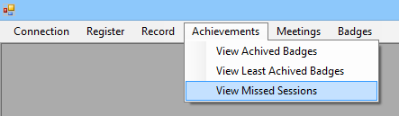

116)

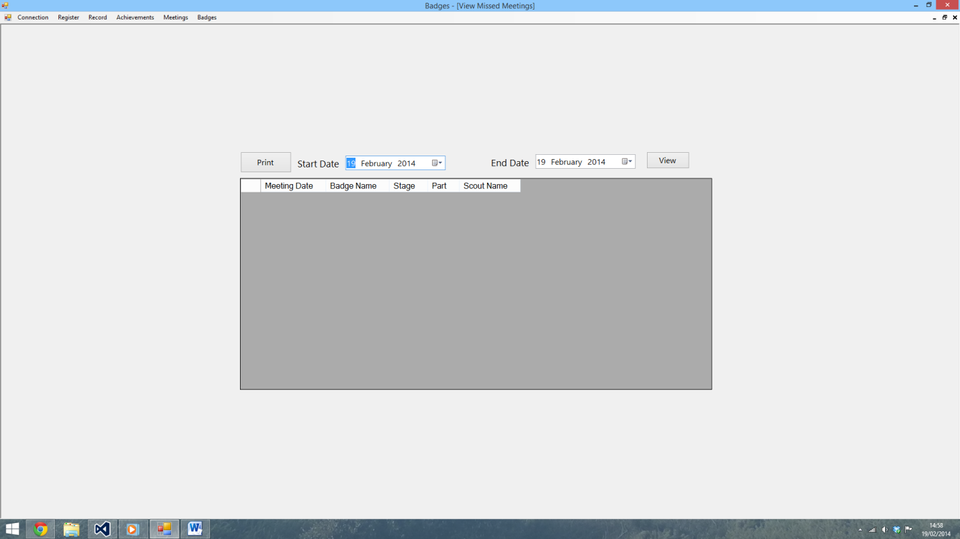

117)

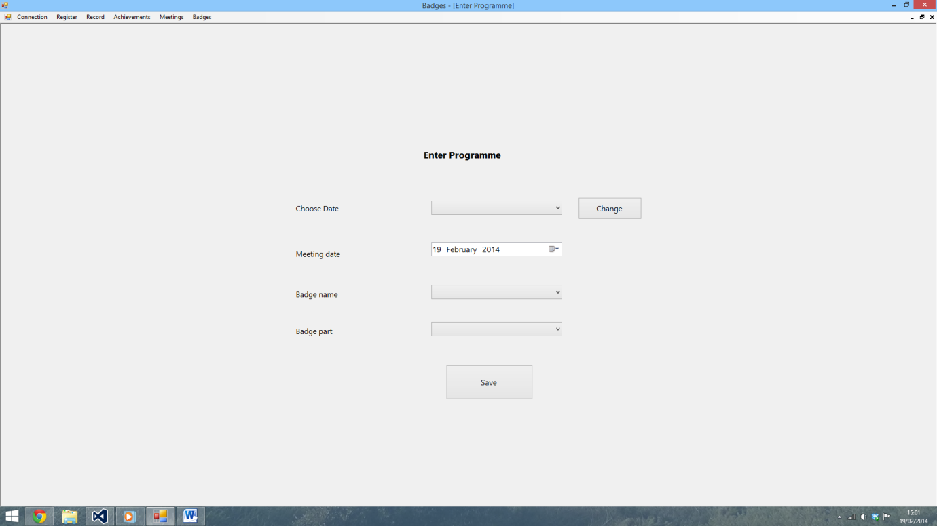

118)

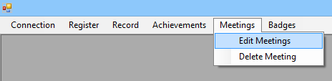

119)

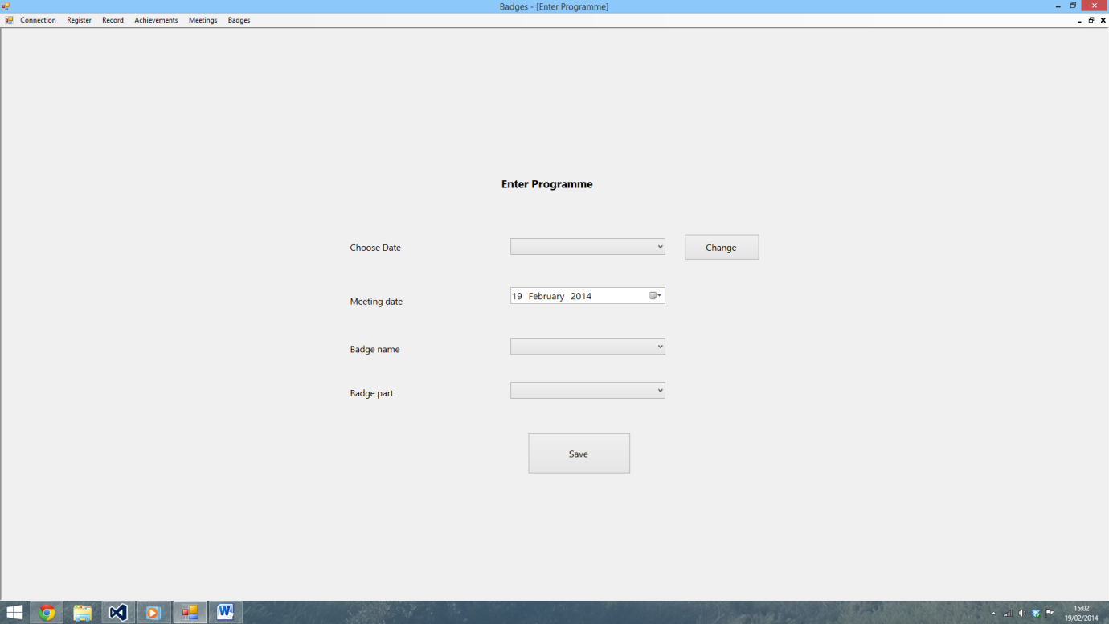

120)

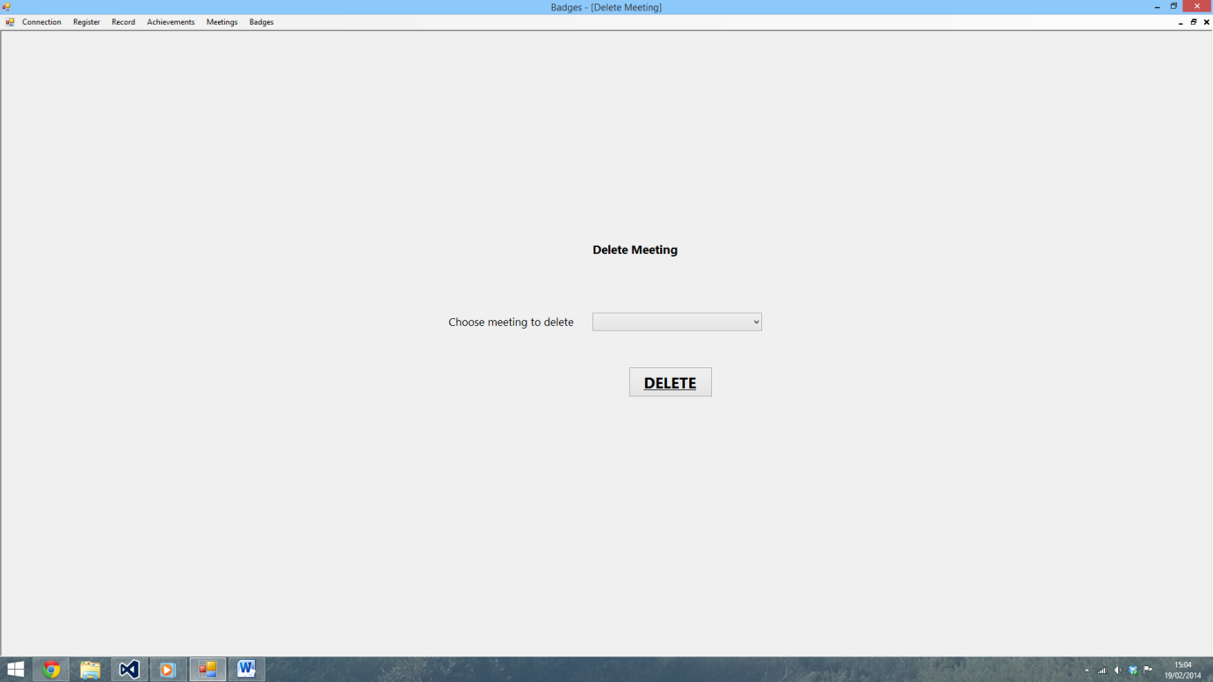

121)

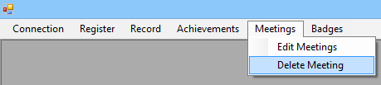

122)

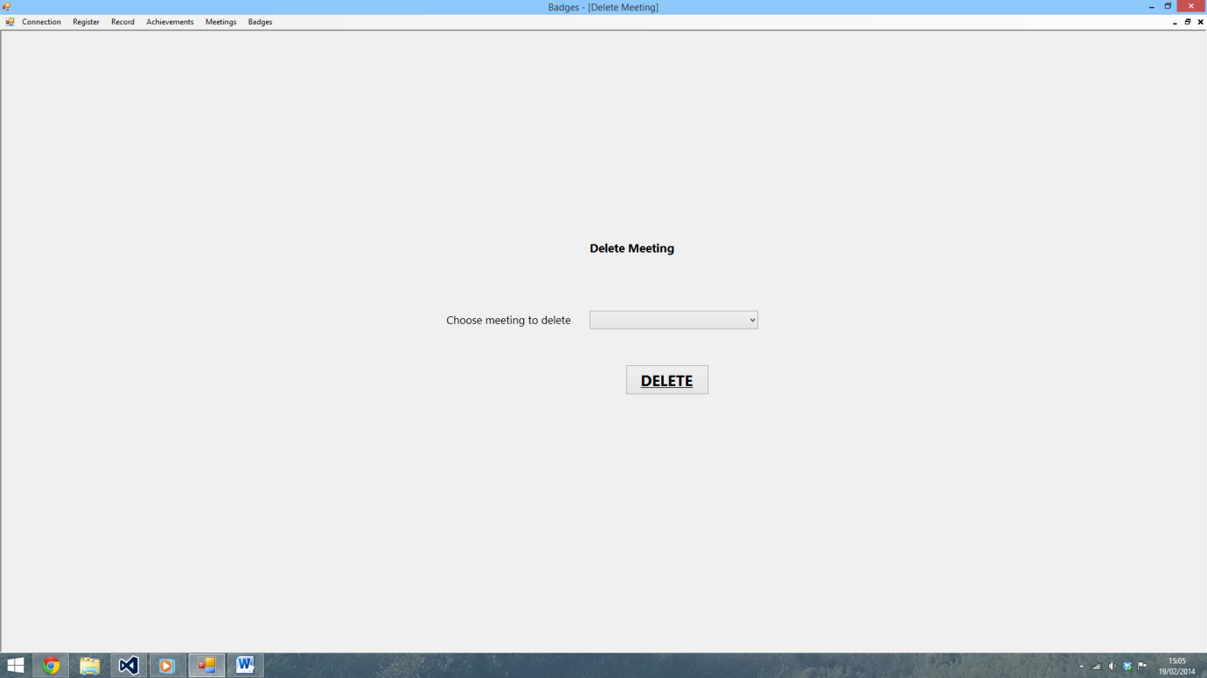

123)

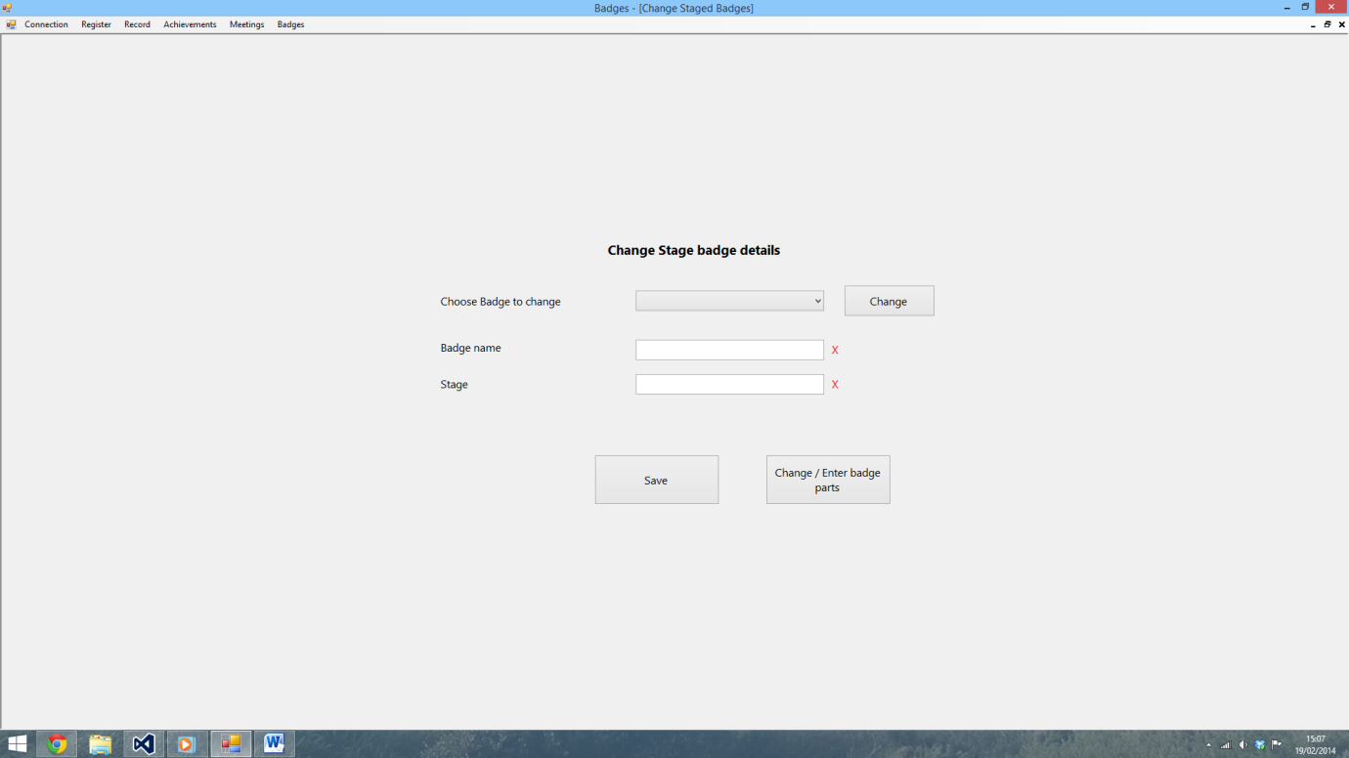

124)

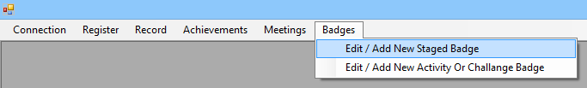

125)

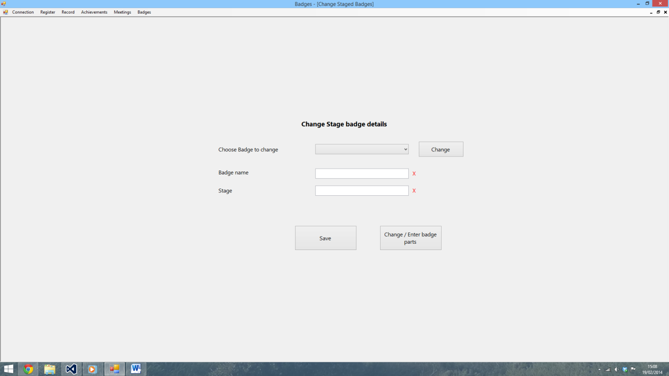

126)

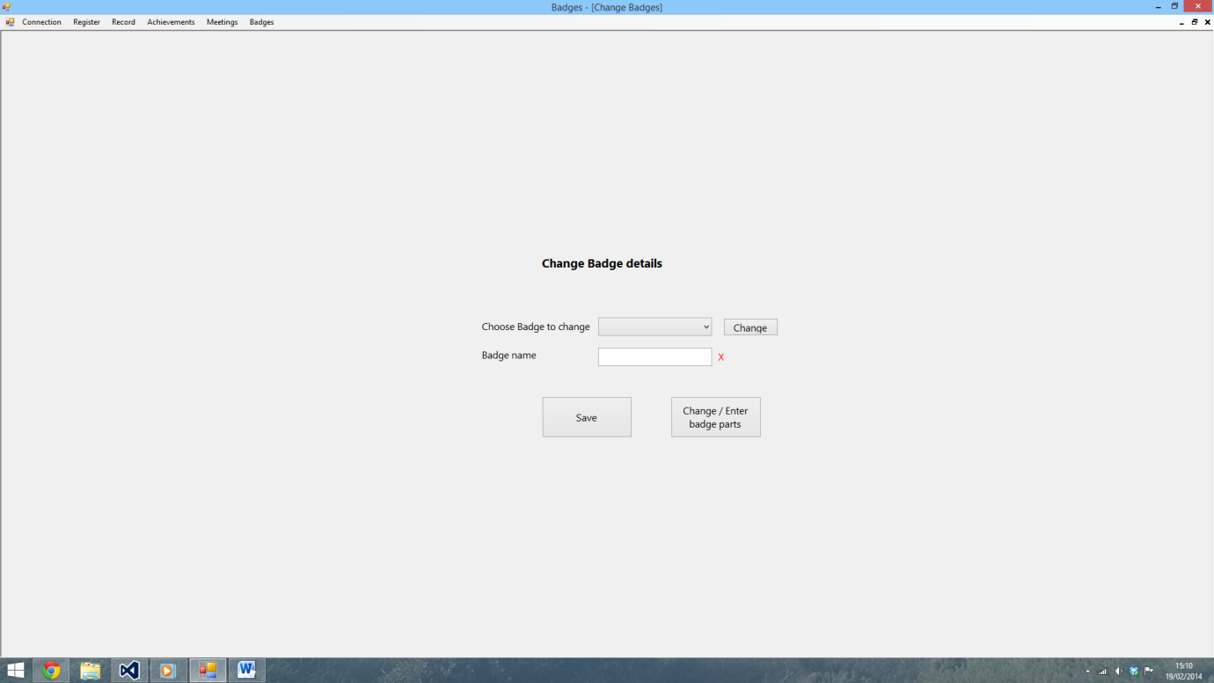

127)

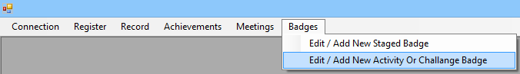

128)

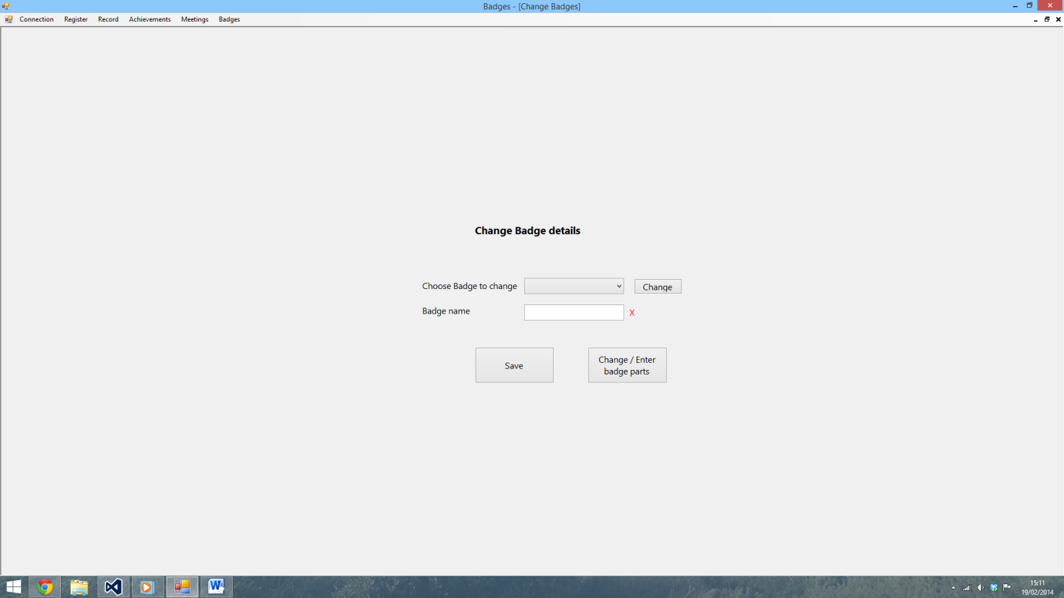

129)

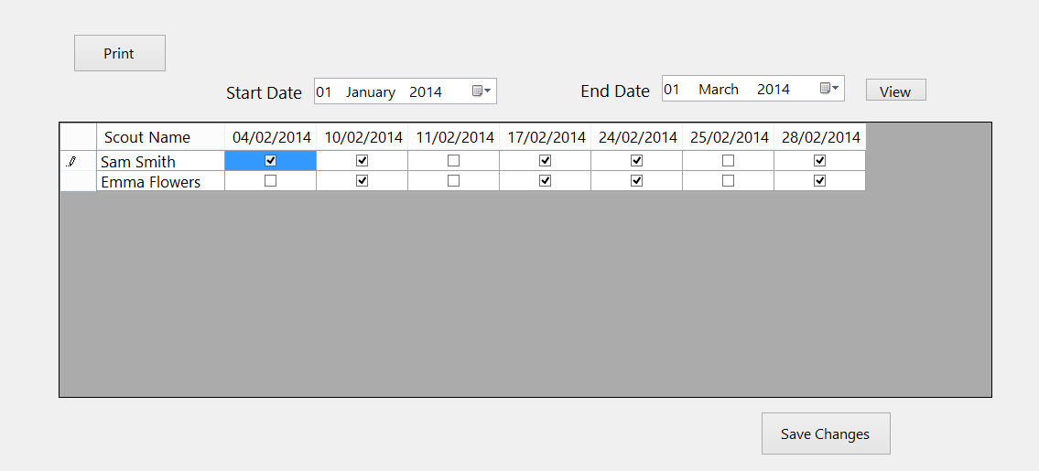

130)

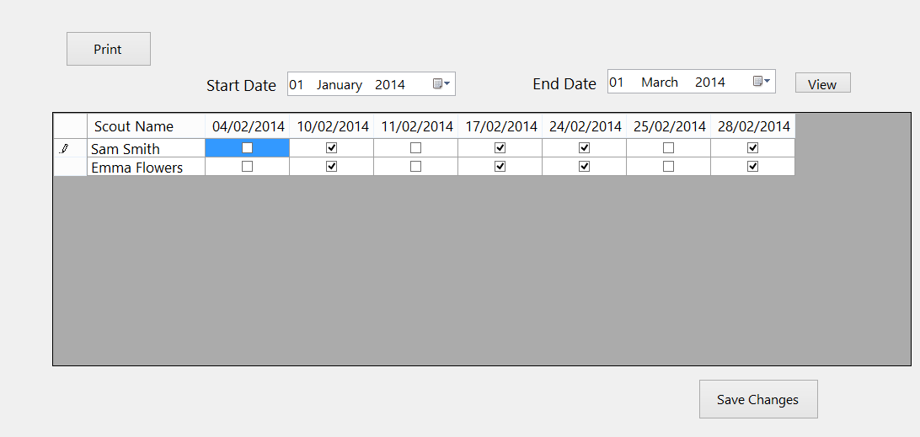

131)

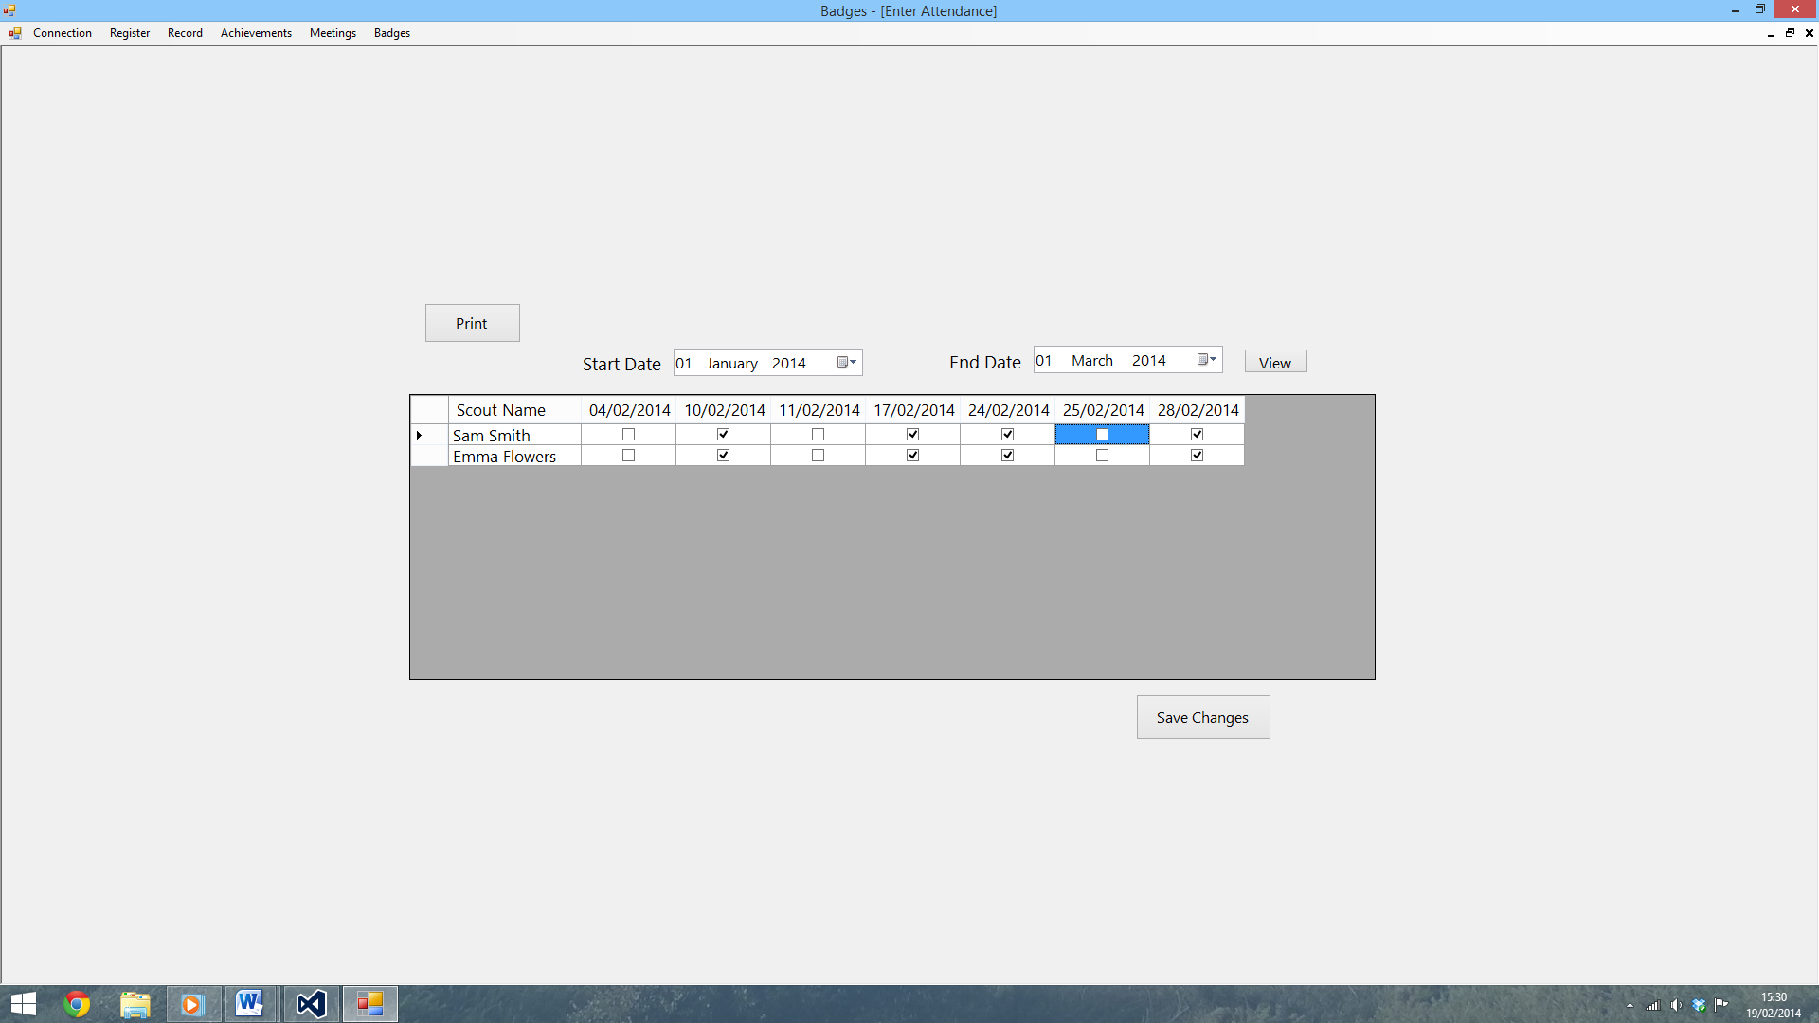

Appendix B – Developmental Testing

This section contains a sample of the testing I did whilst I was creating a program.

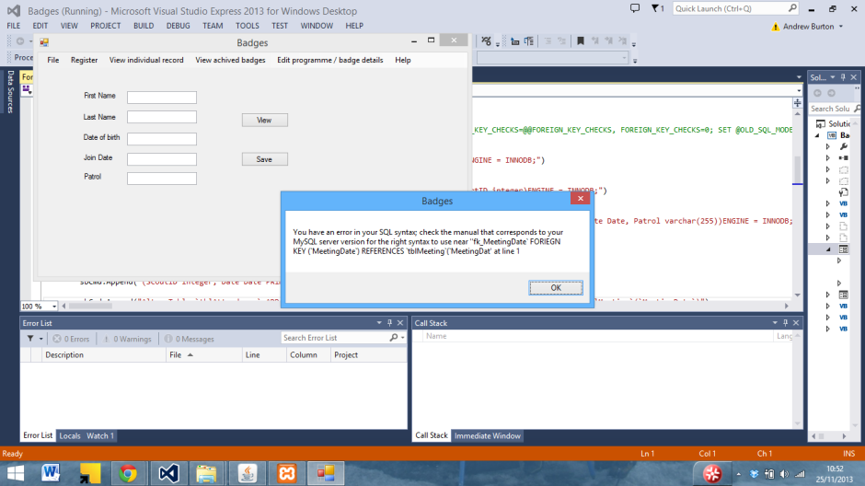

In this screenshot, a SQL syntax error can be seen due to me trying to assign some values a foreign key from another table. After trialling with different methods, I eventually decided to use joins instead to enforce integrity between the databases.

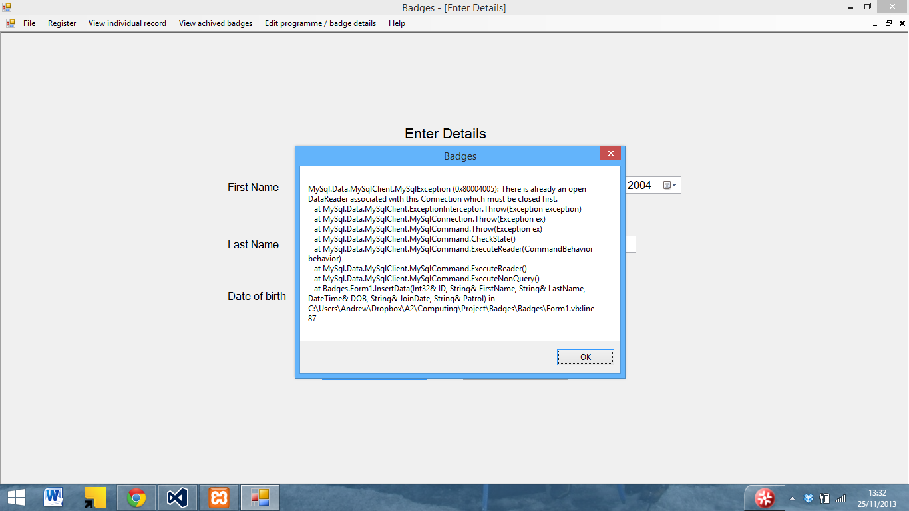

Here another SQL error can be seen whilst inserting data. It has been caused by the fact that I have not closed the data reader when writing or reading the last set of data to the database. As a result I added Reader.Close() to the end SQL statements as can be seen below

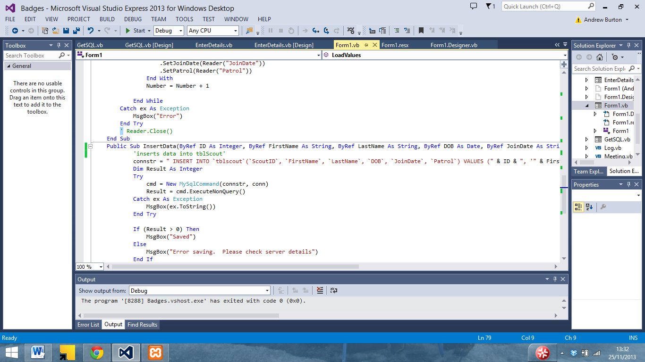

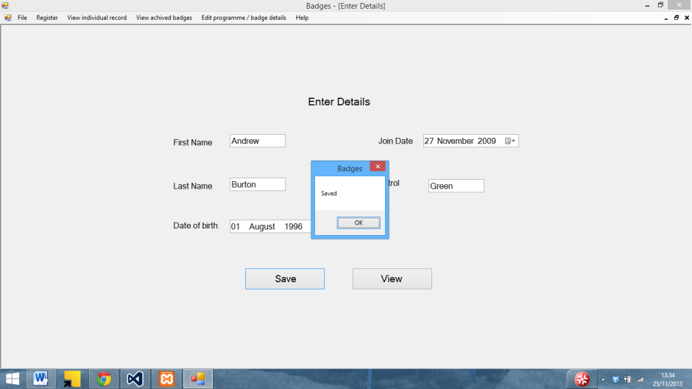

The data could then be saved in the databases

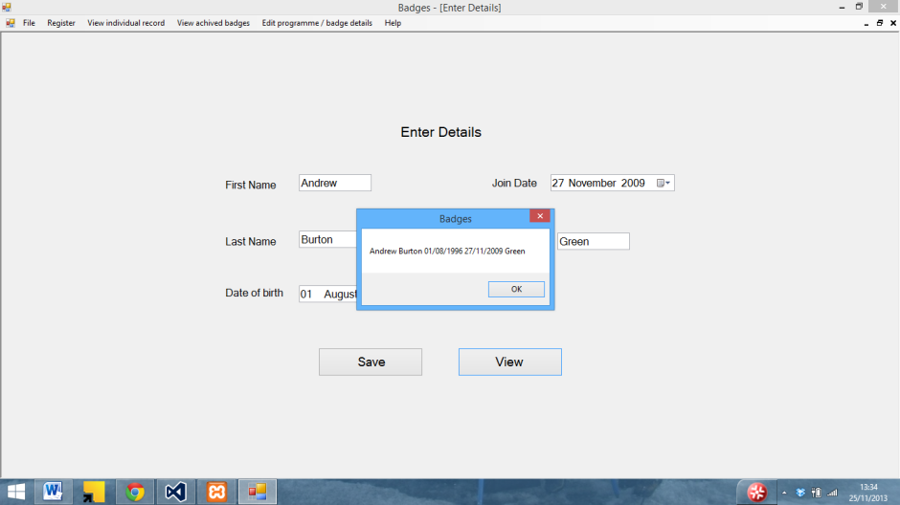

And then displayed in the view function I created to test that the data inserted correctly (removed in final version)

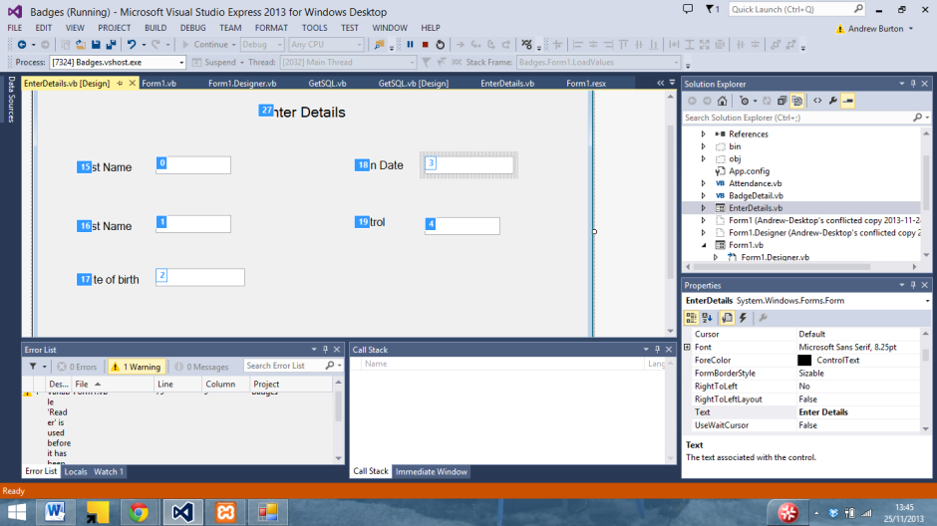

In the above screenshot I am editing the tab order for the enter details form

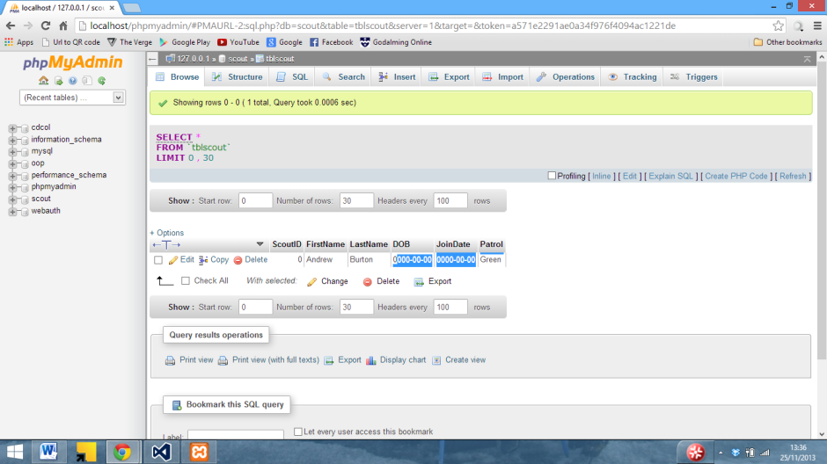

In the above screenshot it can be seen that despite the fact that the data has been entered into the database, the dates have not been stored correctly

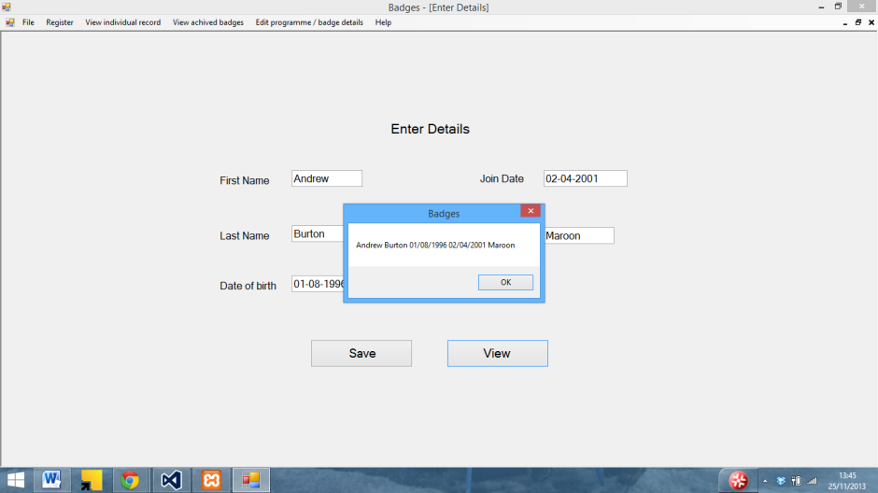

I tried to enter it into the database using – instead of / and replaced the date boxes with text boxed

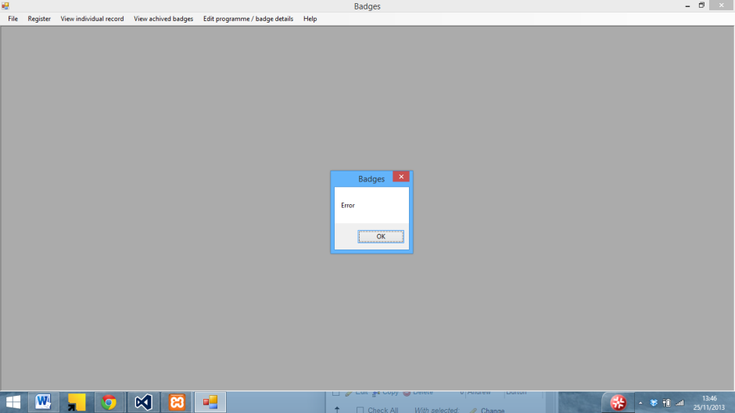

However this crashed the program

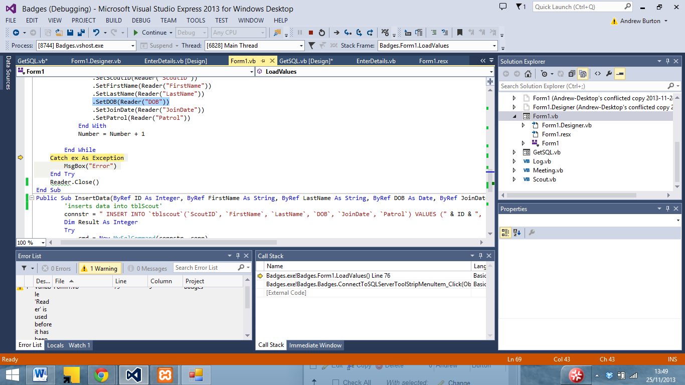

As can be seen above it was due to the program loading the DOB from the SQL server

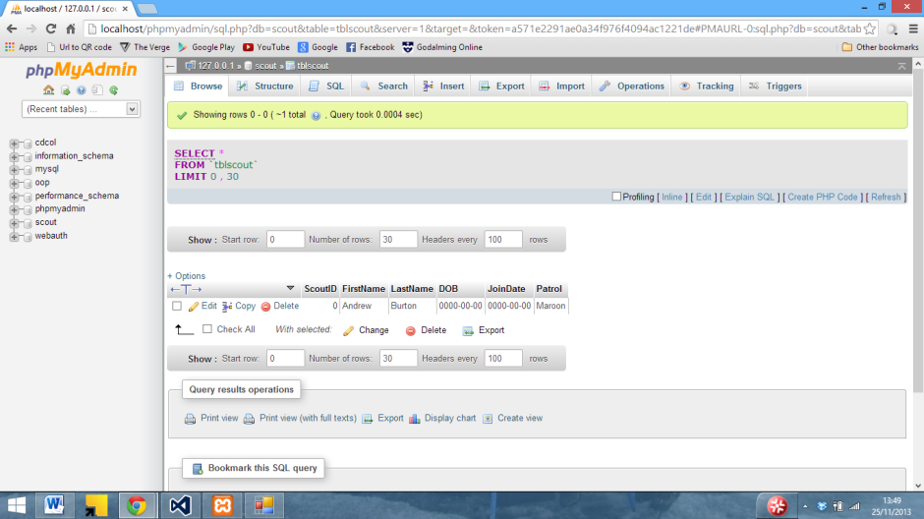

And as can be seen here the database is still not storing the dates.

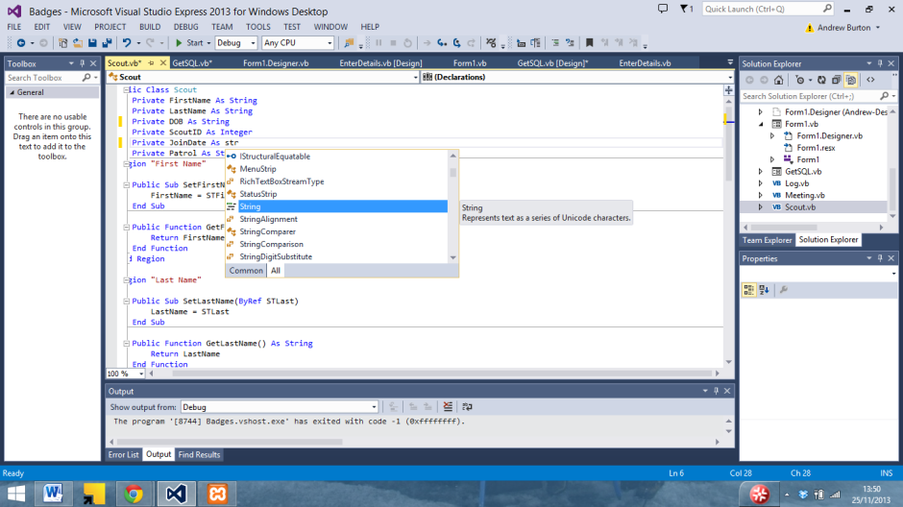

I tried changing the date values in the class to a string

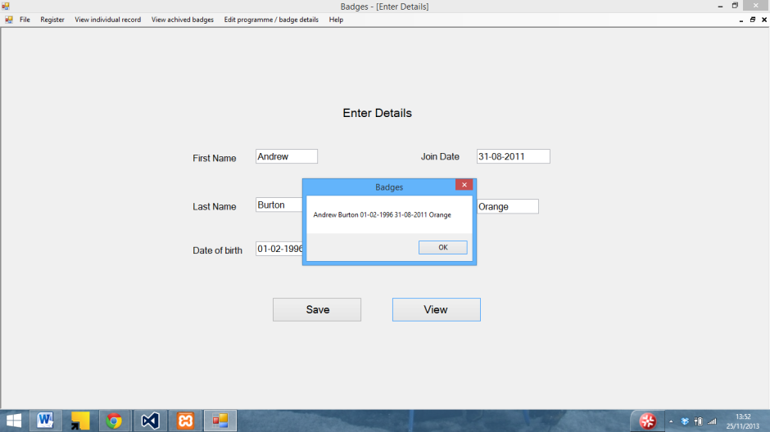

Which whilst saving in the class still wasn’t saving in the database. I eventually realised that SQL uses a 2013-12-29 date format rather than a 29/12/2013 format that is commonly used in the UK.

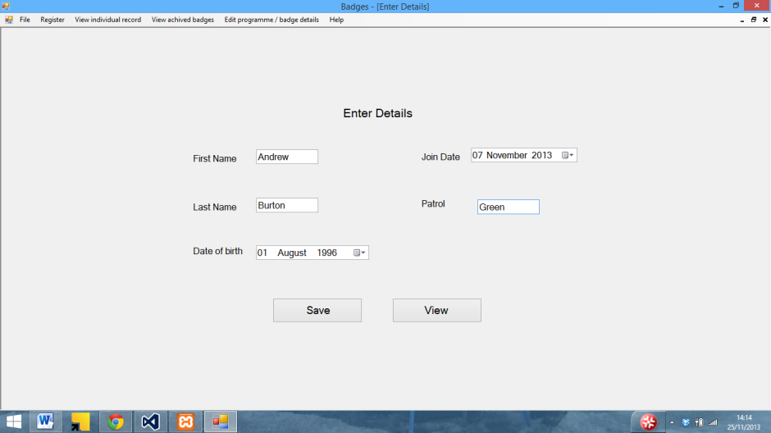

So I changed the date boxes back

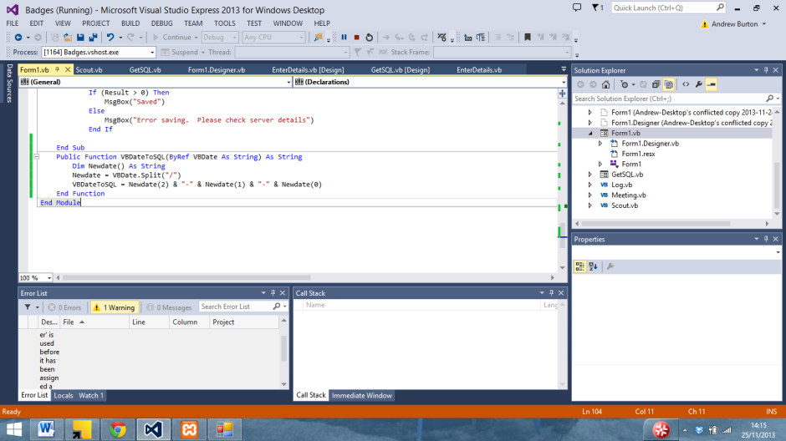

And wrote a function to convert VB dates to the SQL format using the split function

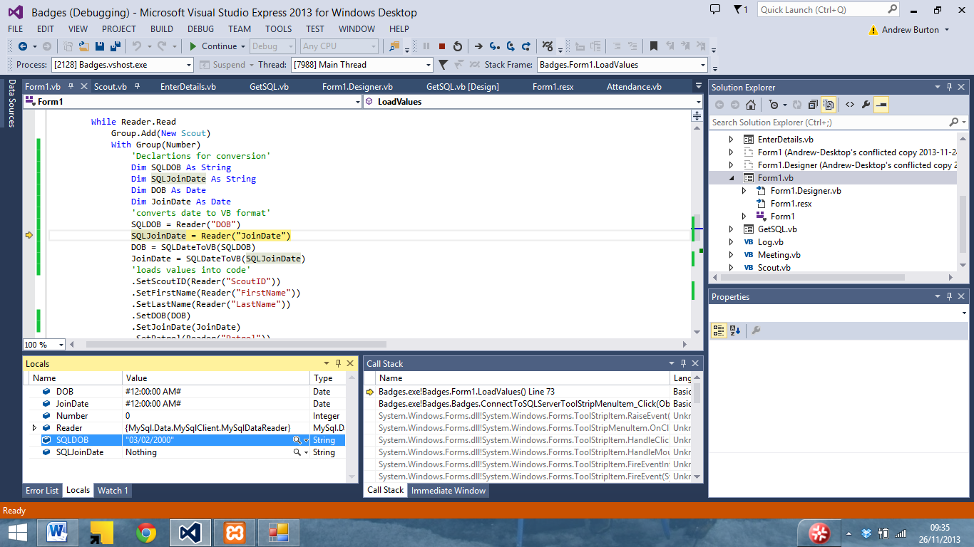On the other hand, whilst loading dates in from the database VB was converting it from a SQ L format

To a US format

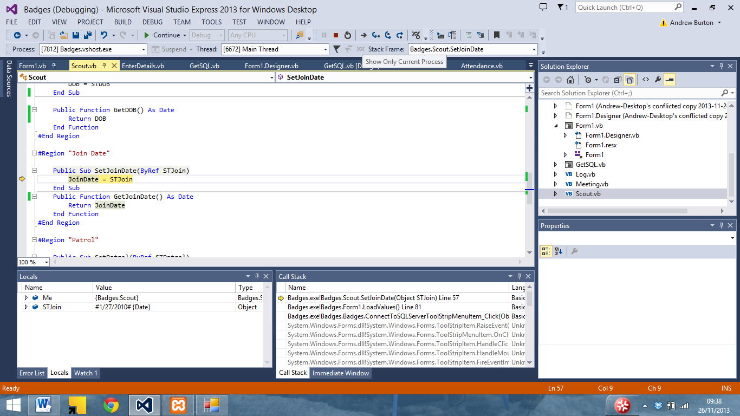

So I wrote a function to convert it to a UK date

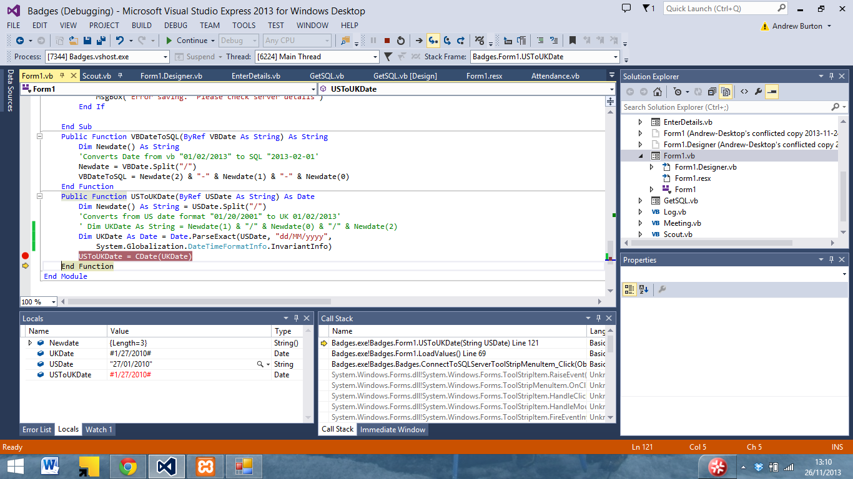

Which now means that data can be written into the database correctly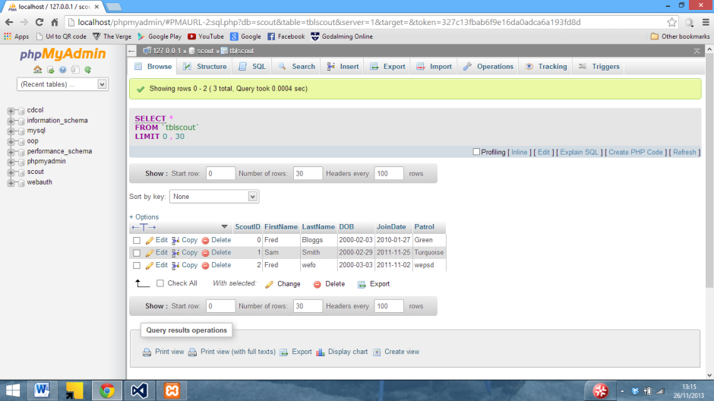

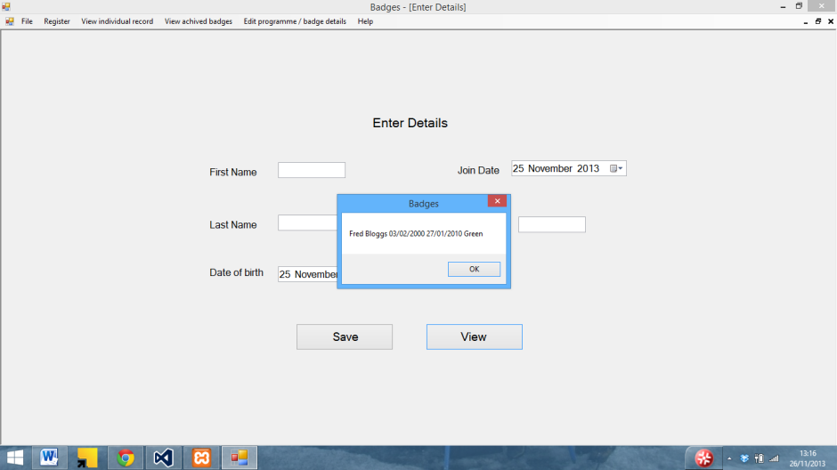

And then load back into VB correctly.

Here an experiment with of putting logs into a datagridview can be seen using an array

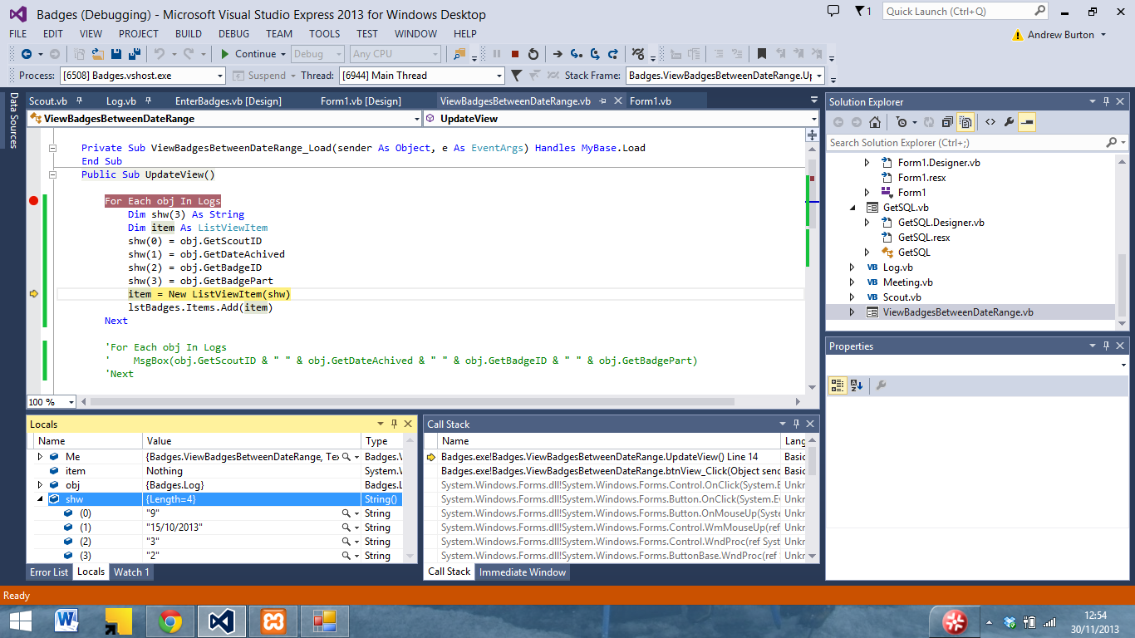

It puts the values into the array

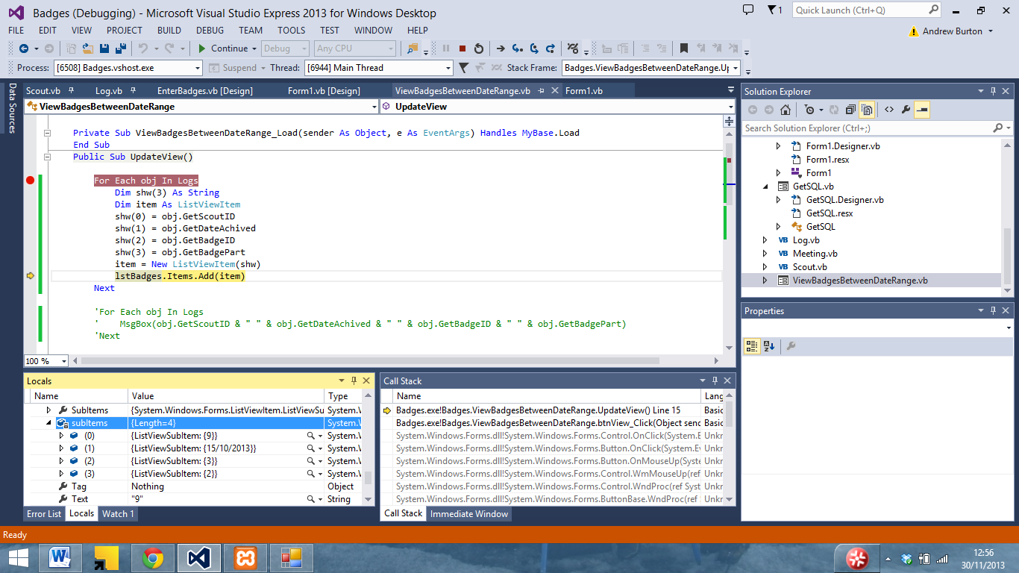

But then won’t display it correctly

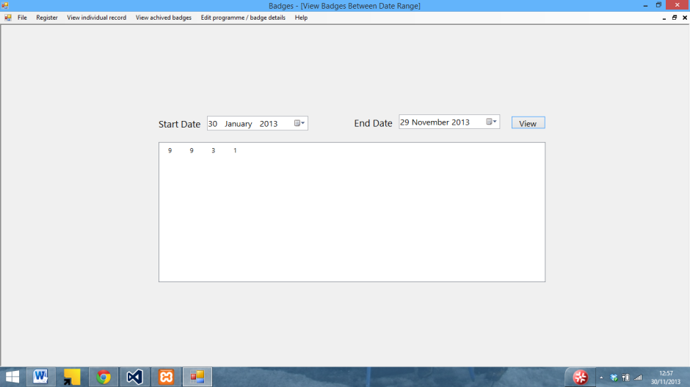

I then tried using some static text to see if that would work

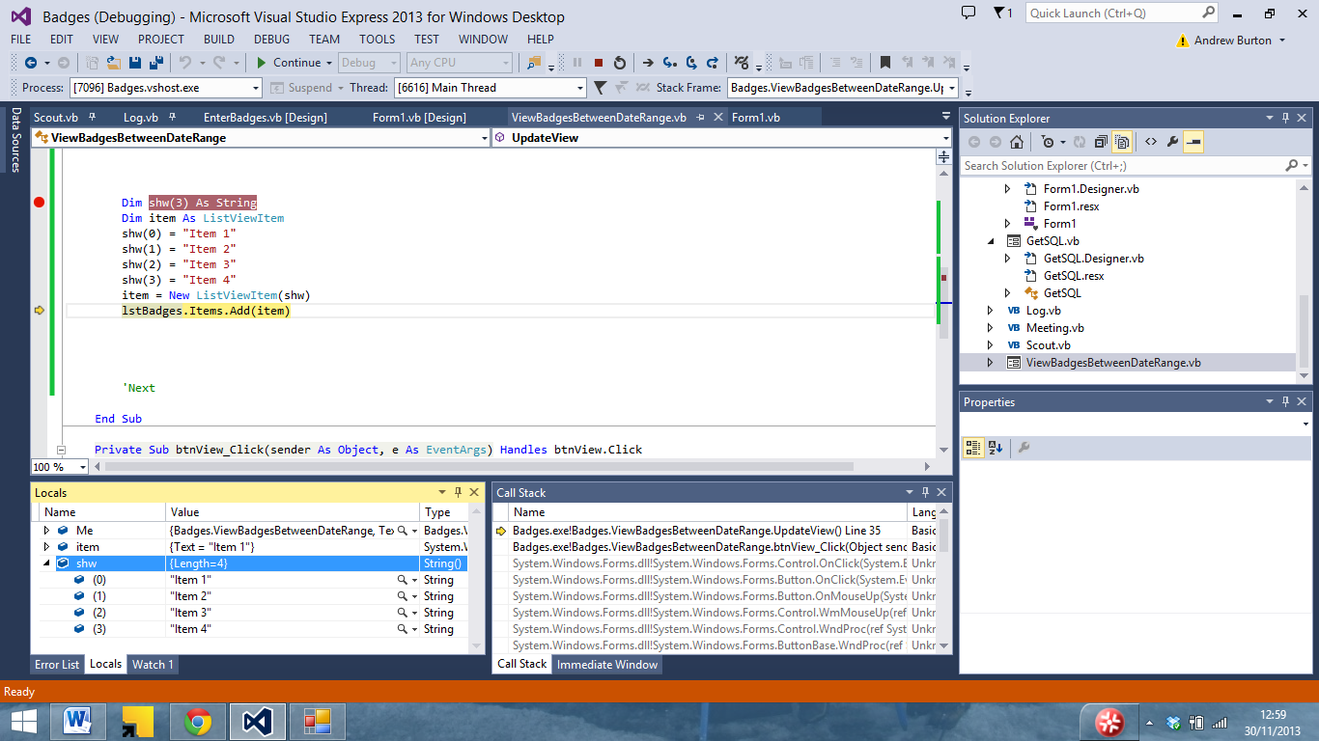

Whilst going into the array with no issue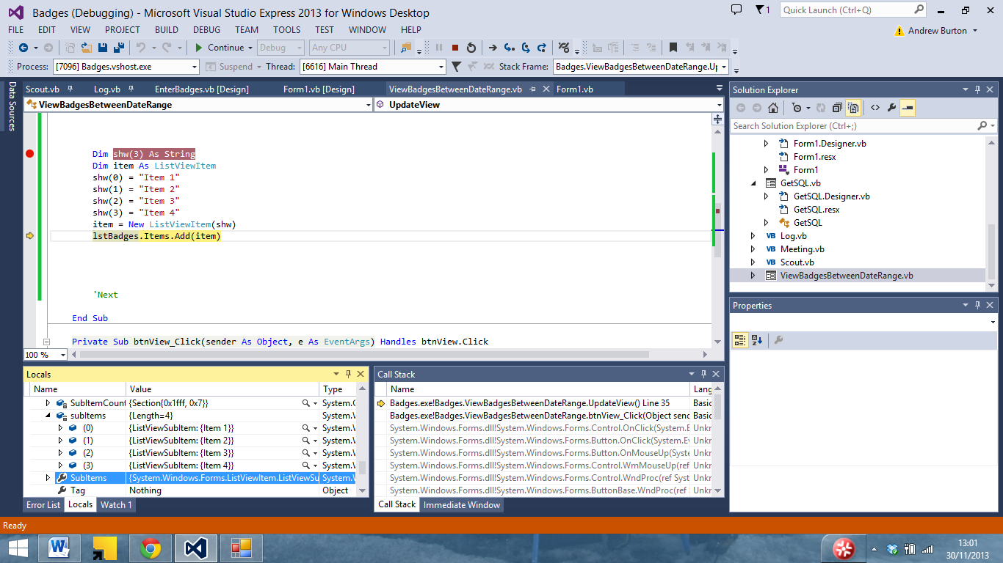

It still would not display correctly.

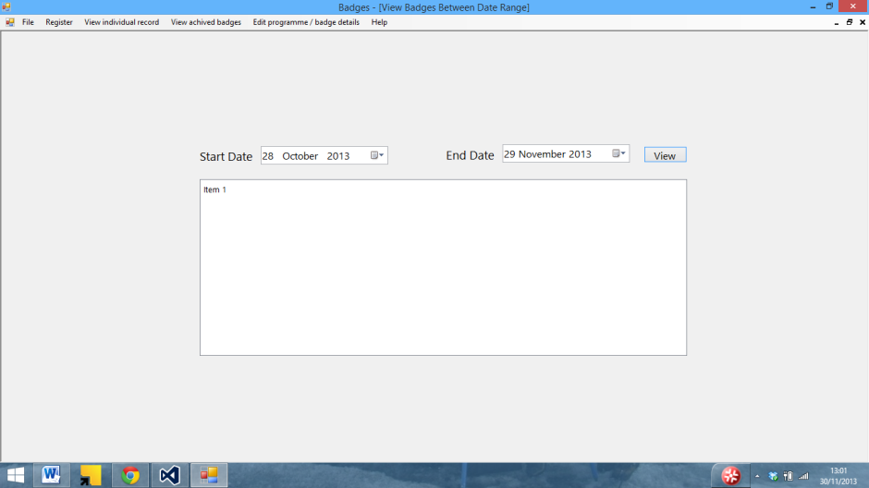

I then tried to get the data from log to display in a message box to ensure that it was in a suitable format to be displayed

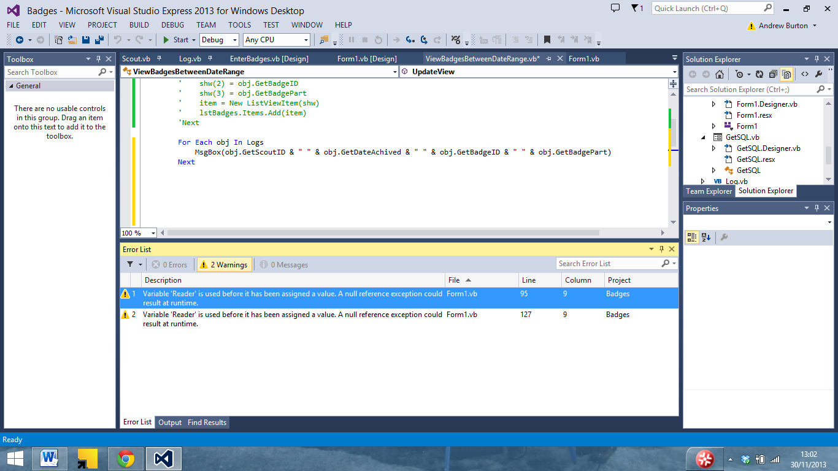

Which was able to display data with no issue.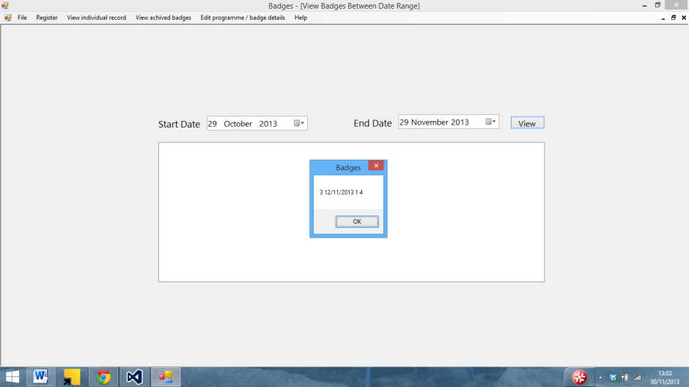

I then tried to use a datagridview to see if that would display the data

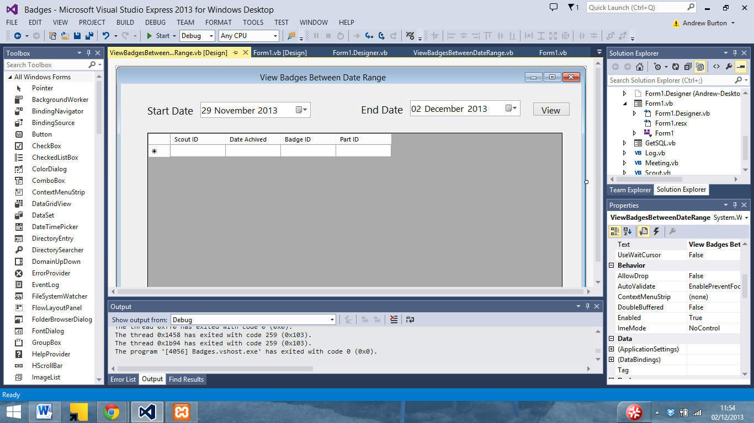

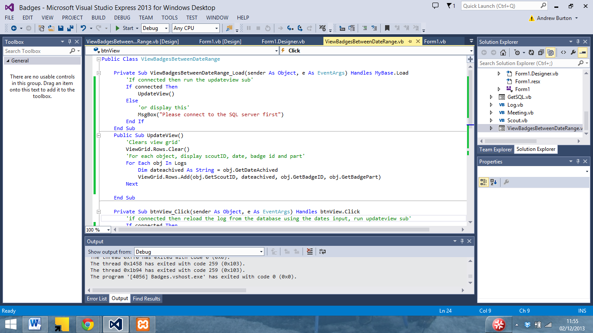

With different code

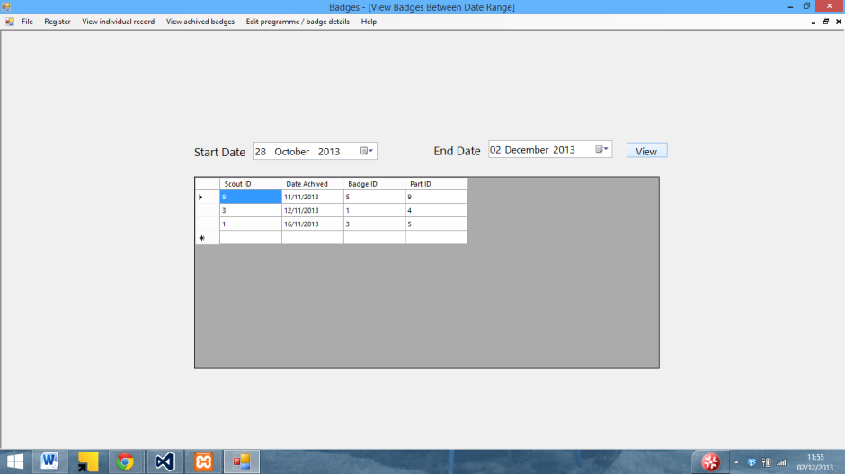

Which was able to display the data from log

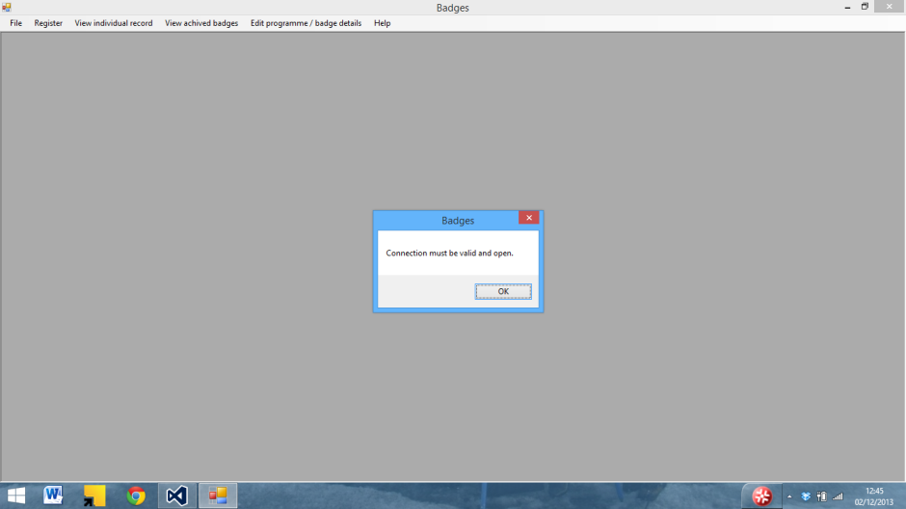

Here an error caused by the fact that the program was unable to connect to the server can be seen

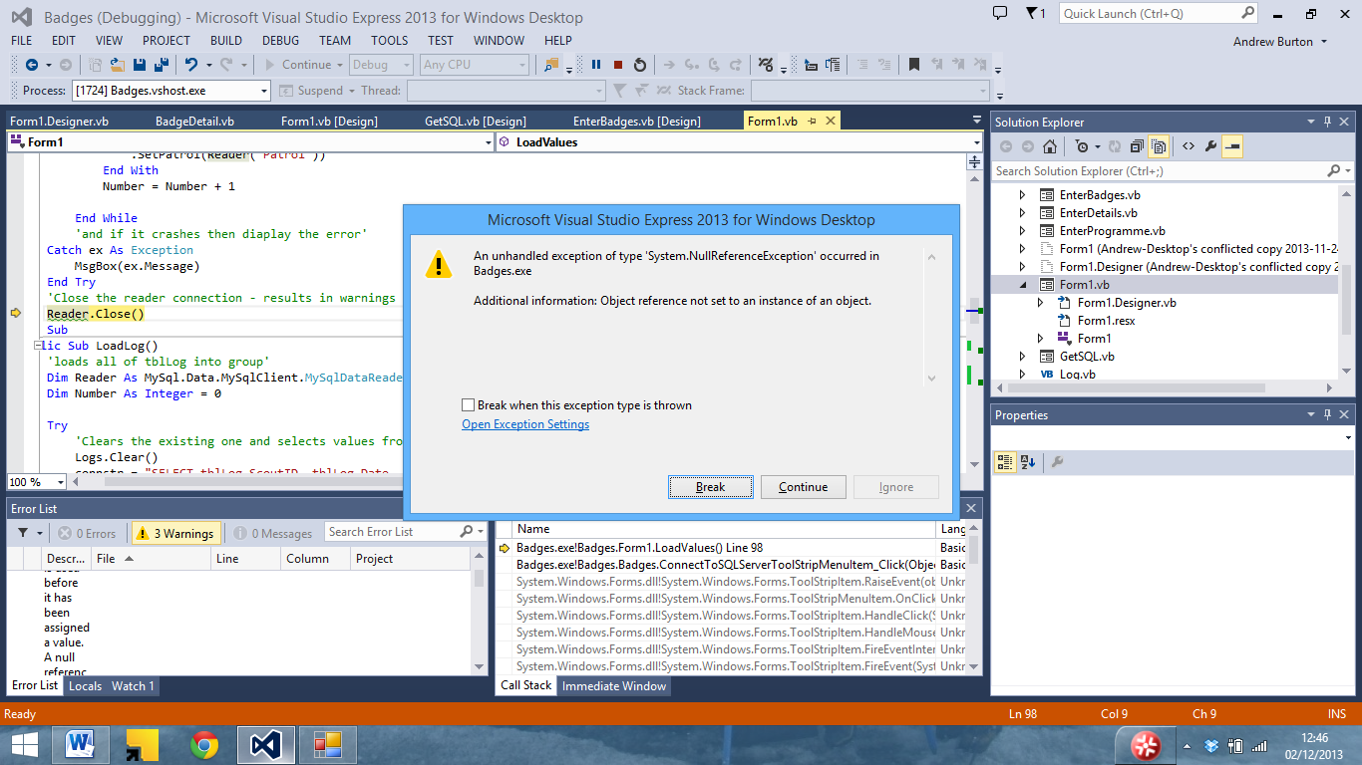

Which then causes the program to crash.

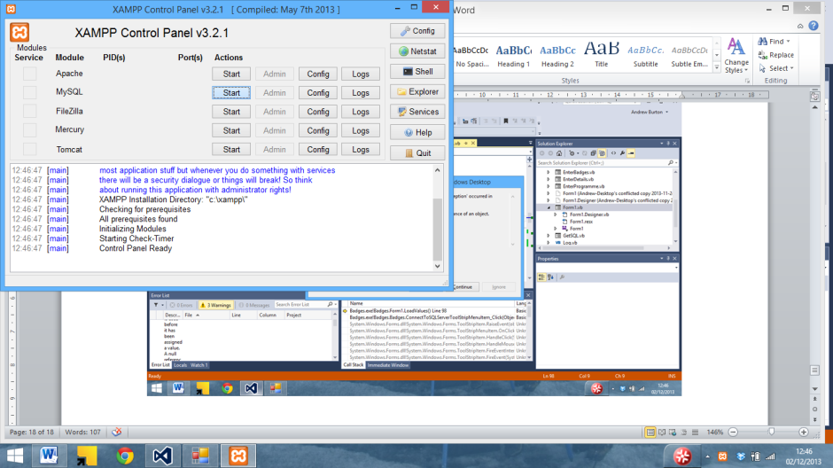

After a bit of troubleshooting it turned out that there was no server running.

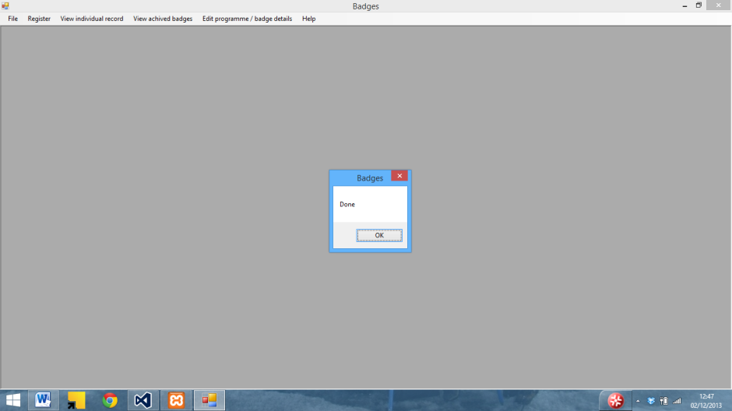

The program was then able to connect to the SQL server

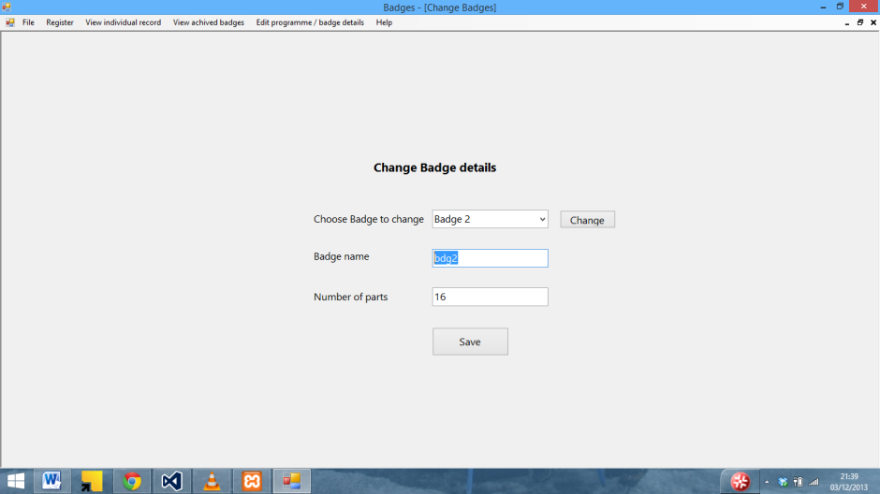

I also had issues with the change badge details form. Here the enter badge name screen can be seen.

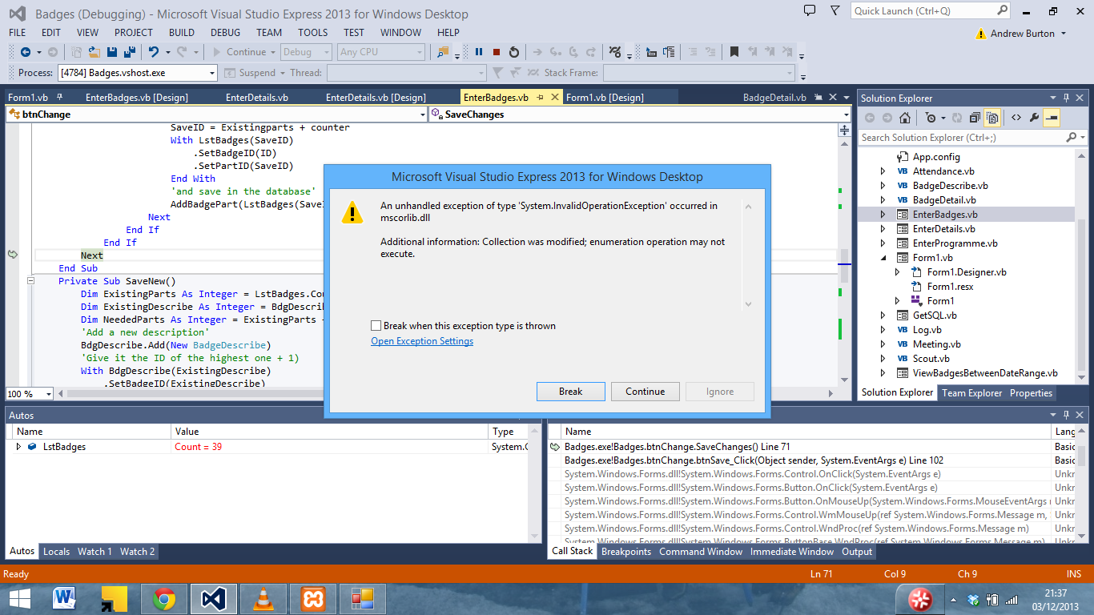

Which crashes when saving

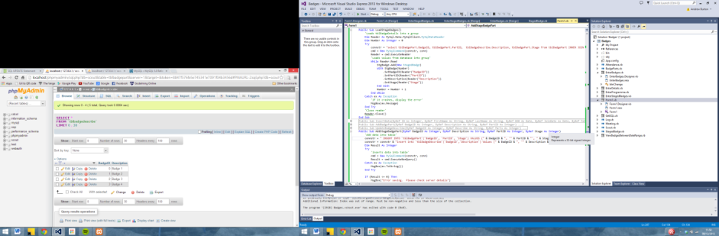

Although not very clear I modified loadbadges to store the position of the item in the list as well

While Reader.Read

StgBadge.Add(New StagedBadge)

With StgBadge(Number)

.SetBadgeID(Reader("BadgeID"))

.SetBadgeDescription(Reader("BadgeDescription"))

.SetStage(Reader("Stage"))

.SetPosition(Number)

End With

Which then saves the badge into the database.

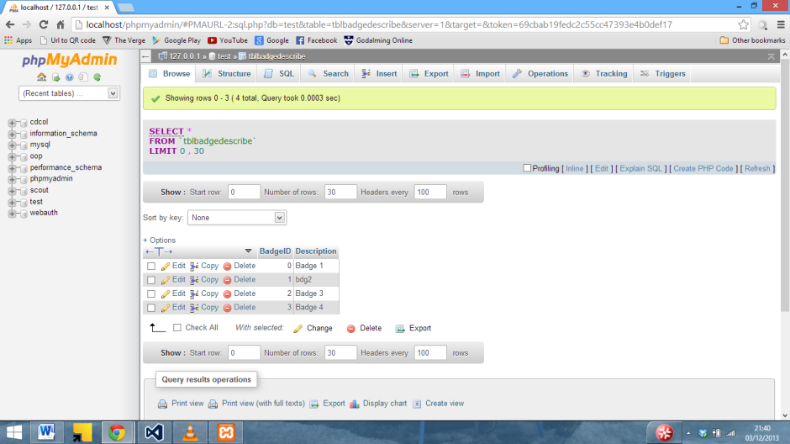

Here an SQL error in the change stage badges screen can be seen.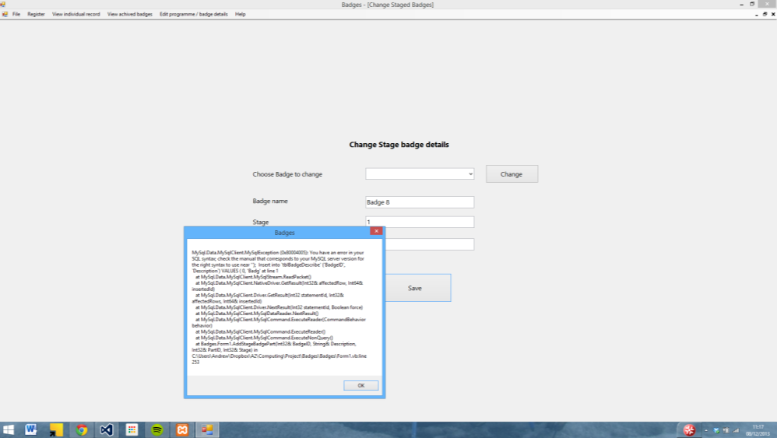

After trying different things with the SQL statement, it turns out there was a ‘ in the SQL statement missing after the date value

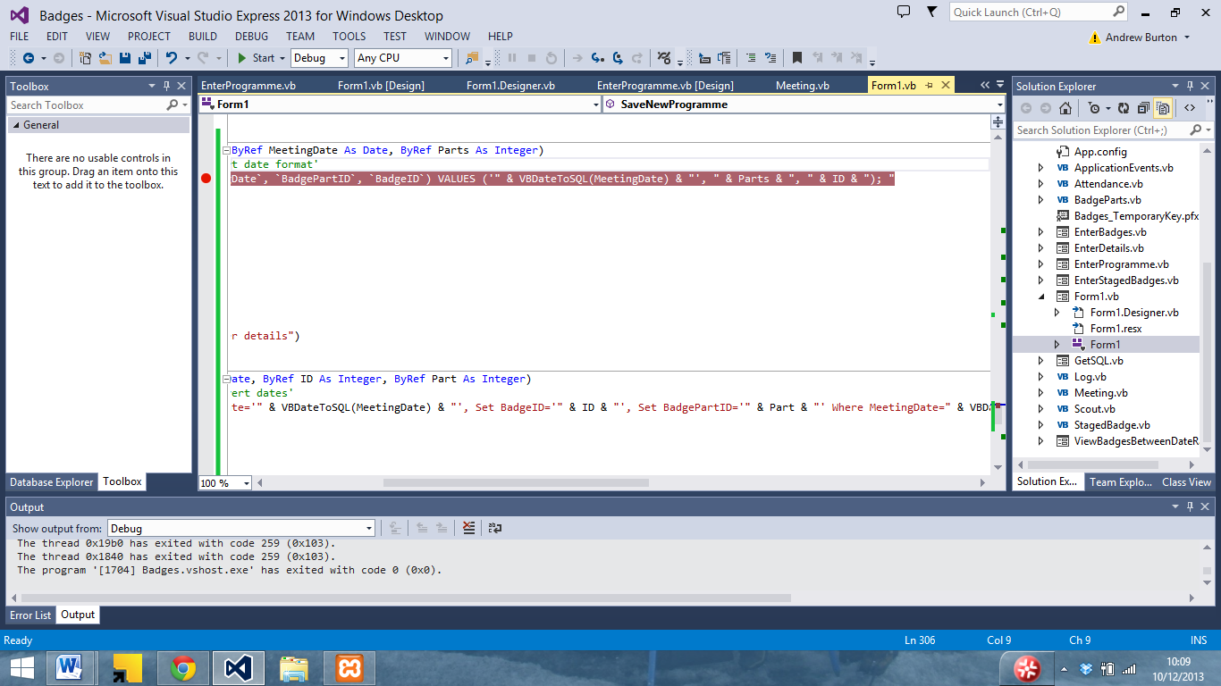

The staged badges now save into the database.

Here another SQL error can be seen in the log table, which has occoured due to the fact that the date already exists as it is the primary key for the table.

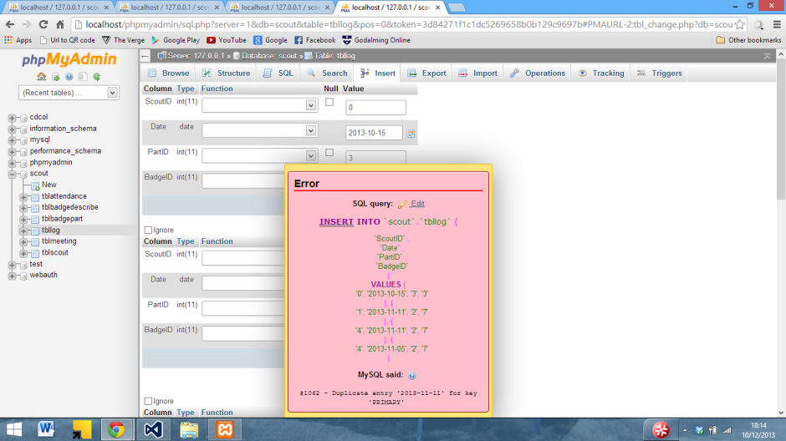

I sorted it by editing the database creation command to remove the primary key from the table

Although this ended up throwing another error due to the fact that I had set dateachived in ViewBadgesBetweenDateRange as a string rather than as a date

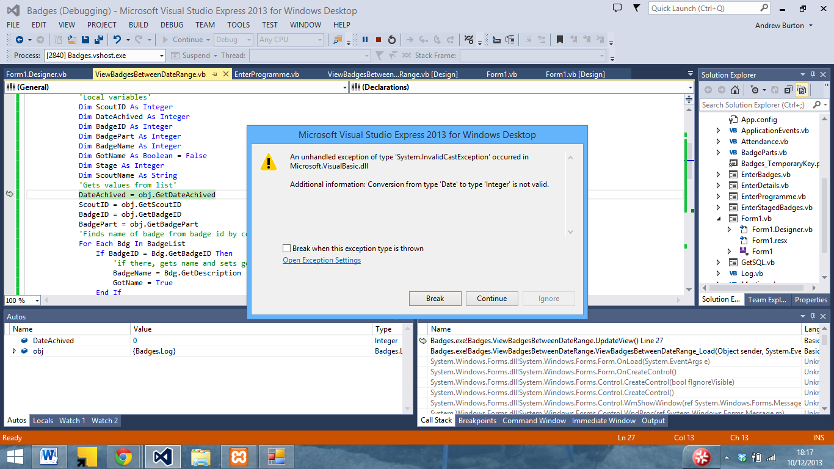

I changed the declaration

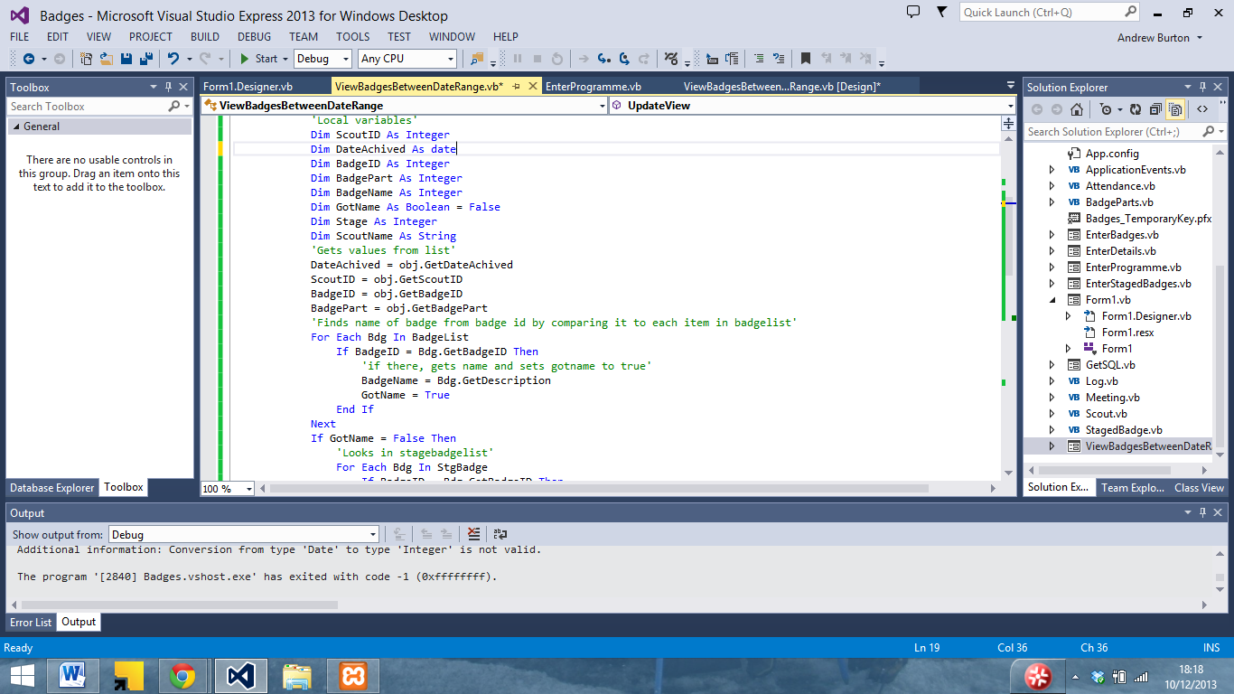

Although when I reran it, I encountered the following error due to the fact that BadgeName had been declared as an integer instead of a string

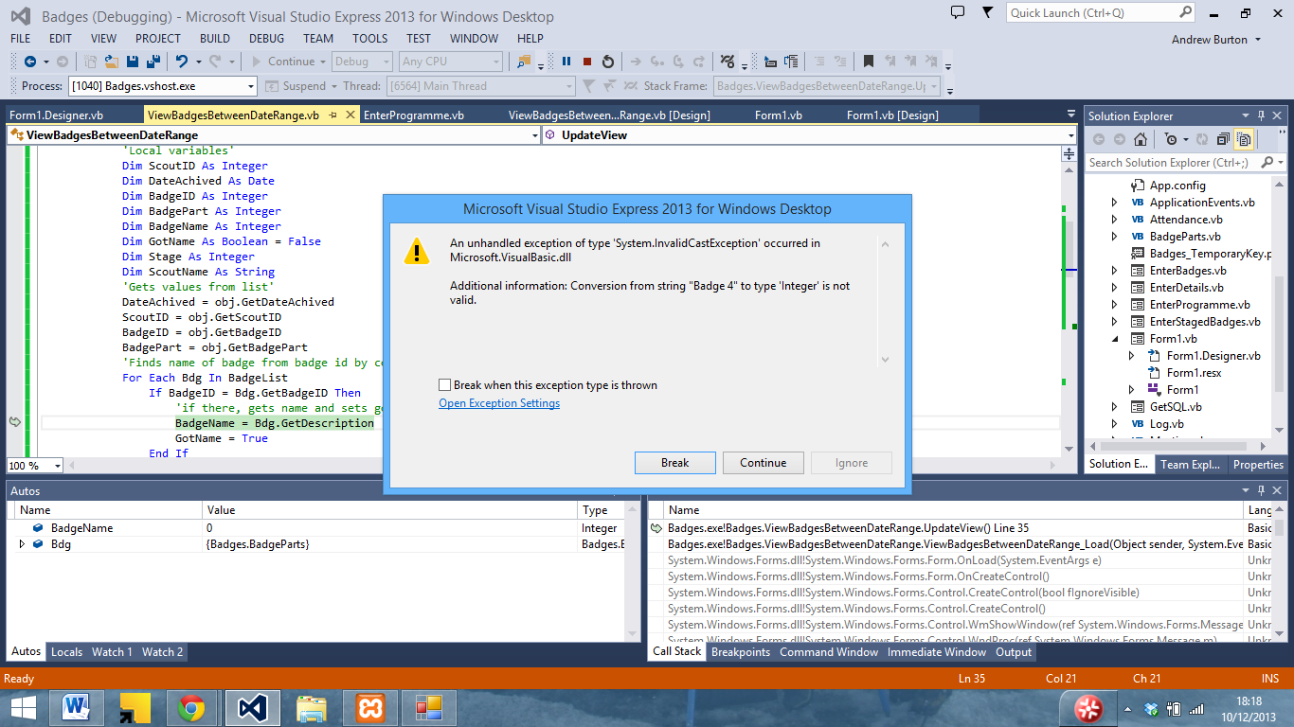

Once I had changed it to a string, I reran the program and it displayed the data correctly

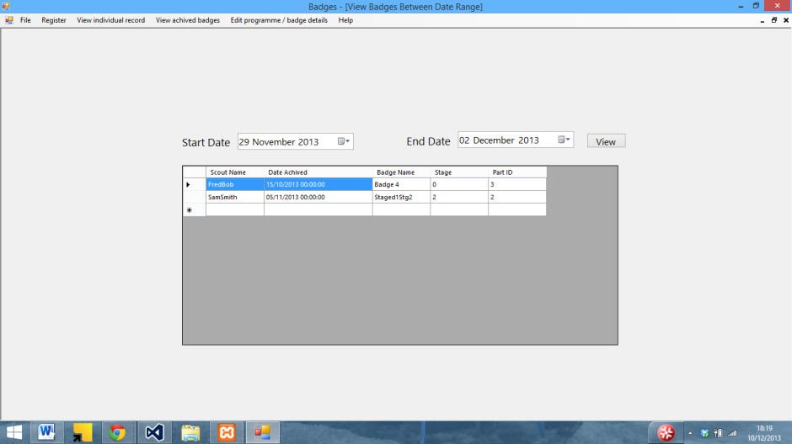

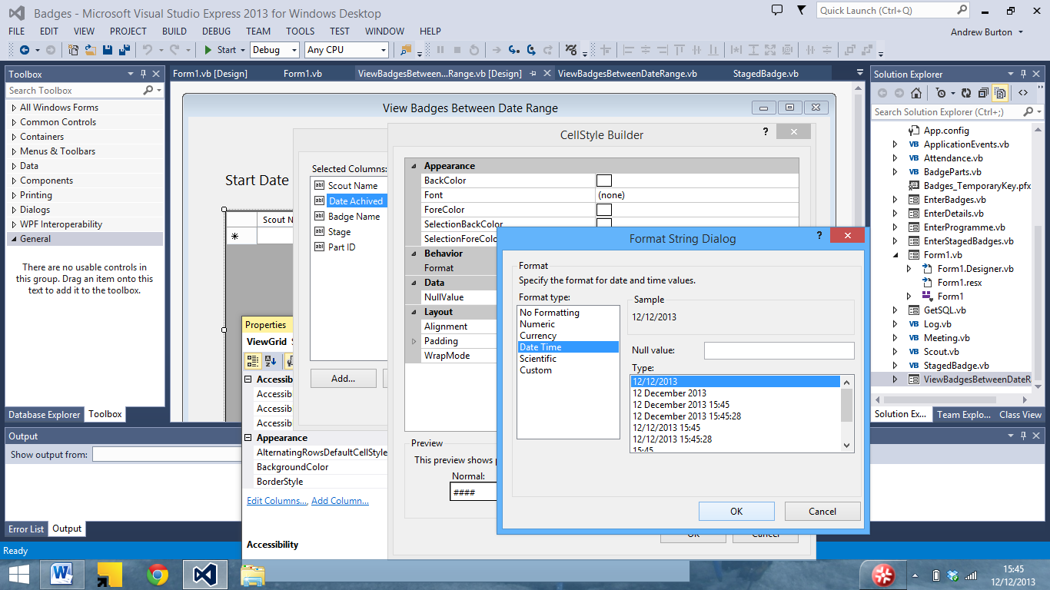I then changed the date format to hide the time.

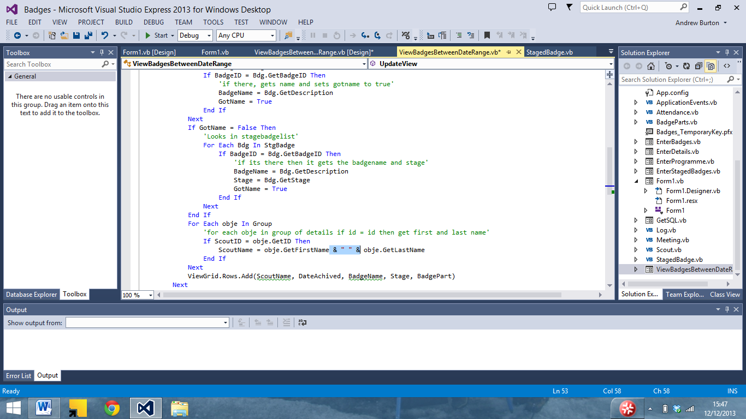

And I added a space between the first name and last name

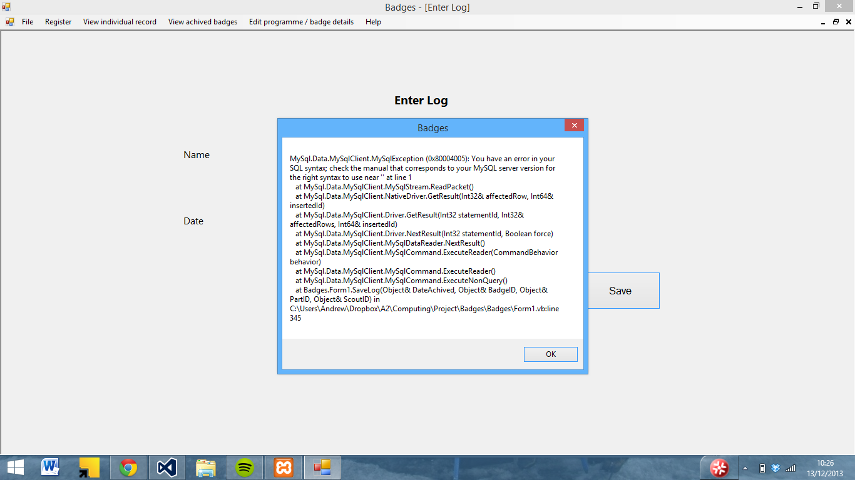

Above a SQL error in enter log can be seen. After some troubleshooting, it turns out SQL statement was missing a )

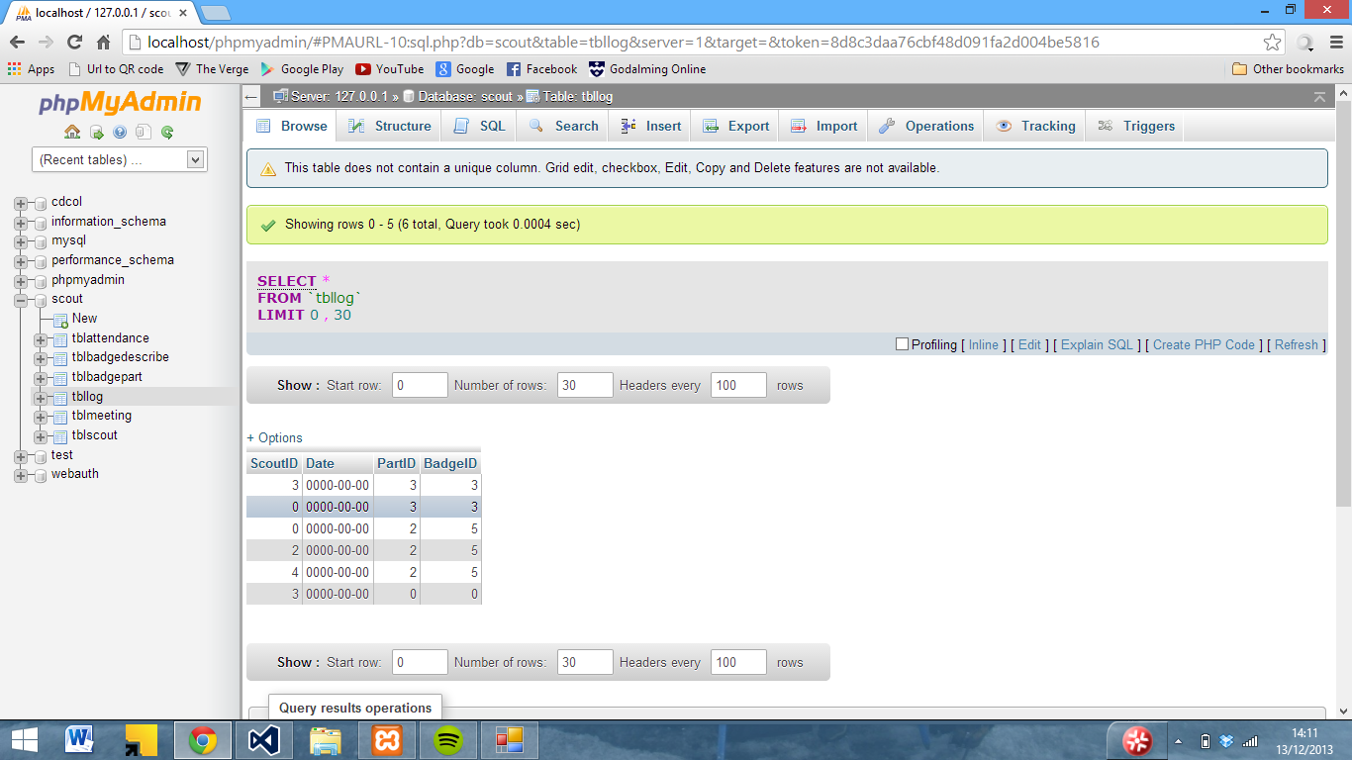

The program was also not storing the date in the correct format as seen above

Stepping through the code I can see that it is inserting it in the correct format.

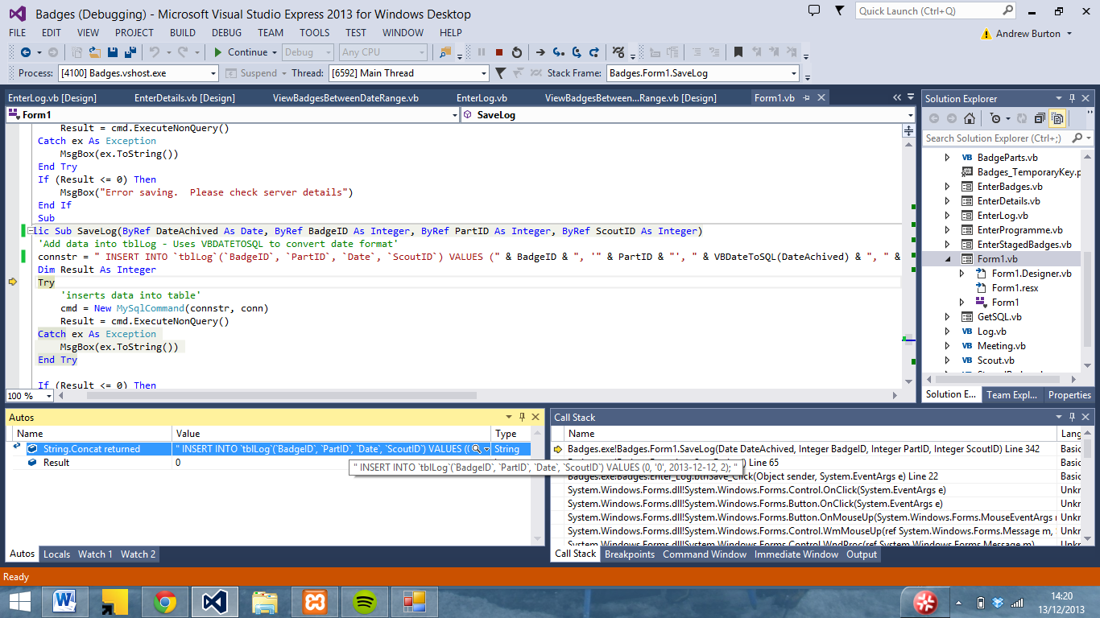

I looked at the other SQL subs to see if there was something missing or wrong with the statement, and found that the date in other subs had been declared as a a string rather than as a date

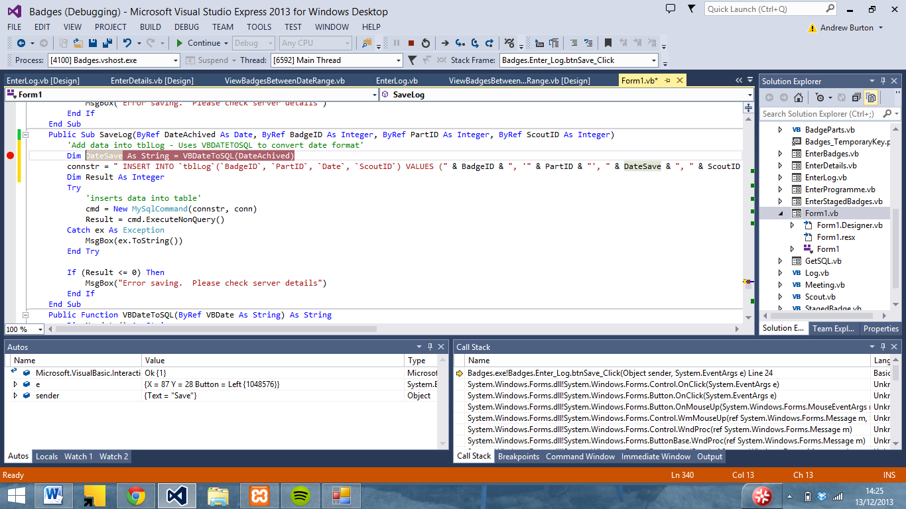

Although this still did not work

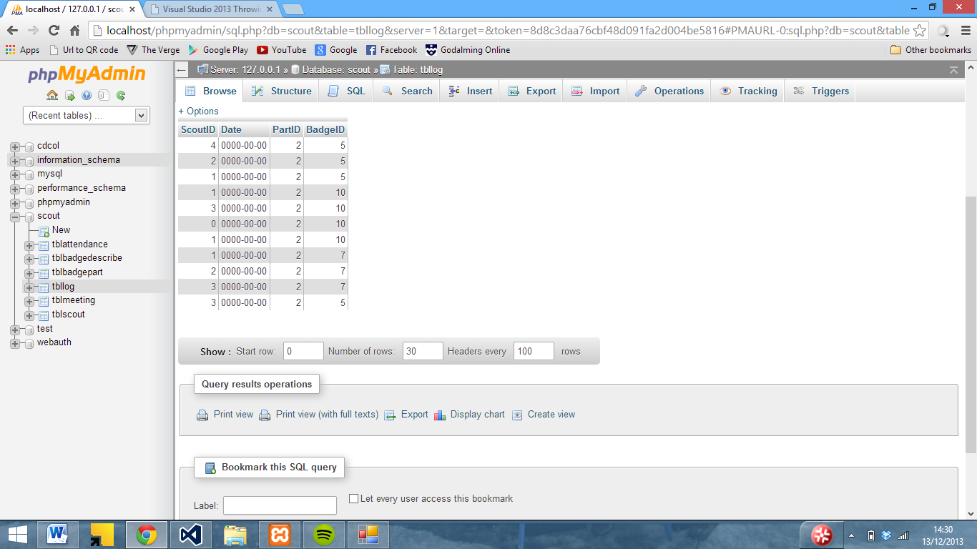

After various other attempts to fix it, it turned out to be an issue with the SQL command.

Here are a few more SQL errors

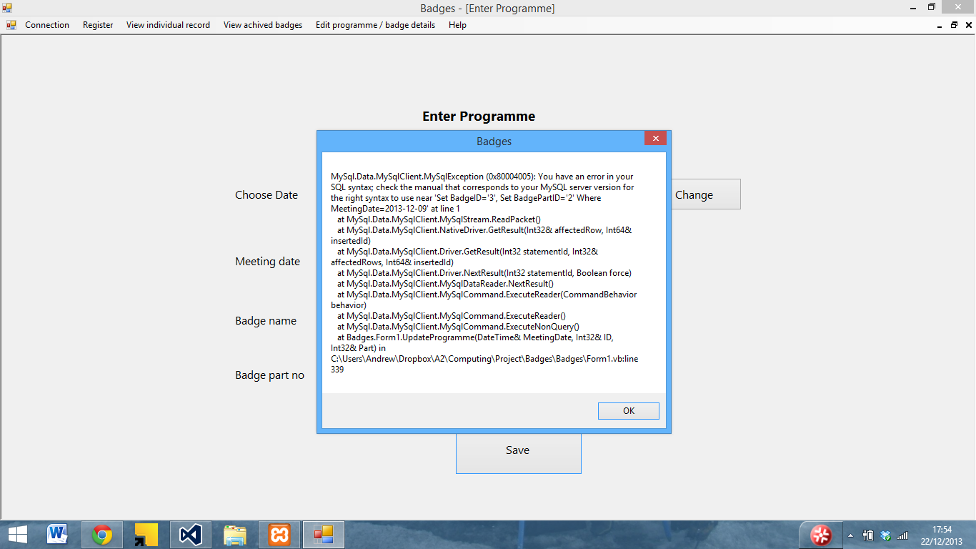

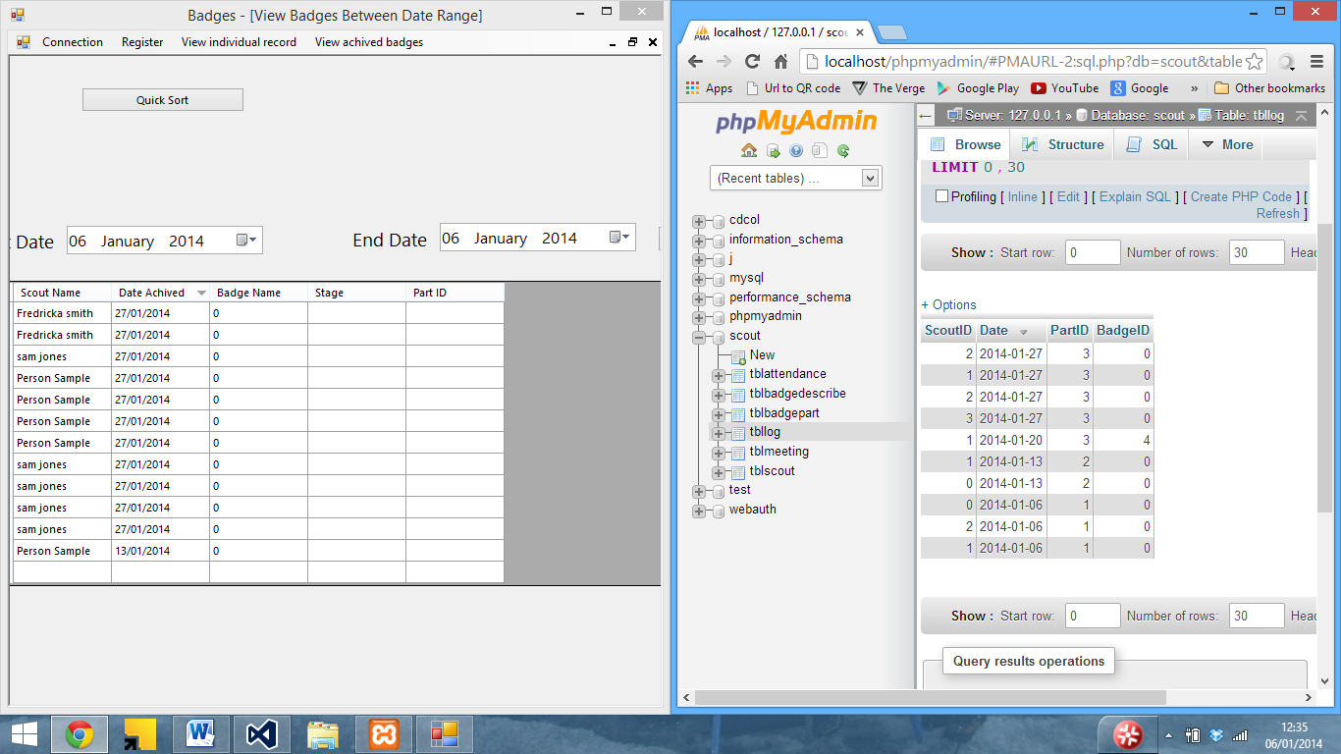

Here an SQL error can be seen whilst adding a badge

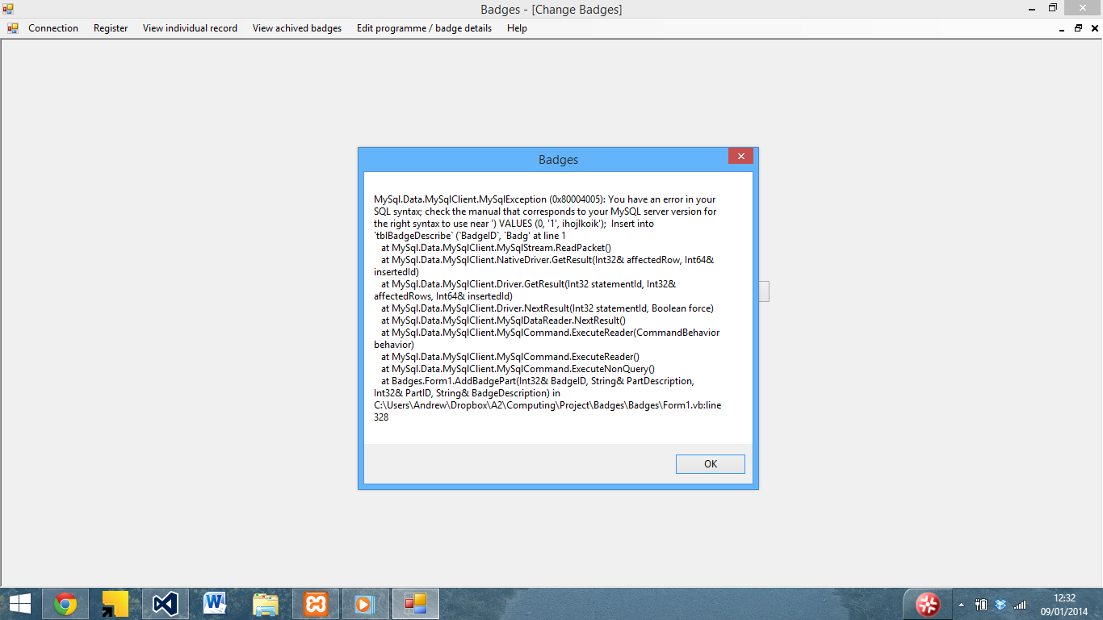

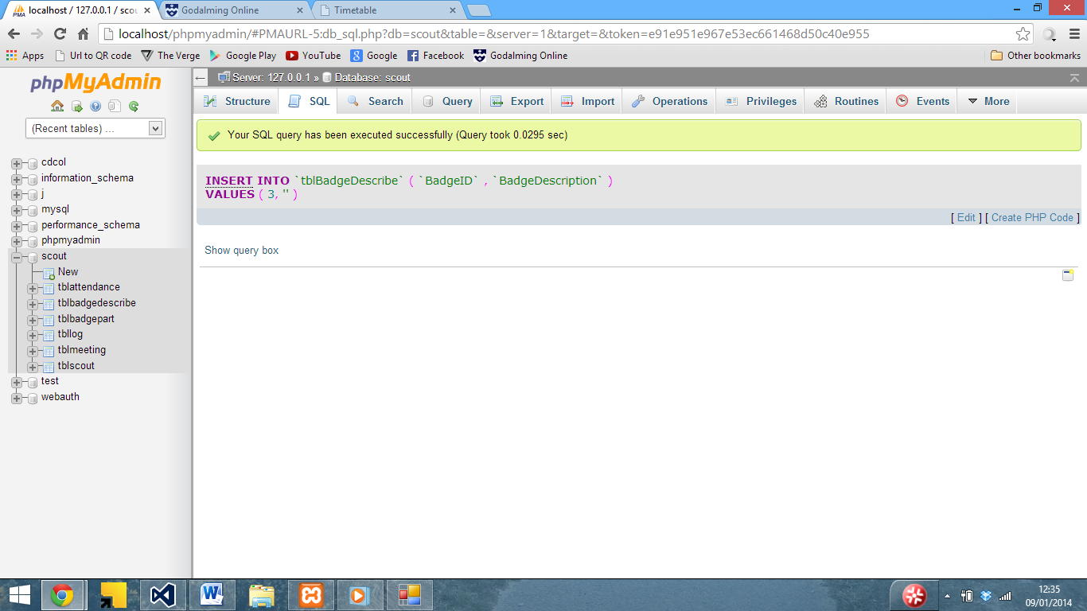Although inserting manually works…

I also had a similar issue with inserting badge parts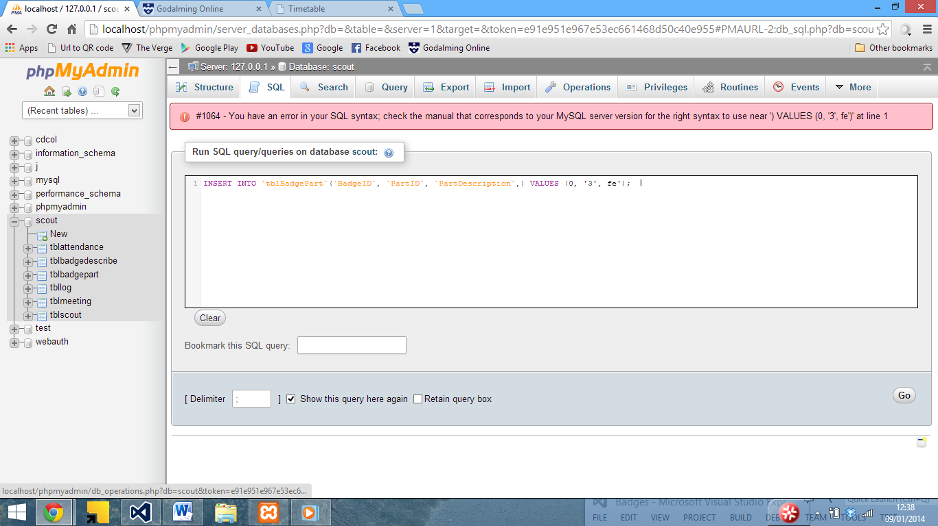

In both cases the issue was caused by a missing ‘ in the SQL statement.

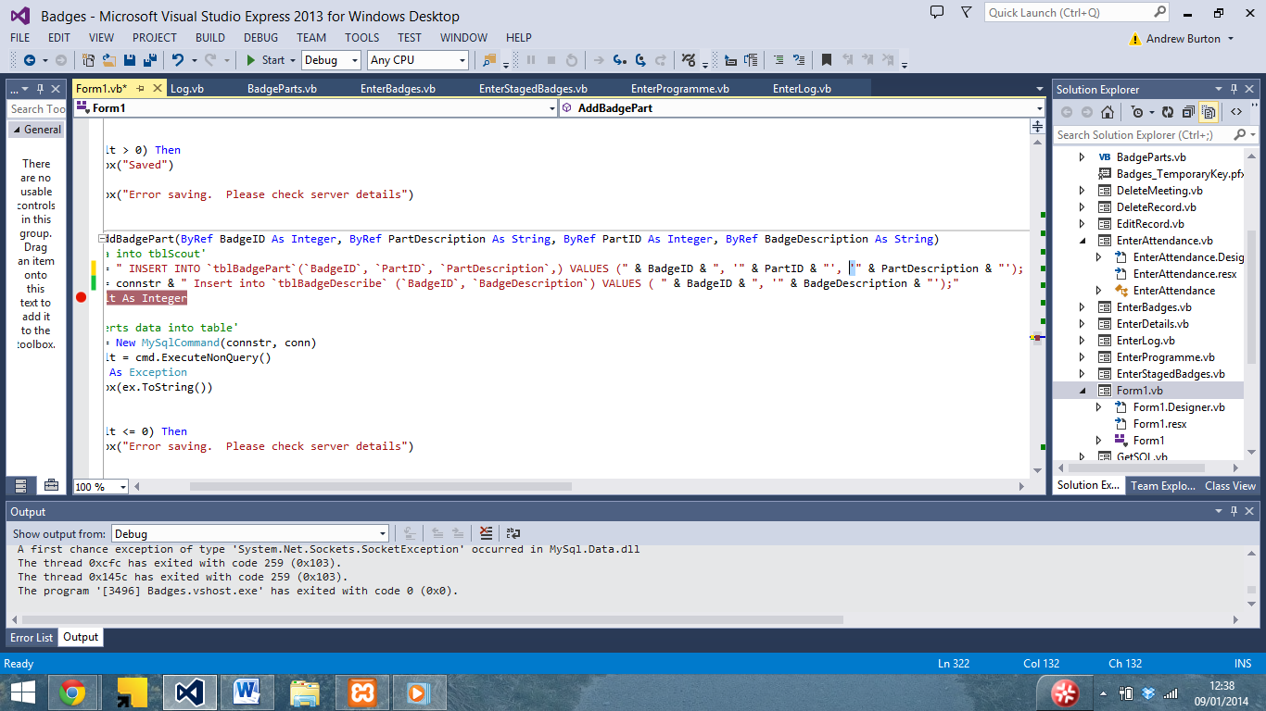

Which I then added to the SQL statement.

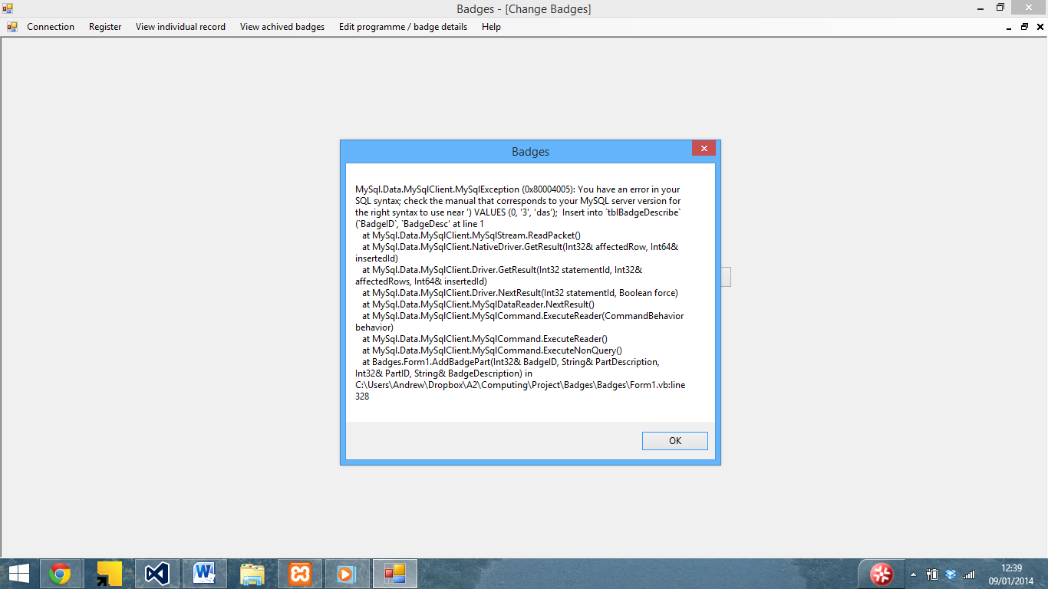

Although another error occoured whilst entering badge details

After looking at the SQL statement in VB, I noticed that there was a comma in the wrong place as well as seen below 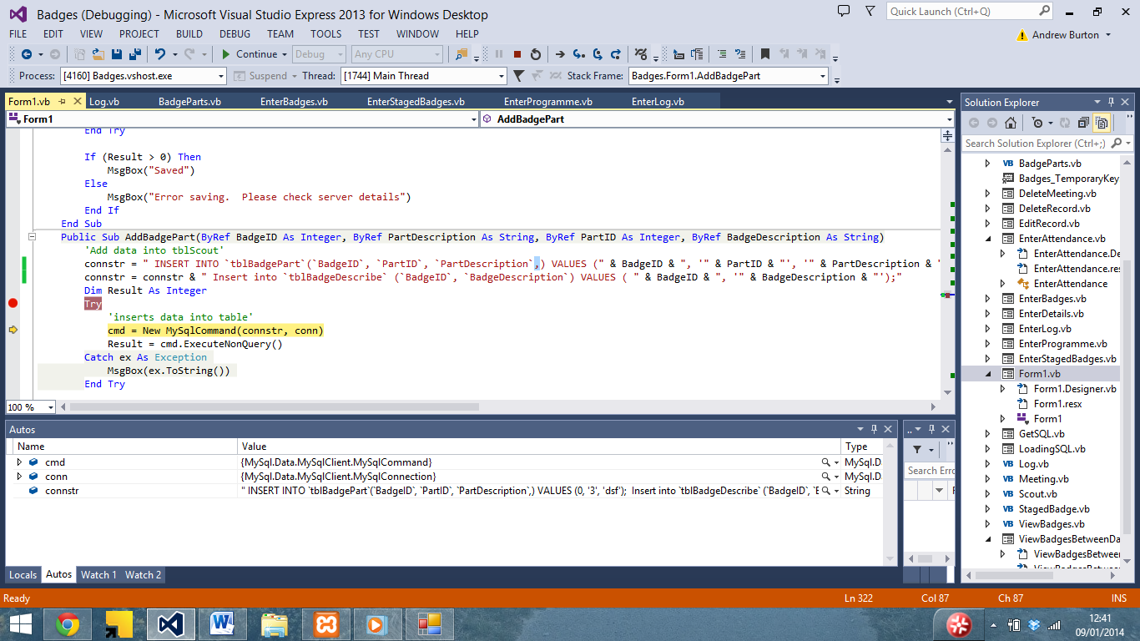

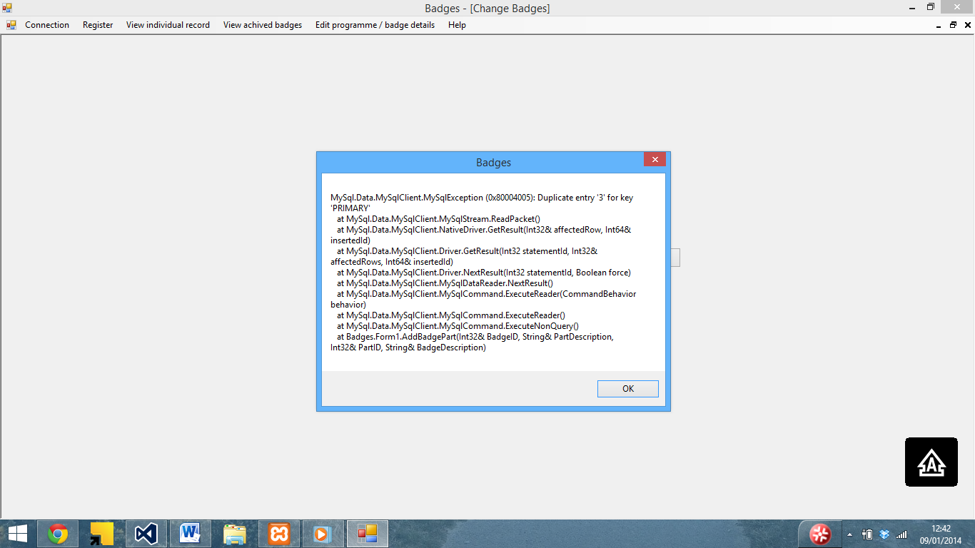

I then reran the program and encountered the error seen above due to a duplicate primary key, which I resolved by editing the database creation code to remove the primary key, which then saved.

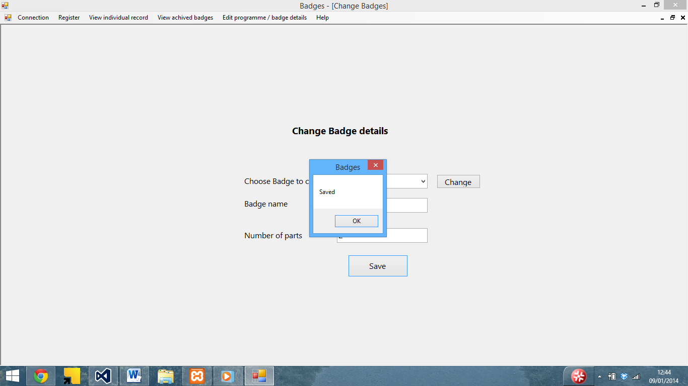

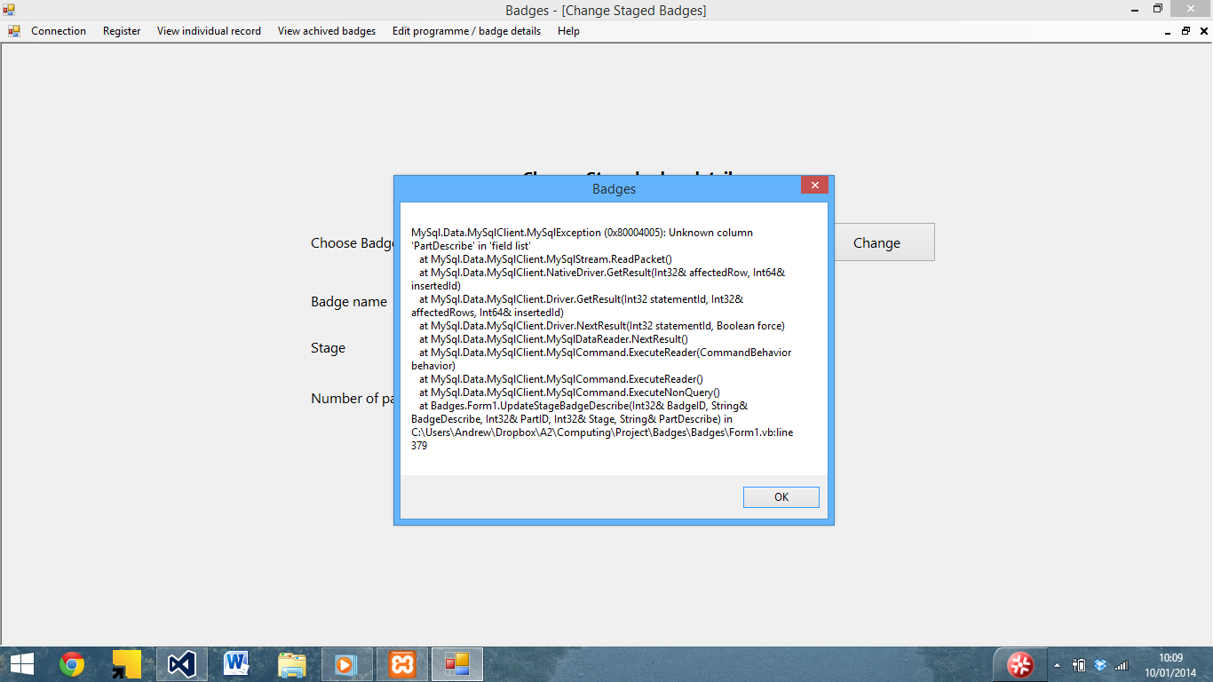

I also encountered a similar issue with enter stage badges

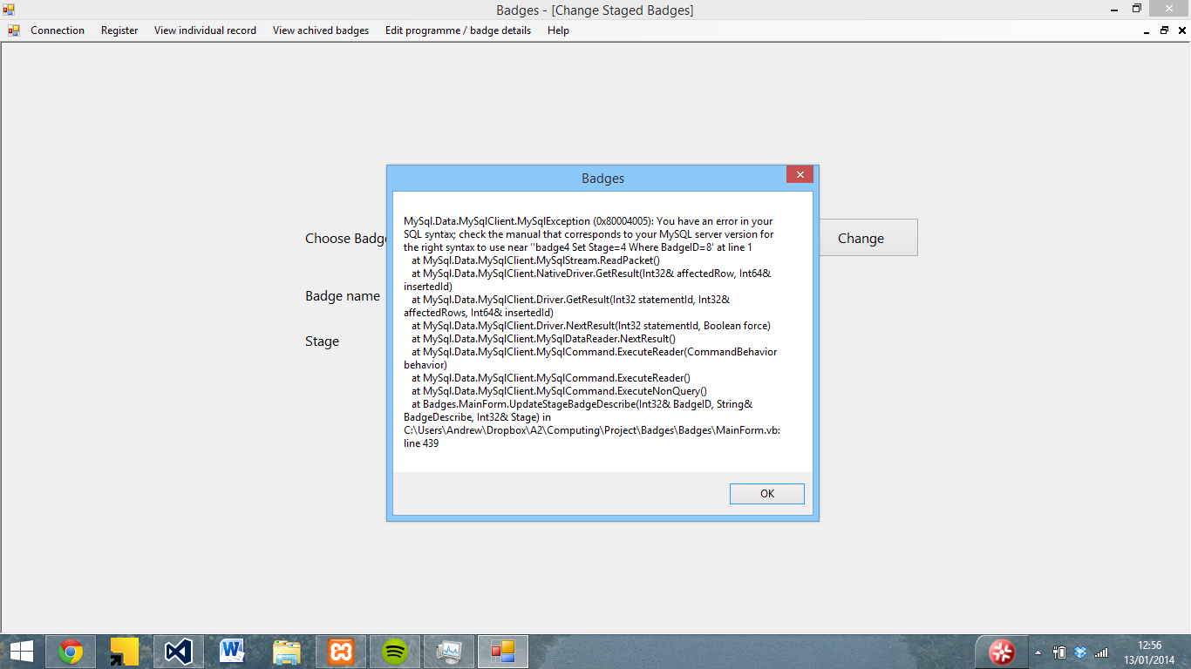

Which was due to an SQL error 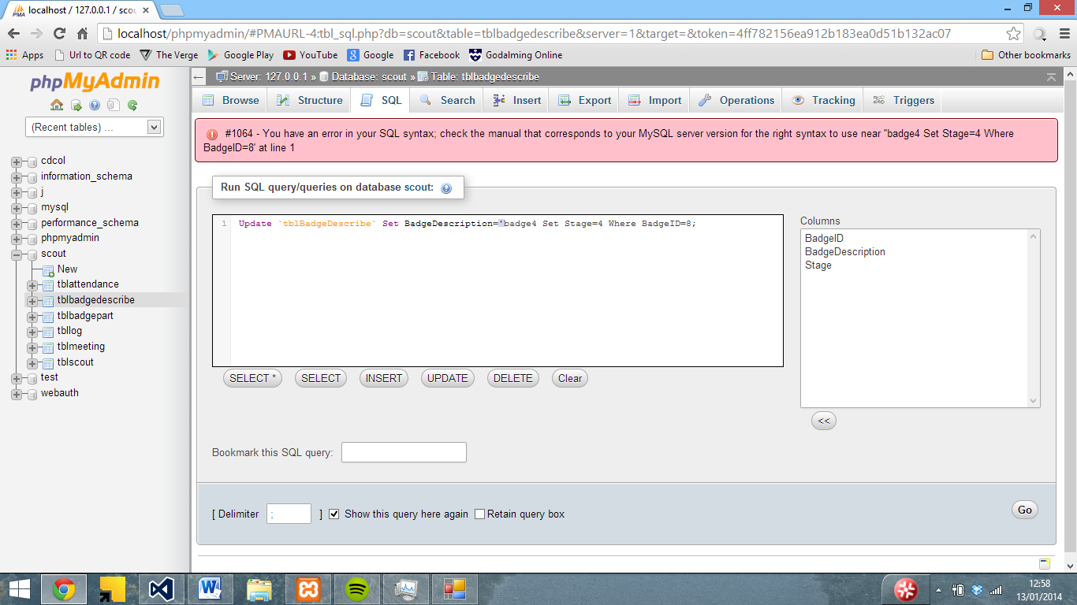

Which I eventually isolated to a missing ‘ after the badge description

I encountered another issue with the enter programme screen – the badge part should be the part name instead of the ID

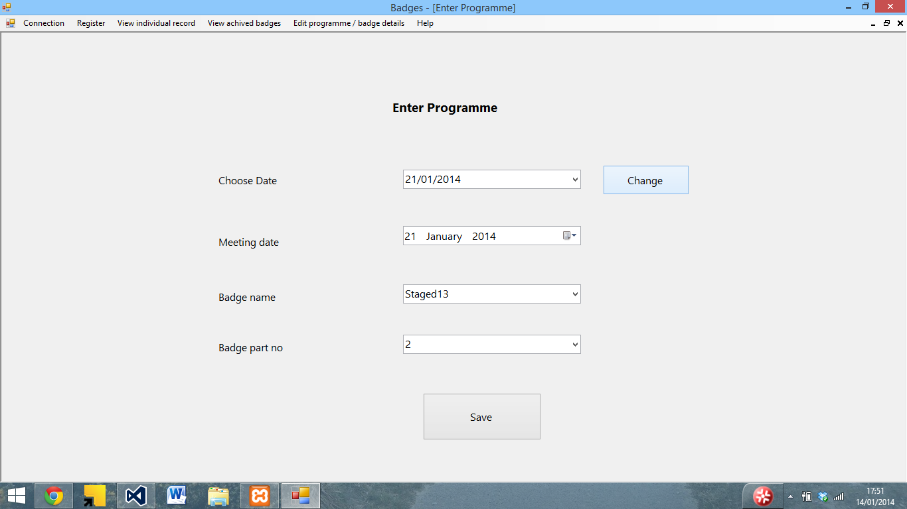

After looking at the code, it turned out that I had set badgepart to Id instead of description

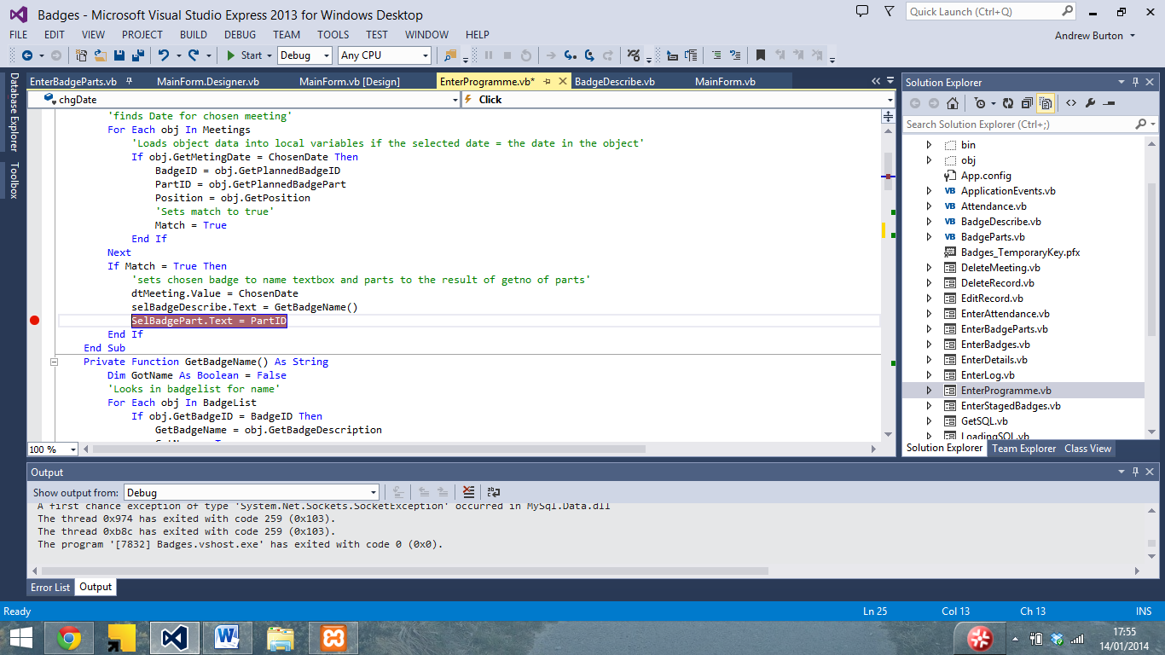

So I created a getpartname function to get the part name from the ID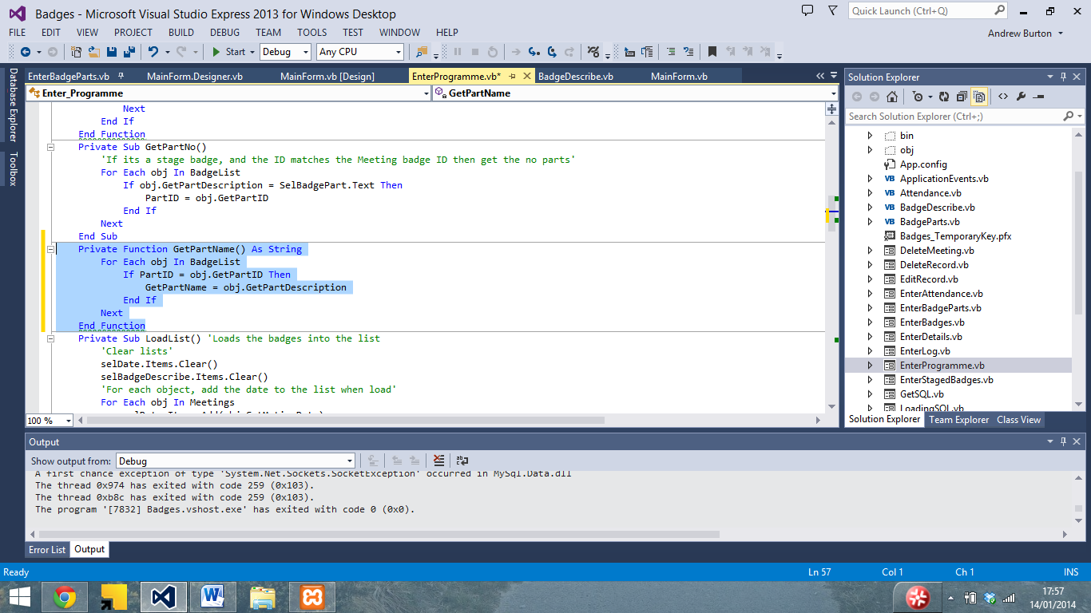

And set selbadgepart to be equal to that function

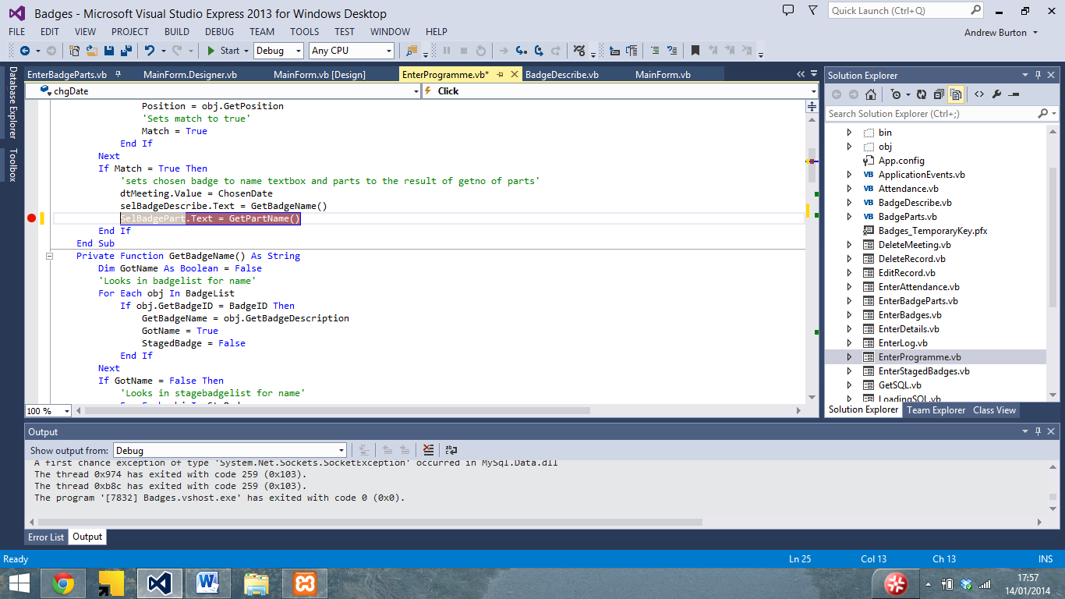

This fixed the issue

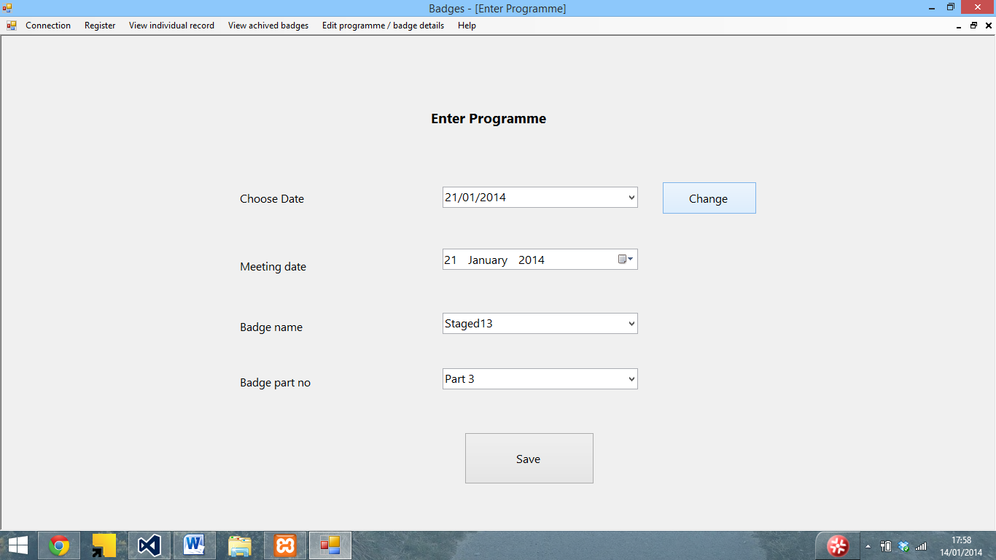

Although I had a similar issue with save changes

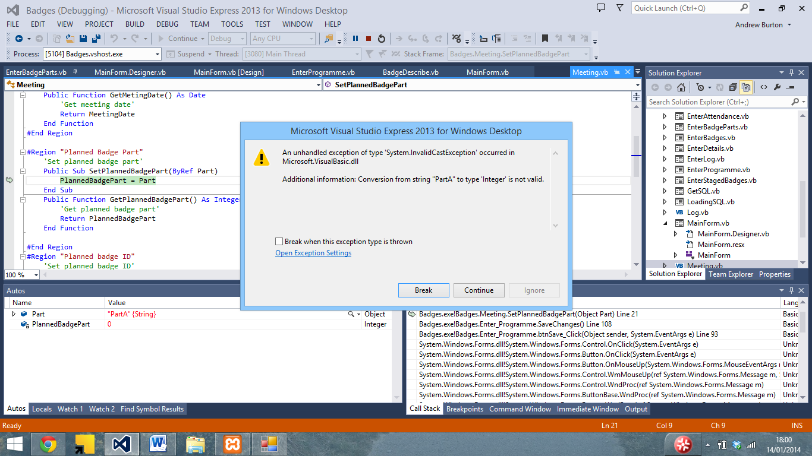

Which I was trying to save as a string rather than an integer

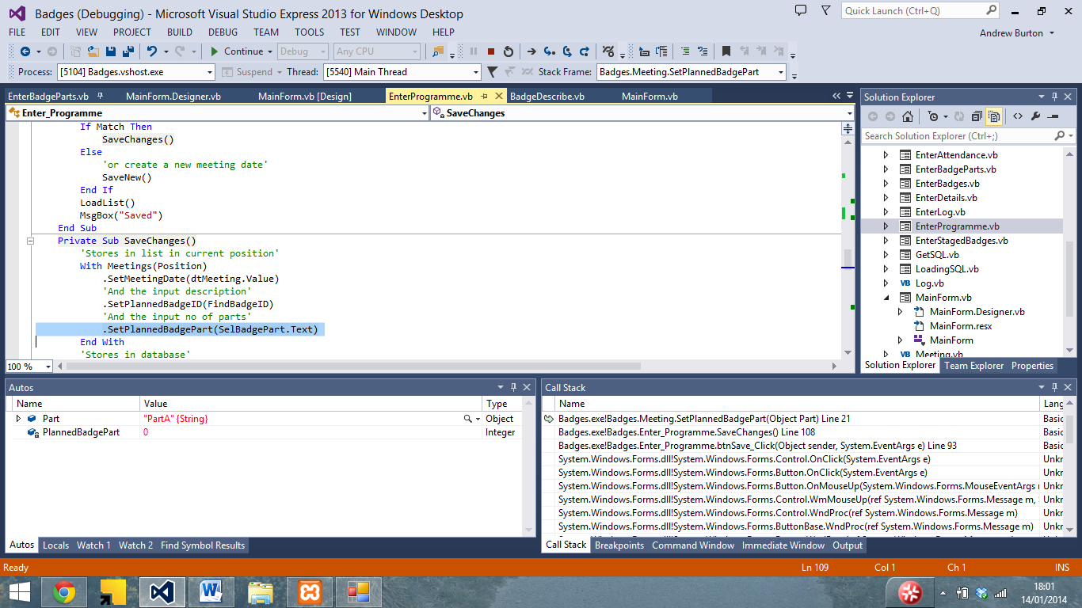

Changed badgepart to partID

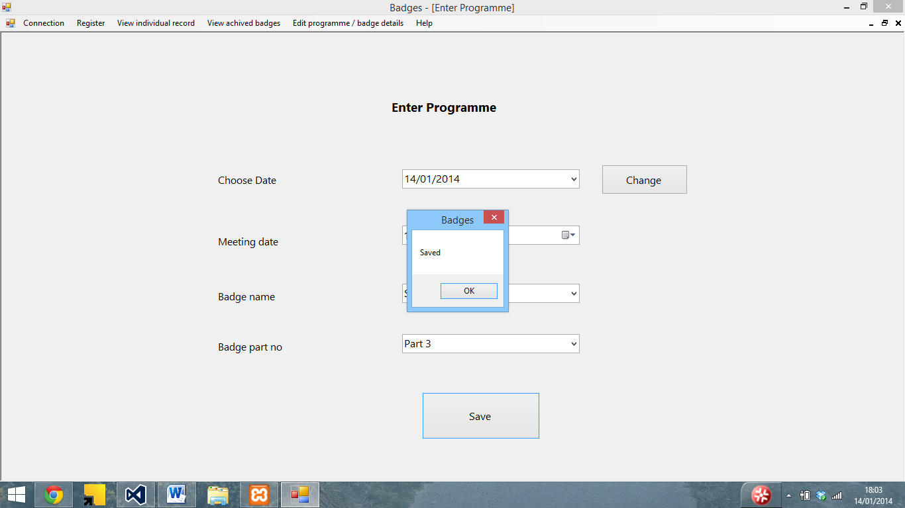

Another issue I encountered was that Attendance being wrongly assigned when new person added

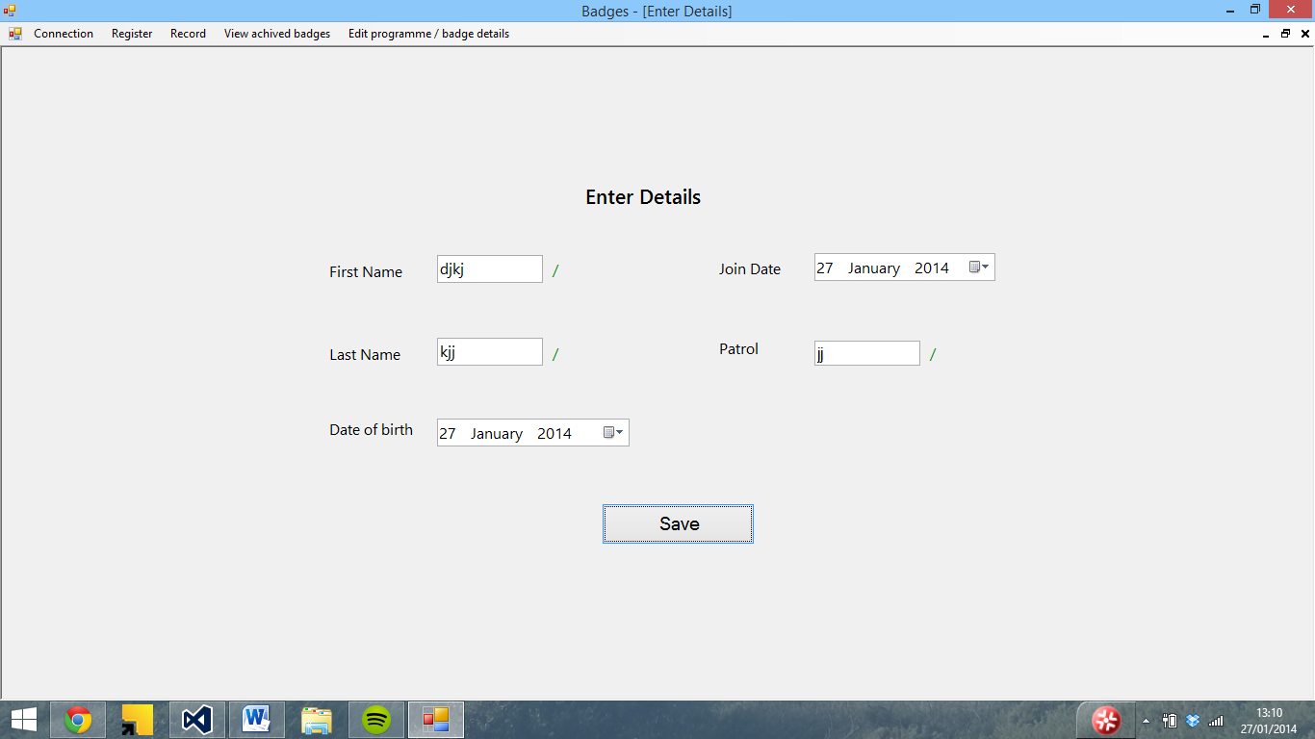

Fine in the SQL server and when you reconnect…

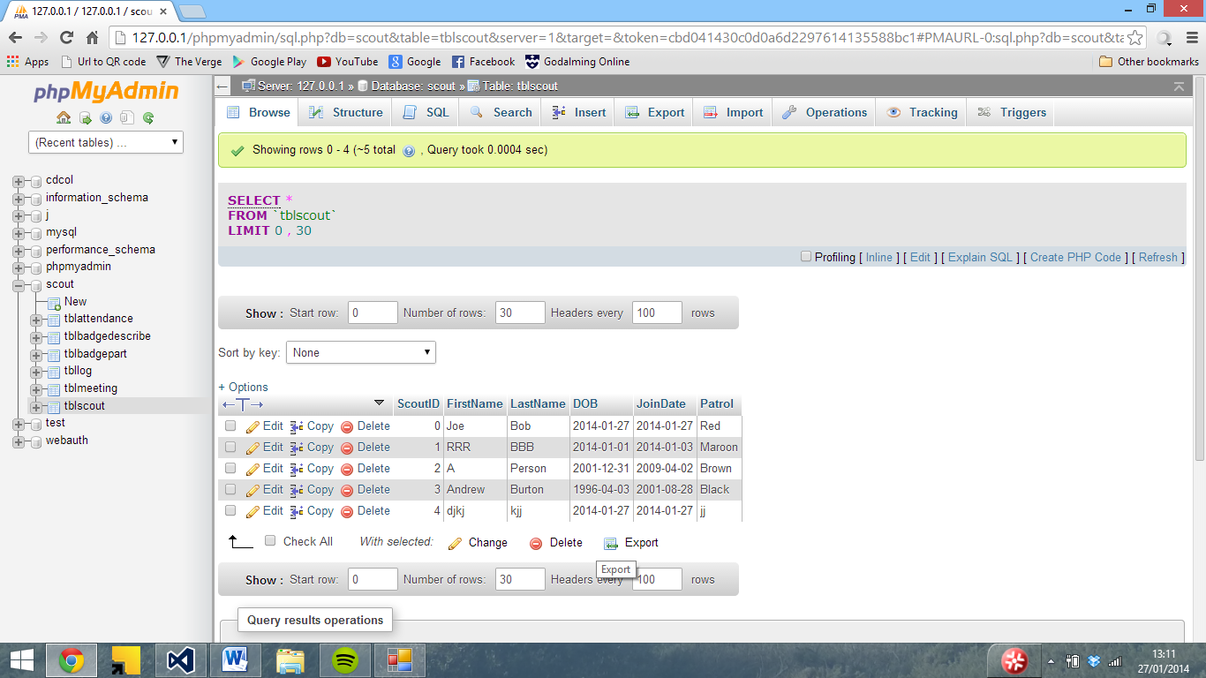

No ID is assigned

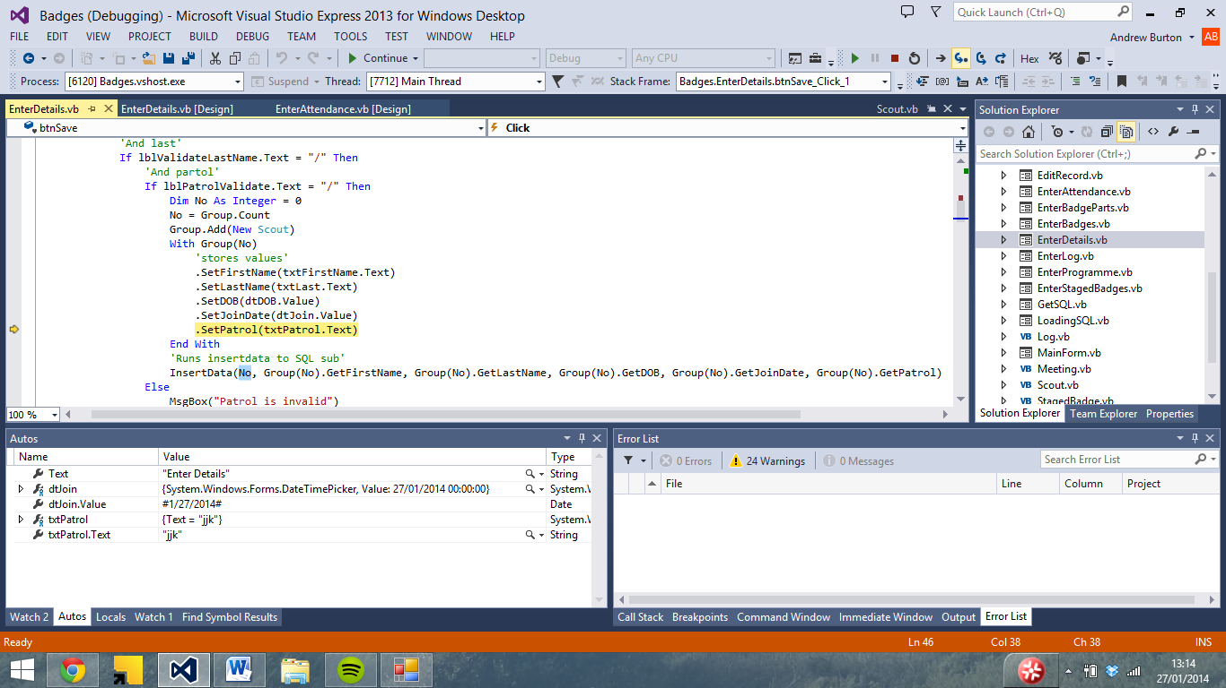

But is at the SQL stage

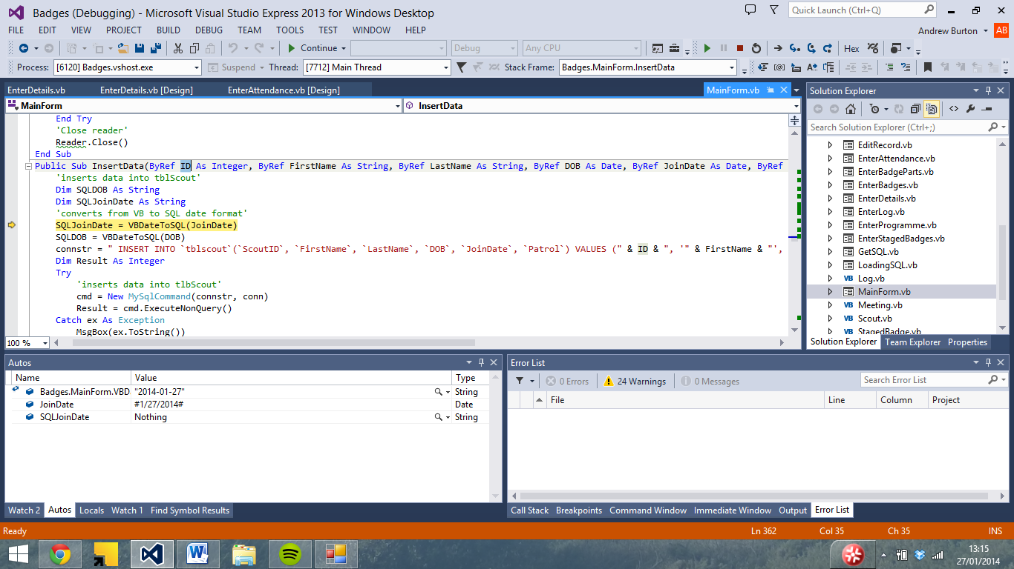

So I added a line of code to assign it the next highest ID

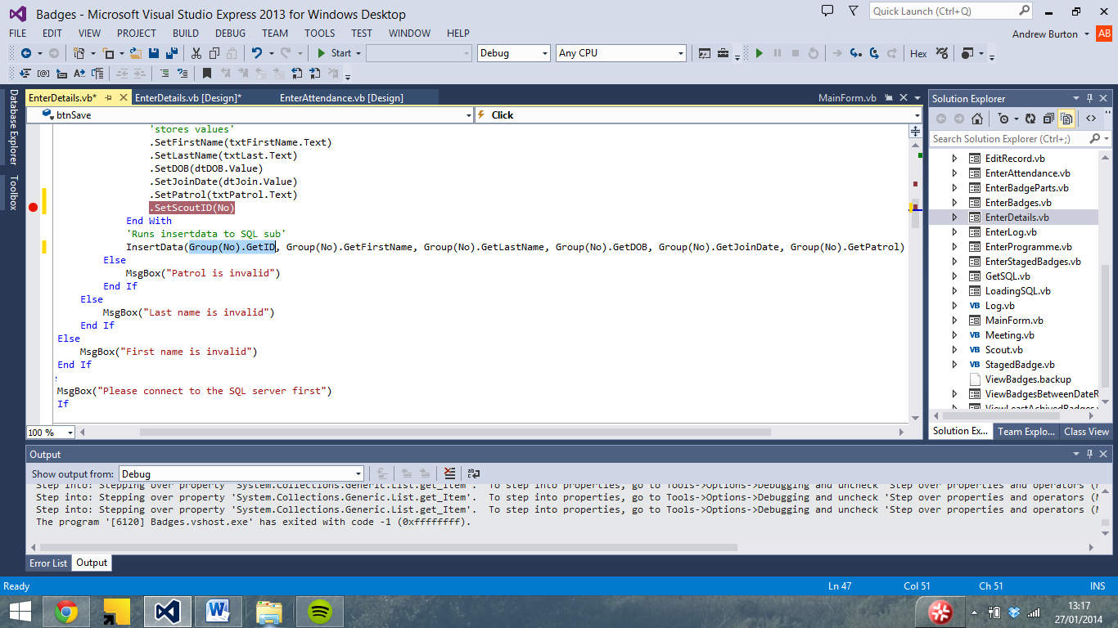

Which meant that the record saved

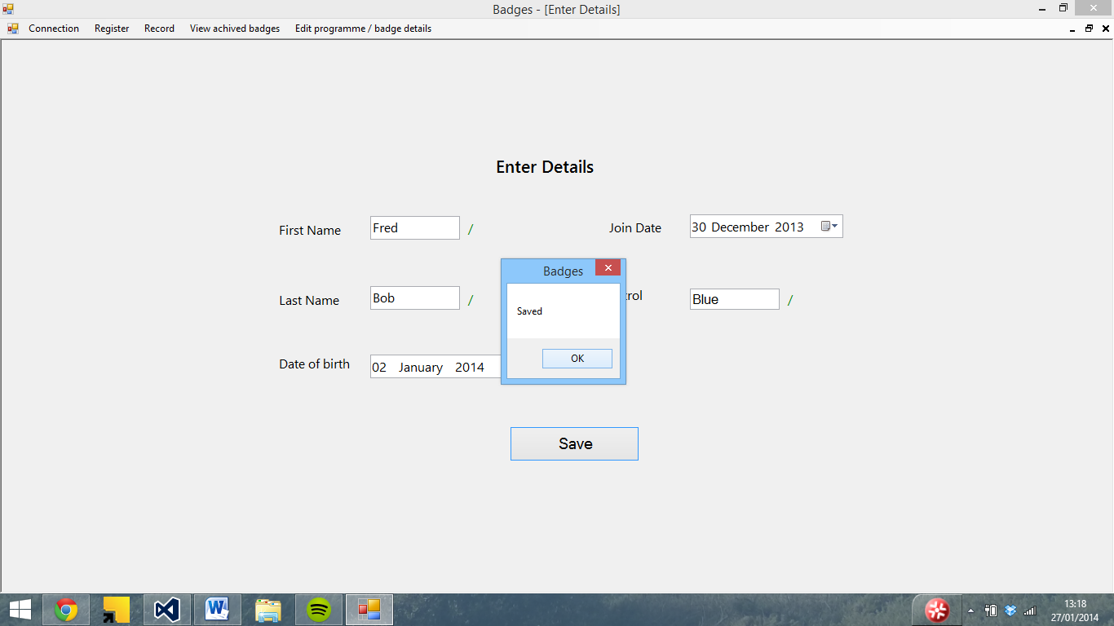

And the attendance displays correctly

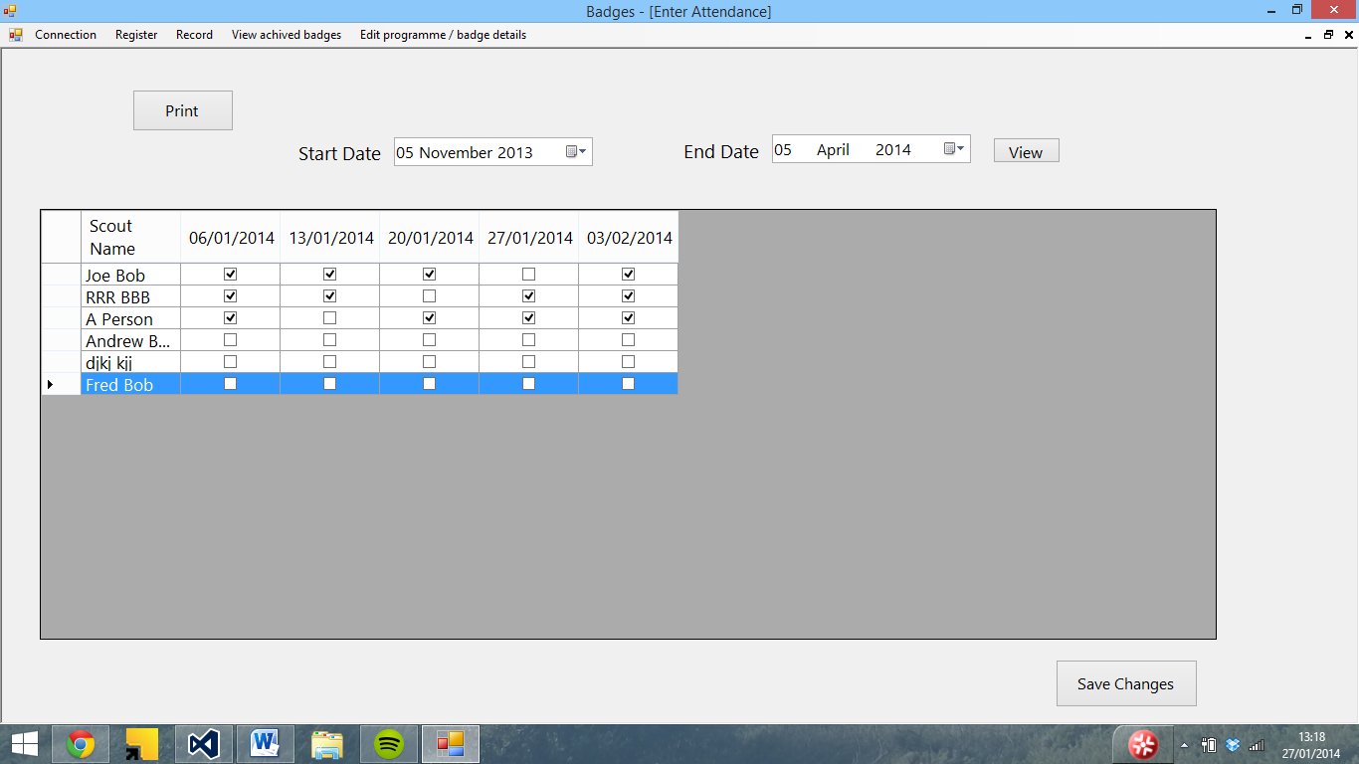

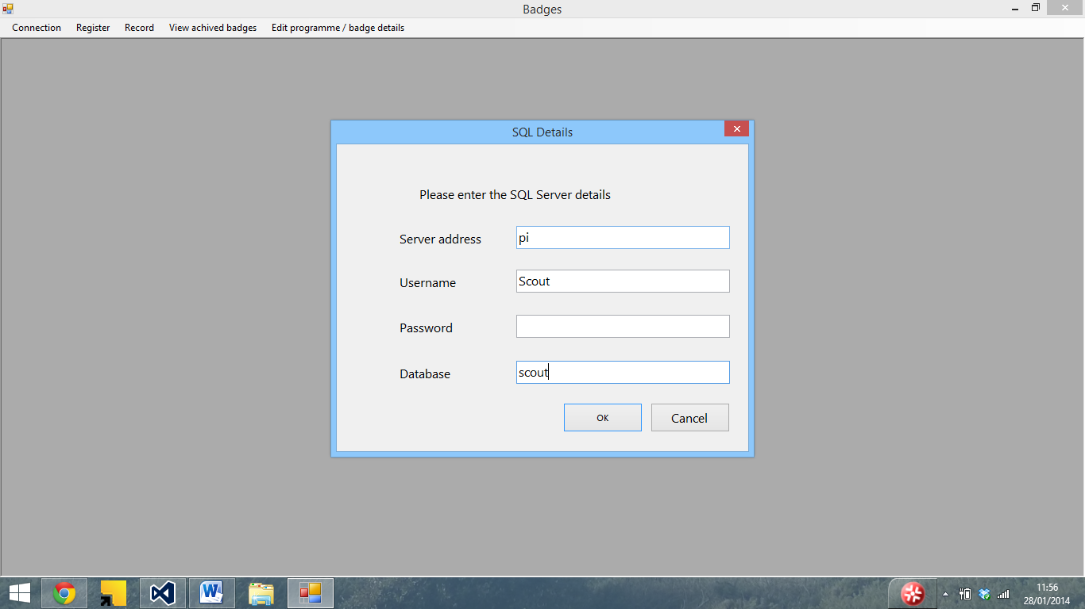

Wrong table name (should be Scout) – password removed

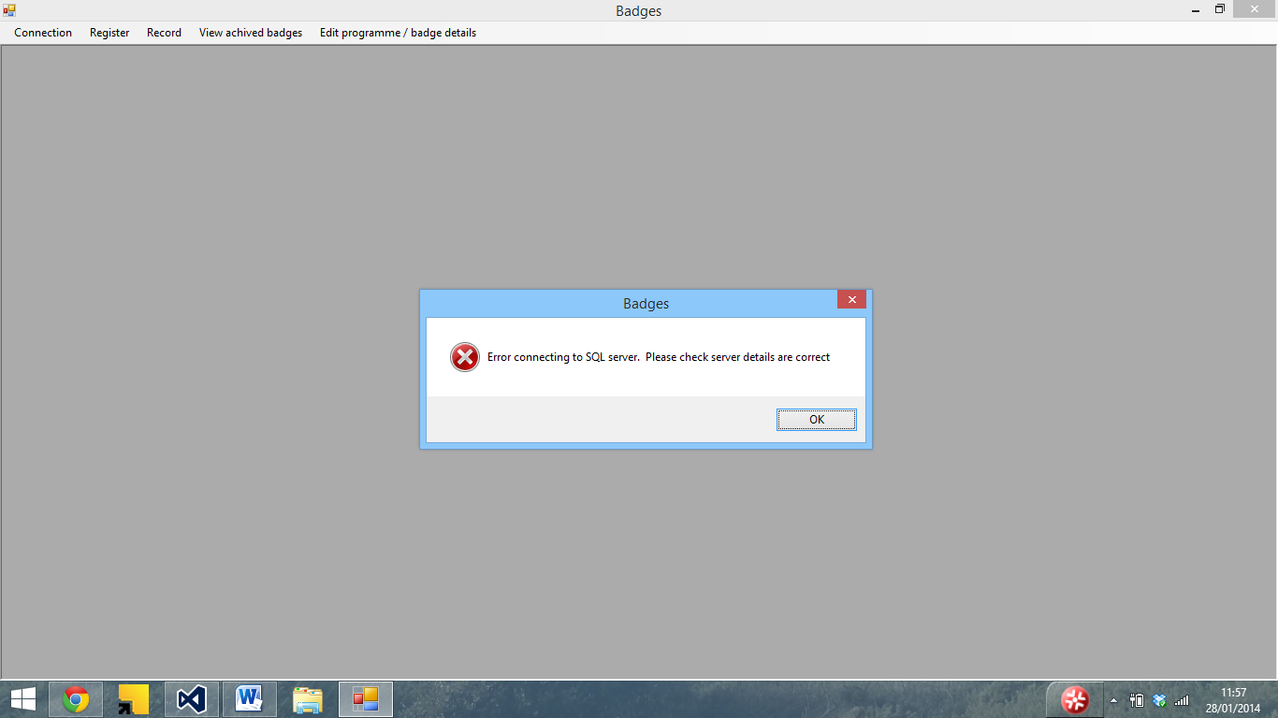

And if I enter the correct details

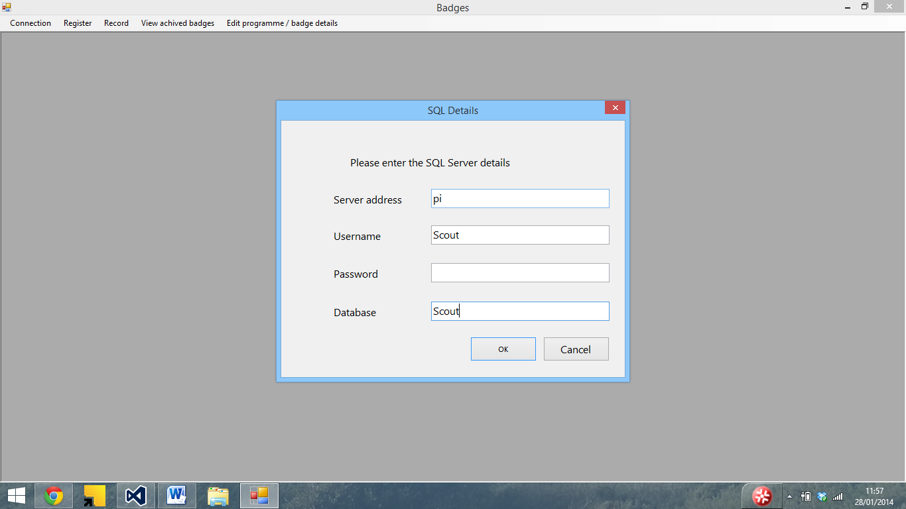

It crashes as the connection is open

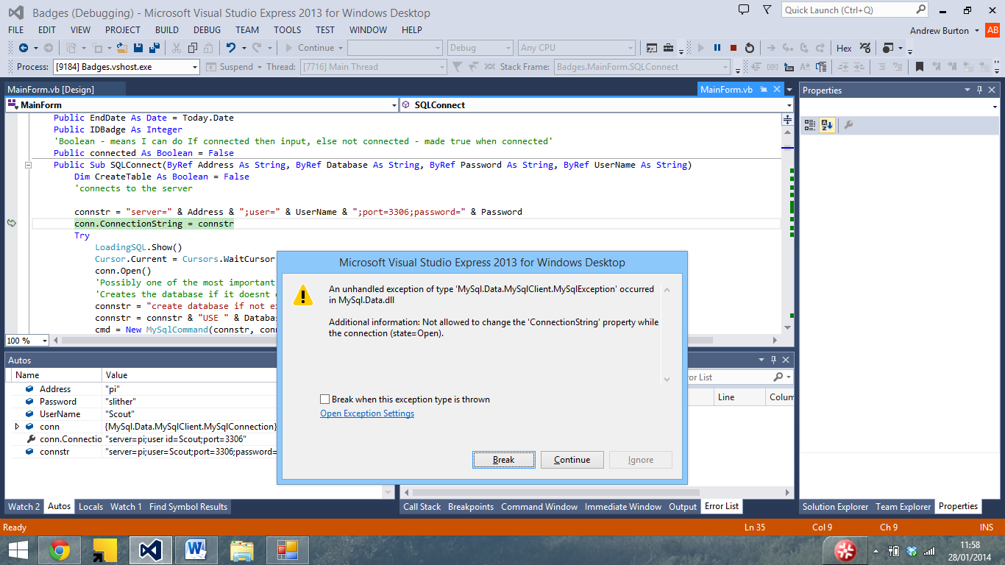

I tried adding in a connection close line

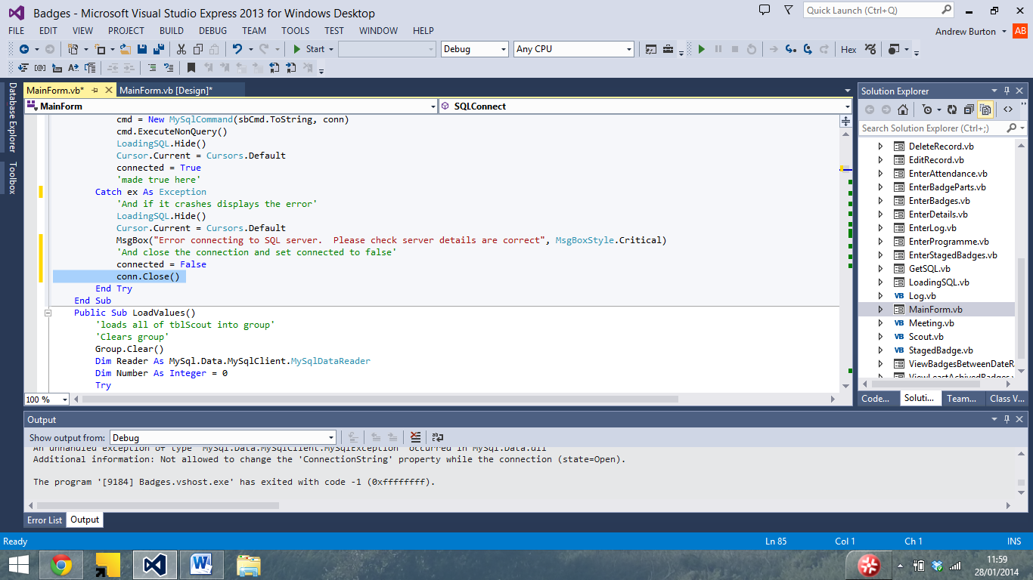

I then tried again With Wrong details

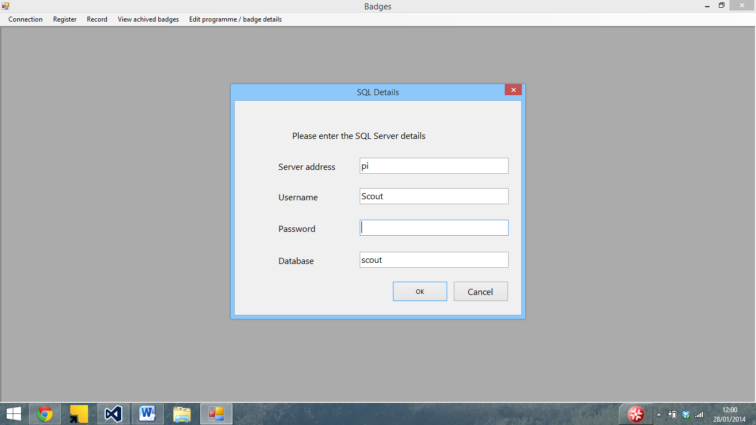

The program throws an error

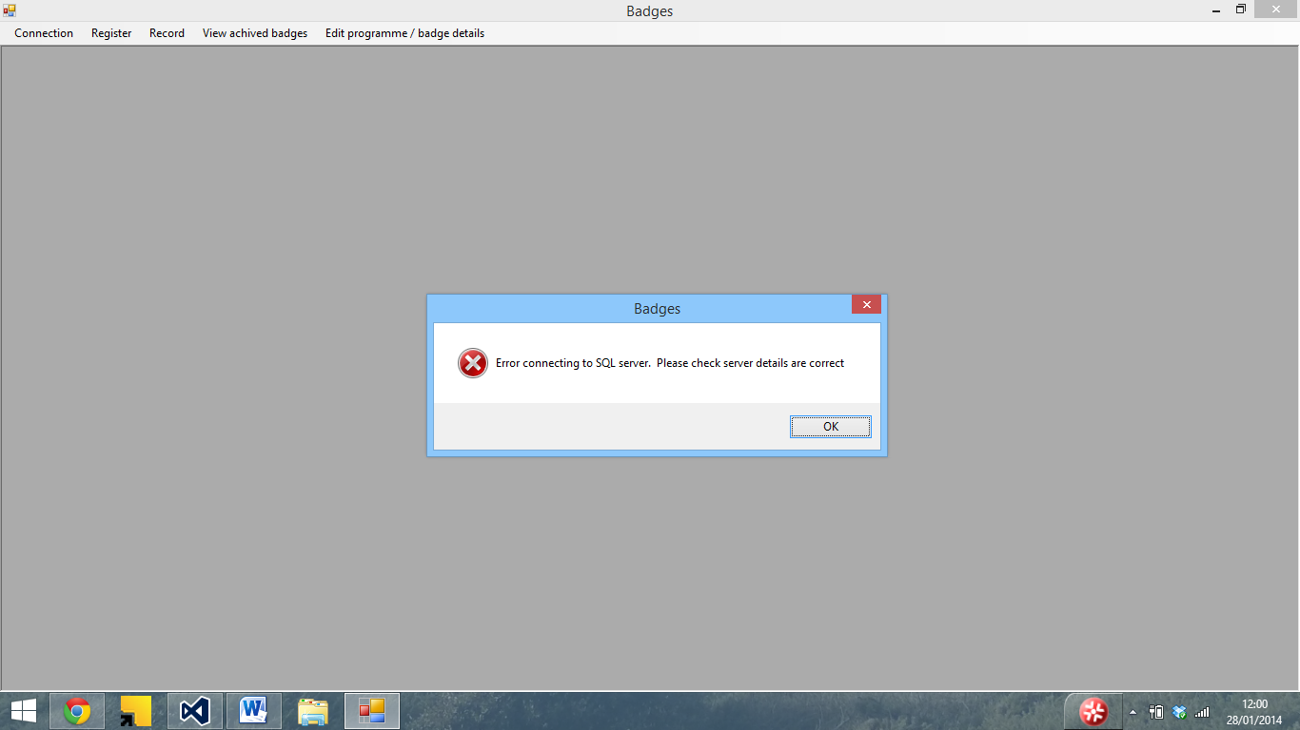

And with correct details

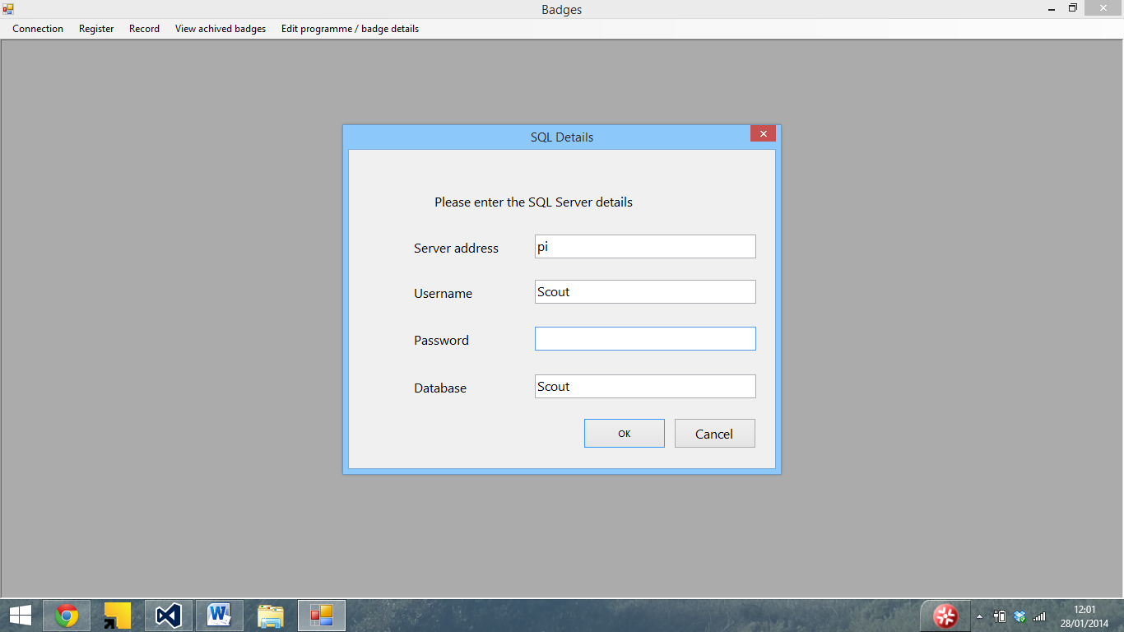

It connects

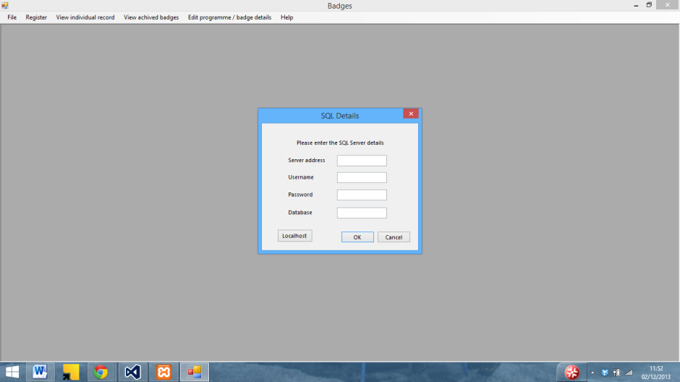

During development I added a localhost button to the SQL details form to allow me to quickly connect to the SQL server

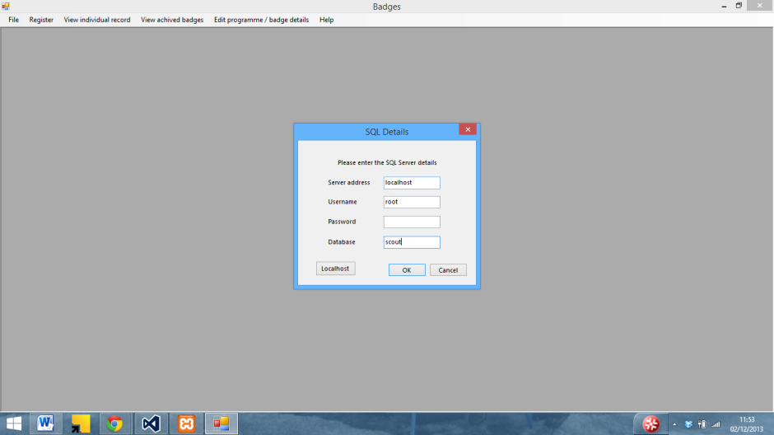

The textboxes also worked

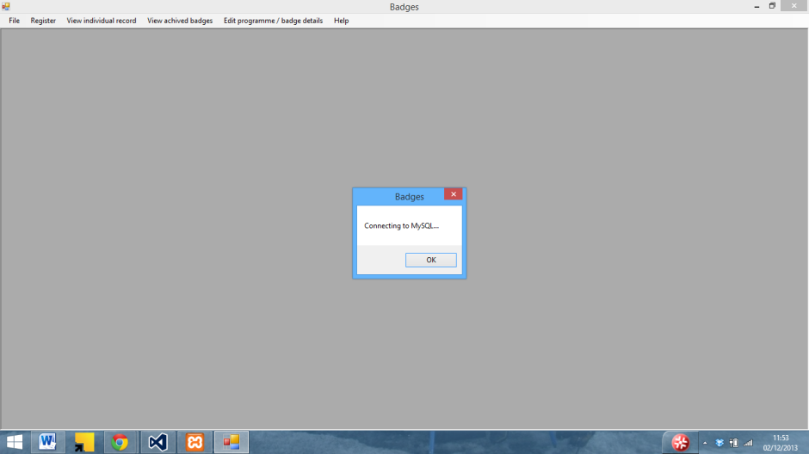

I also originally used a message box instead a form to display that the connection was working, although I changed this since the program would not connect to the server until the OK button was pressed

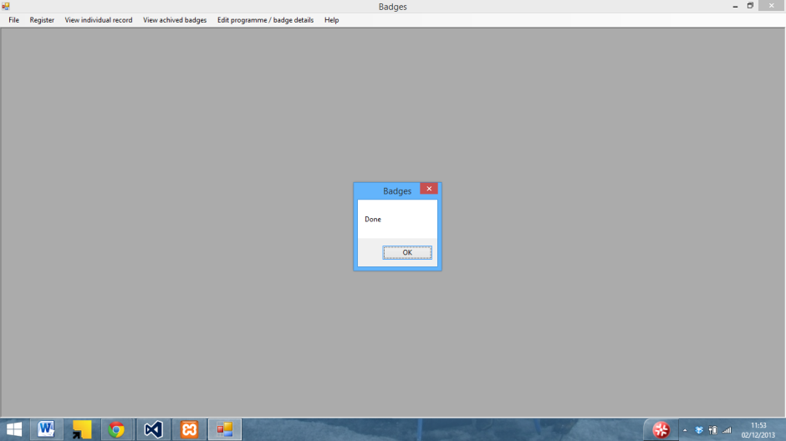

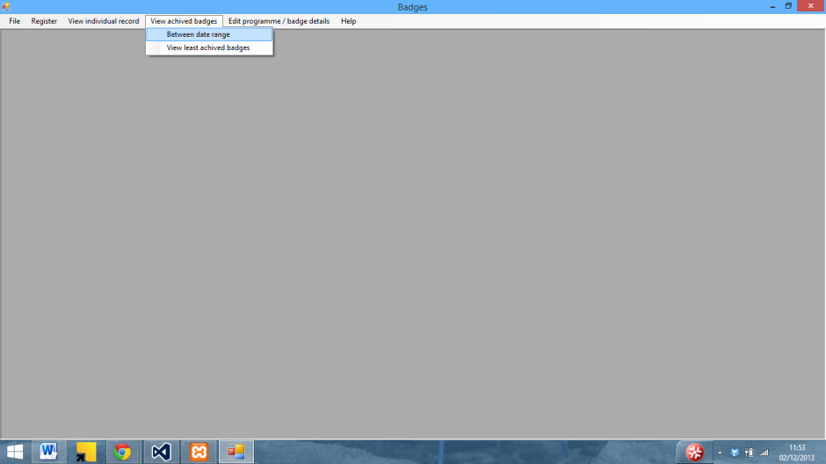

The view badges between date range originally used IDs rather than names whilst I sorted out the issued with the grid view and other parts of the program



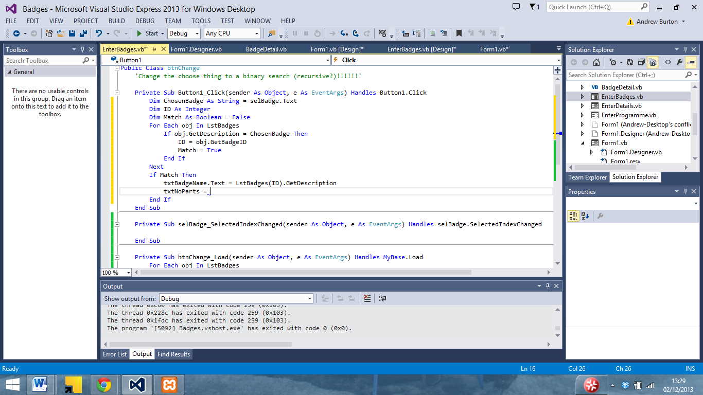

Hmm… if I do this each badge …

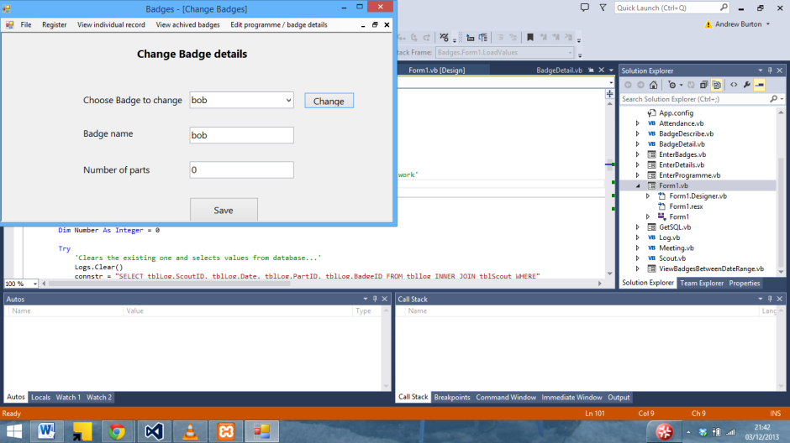

…Except its leaving a load of null values

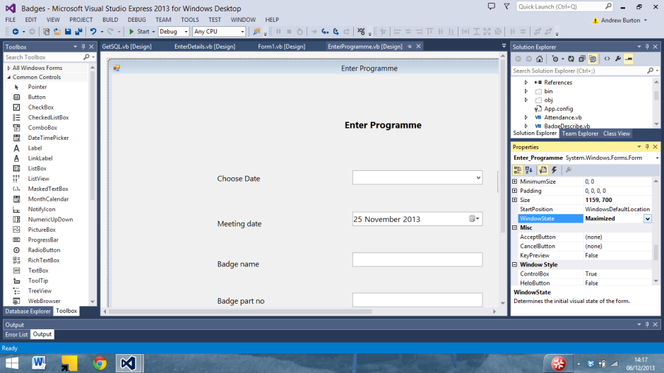

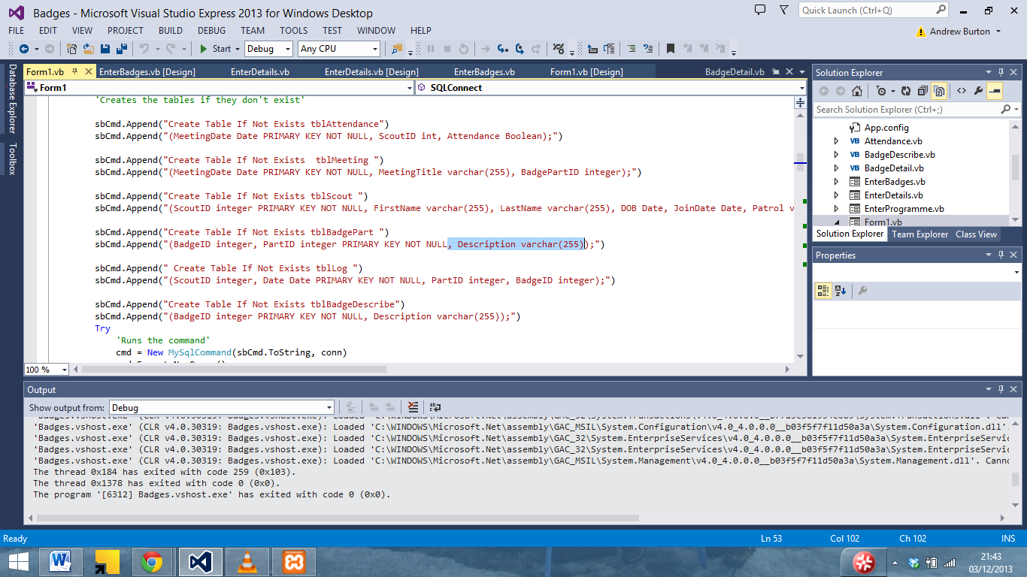

.. and it works

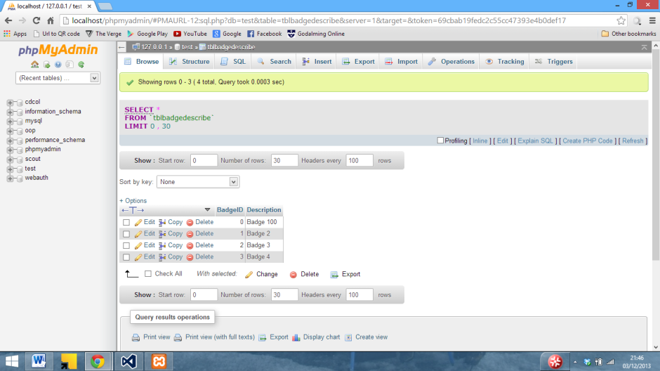

Even if changing a number of parts results in the number of parts being duplicated (And 1 more than entered being added when the badge is created)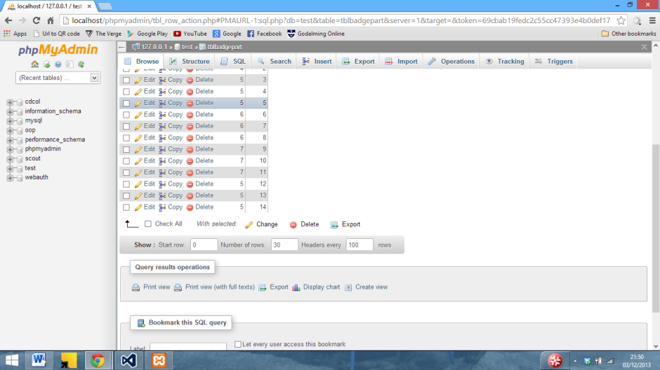

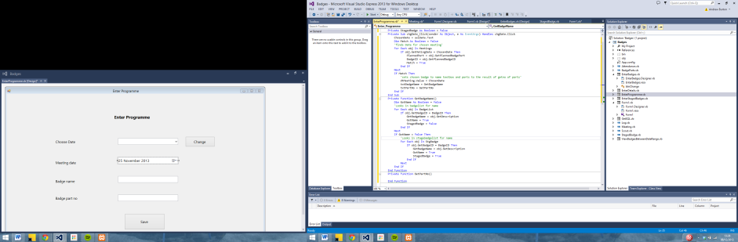

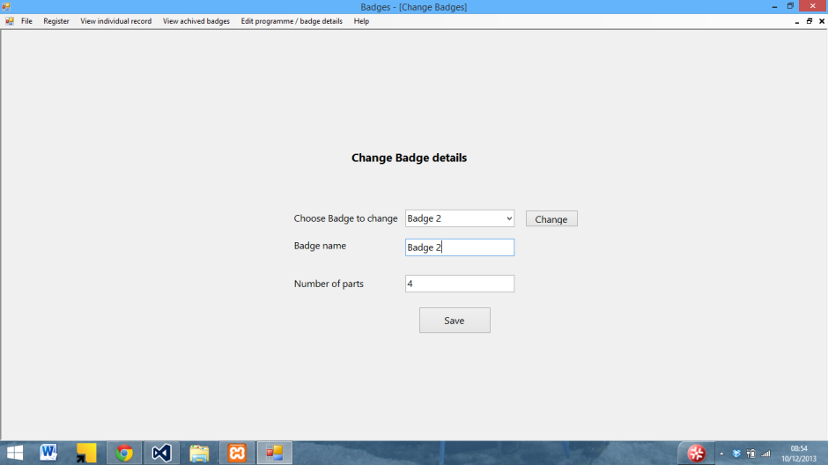

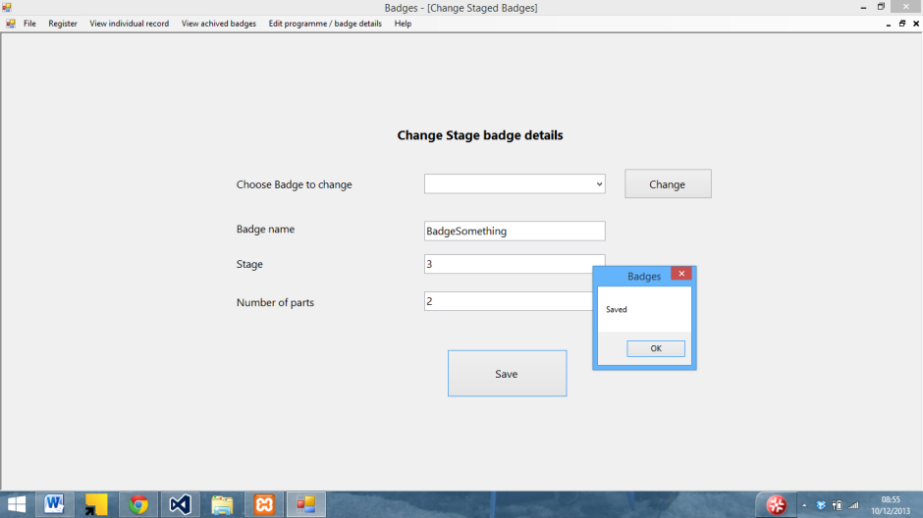

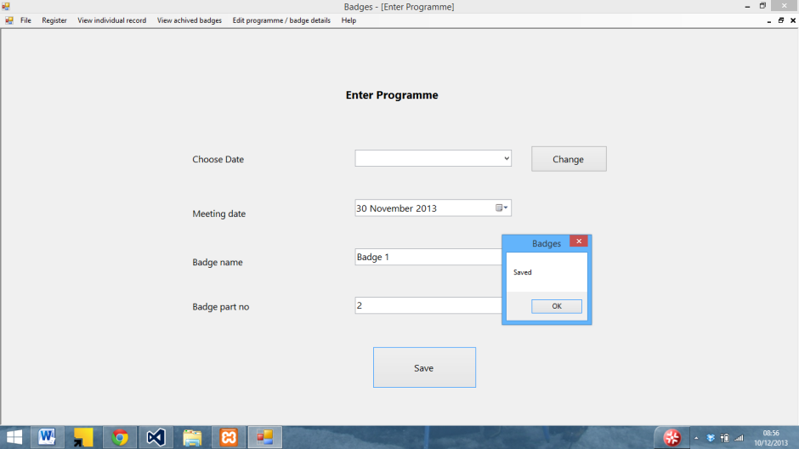

… It saves (but not to the database yet)

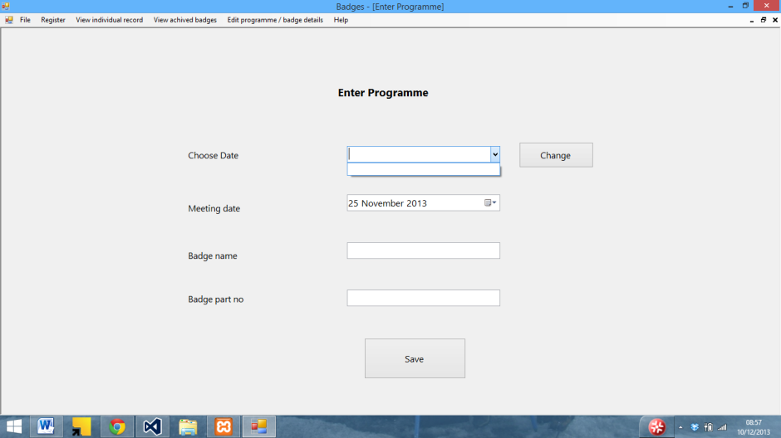

Managed to get a list of the badges in (and working)

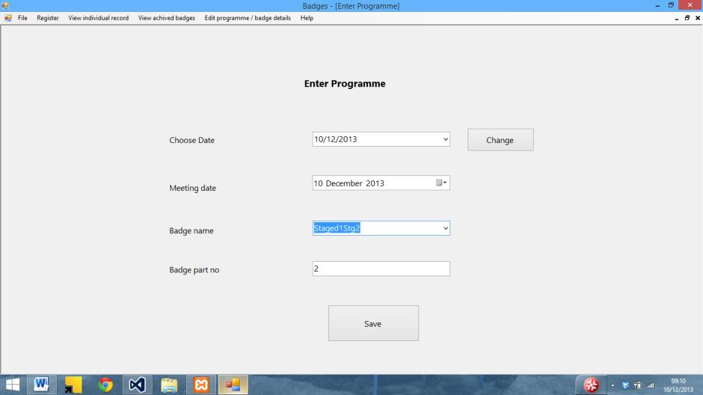

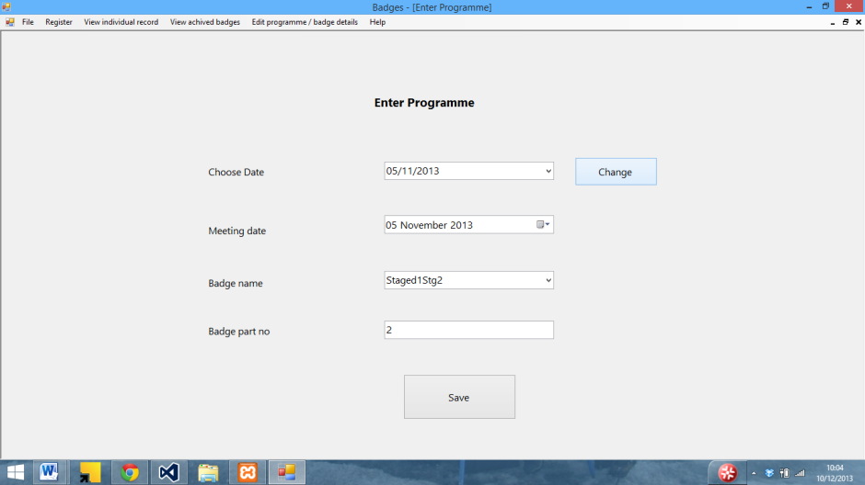

And it now connects to the SQL server

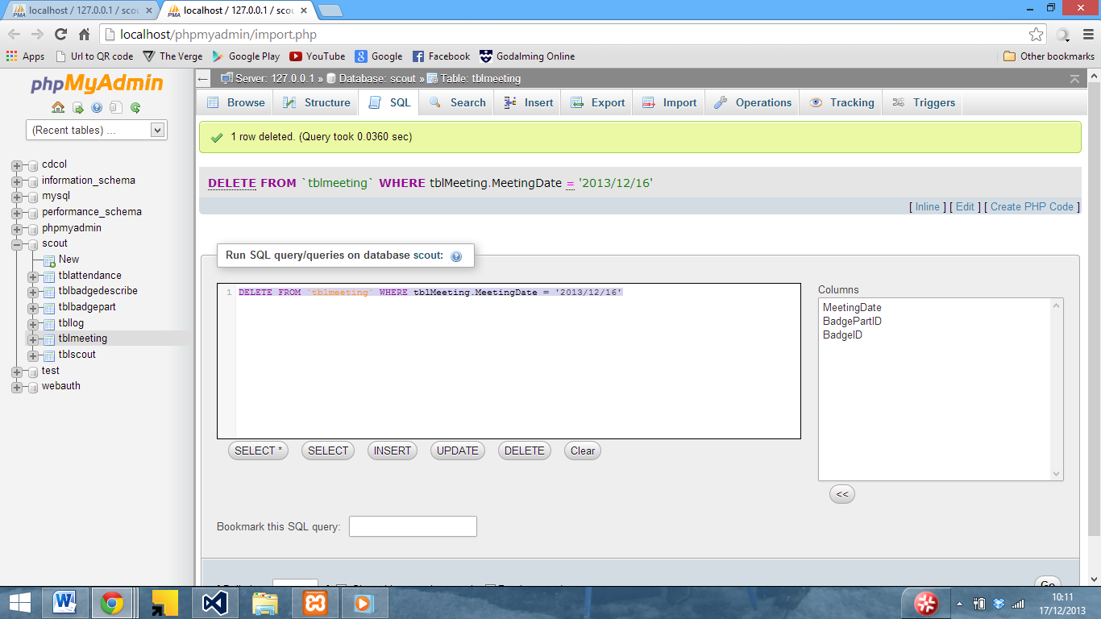

Testing SQL statements before implementing

Appendix C – Program Code

This section lists the code used in the program. Details of the forms and subs which this code relates to can be seen in systems maintenance